

**FPT UNIVERSITY**

Capstone Project Document

**Design and implement a management system for a chain of hotels and motels using IoT technology**

|  |  |
| --- | --- |
| **Group GSU22SE44** | |
| **Group members** | Lê Hồng Nguyên – SE130342 Nguyễn Quốc Trường Huy – SE140296 Hoàng Tuấn Anh– SE140056 |
| **Supervisor** | Mr. Nguyễn Đức Lợi  Mr. Nguyễn Tấn Danh |
| **Capstone Project code** | DIMS |

*- Ho Chi Minh City, 18 May 2022 –*

# Table of Contents

Table of Contents 2

List of Tables 4

List of Figures 6

Acknowledgement 8

Definition and Acronyms 8

I. Project Introduction 9

1. Overview 9

**1.1.** **Project Information** 9

**1.2.** **Project Team** 9

2. Product Background 9

3. Existing Systems 10

**3.1.** **App 1: Pin Bike** 10

**3.2.** **App 2: GoVNU** 10

4. Business Opportunity 11

5. Software Product Vision 11

6. Project Scope and Limitations 11

**6.1.** **Major Features** 11

**6.2.** **Limitations and Exclusions** 12

II. Project Management Plan 12

1. Overview 12

**1.1.** **WBS and Estimation** 12

**1.2.** **Project Objectives** 15

**1.3.** **Project Risks** 15

2. Management Approach 16

**2.1.** **Project Process** 16

**2.2.** **Quality Management** 16

**2.3.** **Training Plan** 17

3. Project Organization 17

**3.1.** **Team and Structures** 17

**3.2.** **Roles and Responsibilities** 18

4. Project Communication 18

**4.1.** **Communication Plan** 18

**4.2.** **External Interface** 19

5. Configuration Management 19

**5.1.** **Tools and Infrastructures** 19

**5.2.** **Document Management** 20

**5.3.** **Source Code Management** 20

III. Software Requirement Specification 20

1. Overall Description 20

**1.1.** **User Requirement Overview** 20

**1.2.** **Business Rules** 22

**1.3.** **Overview** 28

**1.4.** **Use Case Specifications** 34

2. Functional Requirements 140

**2.1.** **System Functional Overview** 140

3. Non-Functional Requirements 146

**3.1.** **External Interfaces** 146

**3.2.** **Quality Attributes** 147

IV. Software Design Description 147

1. Overall Description 147

**1.1.** **Assumptions** 147

2. System Architecture Design 147

**2.1.** **Overall System Architecture** 147

**2.2.** **Component Diagram** 149

**2.3.** **Package Diagram** 150

3. Activity Diagram 151

4. System Detailed Design 154

**4.1.** **Class Diagram** 154

**4.2.** **Class Specification** 155

**4.3.** **State Machine Diagrams** 178

**4.4.** **Sequence Diagram** 179

5. Data and Database Design 183

**5.1.** **Database Design** 183

**5.2.** **Data File Design** 183

6. Algorithm 202

V. Software Testing Documentation 204

1. Overall Description 204

**1.1.** **Test Model** 204

**1.2.** **Testing Levels:** 204

2. Test Plan 204

**2.1.** **Test Stages** 204

**2.2.** **Resources** 204

**2.3.** **Test Milestones** 205

3. Test Cases & Test Reports 205

VI. Release Package and User Guides 205

1. Deliverable Package 205

**1.1.** **Source Codes and Documents** 205

2. Installation Guide 206

**2.1.** **System Requirements** 206

**2.2.** **Setup Files** 207

**2.3.** **Installation Instruction** 207

3. User Manual 215

**3.1.** **Terms and Definitions** 215

**3.2.** **System Requirement** 215

**3.3.** **Application Usage** 215

**3.4.** **Troubleshooting** 265

VII. Appendix 265

# List of Tables

Table 1. Definition and Acronyms 9

Table 2. Supervisor 9

Table 3. Team members 9

Table 4. WBS and Estimation 15

Table 5. Project Objectives 15

Table 6. Project Risks 16

Table 7. Training Plan 17

Table 8. Team and Structures 18

Table 9. Roles and Responsibilities 18

Table 10. Communication Plan 19

Table 11. FPTU Contacts 19

Table 12. Tools and Infrastructures 20

Table 13. Business Rules 28

Table 14. System Actors 30

Table 15. Use Cases List 34

Table 16. System Architecture 149

Table 17. Component Diagram Description 150

Table 18. Package Diagram Description 151

Table 19. AppUser Class Attribute 157

Table 20. AppUser Class Method 157

Table 21. Bike Class Attribute 158

Table 22. Bike Class Method 158

Table 23. UserAddress Class Attribute 159

Table 24. UserAddress Class Method 159

Table 25. Intimacy Class Attribute 159

Table 26. Intimacy Class Method 160

Table 27. Report Class Attribute 160

Table 28. Report Class Method 160

Table 29. S.O.S Class Attribute 161

Table 30. S.O.S Class Method 161

Table 31. Point History Class Attribute 162

Table 32. Point History Class Method 162

Table 33. Trip Class Attribute 163

Table 34. Trip Class Method 163

Table 35. Route Class Attribute 164

Table 36. Route Class Method 164

Table 37. Station Class Attribute 165

Table 38. Station Class Method 165

Table 39. Area Class Attribute 165

Table 40. Area Class Method 166

Table 41. Feedback Class Attribute 166

Table 42. Feedback Class Method 167

Table 43. Trip Transaction Class Attribute 167

Table 44. Trip Transaction Class Method 167

Table 45. Wallet Class Attribute 168

Table 46. Wallet Class Method 168

Table 47. Redemption Class Attribute 168

Table 48. Redemption Class Method 169

Table 49. Voucher Category Class Attribute 169

Table 50. Voucher Category Class Method 169

Table 51. Voucher Class Attribute 170

Table 52. Voucher Class Method 170

Table 53. Voucher Address Class Attribute 171

Table 54. Voucher Address Class Method 171

Table 55. Address Class Attribute 171

Table 56. Address Class Method 172

Table 57. Advertisement Address Class Attribute 172

Table 58. Advertisement Address Method 172

Table 59. Advertisement Class Attribute 173

Table 60. Advertisement Class Method 173

Table 61. Voucher Image Class Attribute 173

Table 62. Voucher Image Class Method 173

Table 63. Voucher Code Class Attribute 174

Table 64. Voucher Code Class Method 174

Table 65. Momo Transaction Class 175

Table 66. Momo Transaction Method 175

Table 67. Role Class Attribute 175

Table 68. Role Class Method 175

Table 69. Notification Class Attribute 176

Table 70. Notification Class Method 176

Table 71. Configuration Class Attribute 177

Table 72. Configuration Class Method 177

Table 73. App User Table 185

Table 74. Bike Table 186

Table 75. Intimacy Table 186

Table 76. Wallet Table 187

Table 77. Trip Tabel 189

Table 78. Route Table 189

Table 79. Station Table 190

Table 80. Area Table 190

Table 81. Trip Transaction Table 191

Table 82. Feedback Table 192

Table 83. Redemption Table 192

Table 84. Voucher Table 193

Table 85. Advertisement Table 194

Table 86. Report Table 195

Table 87. S.O.S Table 195

Table 88. Point History Table 196

Table 89. User Address Table 196

Table 90. Address Table 197

Table 91. Advertisement Address 197

Table 92. Advertisement Image Table 198

Table 93. Voucher Code Table 198

Table 94. Voucher Category table 199

Table 95. Voucher Image Table 199

Table 96. Voucher Address Table 199

Table 97. Role Table 200

Table 98. Notification Table 201

Table 99. Bike Availability Table 201

Table 100. Momo Transaction Table 202

Table 101. Configuration Table 202

Table 102. Source Codes and Documents 206

Table 103. Software Requirement 207

Table 104. Hardware Requirements 215

# List of Figures

Figure 1. Incremental Model 16

Figure 2. Use Case Diagram 29

Figure 3. Mobile App Screen Flow 140

Figure 4. Web Admin Screen Flow 141

Figure 5. Entity Relationship Diagram 146

Figure 6. System Architecture Diagram 148

Figure 7. Component Diagram 149

Figure 8. Package Diagram 150

Figure 9. Activity Diagram - Create trip 152

Figure 10. Activity Diagram - Redeem voucher 153

Figure 11. Activity Diagram - Accept a trip 154

Figure 12. Class Diagram 155

Figure 13. Trip's States 179

Figure 14. Create Trip Now Sequence Diagram 180

Figure 15. Create Schedule Trip Sequence Diagram 180

Figure 16. Redeem Voucher Sequence Diagram 181

Figure 17. Search Trip Sequence Diagram 182

Figure 18. Send Trip Feedback Sequence Diagram 183

Figure 19. Physical Diagram 183

Figure 20. Application Usage Overview 216

# Acknowledgement

Foremost, we would like to express our sincere gratitude to our mentor Mr. Nguyen Duc Loi and Mr. Nguyen Tan Danh for the continuous support of our capstone project, for his patience, motivation, enthusiasm, and immense knowledge. His guidance helped us in all the time of research, designing, building, and developing of this thesis. We could not have imagined having a better advisor and mentor for our capstone project.

Last but not the least, we would like to thank our family for giving birth to us at the first place and supporting us spiritually throughout our life.

# Definition and Acronyms

|  |  |
| --- | --- |
| **Acronym** | **Definition** |
| DIMS | Management system for a chain of hotels and motels using IoT technology |
| BR | Business Rule |
| ERD | Entity Relationship Diagram |
| GUI | Graphical User Interface |
| UC | Use Case |
| W | Web App |
| M | Mobile App |
| API | Application Program Interface |

Table 1. Definition and Acronyms

1. Project Introduction
2. Overview
   1. **Project Information**

* Project name: Design and implement a management system for a chain of hotels and motels using IoT technology
* Project code: DIMS
* Group name: GSU22SE44
* Software type: Web Application, Mobile Application, Hardware system of lock door
  1. **Project Team**

1. **Supervisor**

|  |  |  |  |
| --- | --- | --- | --- |
| **Full Name** | **Email** | **Phone Number** | **Title** |
| Nguyễn Đức Lợi | loind9@fpt.edu.vn | 0916 7439 39 | Lecturer |
| Nguyễn Tấn Danh | danhnt16@fpt.edu.vn |  | Lecturer |

Table 2. Supervisor

1. **Team members**

|  |  |  |  |
| --- | --- | --- | --- |
| **Full Name** | **Email** | **Mobile** | **Role** |
| Lê Hồng Nguyên | nguyenlhse130342@fpt.edu.vn | 0934 0924 25 | Leader |
| Nguyễn Quốc Trường Huy | huynqtse140296@fpt.edu.vn | 0706 7496 73 | Member |
| Hoàng Tuấn Anh | anhhtse140335@fpt.edu.vn | 0797 9917 07 | Member |

Table 3. Team members

1. Product Background

In today's era when people's economic life is improved and they really focus on activities such as travel, experience, private life. Especially young people today, the demand for renting hotels and motels is very high. They are a group of customers who can access high technology very quickly, often they want the procedures of room rental and check-out to be quick, convenient and private, discreet and comfortable. At the same time, the owners of hotels and motels also want to have more customers access to their services. For the manager of a series of hotel chains, motels they also have to implement a smart management system to easily track all activities there.

1. Existing Systems
   1. **App 1: Pin Bike**

An application that gives user money on how much they use their bicycle to help protect environment.

* Pros:
  + Help user keep track of the time, distance, and velocity during the time they ride a bicycle.
  + Help user gain motivation to use another way of transportation that is more friendly with the environment and earned money during doing so.
  + Help user find garage repair shop.
* Cons:
  + The app does not support English version which is hard for user to use.
  + Since the app is quite nearly not supported anymore, sign up step is not working as it supposed to be along with some other functions.
  1. **App 2: GoVNU**

A hitchhiking platform for students of HCM National University.

* Pros:
  + Provide a platform for students of HCM National University to use to help other student on transportation with optional amount of money.
  + Allows user to find other user by phone numbers.
* Cons:
  + Anyone can use this app without verification.
  + User can book trip at any time, even past time.
  + Does not provide a safe solution for student: anyone can see the trip information and user information without any constraint.
  + User pay by optional amount of money which is not fair and square that may leads to driver hesitate in accept the trip because they might want to wait for another request that has higher paid.

1. Business Opportunity

In today's era when people's economic life is improved and they really focus on activities such as travel, experience, private life. Especially young people today, the demand for renting hotels and motels are very high. They are a group of customers who can access high technology very quickly, often they want the procedures of room rental and check-out to be quick, convenient and private, discreet and comfortable. At the same time, the owners of hotels and motels also want to have more customers access to their services. For the manager of a series of hotel chains, motels they also have to implement a smart management system to easily track all activities there. The hotel and motel chain management system applies technology, including functions such as booking, check-in, check-out, payment, budget management and statistics, history tracking ...

1. Software Product Vision

To help modern people change their habits of transportation, Biiké is an Internet-based and Smartphone-enable application that will help connect Biker (who offer a free ride) and Keer (who seek for a free ride). Unlike the existing systems, people who use Biiké will not have to pay money after every trip. On the contrary, through using this app, they earn their points after trips and use that point for other services provided by Biiké.

1. Project Scope and Limitations
   1. **Major Features**
2. **Users use Mobile Application**

As a user who use Biiké mobile application, I want to use these following features:

**FE-01:** Manage account: Create account, update profile, view profile

**FE-02:** Manage bike: Create bike, delete bike, update bike

**FE-03:** View trip history

**FE-04:** View trip details: View map, partner and help center

**FE-05:** Create new trip

**FE-06:** Send trip feedback

**FE-07:** Search trip: accept a trip

**FE-08:** Get point after a trip

**FE-09:** Use point to redeem vouchers

**FE-10:** Switch between two user modes: Keer and Biker

1. **Admin & Moderator use System Admin Web Application:**

As a Biiké’ s admin, I want to view report and manage users with following features:

**FE-11:** Manage station: create, update, delete station

**FE-12:** Manage feedback: view, accept feedback

**FE-13:** View report

**FE-14:** Manage help center: add, update, delete help center information

**FE-15:** Manage voucher: add, update, delete voucher and voucher category

**FE-16:** Manage push notification

**FE-17:** Manage bike: view and confirm user’s bike

* 1. **Limitations and Exclusions**
     + **LE1:** Only develop for FPT University’s student, staff and lecturer currently (first area deployment)
     + **LE2:** User cannot choose random positions for their trip; the trip is created based on defined routes and stations
     + **LE3:** The Routes and Stations at this moment is limited around FPT Campus
     + **LE4:** Since this app is for FPT University’s Student only, once user graduated and the old email is not available, user cannot create a new account with different Gmail

1. Project Management Plan
2. Overview
   1. **WBS and Estimation**

|  |  |  |  |
| --- | --- | --- | --- |
| **#** | **WBS Item** | **Complexity** | **Est. Effort** |
| 1 | Log in | Complex | 3 |
| 2 | Sign up | Complex | 3 |
| 3 | Verify Email | Average | 2 |
| 4 | Verify Phone Numbers | Average | 2 |
| 5 | Reset Password | Average | 2 |
| 6 | Log out | Simple | 1 |
| 7 | View Profile | Simple | 1 |
| 8 | Update profile | Simple | 1 |
| 9 | Choose Role | Average | 2 |
| 10 | View Top Bikers | Simple | 1 |
| 11 | View Notification | Simple | 1 |
| 12 | View Available Voucher List | Average | 2 |
| 13 | View Voucher Details | Simple | 1 |
| 14 | Redeem Vouchers | Simple | 1 |
| 15 | View redemption list | Simple | 1 |
| 16 | View redemption details | Simple | 1 |
| 17 | View advertisement | Average | 2 |
| 18 | View Point transaction | Simple | 1 |
| 19 | View S.O.S number | Simple | 1 |
| 20 | Add S.O.S number | Simple | 1 |
| 21 | Update S.O.S number | Simple | 1 |
| 22 | Delete S.O.S number | Simple | 1 |
| 23 | Change Language | Simple | 1 |
| 24 | View address | Simple | 1 |
| 25 | Update address | Average | 2 |
| 26 | Add address | Average | 2 |
| 27 | Delete address | Simple | 1 |
| 28 | Buy Point | Complex | 3 |
| 29 | Get suggest address | Average | 2 |
| 30 | View Privacy Policy | Simple | 1 |
| 31 | View Terms Of Use | Simple | 1 |
| 32 | View Upcoming trips | Average | 2 |
| 33 | View Past trips | Average | 2 |
| 34 | View trip detail | Complex | 3 |
| 35 | View partner profile | Simple | 1 |
| 36 | Report partner | Simple | 1 |
| 37 | Block partner | Simple | 1 |
| 38 | View past trip with partner | Simple | 1 |
| 39 | Cancel trip | Simple | 1 |
| 40 | Mark as arrived | Complex | 3 |
| 41 | View trip map | Average | 2 |
| 42 | View help center | Simple | 1 |
| 43 | Share real-time location | Average | 2 |
| 44 | Send location to S.O.S number | Complex | 3 |
| 45 | Get nearest police station | Simple | 1 |
| 46 | Get nearest mechanic shop | Simple | 1 |
| 47 | Get nearest gas station | Simple | 1 |
| 48 | Get nearest hospital | Simple | 1 |
| 49 | View ban list | Simple | 1 |
| 50 | Unblock partner | Simple | 1 |
| 51 | Send trip feedback | Average | 2 |
| 52 | Switch mode | Average | 2 |
| 53 | Create trip Now | Complex | 3 |
| 54 | View position detail | Simple | 1 |
| 55 | Schedule trip | Simple | 1 |
| 56 | Tip for biker | Simple | 1 |
| 57 | Filter Schedule Trip | Simple | 1 |
| 58 | View Bike | Average | 2 |
| 59 | Delete Bike | Simple | 1 |
| 60 | Add Bike | Simple | 1 |
| 61 | View Ride Now | Simple | 1 |
| 62 | Switch Ride Now status | Simple | 1 |
| 63 | Add Ride Now station | Simple | 1 |
| 64 | Delete Ride Now station | Simple | 1 |
| 65 | Accept a trip | Simple | 1 |
| 66 | Mark as completed | Complex | 3 |
| 67 | Notify user | Complex | 3 |
| 68 | View report | Average | 2 |
| 69 | Download report | Simple | 1 |
| 70 | View wallet transaction | Simple | 1 |
| 71 | View trip list | Simple | 1 |
| 72 | View feedback | Simple | 1 |
| 73 | Lock customer | Simple | 1 |
| 74 | View route | Simple | 1 |
| 75 | Add route | Simple | 1 |
| 76 | Update route | Simple | 1 |
| 77 | Delete route | Simple | 1 |
| 78 | View area | Simple | 1 |
| 79 | View station | Simple | 1 |
| 80 | Add station | Simple | 1 |
| 81 | Update station | Simple | 1 |
| 82 | Delete station | Simple | 1 |
| 83 | View voucher | Simple | 1 |
| 84 | Add voucher | Average | 2 |
| 85 | Add voucher code | Simple | 1 |
| 86 | Update voucher | Average | 2 |
| 87 | Delete voucher | Simple | 1 |
| 88 | Add voucher category | Simple | 1 |
| 89 | View voucher category | Simple | 1 |
| 90 | Update voucher category | Simple | 1 |
| 91 | Delete voucher category | Simple | 1 |
| 92 | Add ads | Average | 2 |
| 93 | View ads | Simple | 1 |
| 94 | Update ads | Average | 2 |
| 95 | Delete ads | Simple | 1 |
| 96 | Verify bike | Simple | 1 |
| 97 | Add admin | Simple | 1 |
| 98 | View admin | Simple | 1 |
| 99 | Update admin | Simple | 1 |
| 100 | Delete admin | Simple | 1 |
| **Total Estimated Effort (man-days): 139** | | | |

Table 4. WBS and Estimation

* 1. **Project Objectives**

|  |  |  |  |  |
| --- | --- | --- | --- | --- |
| **#** | **Quality Stage** | **No. of Defects** | **% of Defect** | **Notes** |
| 1 | Reviewing | 20 | 27.6 % |  |
| 2 | System Test | 40 | 72.4% |  |
| 3 | User Acceptance Test | X | X |  |
| **Total** | | **60** | **100%** |  |

Table 5. Project Objectives

* 1. **Project Risks**

|  |  |  |  |  |
| --- | --- | --- | --- | --- |
| **#** | **Risk Description** | **Impact** | **Possibility** | **Response Plans** |
| 1 | Technology risk: cannot find the suitable solution for technique problems, the software cannot fulfill the expectation | High | Medium | Do more research on official resources, discuss with mentor |
| 2 | Requirement changes: requirements unexpected changes | Critical | Medium | Choose another way of solution to respond to those changes |
| 3 | Communication risk during COVID-19 crisis: lack of communication leads to lack of clarity and confusion | Critical | High | Schedule an online meeting plan and write meeting minutes include time, tasks, reports, opinions of each members |

Table 6. Project Risks

1. Management Approach
   1. **Project Process**



Figure 1. Incremental Model

Biiké project is developed using the Incremental model which is known as a software development where requirements are divided into different separated modules of development cycle. Using this model, each separated module developed through the requirements, design, implementation, testing phases. The reasons Biiké using this model are:

* We focus on the priority requirements to implements the main functions first.
* Easy to manage risks.
* Design and implements the phrase step by step → Easy to find errors.
* The development team is not very skilled.
* As some of the function is priority to implements first, user gets to use the application earlier.
  1. **Quality Management**

To increase the project quality and user experience, Biiké team apply those:

* Coding convention:
* Pascal casing: "PascalCasing" for class, record, or struct name.
* Camel casing: "camelCasing" for private or internal fields name, and prefix them with _ for private fields.
* Use meaningful names for variables.
* Do prefix interfaces with the letter I.
* Cross-check each member’s code.
* Run Integration testing and System testing.
* Due to the Covid-19 pandemic, there was difficulty in testing the application in real life. Some of the functions require testing in real life which was hard to do. The other functions that can be tested is well tested with real data.
* Acceptance testing:
* Do survey to understand how users receive the application and collect feedbacks.
* Based on users’ feedbacks, fix bugs and update.
  1. **Training Plan**

|  |  |  |  |
| --- | --- | --- | --- |
| **Training Area** | **Participants** | **When, Duration** | **Waiver Criteria** |
| Flutter, GetX | Đỗ Hữu Phát Lê Nguyễn Thảo Vân Nguyễn Thế Thanh Tâm Nguyễn Lê Phương Uyên | Week 1 – 3 days | Mandatory |
| C# Entity Framework | Nguyễn Lê Phương Uyên Đinh Phan Hải Triều | Week 1 – 6 days | Mandatory |
| Project flow, GIT management | All members | Week 1 – 2 days | Mandatory |
| PathShare API | Nguyễn Thế Thanh Tâm | Week 2 – 2 days | Mandatory |
| Firebase | Đỗ Hữu Phát Lê Nguyễn Thảo Vân | Week 2 – 2 days | Mandatory |

Table 7. Training Plan

1. Project Organization
   1. **Team and Structures**

|  |  |
| --- | --- |
| **Role** | **Full name** |
| Project Mentors | Nguyễn Đức Lợi Nguyễn Tấn Danh |
| Technical Master | Lê Hồng Nguyên |
| Technical Members | Nguyễn Quốc Trường Huy Hoàng Tuấn Anh |

Table 8. Team and Structures

* 1. **Roles and Responsibilities**

|  |  |
| --- | --- |
| **Role** | **Responsibility** |
| Project Mentor | Help team finish the project with advice on business and technical issues |
| Technical Members | Implement the task Keep track and help members to finish their task on time |
| Technical Master | Help members to finish their technical task on time and decide the technical solution for the issue  Divide the project into tasks and sign it to specific members.  Schedule the process plan for team. |

Table 9. Roles and Responsibilities

1. Project Communication
   1. **Communication Plan**

|  |  |  |  |  |
| --- | --- | --- | --- | --- |
| **Communication Item** | **Who/ Target** | **Purpose** | **When, Frequency** | **Type, Tool, Method(s)** |
| Phone | Team Members | Emergency cases: sudden meeting, quick talk to confirm an issue | Rarely | Personal Phone / Messenger Free Call |
| Zalo Texting | Supervisor | Confirm Meeting Time, Report Working Progress | Usually | Zalo |
| Meeting Online | Team Members + Supervisor | Progress Reports, Show Demo, Report Problem and receive reviews from Supervisor | Always | Google Meet |
| Messenger Texting | Team Members | Internal conversations, internal reports between members | Always | Messenger |
| Meeting Online | Team Members | Internal conversations, internal reports between members | Always | Discord |

Table 10. Communication Plan

* 1. **External Interface**

1. **FPTU Contacts**

|  |  |  |  |
| --- | --- | --- | --- |
| **Function** | **Contact Person (name, position)** | **Contact address (email, telephone)** | **Responsibility** |
| Supervisor | Nguyễn Đức Lợi  Nguyễn Tấn Danh | [loind9@fpt.edu.vn](mailto:loind9@fpt.edu.vn)  [danhnt16@fpt.edu.vn](mailto:danhnt16@fpt.edu.vn) | - Provide document template  - Guide project team with problems  - Review project result  - Supervise project status |

Table 11. FPTU Contacts

1. Configuration Management
   1. **Tools and Infrastructures**

|  |  |
| --- | --- |
| **Programming languages** | **Dart, C#, TypeScript** |
| Framework | Entity Framework, Flutter, React |
| API | ASP.NET Core (.NET 5) |
| DBMS | SQL Server |
| IDEs/Editors | Visual Studio Code, Visual Studio, Arduino IDE |
| UML tools | Draw.io |
| Version Control | GitHub |
| Deployment server | SQL Server |
| Project management tool |  |

Table 12. Tools and Infrastructures

* 1. **Document Management**
* Use OneDrive to save document and for real-time editing on Microsoft Word.
* Upload the links of diagrams, images, documents to each category that divided on Github.
  1. **Source Code Management**
* GitHub server to store source code.
* Follow the rule of team when using Git:
* Commit and note the changes details often.
* Review carefully before push into develop branch.
* Fetch, review and resolve conflicts when merging usually.

1. Software Requirement Specification
2. Overall Description
   1. **User Requirement Overview**
      1. **Unauthenticated User**

Users that are not authenticated gets to use following functions:

* Sign up
  + 1. **Authenticated User**

Users that are authorizes, can choose “Biker” or ‘Keer” mode and can switch later, they get to use the following functions:

* + Log in
  + Log out
  + View profile
  + Update profile
  + Manage bike
  + Exchange vouchers
  + View history trips
  + View trip details
  + View trip map
  + View top bikers
  + View upcoming trips
  + View advertisement
  + Mark arrived position
  + Cancel trip
  + View position details
  + Send trip feedback
  + View partner profile
  + Call partner
  + Message partner
  + Block/unblock partner
  + Report partner
  + View history trip with partner
  + View ban list
  + View point
  + View point’s expired date
  + View point transaction
  + View available vouchers list
  + View my vouchers list
  + View voucher details
  + Buy point via MOMO
  + Reset password
  + Choose role
  + Switch role
  + Change language
    1. **Biker**

For Biker, they get to use following functions:

* + Manage bike
  + Accept keer trip
  + Manage trip now station
  + Mark as completed trip
    1. **Keer**

Keer gets to use these functions:

* + Create trip
  + Tip for biker by point
    1. **Admin**

Admin gets to use these functions:

* + View analytical report
  + Download report
  + View total trips
  + Manage station
  + Manage vouchers
  + Manage advertisements list
  + Manage area
  + Manage routes
  + View total users
  + View biker’s bike
  + Verify biker’s bike
  + View feedback
  + Verify feedback
  + View total wallet transactions
  + Manage admin
  1. **Business Rules**

|  |  |
| --- | --- |
| **Code** | **Business definition** |
| BR-01 | User logs in using email in order to use system functions. If the email is in the system, Biké returns a token for users and redirect them to selected mode page |
| BR-02 | If user's account has not been stored in the system, the system will inform that no user found for that email, please sign up |
| BR-03 | User's login session lasts forever by default. |
| BR-04 | Password must be encrypted to Bcrypt |
| BR-05 | Password can contain any character |
| BR-06 | Password length must be between 6 and 32 characters |
| BR-07 | Admin's account must be created by another admin before they can login into admin website |
| BR-08 | Phone numbers must be verified by verification code. |
| BR-09 | Name length limit must be in range 1 - 50 characters. |
| BR-10 | Name only contains alphabetical characters. |
| BR-11 | Name must not contain inappropriate words which defined in system blacklist words. |
| BR-12 | Phone number only contains numeric characters. |
| BR-13 | Phone number length limit must be 10 characters. |
| BR-14 | Verification code only contains numeric characters. |
| BR-15 | Phone number verification code length limit must be 6 characters. |
| BR-16 | Phone numbers and email must be unquie |
| BR-17 | Email must contain email condition suffix. In first area depolyment, email must contain “fpt.edu.vn” or “fe.edu.vn” |
| BR-18 | After user register to Biiké application, user will be redirect to login screen |
| BR-19 | User must verify email in order to finish sign up process |
| BR-20 | User must enter all required fields before receiving the verification link |
| BR-21 | Verification code will expired after 60s, user has to request resend verify code |
| BR-22 | User must vefiry phone number and email in order to use Biiké's trip service |
| BR-23 | When the verification code is expired, user cannot use that code to verify phone number |
| BR-24 | New password must not duplicate the old password |
| BR-25 | After reset pasword, user has to login again to use application |
| BR-26 | After user sends logout request, system redirects into login page and clear user token |
| BR-27 | After user logged out, user will not receive any notification from Biiké system |
| BR-28 | User can not update their phone number and email |
| BR-29 | User can only update their own profile includes their avatar, full name, gender and birthday |
| BR-30 | User's avatar file must be image file format |
| BR-31 | User can switch between two modes when using the mobile application |
| BR-32 | User has to choose mode to use Biiké services |
| BR-33 | User only can view their own notification |
| BR-34 | User can only view vouchers which are not expired and are redeemable |
| BR-35 | User can only exchange for available vouchers |
| BR-36 | If user does not have enough points, user will have to buy points via Momo or go for a ride to earn more points |
| BR-37 | User can redeem more than one time for the same voucher if voucher is available |
| BR-38 | User can only view exchanged vouchers that has not used on view redemption voucher screen |
| BR-39 | User can only view exchanged vouchers that has not expired on view redemption voucher screen |
| BR-40 | User must turn on GPS location on device and grant location permission to the mobile application |
| BR-41 | User cannot turn off advertisement |
| BR-42 | All S.O.S phone number of an user must not be duplicate |
| BR-43 | After deleting an S.O.S number, user cannot send their S.O.S message to that number through Help center |
| BR-44 | User can not save duplicate address |
| BR-45 | User can only change the app language to Vietnamese or English |
| BR-46 | User will be redirect to MOMO wallet app to confirm buying point |
| BR-47 | Convert VND currency to Biiké points depend on configuration value. For example, if configuration value is 0.06, so 1000 VND will be 60 point in app |
| BR-48 | User cannot edit partner's profile |
| BR-49 | User can only view partner's name and avatar in view partner profile screen |
| BR-50 | User can report one person multiple times |
| BR-51 | User cannot report themselves |
| BR-52 | After user A block user B, user A and B will not ever be matched with each other again until user A unblock user B.  User A also can't view/find any trip created by user B. |
| BR-53 | After trip is started, user can still cancel trip |
| BR-54 | Each user is allowed to cancel maximum 3 trips per day. |
| BR-55 | Biker will not receive bonus points if the trip is canceled. |
| BR-56 | When user cancel a trip, a notification will be sent to their trip's partner. |
| BR-57 | When the current time match with the book time of an upcoming trip, but that trip has not had a Biker yet, then the system will automatically cancel that trip. |
| BR-58 | User must provide a reason when canceling a trip |
| BR-59 | Once marked as arrived to pick up position, user can not unmarked |
| BR-60 | After trip is canceled or finished, user is unable to share real-time location through help center |
| BR-61 | User cannot view help center when the trip is finished or canceled |
| BR-62 | User can only view users who they block, user cannot view who block themselves |
| BR-63 | After block user B, User A can still their previous trip on user A history trip screen |
| BR-64 | If the trip is canceled or finished, user will not be able to see the mini map. |
| BR-65 | Mini map function also provide full map option |
| BR-66 | After unblock, users can be matched with each other again |
| BR-67 | After unblock, user can view each other profile |
| BR-68 | Keer create trip base on predefined stations (one must be central point of area) |
| BR-69 | 9 mins after Keer create Trip Now, if no Biker accept trip, then trip is canceled |
| BR-70 | If user has canceled 3 trips on that day, user is not allowed to book any trip for the next 24 hours |
| BR-71 | User can only create Trip from 5a.m. to 9p.m. |
| BR-72 | User cannot schedule trip in the past |
| BR-73 | User has to choose station before create trip |
| BR-74 | Admin can download report with pdf format |
| BR-75 | Admin can download report with data that shown on dashboard screen |
| BR-76 | After admin lock a user, that user's account can no longer use Biiké's service anymore until be unlocked |
| BR-77 | Admin can unlock a user to restore user's right and data when using Biiké application |
| BR-78 | After lock user, user will not be deleted from user list, but user's status is changed |
| BR-79 | Keer can have maximum 15 schedule trips at a time |
| BR-80 | If the schedule trip is not accepted before its start time 5 minutes, sytem must send notification to user. |
| BR-81 | User can only schedule trip for the current week and the next week. |
| BR-82 | Biker can search all schedule trips and filtered schedule trips based on chosen standard |
| BR-83 | Biker must add Ride Now station to receive Trip Now request notification on added station |
| BR-84 | After user finished trip, Keer need to feedback so Biker can gain more bonus points |
| BR-85 | Users cannot send feedback including inappropriate words. |
| BR-86 | A user can only send one feedback per trip. |
| BR-87 | When giving feedback, users have to rate trips on 5 stars scale and write reviews. |
| BR-88 | Feedback options for keer in 3-5 stars case: - On time  - Happy partner  - Friendly & funny  - Grateful |
| BR-89 | Feedback options for driver in 1-2 stars case: - Late  - Not farmiliar with road - Angry  - Helmet non-prepared |
| BR-90 | Feedback options for keer in 1-2 stars case: - Late  - Not kind & friendly  - Angry  - Disrespect |
| BR-91 | Each user can only have maximum one bike. |
| BR-92 | Point received time and expired time:  - 1/1 to 30/4: Expired on 31/8 - 1/5 to 31/8: Expired on 31/12 - 1/9 to 31/12: Expired on 30/4 The current point and expire point estimated amount and date wiil be displayed on screen |
| BR-93 | For each kilometers user gains 2 points. Maximum points earn from trip kilometers is 20 points  - If feedback rate is 4 stars: plus 5 points  - If feedback rate 5 stars: plus 10 points  Maximum points received after one trip is 30 points (not includes tip from Keer) |
| BR-94 | Keer does not received bonus point |
| BR-95 | Voucher provided by sponsor store/company. voucher code is added on store/company system. Sponsor unit provide list of voucher code to Admin, admin add those codes to application system |
| BR-96 | After user exchange voucher will receive voucher code. User use this code on their cart at offline store/company or online cart |
| BR-97 | Top biker only show maximum 10 bikers with highest point get from trip, not include point from top up via MOMO |
| BR-98 | The first address that user add to address book will be default address |
| BR-99 | One user only have one defult address |
| BR-100 | User cannot delete default address or update it to be not default |
| BR-101 | When user update a non-default address to default, the address that have already is default will be non-default |
| BR-102 | If user has no bike, Biiké will ask user to add bike before manage bike |
| BR-103 | User can view all their upcoming trips in system. List upcoming trips is sorted by book time in ascending order |
| BR-104 | User can view all their past trips in system. List past trips is sorted by book time in descending order |
| BR-105 | All field is required, if any field is blank, when user click submit button, a message is shown: "Please fill enough data" |
| BR-106 | If bike is sucessfully add, user cannot update |
| BR-107 | If user delete the only bike they have been verified, user will become Keer |
| BR-108 | An user only have maximum 3 S.O.S numbers |
| BR-109 | New user in report is number of new users in the current month |
| BR-110 | A route must contain one station that is central point of area |
| BR-111 | Default point is relate to the distance from departure point to destination point follow the formula: 1 kilometer equal to 2 points |
| BR-112 | First station is created is central point |
| BR-113 | Station that is central point cannot be deleted |
| BR-114 | Station that is central point can be update only when there are no activated station else |
| BR-115 | Station cannot be delete if there is a active route has that station |
| BR-116 | Voucher must have voucher code list to be redeem by user |
| BR-117 | Point ro redeem must bigger than 0 |
| BR-118 | If end time is in the past, voucher is no available in mobile app voucher list |
| BR-119 | All field is required except address, if any field left is blank, when user click submit button, a message is shown: "Please fill enough data" in every field that is missing |
| BR-120 | If there is no voucher code, voucher will not be shown on user mobile app |
| BR-121 | If voucher has address, the vouchers with address that nearest to customer will ne shown on user home page in mobile app |
| BR-122 | Voucher has no address will be shown on the top of voucher list when user tap "Near me" on voucher page |
| BR-123 | All voucher category must have unique name |
| BR-124 | If there is voucher have the voucher category admin is going to edit, admin still can update it and the voucher also have new voucher category name |
| BR-125 | Admin cannot delete voucher category that there is a voucher saved with that category |
| BR-126 | If ads has address, the ads with address that nearest to customer will ne shown on user home page in mobile app |
| BR-127 | Only ads with end time is not in the past can be shown on home page in mobile app |
| BR-128 | A bike that has been verified can be change verify status from vaid to invalid and vice versa |
| BR-129 | Only user that signed up to Biiké through mobile app can become admin |
| BR-130 | Admin can delete other admin if there are more than 2 admins in the system |
| BR-131 | When admin is deleted, they can continue use mobile app as a Keer wihout losing data |
| BR-132 | Admin can only view notification from admin, not from system handler such as automatic notification when an biker accept a keer's trip |
| BR-133 | System will display maximum 10 first schedule trips |
| BR-134 | Biker can only view their Ride Now station |
| BR-135 | Biker can only add station with time between 5AM and 9PM |
| BR-136 | From time must be before to time |
| BR-137 | Biker cannot add two stations with same name and same time |
| BR-138 | Biker can only add station which predefined in Biiké system |
| BR-139 | One trip can only be accepted by one Biker |
| BR-140 | Biker and Keer location can have a distance of maximum 500m compare to the booking arrived location |
| BR-141 | User location will automatically stop sharing after 1 hour or when the trip is completed or when user exit the mobile application |

Table 13. Business RulesChưa

User Requirement Specification

* 1. **Overview**

1. **Use Case Diagram**

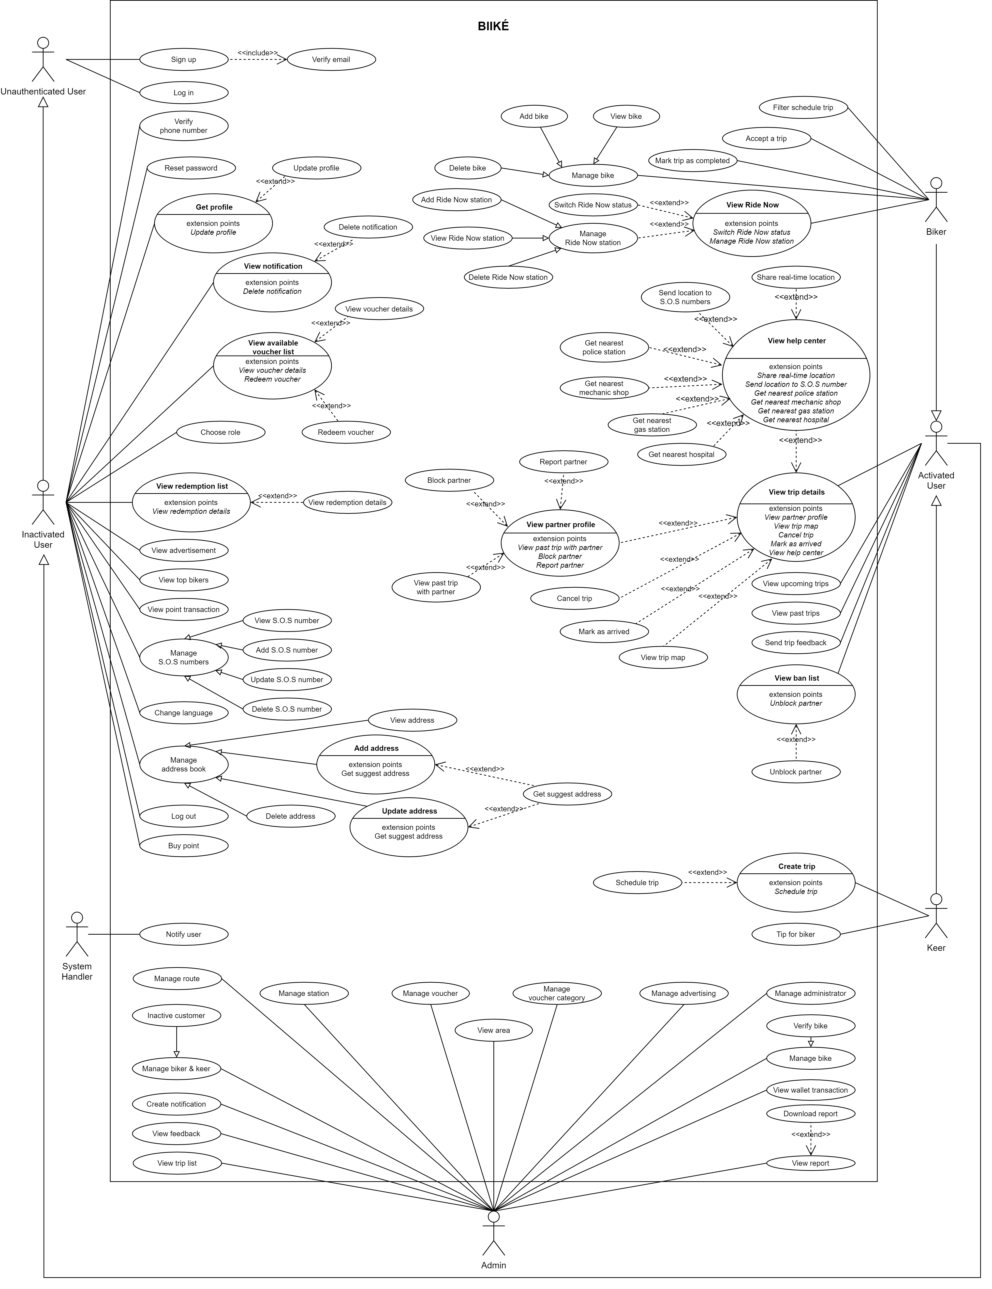

Figure 2. Use Case Diagram

1. **System Actors**

|  |  |  |
| --- | --- | --- |
| **#** | **Actor** | **Description** |
| 1 | Unauthenticated User | Users that have not logged in to the Biiké application. |
| 2 | Inactivated User | Users that have logged into the Biiké application but have not been verified phone number |
| 3 | Activated User | Users that have logged into the Biiké application and have been verified phone number |
| 4 | Biker | Activated user and have been verified two-wheeler license; Customer that use vehicle to take Keer on a ride |
| 5 | Keer | Hitchhiker or customer that need a free ride from Biker |
| 6 | System Handler | Biiké system |
| 7 | Admin | Users that logged in to Biiké web application as admin role |

Table 14. System Actors

1. **Use Cases List**

|  |  |  |  |
| --- | --- | --- | --- |
| **ID** | **Use Case** | **Primary Actors** | **Secondary Actors** |
| 1 | Log in | Unauthenticated User | Firebase |
| 2 | Sign up | Unauthenticated User | Firebase |
| 3 | Verify Email | Unauthenticated User | Firebase |
| 4 | Verify Phone Numbers | Inactivated User | Firebase |
| 5 | Reset Password | Inactivated User | Firebase |
| 6 | Log out | Inactivated User |  |
| 7 | View Profile | Inactivated User |  |
| 8 | Update profile | Inactivated User |  |
| 9 | Choose Role | Inactivated User |  |
| 10 | View Top Bikers | Inactivated User |  |
| 11 | View Notification | Inactivated User |  |
| 12 | View Available Voucher List | Inactivated User |  |
| 13 | View Voucher Details | Inactivated User |  |
| 14 | Redeem Vouchers | Inactivated User |  |
| 15 | View redemption list | Inactivated User |  |
| 16 | View redemption details | Inactivated User |  |
| 17 | View advertisement | Inactivated User |  |
| 18 | View Point transaction | Inactivated User |  |
| 19 | View S.O.S number | Inactivated User |  |
| 20 | Add S.O.S number | Inactivated User |  |
| 21 | Update S.O.S number | Inactivated User |  |
| 22 | Delete S.O.S number | Inactivated User |  |
| 23 | Change Language | Inactivated User |  |
| 24 | View address | Inactivated User |  |
| 25 | Update address | Inactivated User |  |
| 26 | Add address | Inactivated User |  |
| 27 | Delete address | Inactivated User |  |
| 28 | Buy Point | Inactivated User |  |
| 29 | Get suggest address | Inactivated User |  |
| 30 | View Privacy Policy | Inactivated User |  |
| 31 | View Term Of Use | Inactivated User |  |
| 32 | View Upcoming trips | Activated User |  |
| 33 | View Past trips | Activated User |  |
| 34 | View trip detail | Activated User |  |
| 35 | View partner profile | Activated User |  |
| 36 | Report partner | Activated User |  |
| 37 | Block partner | Activated User |  |
| 38 | View past trip with partner | Activated User |  |
| 39 | Cancel trip | Activated User |  |
| 40 | Mark as arrived | Activated User |  |
| 41 | View trip map | Activated User | Google Map |
| 42 | View help center | Activated User |  |
| 43 | Share real-time location | Activated User | Pathshare |
| 44 | Send location to S.O.S number | Activated User |  |
| 45 | Get nearest police station | Activated User | Google Map |
| 46 | Get nearest mechanic shop | Activated User | Google Map |
| 47 | Get nearest gas station | Activated User | Google Map |
| 48 | Get nearest hospital | Activated User | Google Map |
| 49 | View ban list | Activated User |  |
| 50 | Unblock partner | Activated User |  |
| 51 | Send trip feedback | Activated User |  |
| 52 | Switch mode | Activated User |  |
| 53 | Create trip Now | Keer |  |
| 54 | View position detail | Activated User | Google Map |
| 55 | Schedule trip | Keer |  |
| 56 | Tip for biker | Keer |  |
| 57 | Filter Schedule Trip | Biker |  |
| 58 | View Bike | Biker |  |
| 59 | Delete Bike | Biker |  |
| 60 | Add Bike | Biker |  |
| 61 | View Ride Now | Biker |  |
| 62 | Switch Ride Now status | Biker |  |
| 63 | View Ride Now station | Biker |  |
| 64 | Add Ride Now station | Biker |  |
| 65 | Delete Ride Now station | Biker |  |
| 66 | Accept a trip | Biker |  |
| 67 | Mark as completed | Biker |  |
| 68 | Notify user | System Handler |  |
| 69 | View report | Admin |  |
| 70 | Download report | Admin |  |
| 71 | View wallet transaction | Admin |  |
| 72 | View trip list | Admin |  |
| 73 | View feedback | Admin |  |
| 74 | View Biker and Keer | Admin |  |
| 75 | Inactive customer | Admin |  |
| 76 | View route | Admin |  |
| 77 | Add route | Admin |  |
| 78 | Update route | Admin |  |
| 79 | Delete route | Admin |  |
| 80 | View area | Admin |  |
| 81 | View station | Admin |  |
| 82 | Add station | Admin |  |
| 83 | Update station | Admin |  |
| 84 | Delete station | Admin |  |
| 85 | View voucher | Admin |  |
| 86 | Add voucher | Admin |  |
| 87 | Add voucher code | Admin |  |
| 88 | Update voucher | Admin |  |
| 89 | Delete voucher | Admin |  |
| 90 | Add voucher category | Admin |  |
| 91 | View voucher category | Admin |  |
| 92 | Update voucher category | Admin |  |
| 93 | Delete voucher category | Admin |  |
| 94 | Add ads | Admin |  |
| 95 | View ads | Admin |  |
| 96 | Update ads | Admin |  |
| 97 | Delete ads | Admin |  |
| 98 | Verify user's bike | Admin |  |
| 99 | Add admin | Admin |  |
| 100 | View admin | Admin |  |
| 101 | Update admin | Admin |  |
| 102 | Delete admin | Admin |  |
| 103 | View customized notification | Admin |  |
| 104 | Send Notification | Admin |  |

Table 15. Use Cases List

* 1. **Use Case Specifications**
     1. **Login**

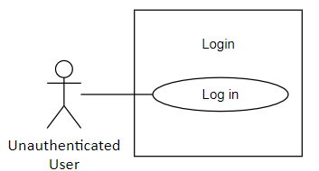

|  |  |  |  |  |  |
| --- | --- | --- | --- | --- | --- |
| ID and Name: | **UC-01. Login** | | | | |
| Created By: | VanLNT | | Date Created: | | 25/9/2021 |
| Primary Actor: | Unauthenticated User | | Secondary Actors: | | Firebase |
| Trigger: | The user sends Login request. | | | | |
| Description: | This feature allows users to login to the application, determine if user is FPT student or not. | | | | |
| Preconditions: | Actor has authenticated Biiké account. | | | | |
| Post-conditions: | **Success**: User will be redirected to choose mode screen.  **Failure**: System show error message | | | | |
| Normal Flow: | Step | Actor Action | | System Response | |
| 1 | Actor goes to login screen | | System redirects to login screen with email and password fields | |
| 2 | Actor input username and password | |  | |
| 3 | Actor taps “Login” / “Đăng nhập” button | | Rdirect Actor to choose mode screen | |
| Alternative Flows: | N/A | | | | |
| Exceptions: | No | Cause | | System Response | |
| 1 | The actor’s account is deactivated by the system | | The system informs “your account is temporary deactivated, contact us for support” / “Tài khoản của bạn đã tạm thời bị khóa, vui lòng liên hệ chúng tôi để được hỗ trợ” | |
| 2 | Actor inputs invalid accont | | System show error message “Email/Password is incorrect” | |
| Priority: | High | | | | |
| Frequency of Use: | Always | | | | |
| Business Rules: | **BR-01:** User logs in using email in order to use system functions. If the email is in the system, Biké returns a token for users and redirect them to selected mode page  **BR-02:** If user's account has not been stored in the system, the system will inform that no user found for that email, please sign up  **BR-03:** User's login session lasts forever by default.  **BR-04:** Password must be encrypted to Bcrypt  **BR-05:** Password can contain any character  **BR-06:** Password length must be between 6 and 32 characters  **BR-07:** Admin's account must be created by another admin before they can login into admin website | | | | |
| Other Information: | N/A | | | | |
| Assumptions: | * + Internet Connection is available.   + Actor has valid Biiké account.   + Actor has verified Gmail | | | | |

* + 1. **Sign up**

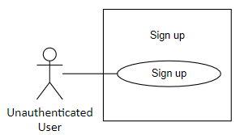

|  |  |  |  |  |  |
| --- | --- | --- | --- | --- | --- |
| ID and Name: | **UC-02. Sign Up** | | | | |
| Created By: | VanLNT | | Date Created: | | 25/9/2021 |
| Primary Actor: | Unauthenticated User | | Secondary Actors: | | Firebase |
| Trigger: | The actor sends Sign up request | | | | |
| Description: | This feature allows users to create Biiké account | | | | |
| Preconditions: | User has FPT’s Student Email | | | | |
| Post-conditions: | **Success**: User will be redirected to login screen of the application  **Failure**: System inform: “Create Account Failed” | | | | |
| Normal Flow: | Step | Actor Action | | System Response | |
| 1 | Actor taps “Sign up”/ “Đăng ký” | | System redirects to sign up screen with name, email phone number and password fields | |
| 2 | Actor fills name, email, and password | |  | |
| 3 | Actor taps “Sign up” / “Đăng ký” button | | - System check the account input information was already stored in Database  - Firebase Actor sends verify link to the email that actor filled  - If the sign-up information is valid, the system redirects to Sign in screen and notify “Verify Code sent to your email, please activate”/ “Đã gửi code xác thực qua email của bạn, xin hãy xác thực email trước khi sign in”  [Exception 1] | |
| Alternative Flows: | N/A | | | | |
| Exceptions: | No | Cause | | System Response | |
| 1 | The sign-up information is invalid (duplicate, already sign up) | | The system informs “email / phone numbers must be unique” / “email/Số điện thoại này đã được đăng ký” | |
| Priority: | High | | | | |
| Frequency of Use: | Usually | | | | |
| Business Rules: | **BR-05:** Password can contain any character.  **BR-06:** Password length must be between 6 and 32 character.  **BR-06:** Phone numbers must be verified by verification code.  **BR-07:** Admin's account must be created by another admin before they can login into admin website.  **BR-08:** Phone numbers must be verified by verification code.  **BR-09:** Name length limit must be in range 1 - 50 characters.  **BR-10:** Name only contains alphabetical characters.  **BR-11:** Name must not contain inappropriate words which defined in system blacklist words.  **BR-12:** Phone number only contains numeric characters.  **BR-13:** Phone number length limit must be 10 characters.  **BR-14:** Verification code only contains numeric characters.  **BR-15:** Phone number verification code length limit must be 6 characters.  **BR-16:** Phone numbers and email must be unquie.  **BR-17:**  Email must contain email condition suffix. In first area depolyment, email must contain “fpt.edu.vn” or “fe.edu.vn”.  **BR-18:** After user register to Biiké application, user will be redirect to login screen. | | | | |
| Other Information: | N/A | | | | |
| Assumptions: | * + Internet Connection is available | | | | |

* + 1. **Verify Email**

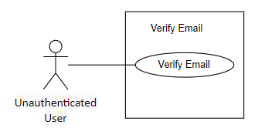

|  |  |  |  |  |  |
| --- | --- | --- | --- | --- | --- |
| ID and Name: | **UC-03. Verify Email** | | | | |
| Created By: | VanLNT | | Date Created: | | 25/9/2021 |
| Primary Actor: | Unauthenticated User | | Secondary Actors: | | Firebase |
| Trigger: | The actor wants to login for the first time after signing up. | | | | |
| Description: | This feature allows users to verify email before sign in. | | | | |
| Preconditions: | User has FPT student email.  User already sign up successfully. | | | | |
| Post-conditions: | **Success**: User will verify email successfully and able to sign in. | | | | |
| Normal Flow: | Step | Actor Action | | System Response | |
| 1 | Actor click verify link sent by Firebase. | | - System redirects to verify page created by Firebase.  - Success: Firebase notify “Verify Email Successful” | |
| Alternative Flows: | N/A | | | | |
| Exceptions: | N/A | | | | |
| Priority: | High | | | | |
| Frequency of Use: | Usually | | | | |
| Business Rules: | **BR-19:** User must verify email in order to finish sign up process.  **BR-20 :** User must enter all required fields before receiving the verification link. | | | | |
| Other Information: | N/A | | | | |
| Assumptions: | * + Internet Connection is available.   + User already finished sign-up. | | | | |

* + 1. **Verify Phone Numbers**

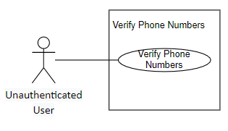

|  |  |  |  |  |  |
| --- | --- | --- | --- | --- | --- |
| ID and Name: | **UC-04. Verify Phone Numbers** | | | | |
| Created By: | VanLNT | | Date Created: | | 25/9/2021 |
| Primary Actor: | Inactivated User | | Secondary Actors: | | Firebase |
| Trigger: | The actor wants to book a trip / accept a trip for the first time.  The actor send verify phone numbers request. | | | | |
| Description: | This feature allows users to verify phone numbers, to activate user account. | | | | |
| Preconditions: | User already login to application. | | | | |
| Post-conditions: | **Success**: User will be able to use the function in activated users’ requirements functions.  **Failure**: System sends error message | | | | |
| Normal Flow: | Step | Actor Action | | System Response | |
| 1 | Actor request verify phone number | | Firebase send verify code to phone number via SMS. | |
| 2 | Actor types verify code. | | - Firebase check if verify code is valid or not. Redirect to main page.  [Exception1] | |
| Alternative Flows: | N/A | | | | |
| Exceptions: | No | Cause | | System Response | |
| 1 | The verify code is invalid. | | The system informs “The Verify Code is invalid, please enter again” / “Mã xác thực của bạn không chính xác, xin hãy nhập lại”. | |
| Priority: | High | | | | |
| Frequency of Use: | Usually | | | | |
| Business Rules: | **BR-21:** Verification code will expired after 60s, user has to request resend verify code  **BR-22:** User must vefiry phone number and email in order to use Biiké's trip service  **BR-23:** When the verification code is expired, user cannot use that code to verify phone number | | | | |
| Other Information: | N/A | | | | |
| Assumptions: | * + Internet Connection is available.   + Actor already has a valid phone number. | | | | |

* + 1. **Reset Password**

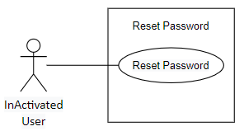

|  |  |  |  |  |  |
| --- | --- | --- | --- | --- | --- |
| ID and Name: | **UC-05. Reset Password** | | | | |
| Created By: | VanLNT | | Date Created: | | 25/9/2021 |
| Primary Actor: | Inactivated User | | Secondary Actors: | | Firebase |
| Trigger: | The actor sent reset password request. | | | | |
| Description: | This feature allows users to change passwords. | | | | |
| Preconditions: | User already has Biiké account. | | | | |
| Post-conditions: | **Success**: User will be redirected to main page of the application and use the new password. | | | | |
| Normal Flow: | Step | Actor Action | | System Response | |
| 1 | Actor taps “Reset Password” / “Đổi mật khẩu” button. | | System sent verify code to email. | |
| 2 | Actor verify email. | | Redirect to new password enter screen. | |
| 3 | Actor fill new password. | |  | |
| 4 | Actor tap “Save Password”/ “Lưu Mật Khẩu”. | | Redirect to main page of application. | |
| Alternative Flows: | N/A | | | | |
| Exceptions: | N/A | | | | |
| Priority: | Medium | | | | |
| Frequency of Use: | Occasionally | | | | |
| Business Rules: | **BR-24:** New password must not duplicate the old password  **BR-25:** After reset pasword, user has to login again to use application | | | | |
| Other Information: | N/A | | | | |
| Assumptions: | Internet Connection is available. | | | | |

* + 1. **Log out**

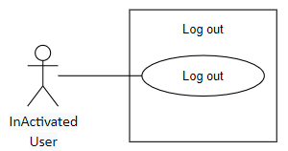

|  |  |  |  |  |  |
| --- | --- | --- | --- | --- | --- |
| ID and Name: | **UC-06. Log out** | | | | |
| Created By: | VanLNT | | Date Created: | | 25/9/2021 |
| Primary Actor: | Inactivated User | | Secondary Actors: | | N/A |
| Trigger: | The actor sends logout request. | | | | |
| Description: | This feature allows users to log out of application. | | | | |
| Preconditions: | User already login to application. | | | | |
| Post-conditions: | **Success**: User will be redirected to sign-up screen of the application. | | | | |
| Normal Flow: | Step | Actor Action | | System Response | |
| 1 | Actor tap “Log out” / “Đăng xuất”. | | System redirects to login screen and delete user session. | |
| Alternative Flows: | N/A | | | | |
| Exceptions: | N/A | | | | |
| Priority: | Medium | | | | |
| Frequency of Use: | Sometimes | | | | |
| Business Rules: | **BR-26**: After user sends logout request, system redirects into login page and clear user token  **BR-27:** After user logged out, user will not receive any notification from Biiké system | | | | |
| Other Information: | N/A | | | | |
| Assumptions: | Internet Connection is available. | | | | |

* + 1. **View Profile**

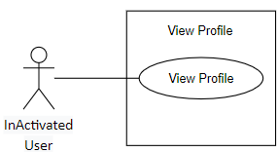

|  |  |  |  |  |  |
| --- | --- | --- | --- | --- | --- |
| ID and Name: | **UC-07. View Profile** | | | | |
| Created By: | TrieuDPH | | Date Created: | | 25/9/2021 |
| Primary Actor: | Inactivated User | | Secondary Actors: | | N/A |
| Trigger: | The actor wants to view their profile. | | | | |
| Description: | This feature allows users to view their profile information. | | | | |
| Preconditions: | User has login to Biiké application. | | | | |
| Post-conditions: | **Success**: User will be redirected to view profile screen. | | | | |
| Normal Flow: | Step | Actor Action | | System Response | |
| 1 | Actor tap “View Profile”/ “Xem thông tin cá nhân”. | | System redirects to view profile screen. | |
| Alternative Flows: | N/A | | | | |
| Exceptions: | N/A | | | | |
| Priority: | High | | | | |
| Frequency of Use: | Always | | | | |
| Business Rules: | N/A | | | | |
| Other Information: | N/A | | | | |
| Assumptions: | Internet Connection is available | | | | |

* + 1. **Update Profile**

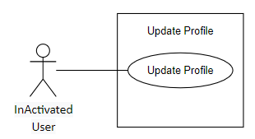

|  |  |  |  |  |  |
| --- | --- | --- | --- | --- | --- |
| ID and Name: | **UC-08. Update Profile** | | | | |
| Created By: | TrieuDPH | | Date Created: | | 25/9/2021 |
| Primary Actor: | Inactivated User | | Secondary Actors: | | N/A |
| Trigger: | The actor sends update profile request. | | | | |
| Description: | This feature allows users to change their profile information. | | | | |
| Preconditions: | User already login to Biiké application. | | | | |
| Post-conditions: | **Success**: User new information will be saved and redirect user to view profile screen.  **Failure**: System informs “Something went wrong, please try again later”. | | | | |
| Normal Flow: | Step | Actor Action | | System Response | |
| 1 | Actor tap “Update Profile” / “Cập nhật thông tin” button. | |  | |
| 2 | Actor enter update fields. | |  | |
| 3 | Actor tap “Save” / “Lưu” Button. | | - System check if the update information is valid or not.  - Success: Saved new information to Database and redirect to view profile screen.  - Failure: System show error message if something gone wrong under server. | |
| Alternative Flows: | N/A | | | | |
| Exceptions: | N/A | | | | |
| Priority: | Medium | | | | |
| Frequency of Use: | Normally/Generally | | | | |
| Business Rules: | **BR-28:** User can not update their phone numbers and email **BR-29:** User can only update their own profile includes their avatar, full name, gender and birthday **BR-30:** User's avatar file must be image file format | | | | |
| Other Information: | N/A | | | | |
| Assumptions: | Internet Connection is available | | | | |

* + 1. **Choose Role**

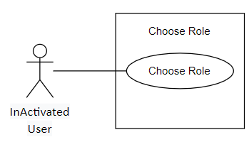

|  |  |  |  |  |
| --- | --- | --- | --- | --- |
| ID and Name: | **UC-09. Choose Role** | | | |
| Created By: | TamNTT | | Date Created: | 25/9/2021 |
| Primary Actor: | Inactivated User | | Secondary Actors: | N/A |
| Trigger: | User sends a request to choose a role | | | |
| Description: | This feature allows users to use the application’s service with selected mode | | | |
| Preconditions: | User has logged in to Biiké application. | | | |
| Post-conditions: | **Success**: User will be redirected to home page of the application with selected role  **Failure**: System shows error message | | | |
| Normal Flow: | Step | Actor Action | | System Response |
| 1 | User taps “Biker” / “Chở ké” or “Keer” / “Đi ké” mode | | [Alternative 2] |
| 2 | User tap “Next” icon button [Exception 1] | | System redirects to home page with selected mode that user chose [Alternative 1] [Exception 1] [Exception 2] |
| Alternative Flows: | Step | | Actor Action | System Response |
| 1 | | User select Biker mode when not having a bike | System redirects to add bike page |
| 2 | | User taps “Back” icon button | System redirects to login page |
| Exceptions: | No | | Cause | System Response |
| 1 | | User does not select a mode | System shows error message: “You must choose a role to use our service” |
| 2 | |  | System shows error message: “There are some errors, please try again later or contact Biiké development team for support” when the Azure server return error response |
| Priority: | High | | | |
| Frequency of Use: | This feature is only used after use log in | | | |
| Business Rules: | **BR-32:** User has to choose mode to use Biiké services | | | |
| Other Information: | In case of Internet connection failure, user will not be able to select a mode | | | |
| Assumptions: | Internet Connection is available. | | | |

* + 1. **View Top Bikers**

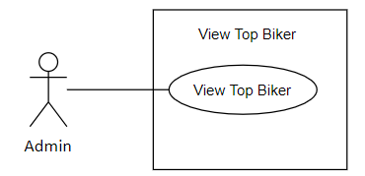

|  |  |  |  |  |  |
| --- | --- | --- | --- | --- | --- |
| ID and Name: | **UC-10. View Top Bikers** | | | | |
| Created By: | PhatDH | | Date Created: | | 25/9/2021 |
| Primary Actor: | Inactivated User | | Secondary Actors: | | N/A |
| Trigger: | The actor wants to view top Bikers of the Biiké community. | | | | |
| Description: | This feature allows users to view top Bikers in the current month. | | | | |
| Preconditions: | User has logged in to Biiké application. | | | | |
| Post-conditions: | **Success**: User will be able to view list top Bikers and their contribute work for the community along with their rewards. | | | | |
| Normal Flow: | Step | Actor Action | | System Response | |
| 1 | Actor tap “Top Bikers” button | | System redirects to Top Bikers List Screen | |
| Alternative Flows: | N/A | | | | |
| Exceptions: | N/A | | | | |
| Priority: | Medium | | | | |
| Frequency of Use: | Usually | | | | |
| Business Rules: | **BR-97:** Top biker only show maximum 10 bikers with highest point get from trip, not include point from top up via MOMO | | | | |
| Other Information: | N/A | | | | |
| Assumptions: | Internet Connection is available | | | | |

* + 1. **View Notification**

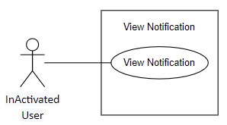

|  |  |  |  |  |  |
| --- | --- | --- | --- | --- | --- |
| ID and Name: | **UC-11. View Notification** | | | | |
| Created By: | UyenNLP | | Date Created: | | 25/9/2021 |
| Primary Actor: | Inactivated User | | Secondary Actors: | | N/A |
| Trigger: | The actor received notification from system. | | | | |
| Description: | This feature allows users to view notification information. | | | | |
| Preconditions: | User has logged into Biiké application. | | | | |
| Post-conditions: | **Success**: Redirect to view Notification Screen  **Fail**: System sends error message | | | | |
| Normal Flow: | Step | Actor Action | | System Response | |
| 1 | Actor tap “Notification” / “Thông báo” button | | System redirects to view notification screen | |
|  | 2 | Actor click on a notification | | System redirects to view notification details screen | |
| Alternative Flows: | N/A | | | | |
| Exceptions: | N/A | | | | |
| Priority: | High | | | | |
| Frequency of Use: | Usually | | | | |
| Business Rules: | **BR-33:** User only can view their own notification | | | | |
| Other Information: | N/A | | | | |
| Assumptions: | Internet Connection is available. | | | | |

* + 1. **View Available Voucher List**

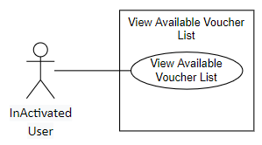

|  |  |  |  |  |  |
| --- | --- | --- | --- | --- | --- |
| ID and Name: | **UC-12. View Available Voucher List** | | | | |
| Created By: | UyenNLP | | Date Created: | | 25/9/2021 |
| Primary Actor: | Inactivated User | | Secondary Actors: | | N/A |
| Trigger: | View Available Voucher List | | | | |
| Description: | This feature allows users to view list available vouchers | | | | |
| Preconditions: | User has logged into Biiké application | | | | |
| Post-conditions: | **Success**: User will be redirected to view available vouchers screen  **Failure**: System shows error message | | | | |
| Normal Flow: | Step | Actor Action | | System Response | |
| 1 | Actor tap “Voucher” button | | System redirects to Voucher lists screen | |
| Alternative Flows: | N/A | | | | |
| Exceptions: | N/A | | | | |
| Priority: | High | | | | |
| Frequency of Use: | Usually | | | | |
| Business Rules: | **BR-34:** User can only view vouchers which are not expired and are redeemable | | | | |
| Other Information: | N/A | | | | |
| Assumptions: | Internet Connection is available | | | | |

* + 1. **View Voucher Details**

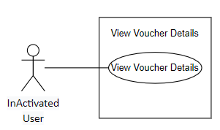

|  |  |  |  |  |  |
| --- | --- | --- | --- | --- | --- |
| ID and Name: | **UC-13. View Voucher Details** | | | | |
| Created By: | UyenNLP | | Date Created: | | 25/9/2021 |
| Primary Actor: | Inactivated User | | Secondary Actors: | | N/A |
| Trigger: | The actor sends view voucher details request | | | | |
| Description: | This feature allows users to view voucher details | | | | |
| Preconditions: | User has logged into Biiké application | | | | |
| Post-conditions: | **Success**: User will be redirected to view voucher details screen | | | | |
| Normal Flow: | Step | Actor Action | | System Response | |
| 1 | Actor tap voucher card or “View” / “Xem” button | | System redirects to voucher details screen | |
| Alternative Flows: | N/A | | | | |
| Exceptions: | N/A | | | | |
| Priority: | High | | | | |
| Frequency of Use: | Usually | | | | |
| Business Rules: | N/A | | | | |
| Other Information: | N/A | | | | |
| Assumptions: | Internet Connection is available | | | | |

* + 1. **Redeem Vouchers**

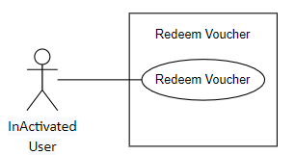

|  |  |  |  |  |  |
| --- | --- | --- | --- | --- | --- |
| ID and Name: | **UC-14. Redeem Vouchers** | | | | |
| Created By: | UyenNLP | | Date Created: | | 25/9/2021 |
| Primary Actor: | Inactivated User | | Secondary Actors: | | N/A |
| Trigger: | The actor send redeem voucher request | | | | |
| Description: | This feature allows users to exchange their points for vouchers | | | | |
| Preconditions: | User has logged into Biiké application | | | | |
| Post-conditions: | **Success**: User will have the vouchers on “Exchanged” tab and able to use the voucher, user point will be minus as the voucher amount of point  **Failure**: System informs “Cannot exchange this voucher” / “Bạn không thể đổi voucher này” | | | | |
| Normal Flow: | Step | Actor Action | | System Response | |
| 1 | Actor tap “Redeem Voucher”/ “Đổi voucher” button | | System checks if actor point If enough to exchange the voucher  Not enough points: Exception  Enough point: voucher redeem successfully, redirect to view available vouchers screen | |
| Alternative Flows: | N/A | | | | |
| Exceptions: | No | Cause | | System Response | |
| 1 | The actor’s points are not enough to exchange voucher | | The system informs “User doesn’t have enough point” / “Người dùng không đủ điểm để đổi!” | |
| Priority: | Medium | | | | |
| Frequency of Use: | Usually | | | | |
| Business Rules: | **BR-35:** User can only exchange for available vouchers  **BR-36:** If user does not have enough points, user will have to top up or go for a ride to gain more points  **BR-37:** User can exchange more than one time for the same voucher | | | | |
| Other Information: | N/A | | | | |
| Assumptions: | Internet Connection is available | | | | |

* + 1. **View redemption list**

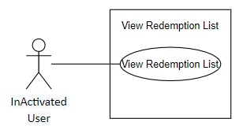

|  |  |  |  |  |  |
| --- | --- | --- | --- | --- | --- |
| ID and Name: | **UC-15. View Redemption List** | | | | |
| Created By: | UyenNLP | | Date Created: | | 25/9/2021 |
| Primary Actor: | Inactivated User | | Secondary Actors: | | N/A |
| Trigger: | The actor sends view my voucher details request | | | | |
| Description: | This feature allows users to view their voucher details include vouchers information, expired date | | | | |
| Preconditions: | User has logged into Biiké application | | | | |
| Post-conditions: | **Success**: User will be redirected to view my voucher details screen  **Failure**: System shows error message | | | | |
| Normal Flow: | Step | Actor Action | | System Response | |
| 1 | Actor taps “Exchanged” / “Đã đổi” tab on appbar | | System redirects to Exchanged tab | |
| Alternative Flows: | N/A | | | | |
| Exceptions: | N/A | | | | |
| Priority: | Medium | | | | |
| Frequency of Use: | Usually | | | | |
| Business Rules: | **BR-38:** User can only view exchanged vouchers that has not used  **BR-39:** User can only view exchanged vouchers that has not expired | | | | |
| Other Information: | N/A | | | | |
| Assumptions: | Internet Connection is available | | | | |

* + 1. **View redemption details**

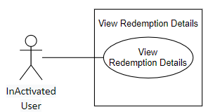

|  |  |  |  |  |  |
| --- | --- | --- | --- | --- | --- |
| ID and Name: | **UC-16. View Redemption Details** | | | | |
| Created By: | UyenNLP | | Date Created: | | 25/9/2021 |
| Primary Actor: | Inactivated User | | Secondary Actors: | | N/A |
| Trigger: | The actor sends view my voucher list request | | | | |
| Description: | This feature allows users to view their voucher list includes their list of redeemed vouchers | | | | |
| Preconditions: | User has logged into Biiké application | | | | |
| Post-conditions: | **Success**: User will be redirected to view my voucher list screen  **Failure**: System shows error message | | | | |
| Normal Flow: | Step | Actor Action | | System Response | |
| 1 | Actor tap voucher card on “Exchanged” or “Expired/Used” tab | | System redirects to Your voucher details screen | |
| Alternative Flows: | N/A | | | | |
| Exceptions: | N/A | | | | |
| Priority: | Medium | | | | |
| Frequency of Use: | Usually | | | | |
| Business Rules: | N/A | | | | |
| Other Information: | N/A | | | | |
| Assumptions: | Internet Connection is available | | | | |

* + 1. **View Advertisement**

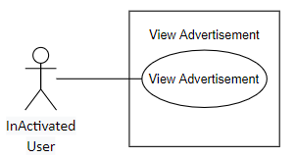

|  |  |  |  |  |  |
| --- | --- | --- | --- | --- | --- |
| ID and Name: | **UC-17. View Advertisement** | | | | |
| Created By: | PhatDH | | Date Created: | | 25/9/2021 |
| Primary Actor: | Inactivated User | | Secondary Actors: | | N/A |
| Trigger: | The actor click on advertisement banner on home screen | | | | |
| Description: | This feature redirect users to custom url from company sponsored the ads and count every click on | | | | |
| Preconditions: | User has logged into Biiké application | | | | |
| Post-conditions: | **Success**: User will be redirected to custom url of the ads through browser  **Failure**: System shows error message | | | | |
| Normal Flow: | Step | Actor Action | | System Response | |
| 1 | Actor tap Advertisement banner on main page | | System redirects to advertisement url | |
| Alternative Flows: | N/A | | | | |
| Exceptions: | N/A | | | | |
| Priority: | Medium | | | | |
| Frequency of Use: | Always | | | | |
| Business Rules: | **BR-40:** User must turn on GPS location on device and grant location permission to the mobile application  **BR-41:** User cannot turn off advertisement | | | | |
| Other Information: | N/A | | | | |
| Assumptions: | Internet Connection is available  User GPS signal is turned on | | | | |

* + 1. **View Point transaction**

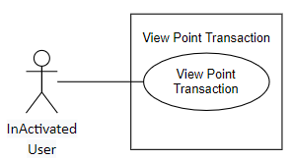

|  |  |  |  |  |  |
| --- | --- | --- | --- | --- | --- |
| ID and Name: | **UC-18. View Point Transaction** | | | | |
| Created By: | PhatDH | | Date Created: | | 25/9/2021 |
| Primary Actor: | Inactivated User | | Secondary Actors: | | N/A |
| Trigger: | The actor sends view point details request | | | | |
| Description: | This feature allows users to view their total points, their point expired date and their point transaction history | | | | |
| Preconditions: | User has logged into Biiké application | | | | |
| Post-conditions: | **Success**: User will be redirected to view point details screen.  **Failure**: System shows error message | | | | |
| Normal Flow: | Step | Actor Action | | System Response | |
| 1 | Actor taps on their point number in profile page | | System redirects to View Point Details screen | |
| Alternative Flows: | N/A | | | | |
| Exceptions | N/A | | | | |
| Priority: | Medium | | | | |
| Frequency of Use: | Normally/Generally | | | | |
| Business Rules: | N/A | | | | |
| Other Information: | N/A | | | | |
| Assumptions: | Internet Connection is available | | | | |

* + 1. **View S.O.S number**

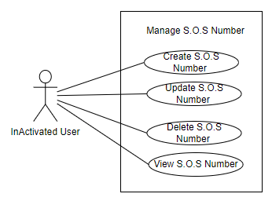

|  |  |  |  |  |  |
| --- | --- | --- | --- | --- | --- |
| ID and Name: | **UC-19. View S.O.S Number** | | | | |
| Created By: | PhatDH | | Date Created: | | 25/9/2021 |
| Primary Actor: | Inactivated User | | Secondary Actors: | | N/A |
| Trigger: | The actor sends View S.O.S List request | | | | |
| Description: | This feature allows users to vie list of S.O.S options | | | | |
| Preconditions: | User has logged into Biiké application | | | | |
| Post-conditions: | **Success**: User will be redirected to S.O.S list screen  **Failure**: System shows error message | | | | |
| Normal Flow: | Step | Actor Action | | System Response | |
| 1 | Actor tap “View S.O.S List” / “Xem danh sách S.O.S” button | | System redirects to S.O.S List screen | |
| Alternative Flows: | N/A | | | | |
| Exceptions: | N/A | | | | |
| Priority: | Medium | | | | |
| Frequency of Use: | Usually | | | | |
| Business Rules: | **BR-42:** All S.O.S phone number of an user must not be duplicate  **BR-108:** An user only have maximum 3 S.O.S numbers | | | | |
| Other Information: | N/A | | | | |
| Assumptions: | Internet Connection is available | | | | |

* + 1. **Add S.O.S number**



|  |  |  |  |  |  |
| --- | --- | --- | --- | --- | --- |
| ID and Name: | **UC-20. Add S.O.S Number** | | | | |
| Created By: | PhatDH | | Date Created: | | 25/9/2021 |
| Primary Actor: | Inactivated User | | Secondary Actors: | | N/A |
| Trigger: | The actor sends add S.O.S number request | | | | |
| Description: | This feature allows users to add S.O.S number into their emergency list | | | | |
| Preconditions: | User has logged into Biiké application | | | | |
| Post-conditions: | **Success**: User will be redirected to add S.O.S number screen  **Failure**: System shows error message | | | | |
| Normal Flow: | Step | Actor Action | | System Response | |
| 1 | User taps on plus icon | | System redirects to add S.O.S number screen | |
| 2 | User inputs fields | |  | |
| 3 | User taps “Save” / “Lưu” button | | System redirects to view S.O.S list page [Exception 1] [Exception 2] | |
| Alternative Flows: | N/A | | | | |
| Exceptions: | No | Cause | | System Response | |
| 1 | User enters invalid phone number | | System shows error message “Invalid phone number” | |
| 2 |  | | System shows error message: “There are some errors, please try again later or contact Biiké development team for support” when the Azure server return error response | |
| Priority: | Medium | | | | |
| Frequency of Use: | Sometimes | | | | |
| Business Rules: | **BR-12:** Phone number only contains numeric characters  **BR-13:** Phone number length limit must be 10 characters.  **BR-42:** All S.O.S phone number of an user must not be duplicate  **BR-108:** An user only have maximum 3 S.O.S numbers  **BR-105:** All field is required, if any field is blank, when user click submit button, a message is shown: "Please fill enough data" | | | | |
| Other Information: | In case of Internet connection failure, user will not be able to add S.O.S number | | | | |
| Assumptions: | Internet Connection is available | | | | |

* + 1. **Update S.O.S number**



|  |  |  |  |  |  |
| --- | --- | --- | --- | --- | --- |
| ID and Name: | **UC-21. Update S.O.S Number** | | | | |
| Created By: | PhatDH | | Date Created: | | 25/9/2021 |
| Primary Actor: | Inactivated UserUser | | Secondary Actors: | | N/A |
| Trigger: | The actor sends Edit S.O.S number | | | | |
| Description: | This feature allows users to change their S.O.S number information | | | | |
| Preconditions: | User has logged into Biiké application | | | | |
| Post-conditions: | **Success**: User S.O.S number will be updated  **Failure**: System shows error message | | | | |
| Normal Flow: | Step | Actor Action | | System Response | |
| 1 | Actor taps on a S.O.S number | | System redirects to update S.O.S Number screen | |
| 2 | Actor enter new S.O.S number | |  | |
| 3 | Actor tap “Save” / “Lưu” button | | System will store the new S.O.S Number to Database | |
| Alternative Flows: | N/A | | | | |
| Exceptions: | N/A | | | | |
| Priority: | Medium | | | | |
| Frequency of Use: | Occasionally | | | | |
| Business Rules: | **BR-12:** Phone number only contains numeric characters  **BR-13:** Phone number length limit must be 10 characters.  **BR-42:** All S.O.S phone number of an user must not be duplicate  **BR-108:** An user only have maximum 3 S.O.S numbers  **BR-105:** All field is required, if any field is blank, when user click submit button, a message is shown: "Please fill enough data" | | | | |
| Other Information: |  | | | | |
| Assumptions: | Internet Connection is available | | | | |

* + 1. **Delete S.O.S number**



|  |  |  |  |  |  |
| --- | --- | --- | --- | --- | --- |
| ID and Name: | **UC-22. Delete S.O.S Number** | | | | |
| Created By: | PhatDH | | Date Created: | | 25/9/2021 |
| Primary Actor: | Inactivated User | | Secondary Actors: | | N/A |
| Trigger: | The actor sends Delete S.O.S number | | | | |
| Description: | This feature allows users to delete their S.O.S Number | | | | |
| Preconditions: | User has logged into Biiké application | | | | |
| Post-conditions: | **Success**: User S.O.S Number will be deleted  **Failure**: System shows error message | | | | |
| Normal Flow: | Step | Actor Action | | System Response | |
| 1 | Actor taps on delete icon | | S.O.S Number is deleted | |
| Alternative Flows: | N/A | | | | |
| Exceptions: | N/A | | | | |
| Priority: | Medium | | | | |
| Frequency of Use: | Occasionally | | | | |
| Business Rules: | **BR-43:** After deleting an S.O.S number, user cannot send their S.O.S message to that number through Help center | | | | |
| Other Information: | N/A | | | | |
| Assumptions: | Internet Connection is available | | | | |

* + 1. **Change Language**

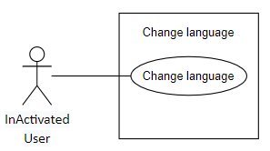

|  |  |  |  |  |  |
| --- | --- | --- | --- | --- | --- |
| ID and Name: | **UC-23. Change Language** | | | | |
| Created By: | VanLNT | | Date Created: | | 25/9/2021 |
| Primary Actor: | Inactivated User | | Secondary Actors: | | N/A |
| Trigger: | The actor sends Change Language request | | | | |
| Description: | This feature allows users to change the current language to their understandable language | | | | |
| Preconditions: | User has logged into Biiké account | | | | |
| Post-conditions: | **Success**: Biiké application will changed to the language that Actor chose | | | | |
| Normal Flow: | Step | Actor Action | | System Response | |
| 1 | Actor tap “Change Language” / “Đổi ngôn ngữ” button | | System checks the current language that Actor using  VN: System will change the application to ENG  ENG: System will change the application to VN | |
| Alternative Flows: | N/A | | | | |
| Exceptions: | N/A | | | | |
| Priority: | Medium | | | | |
| Frequency of Use: | Sometimes | | | | |
| Business Rules: | **BR-45** User can only change the app language to Vietnamese or English | | | | |
| Other Information: | N/A | | | | |
| Assumptions: | Internet Connection is available | | | | |

* + 1. **View address**

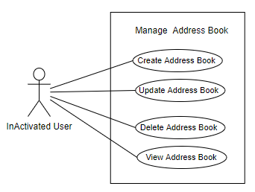

|  |  |  |  |  |  |
| --- | --- | --- | --- | --- | --- |
| ID and Name: | **UC-24. View Address** | | | | |
| Created By: | PhatDH | | Date Created: | | 25/9/2021 |
| Primary Actor: | Inactivated User | | Secondary Actors: | | N/A |
| Trigger: | The actor sends view address book request | | | | |
| Description: | This feature allows users to view their address deatail | | | | |
| Preconditions: | User has logged into Biiké application | | | | |
| Post-conditions: | **Success**: User will be redirected to View Address details screen  **Failure**: System shows error message | | | | |
| Normal Flow: | Step | Actor Action | | System Response | |
| 1 | Actor taps “View Address Book” button | | Redirect to Address Book screen | |
| Alternative Flows: | N/A | | | | |
| Exceptions: | N/A | | | | |
| Priority: | Medium | | | | |
| Frequency of Use: | Sometimes | | | | |
| Business Rules: | N/A | | | | |
| Other Information: | N/A | | | | |
| Assumptions: | Internet Connection is available | | | | |

* + 1. **Update address**



|  |  |  |  |  |  |
| --- | --- | --- | --- | --- | --- |
| ID and Name: | **UC-25. Update Address** | | | | |
| Created By: | PhatDH | | Date Created: | | 25/9/2021 |
| Primary Actor: | User | | Secondary Actors: | | N/A |
| Trigger: | The actor sends Edit Address | | | | |
| Description: | This feature allows users to change their address information | | | | |
| Preconditions: | User has logged into Biiké application | | | | |
| Post-conditions: | **Success**: User Address is updated  **Failure**: System shows error message | | | | |
| Normal Flow: | Step | Actor Action | | System Response | |
| 1 | Actor tap on a address card | | System redirects to update Address Book screen | |
| 2 | Actor enter new address or note or name | |  | |
| 3 | Actor tap “Save” / “Lưu” button | | System will store the new address to Database | |
| Alternative Flows: | N/A | | | | |
| Exceptions: | N/A | | | | |
| Priority: | Medium | | | | |
| Frequency of Use: | Seldom | | | | |
| Business Rules: | **BR-46:** User can not save duplicate address  **BR-100:** User cannot delete default address or update it to be not default  **BR-101:** When user update a non-default address to default, the address that have already is default will be non-default  **BR-105:** All field is required, if any field is blank, when user click submit button, a message is shown: "Please fill enough data" | | | | |
| Other Information: | N/A | | | | |
| Assumptions: | Internet Connection is available | | | | |

* + 1. **Add address**



|  |  |  |  |  |  |  |
| --- | --- | --- | --- | --- | --- | --- |
| ID and Name: | **UC-26. Add Address** | | | | | |
| Created By: | PhatDH | | | Date Created: | | 25/9/2021 |
| Primary Actor: | Inactivated User | | | Secondary Actors: | | N/A |
| Trigger: | The actor sends save address during create trip | | | | | |
| Description: | This feature allow users to save the address as they are creating trip | | | | | |
| Preconditions: | User has logged into Biiké application and verify their phone numbers and creating trip | | | | | |
| Post-conditions: | **Success**: The address will be saved to their address book  **Failure**: System shows error message | | | | | |
| Normal Flow: | Step | Actor Action | | | System Response | |
| 1 | Actor goes to add address screen | | | There are following fields for user to enter:  Address: Blank text field | |
| 1 | Actor tap “Save Adress” / “Lưu địa chỉ này” button | | | System shows pop up “Are you sure to save this address?” / “Bạn có chắc muốn lưu địa chỉ này không?” | |
| 2 | Actor tap “Yes” / “Có” | | | The system checks if this address is saved before  Yes: Saved address, redirect to View Address Screen [Exception1]  No: [Alternative 1] | |
| Alternative Flows: | No | | Actor Action | | System Response | |
| 1 | | Actor tap “No” / “Không” | | Redirect to create trip screen | |
| Exceptions: | No | Cause | | | System Response | |
| 1 | The address is already exist in Actor’s address book | | | Show pop up “This address is saved before”, redirect to create trip screen | |
| Priority: | Medium | | | | | |
| Frequency of Use: | Sometimes | | | | | |
| Business Rules: | **BR-46:** User can not save duplicate address  **BR-98:** The first address that user add to address book will be default address  **BR-99:** One user only have one defult address  **BR-100:** User cannot delete default address or update it to be not default  **BR-101:** When user update a non-default address to default, the address that have already is default will be non-default  **BR-105:** All field is required, if any field is blank, when user click submit button, a message is shown: "Please fill enough data" | | | | | |
| Other Information: | N/A | | | | | |
| Assumptions: | Internet Connection is available | | | | | |

* + 1. **Delete address**



|  |  |  |  |  |  |
| --- | --- | --- | --- | --- | --- |
| ID and Name: | **UC-27. Delete Address** | | | | |
| Created By: | PhatDH | | Date Created: | | 25/9/2021 |
| Primary Actor: | Inactivated User | | Secondary Actors: | | N/A |
| Trigger: | The actor sends Delete Address Book request | | | | |
| Description: | This feature allows users to delete their address book | | | | |
| Preconditions: | User has logged into Biiké application | | | | |
| Post-conditions: | **Success**: User address book will be deleted | | | | |
| Normal Flow: | Step | Actor Action | | System Response | |
| 1 | Actor tap on icon delete | | System show pop up “Are you sure to delete this address?” / “Bạn có chắc muốn xóa địa chỉ này không?” | |
| 2 | Actor tap “Yes” | | The address will be deleted from address list screen and Database [Alternative 1] | |
| Alternative Flows: | No | Actor Action | | System Response | |
| 1 | Actor tap “No” | | The system will redirect to View Address Book List screen | |
| Exceptions: | N/A | | | | |
| Priority: | Medium | | | | |
| Frequency of Use: | Seldom | | | | |
| Business Rules: | **BR-100:** User cannot delete default address or update it to be not default | | | | |
| Other Information: | N/A | | | | |
| Assumptions: | Internet Connection is available | | | | |

* + 1. **Buy Point**

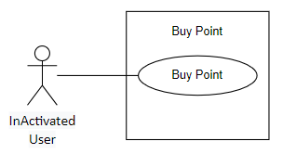

|  |  |  |  |  |  |
| --- | --- | --- | --- | --- | --- |
| ID and Name: | **UC-28. Buy Point** | | | | |
| Created By: | PhatDH | | Date Created: | | 25/9/2021 |
| Primary Actor: | Inactivated User | | Secondary Actors: | | N/A |
| Trigger: | The actor sends buy points request | | | | |
| Description: | This feature allows users to top up their points via Momo | | | | |
| Preconditions: | User has logged into Biiké application | | | | |
| Post-conditions: | **Success**: User points will be upgraded and redirect to main screen of Biiké application  **Failure:** System informs “Something went wrong, please try again later” | | | | |
| Normal Flow: | Step | Actor Action | | System Response | |
| 1 | Actor taps “Top up point” / “Nạp điểm” button | | System redirects to Buy points screen and MoMo actor will check if Actor balance if enough to afford the amount of points or not  Enough: Boy point successful, Actor money account will be charged and Actor Biiké wallet will be topped up. Actor will be redirected to main screen of Biiké application  Not Enough: Exception | |
| Alternative Flows: | N/A | | | | |
| Exceptions: | No | Cause | | System Response | |
| 1 | Actor balance is too low to buy points | | System informs “You balance is not enough, please try again later” / “Tài khoản của bạn không đủ, xin hãy thử lại sau”. | |
| Priority: | Medium | | | | |
| Frequency of Use: | Normally/Generally | | | | |
| Business Rules: | **BR-46:** User will be redirect to MOMO wallet app to confirm buying point  **BR-47:** Convert VND currency to Biiké points depend on configuration value. For example, if configuration value is 0.06, so 1000 VND will be 60 point in app  **BR-105:** All field is required, if any field is blank, when user click submit button, a message is shown: "Please fill enough data" | | | | |
| Other Information: | N/A | | | | |
| Assumptions: | Internet Connection is available | | | | |

* + 1. **Get Suggest Address**

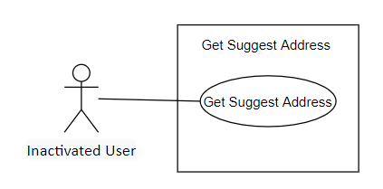

|  |  |  |  |  |  |  |
| --- | --- | --- | --- | --- | --- | --- |
| ID and Name: | **UC-29. Get Suggest Address** | | | | | |
| Created By: | PhatDH | | Date Created: | | 25/9/2021 | |
| Primary Actor: | Inactivated User | | Secondary Actors: | | N/A | |
| Trigger: | User sends a request to get suggest address | | | | | |
| Description: | This function allows user to get suggest address | | | | | |
| Preconditions: | User is on add address page | | | | | |
| Post-conditions: | **Success**: System shows a list of suggest address as user type address  **Failure:** System does not suggest address | | | | | |
| Normal Flow: | Step | Actor Action | | System Response | | |
| 1 | User taps arrow icon button | | System redirects to search address page | | |
|  | 2 | User types in address | | System shows a list of suggest address as user type address in search box [Exception 1] | | |
| Alternative Flows: | N/A | | | | | |
| Exceptions: | No | | Cause | | | System Response |
| 1 | | User does not have internet or the server returns error response | | | System does not suggest address |
| Priority: | Medium | | | | | |
| Frequency of Use: | Occasionally | | | | | |
| Business Rules: | N/A | | | | | |
| Other Information: | In case of Internet connection failure, user will not be able to get suggest address | | | | | |
| Assumptions: | Internet Connection is available | | | | | |

* + 1. **View Privacy Policy**

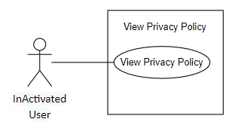

|  |  |  |  |  |  |
| --- | --- | --- | --- | --- | --- |
| ID and Name: | **UC-30. View Privacy Policy** | | | | |
| Created By: | VanLNT | | Date Created: | | 25/9/2021 |
| Primary Actor: | Inactivated User | | Secondary Actors: | | N/A |
| Trigger: | User taps Privacy Policy button | | | | |
| Description: | This function redirect user to Biiké privacy policy site | | | | |
| Preconditions: | User has logged into Biiké application | | | | |
| Post-conditions: | **Success**: Redirect to Biiké Privacy Policy site  **Failure:** System sends error message | | | | |
| Normal Flow: | Step | Actor Action | | System Response | |
| 1 | Actor taps “Biiké Privacy Policy” button | | Redirect to Biiké Privacy Policy site | |
| Alternative Flows: | N/A | | | | |
| Exceptions: | N/A | | | | |
| Priority: | Medium | | | | |
| Frequency of Use: | Seldom | | | | |
| Business Rules: | N/A | | | | |
| Other Information: | N/A | | | | |
| Assumptions: | Internet Connection is available | | | | |

* + 1. **View Terms of Use**

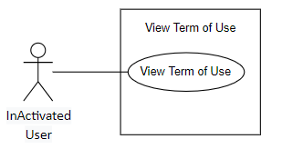

|  |  |  |  |  |  |
| --- | --- | --- | --- | --- | --- |
| ID and Name: | **UC-31. View Terms of use** | | | | |
| Created By: | VanLNT | | Date Created: | | 25/9/2021 |
| Primary Actor: | Inactivated User | | Secondary Actors: | | N/A |
| Trigger: | User taps Terms of use text | | | | |
| Description: | This function redirect user to Biiké Privacy Policy site | | | | |
| Preconditions: | User has logged into Biiké application | | | | |
| Post-conditions: | **Success**: Redirect to Biiké Privacy Policy site  **Failure:** System sends error message | | | | |
| Normal Flow: | Step | Actor Action | | System Response | |
| 1 | Actor taps “Biiké Privacy Policy” button | | Redirect to Biiké Privacy Policy site | |
| Alternative Flows: | N/A | | | | |
| Exceptions: | N/A | | | | |
| Priority: | Medium | | | | |
| Frequency of Use: | Seldom | | | | |
| Business Rules: | N/A | | | | |
| Other Information: | N/A | | | | |
| Assumptions: | Internet Connection is available | | | | |

* + 1. **View Upcoming trips**

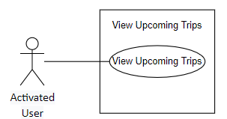

|  |  |  |  |  |  |  |
| --- | --- | --- | --- | --- | --- | --- |
| ID and Name: | **UC-32. View Upcoming Trips** | | | | | |
| Created By: | TamNTT | | Date Created: | | 25/9/2021 | |
| Primary Actor: | Activated User | | Secondary Actors: | | N/A | |
| Trigger: | User sends a request to view upcoming trips | | | | | |
| Description: | This feature allow users to view their upcoming trips | | | | | |
| Preconditions: | User has logged into Biiké application and verify their phone number | | | | | |
| Post-conditions: | **Success**: User will be redirected to view upcoming trips screen  **Failure:** System shows error message | | | | | |
| Normal Flow: | Step | Actor Action | | System Response | | |
| 1 | User taps home tab or activity tab | | System redirects to home page or activity page [Exception 1] | | |
| Alternative Flows: | N/A | | | | | |
| Exceptions: | No | | Cause | | | System Response |
| 1 | |  | | | System shows error message: “There are some errors, please try again later or contact Biiké development team for support” when the Azure server return error response |
| Priority: | High | | | | | |
| Frequency of Use: | Regularly | | | | | |
| Business Rules: | **BR-103:** User can view all their upcoming trips in system. List upcoming trips is sorted by book time in ascending order. | | | | | |
| Other Information: | In case of Internet connection failure, user will not be able to select a mode | | | | | |
| Assumptions: | Internet Connection is available | | | | | |

* + 1. **View Past trips**

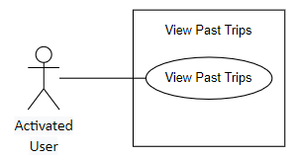

|  |  |  |  |  |  |  |
| --- | --- | --- | --- | --- | --- | --- |
| ID and Name: | **UC-33. View Past Trips** | | | | | |
| Created By: | TamNTT | | Date Created: | | 25/9/2021 | |
| Primary Actor: | Activated User | | Secondary Actors: | | N/A | |
| Trigger: | The user sends a view past trips request | | | | | |
| Description: | This feature allow users to view past trips | | | | | |
| Preconditions: | User has logged into Biiké application and verify their phone numbers | | | | | |
| Post-conditions: | **Success**: User will be redirected to view past trips page  **Failure:** System shows error message | | | | | |
| Normal Flow: | Step | Actor Action | | System Response | | |
| 1 | User taps “View past trips” icon button | | System redirects to view past trips page [Alternative 1] [Exception 1] | | |
| Alternative Flows: | No | | Actor Action | | | System Response |
| 1 | | User taps “Back” icon button | | | System redirects to activity page |
| Exceptions: | No | | Cause | | | System Response |
| 1 | |  | | | System shows error message: “There are some errors, please try again later or contact Biiké development team for support” when the Azure server return error response |
| Priority: | High | | | | | |
| Frequency of Use: | Regularly | | | | | |
| Business Rules: | **BR-104:** User can view all their past trips in system. List past trips is sorted by book time in descending order. | | | | | |
| Other Information: | In case of Internet connection failure, user will not be able to view past trips | | | | | |
| Assumptions: | Internet Connection is available | | | | | |

* + 1. **View trip detail**

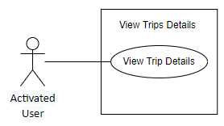

|  |  |  |  |  |  |  |
| --- | --- | --- | --- | --- | --- | --- |
| ID and Name: | **UC-34. View Trip Detail** | | | | | |
| Created By: | TamNTT | | Date Created: | | 25/9/2021 | |
| Primary Actor: | Activated User | | Secondary Actors: | | N/A | |
| Trigger: | User sends a request to view trip details | | | | | |
| Description: | This feature allow users to view their trip details | | | | | |
| Preconditions: | User has logged into Biiké application and verify their phone numbers | | | | | |
| Post-conditions: | **Success**: User will be redirected to view trip details page  **Failure:** System shows error message | | | | | |
| Normal Flow: | Step | Actor Action | | System Response | | |
| 1 | User taps on a trip | | System redirects to view trip details page [Exception 1] | | |
| Alternative Flows: | N/A | | | | | |
| Exceptions: | No | | Cause | | | System Response |
| 1 | |  | | | System shows error message: “There are some errors, please try again later or contact Biiké development team for support” when the Azure server return error response |
| Priority: | High | | | | | |
| Frequency of Use: | Regularly | | | | | |
| Business Rules: | **BR-61:** User cannot view help center when the trip is finished or canceled.  **BR-64:** If the trip is canceled or finished, user will not be able to see the mini map. | | | | | |
| Other Information: | In case of Internet connection failure, user will not be able to view trip details | | | | | |
| Assumptions: | Internet Connection is available | | | | | |

* + 1. **View partner profile**

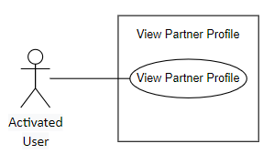

|  |  |  |  |  |  |  |
| --- | --- | --- | --- | --- | --- | --- |
| ID and Name: | **UC-35. View Partner Profile** | | | | | |
| Created By: | TrieuDPH | | Date Created: | | 25/9/2021 | |
| Primary Actor: | Activated User | | Secondary Actors: | | N/A | |
| Trigger: | The actor sends view partner profile request | | | | | |
| Description: | This feature allow user to view their partner profile | | | | | |
| Preconditions: | User is on view trip details page | | | | | |
| Post-conditions: | **Success**: User will be redirected to view partner profile screen  **Failure:** System shows error message | | | | | |
| Normal Flow: | Step | Actor Action | | System Response | | |
| 1 | User taps on their partner avatar | | System redirects to partner profile page | | |
| Alternative Flows: | N/A | | | | | |
| Exceptions: | No | | Cause | | | System Response |
| 1 | |  | | | System shows error message: “There are some errors, please try again later or contact Biiké development team for support” when the Azure server return error response |
| Priority: | Medium | | | | | |
| Frequency of Use: | Normally | | | | | |
| Business Rules: | **BR-48:** User cannot edit partner's profile.  **BR-49:** User can only view partner's name and avatar in view partner profile screen. | | | | | |
| Other Information: | In case of Internet connection failure, user will not be able to view partner profile | | | | | |
| Assumptions: | Internet Connection is available | | | | | |

* + 1. **Report partner**

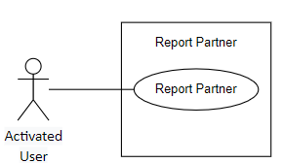

|  |  |  |  |  |  |  |
| --- | --- | --- | --- | --- | --- | --- |
| ID and Name: | **UC-36. Report Partner** | | | | | |
| Created By: | TrieuDPH | | Date Created: | | 25/9/2021 | |
| Primary Actor: | Activated User | | Secondary Actors: | | N/A | |
| Trigger: | The actor sends report partner request | | | | | |
| Description: | This feature allow user to send report about partner | | | | | |
| Preconditions: | User is on partner profile page | | | | | |
| Post-conditions: | **Success**: Report about another user will be noted and consider by Biiké team according to Biiké’s policy and terms of use.  **Failure:** System shows error message. | | | | | |
| Normal Flow: | Step | Actor Action | | System Response | | |
| 1 | User taps “Report” / “Báo cáo” button | | System shows pop up with report reason field and three button: “Report”, “Report and block”, “Exit” [Alternative 1] [Alternative 2] | | |
|  | 2 | User taps “Report” button | | System calls API to create report. If success, system shows a pop-up: “Thank you for your report. Biiké Team apologize for imperfect user experience. We have received your report and will handle it as soon as possible.” [Exception 1] | | |
| Alternative Flows: | No | Actor Action | | System Response | | |
| 1 | User taps “Report and block” button | | System calls API to create report and block user. If success, system shows a pop-up: “Thank you for your report. Biiké Team apologize for imperfect user experience. We have received your report and will handle it as soon as possible.” | | |
| 2 | User taps “Exit” button | | The pop-up will disappear | | |
| Exceptions: | No | | Cause | | | System Response |
| 1 | |  | | | System shows error message: “There are some errors, please try again later or contact Biiké development team for support” when the Azure server return error response |
| Priority: | Medium | | | | | |
| Frequency of Use: | Occasionally | | | | | |
| Business Rules: | **BR-50:** User can report one person multiple times.  **BR-51:** User cannot report themselves. | | | | | |
| Other Information: | In case of Internet connection failure, user will not be able to report | | | | | |
| Assumptions: | Internet Connection is available | | | | | |

* + 1. **Block partner**

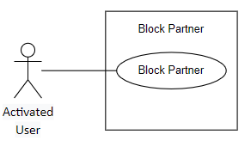

|  |  |  |  |  |  |  |
| --- | --- | --- | --- | --- | --- | --- |
| ID and Name: | **UC-37. Block Partner** | | | | | |
| Created By: | TrieuDPH | | Date Created: | | 25/9/2021 | |
| Primary Actor: | Activated User | | Secondary Actors: | | N/A | |
| Trigger: | The actor sends block partner request | | | | | |
| Description: | This feature allow users to block their partner | | | | | |
| Preconditions: | User is on partner profile page | | | | | |
| Post-conditions: | **Success**: The partner that has been blocked will not be matched with user again until user unblocks that partner  **Failure:** System shows error message | | | | | |
| Normal Flow: | Step | Actor Action | | System Response | | |
| 1 | User taps “Block” / “Chặn” button | | System shows pop up “Are you sure you want to block this user?” / “Bạn có chắc muốn chặn người dùng này không?” [Alternative 1] | | |
|  | 2 | User taps “Yes” / “Có” button | | System calls API to block this user and shows a success message: “This person is blocked” [Exception 1] | | |
| Alternative Flows: | No | Actor Action | | System Response | | |
| 1 | User taps “No” / “Không” button | | The pop-up will disappear | | |
| Exceptions: | No | | Cause | | | System Response |
| 1 | |  | | | System shows error message: “There are some errors, please try again later or contact Biiké development team for support” when the Azure server return error response |
| Priority: | Medium | | | | | |
| Frequency of Use: | Seldom | | | | | |
| Business Rules: | **BR-52:** After user A block user B, user A and B will not ever be matched with each other again until user A unblock user B. After block, they will not able to see each other profile. User A also can't view/find any trip created by user B.  **BR-63:** After block user B, User A can still their previous trip on user A history trip screen | | | | | |
| Other Information: | In case of Internet connection failure, user will not be able to block partner | | | | | |
| Assumptions: | Internet Connection is available | | | | | |

* + 1. **View past trip with partner**

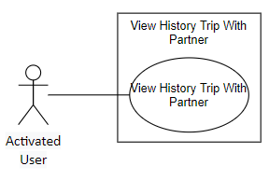

|  |  |  |  |  |  |  |
| --- | --- | --- | --- | --- | --- | --- |
| ID and Name: | **UC-38. View Past Trip with Partner** | | | | | |
| Created By: | TamNTT | | Date Created: | | 25/9/2021 | |
| Primary Actor: | Activated User | | Secondary Actors: | | N/A | |
| Trigger: | User sends a request to view past trips with their partner | | | | | |
| Description: | This feature allow users to view their past trips with their partner | | | | | |
| Preconditions: | User is on view trip details page | | | | | |
| Post-conditions: | **Success**: System loads list of past trips with partner  **Failure:** System shows error message | | | | | |
| Normal Flow: | Step | Actor Action | | System Response | | |
| 1 | User taps on partner avatar | | System redirects to partner profile page | | |
| 2 |  | | System calls API to load partner profile and past trips with partner. If success, system shows partner profile with past trips with partner. If there is no trip, system shows message “No past trip with partner” [Exception 1] | | |
| Alternative Flows: | N/A | | | | | |
| Exceptions: | No | | Cause | | | System Response |
| 1 | |  | | | System shows error message: “There are some errors, please try again later or contact Biiké development team for support” when the Azure server return error response |
| Priority: | Medium | | | | | |
| Frequency of Use: | Usually | | | | | |
| Business Rules: | N/A | | | | | |
| Other Information: | In case of Internet connection failure, user will not be able to view past trips with partner | | | | | |
| Assumptions: | Internet Connection is available | | | | | |

* + 1. **Cancel Trip**

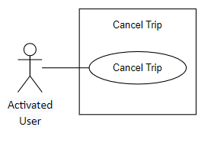

|  |  |  |  |  |  |  |
| --- | --- | --- | --- | --- | --- | --- |
| ID and Name: | **UC-39. Cancel Trip** | | | | | |
| Created By: | TamNTT | | Date Created: | | | 25/9/2021 |
| Primary Actor: | Activated User | | Secondary Actors: | | | N/A |
| Trigger: | User sends a request to cancel trip | | | | | |
| Description: | This feature allows user to cancel their upcoming trip | | | | | |
| Preconditions: | User is on view trip details page | | | | | |
| Post-conditions: | **Success**: Trip status will be changed to canceled  **Failure**: System shows error message | | | | | |
| Normal Flow: | Step | Actor Action | | System Response | | |
| 1 | User taps “Cancel trip / “Hủy chuyến” button | | System shows a pop-up: “Are you sure to cancel this trip” / “Bạn có chắc muốn hủy chuyến này không?” [Alternative 1] | | |
| 2 | User taps “Yes” / “Có” | | System calls API to cancel trip. If success, system shows success message: “Cancel trip successfully” [Exception 1] [Exception 2] | | |
| Alternative Flows: | No | Actor Action | | | System Response | |
| 1 | User taps “No” button | | | The pop-up disappear | |
| Exceptions: | No | Cause | | System Response | | |
| 1 |  | | System shows error message: “There are some errors, please try again later or contact Biiké development team for support” when the Azure server return error response | | |
| 2 | User cancels 3 trips in one day | | System shows error message: “You canceled 3 trips today” | | |
| Priority: | High | | | | | |
| Frequency of Use: | Frequently | | | | | |
| Business Rules: | **BR-53:** After trip is started, user can still cancel trip.  **BR-54:** Each user is allowed to cancel maximum 3 trips per day.  **BR-55:** Biker will not receive bonus points if the trip is canceled.  **BR-56:** When user cancel a trip, a notification will be sent to their trip's partner.  **BR-57:** When the current time match with the book time of an upcoming trip, but that trip has not had a Biker yet, then the system will automatically cancel that trip.  **BR-58:** User must provide a reason when canceling a trip.  **BR-69:** 9 mins after Keer create Trip Now, if no Biker accept trip, then trip is canceled.  **BR-70:** If user has canceled 3 trips on that day, user is not allowed to book any trip for the next 24 hours. | | | | | |
| Other Information: | In case of Internet connection failure, user will not be able to cancel trip | | | | | |
| Assumptions: | Internet Connection is available | | | | | |

* + 1. **Mark as arrived**

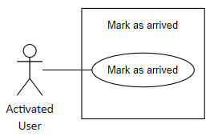

|  |  |  |  |  |  |  |
| --- | --- | --- | --- | --- | --- | --- |
| ID and Name: | **UC-40. Mark As Arrived** | | | | | |
| Created By: | TamNTT | | Date Created: | | 25/9/2021 | |
| Primary Actor: | Activated User | | Secondary Actors: | | N/A | |
| Trigger: | User sends a mark arrived position request | | | | | |
| Description: | This feature allow user to inform to their trip partner that they has arrived to pick up position | | | | | |
| Preconditions: | User is on view trip details page or home page | | | | | |
| Post-conditions: | **Success**: The trip status will be changed to arrive to pick up position  **Failure:** System shows error message | | | | | |
| Normal Flow: | Step | Actor Action | | System Response | | |
| 1 | User taps “I came to pick up point” / “Tôi đã đến điểm đón” button | | System will notify the other partner that their trip partner has arrived, and the button will be disabled [Exception 1] | | |
| Alternative Flows: | N/A | | | | | |
| Exceptions: | No | | Cause | | | System Response |
| 1 | |  | | | System shows error message: “There are some errors, please try again later or contact Biiké development team for support” when the Azure server return error response |
| Priority: | High | | | | | |
| Frequency of Use: | Always | | | | | |
| Business Rules: | **BR-40:** User must turn on GPS location on device and grant location permission to the mobile application  **BR-59:** Once marked as arrived to pick up position, user can not unmarked. | | | | | |
| Other Information: | In case of Internet connection failure, user will not be able to select a mode | | | | | |
| Assumptions: | Internet Connection is available | | | | | |

* + 1. **View trip map**

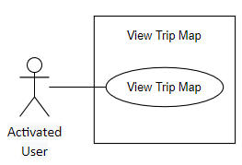

|  |  |  |  |  |  |  |
| --- | --- | --- | --- | --- | --- | --- |
| ID and Name: | **UC-41. View Trip Map** | | | | | |
| Created By: | TamNTT | | Date Created: | | 25/9/2021 | |
| Primary Actor: | Activated User | | Secondary Actors: | | Google Map | |
| Trigger: | User send a request to view map | | | | | |
| Description: | This feature allow user to view a mini map or big map provided by Google Map to show them their trip stations place on map | | | | | |
| Preconditions: | User is on home page or activity page | | | | | |
| Post-conditions: | **Success**: A map will be displayed  **Failure:** System shows error message | | | | | |
| Normal Flow: | Step | Actor Action | | System Response | | |
| 1 | User taps on a trip | | System redirects to view trip details screen [Alternative 1] [Exception 1] | | |
| Alternative Flows: | No | | Actor Action | | | System Response |
| 1 | | Users tap “Expand map” button | | | System redirects to full map page |
| Exceptions: | No | | Cause | | | System Response |
| 1 | |  | | | No map will be displayed if there are some errors with the map package or server |
| Priority: | Medium | | | | | |
| Frequency of Use: | Usually | | | | | |
| Business Rules: | **BR-64:** If the trip is canceled or finished, user will not be able to see the mini map.  **BR-65:** Mini map function also provide full map option. | | | | | |
| Other Information: | In case of Internet connection failure, user will not be able to see the map | | | | | |
| Assumptions: | Internet Connection is available | | | | | |

* + 1. **View help center**

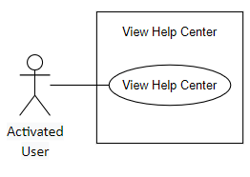

|  |  |  |  |  |  |  |
| --- | --- | --- | --- | --- | --- | --- |
| ID and Name: | **UC-42. View Help Center** | | | | | |
| Created By: | TamNTT | | Date Created: | | 25/9/2021 | |
| Primary Actor: | Activated User | | Secondary Actors: | | N/A | |
| Trigger: | User sends a request to view help center | | | | | |
| Description: | This feature allows user to view help center | | | | | |
| Preconditions: | User is on view trip details page | | | | | |
| Post-conditions: | **Success**: A help center pop-up will be shown  **Failure:** System shows error message | | | | | |
| Normal Flow: | Step | Actor Action | | System Response | | |
| 1 | User taps “Help” button on view trip details page | | System shows a help center pop-up [Exception 1] | | |
| Alternative Flows: | N/A | | | | | |
| Exceptions: | No | | Cause | | | System Response |
| 1 | | User does not turn on GPS location or does not grant the location permission to the application | | | System shows message: “You need to grant location permission and turn on GPS to use this feature” |
| Priority: | Medium | | | | | |
| Frequency of Use: | Normally/Generally | | | | | |
| Business Rules: | **BR-40:** User must turn on GPS location on device and grant location permission to the mobile application  **BR-61:** User cannot view help center when the trip is finished or canceled | | | | | |
| Other Information: | N/A | | | | | |
| Assumptions: | Internet Connection is available | | | | | |

* + 1. **Share real-time location**

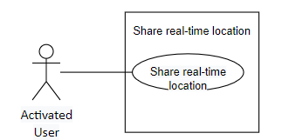

|  |  |  |  |  |  |  |
| --- | --- | --- | --- | --- | --- | --- |
| ID and Name: | **UC-43. Share Real-time Location** | | | | | |
| Created By: | TamNTT | | Date Created: | | 25/9/2021 | |
| Primary Actor: | Activated User | | Secondary Actors: | | Pathshare | |
| Trigger: | User sends a request to share real-time location | | | | | |
| Description: | This function allows user to share their real-time location via Pathshare | | | | | |
| Preconditions: | User views help center | | | | | |
| Post-conditions: | **Success**: User will get a real-time location link  **Failure:** System shows error message | | | | | |
| Normal Flow: | Step | Actor Action | | System Response | | |
| 1 | User taps “Share location” button | | System shows a dialog which contains the real-time location link [Exception 1] | | |
| Alternative Flows: | N/A | | | | | |
| Exceptions: | No | | Cause | | | System Response |
| 1 | |  | | | System shows error message: “There are some errors, please try again later or contact Biiké development team for support” when the Pathshare server return error response |
| Priority: | Low | | | | | |
| Frequency of Use: | Usually | | | | | |
| Business Rules: | **BR-40:** User must turn on GPS location on device and grant location permission to the mobile application  **BR-60:** After trip is canceled or finished, user is unable to share real-time location through help center  **BR-141:** User location will automatically stop sharing after 1 hour or when the trip is completed or when user exit the mobile application | | | | | |
| Other Information: | In case of Internet connection failure, user will not be able to share real-time location | | | | | |
| Assumptions: | Internet Connection is available | | | | | |

* + 1. **Send location to S.O.S number**

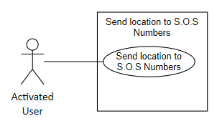

|  |  |  |  |  |  |  |
| --- | --- | --- | --- | --- | --- | --- |
| ID and Name: | **UC-44. Send Location to S.O.S Number** | | | | | |
| Created By: | TamNTT | | Date Created: | | 25/9/2021 | |
| Primary Actor: | Activated User | | Secondary Actors: | | N/A | |
| Trigger: | User sends a request to send location to S.O.S number | | | | | |
| Description: | This function allows user send their real-time location to the S.O.S Number they added before via message app | | | | | |
| Preconditions: | User has shared their current location | | | | | |
| Post-conditions: | **Success**: A message which contains real-time location link will be sent to S.O.S number(s)  **Failure:** System shows error message | | | | | |
| Normal Flow: | Step | Actor Action | | System Response | | |
| 1 | User taps “Send location to S.O.S Numbers” button | | System redirects to default message app with message body [Alternative 1] [Exception 1] | | |
| 2 | User taps “Send” button | | Message will be sent to selected phone numbers | | |
| Alternative Flows: | No | | Actor Action | | | System Response |
| 1 | | User taps “Back” button | | | System redirects user to view trip details page |
| Exceptions: | No | | Cause | | | System Response |
| 1 | | User does not share their location | | | System shows a pop-up: “You need to share your location to use this feature” |
| Priority: | Low | | | | | |
| Frequency of Use: | Usually | | | | | |
| Business Rules: | **BR-43:** After deleting an S.O.S number, user cannot send their S.O.S message to that number through Help center | | | | | |
| Other Information: | N/A | | | | | |
| Assumptions: | Internet Connection is available | | | | | |

* + 1. **Get nearest police station**

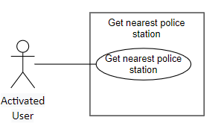

|  |  |  |  |  |  |  |
| --- | --- | --- | --- | --- | --- | --- |
| ID and Name: | **UC-45. Get Nearest Police Station** | | | | | |
| Created By: | TamNTT | | Date Created: | | 25/9/2021 | |
| Primary Actor: | Activated User | | Secondary Actors: | | Google Map | |
| Trigger: | User sends a request to search for nearest police station | | | | | |
| Description: | This function allows user to search for the nearest police station via Google Map | | | | | |
| Preconditions: | User views help center | | | | | |
| Post-conditions: | **Success**: System redirects to Google Map app with keyword “Police station” in search bar  **Failure:** System shows error message | | | | | |
| Normal Flow: | Step | Actor Action | | System Response | | |
| 1 | User taps “Nearest Police Station” button | | System redirects to Google Map app with keyword “Police station” in search bar [Exception 1] | | |
| Alternative Flows: | N/A | | | | | |
| Exceptions: | No | | Cause | | | System Response |
| 1 | | User does not turn on GPS location or does not grant the location permission to the application | | | System shows message: “You need to grant location permission and turn on GPS to use this feature” |
| Priority: | Low | | | | | |
| Frequency of Use: | Normally | | | | | |
| Business Rules: | **BR-40:** User must turn on GPS location on device and grant location permission to the mobile application | | | | | |
| Other Information: | In case of Internet connection failure, user will not be able to search nearest police station | | | | | |
| Assumptions: | Internet Connection is available | | | | | |

* + 1. **Get nearest mechanic shop**

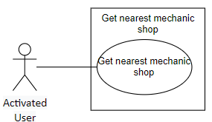

|  |  |  |  |  |  |  |
| --- | --- | --- | --- | --- | --- | --- |
| ID and Name: | **UC-46. Get Nearest Mechanic Shop** | | | | | |
| Created By: | TamNTT | | Date Created: | | 25/9/2021 | |
| Primary Actor: | Activated User | | Secondary Actors: | | Google Map | |
| Trigger: | User sends a request to search for nearest mechanic shop | | | | | |
| Description: | This function allows user to search for the nearest mechanic shop via Google Map | | | | | |
| Preconditions: | User views help center | | | | | |
| Post-conditions: | **Success**: System redirects to Google Map app with keyword “Mechanic shop” in search bar  **Failure:** System shows error message | | | | | |
| Normal Flow: | Step | Actor Action | | System Response | | |
| 1 | User taps “Nearest Mechanic Shop” button | | System redirects to Google Map app with keyword “Mechanic shop” in search bar [Exception 1] | | |
| Alternative Flows: | N/A | | | | | |
| Exceptions: | No | | Cause | | | System Response |
| 1 | | User does not turn on GPS location or does not grant the location permission to the application | | | System shows message: “You need to grant location permission and turn on GPS to use this feature” |
| Priority: | Low | | | | | |
| Frequency of Use: | Normally | | | | | |
| Business Rules: | **BR-40:** User must turn on GPS location on device and grant location permission to the mobile application | | | | | |
| Other Information: | In case of Internet connection failure, user will not be able to search nearest mechanic shop | | | | | |
| Assumptions: | Internet Connection is available | | | | | |

* + 1. **Get nearest gas station**

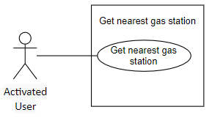

|  |  |  |  |  |  |  |
| --- | --- | --- | --- | --- | --- | --- |
| ID and Name: | **UC-47. Get Nearest Gas Station** | | | | | |
| Created By: | TamNTT | | Date Created: | | 25/9/2021 | |
| Primary Actor: | Activated User | | Secondary Actors: | | Google Map | |
| Trigger: | User sends a request to search for nearest gas station | | | | | |
| Description: | This function allows user to search for the nearest gas station via Google Map | | | | | |
| Preconditions: | User views help center | | | | | |
| Post-conditions: | **Success**: System redirects to Google Map app with keyword “Gas station” in search bar  **Failure:** System shows error message | | | | | |
| Normal Flow: | Step | Actor Action | | System Response | | |
| 1 | User taps “Nearest gas station” button | | System redirects to Google Map app with keyword “Gas station” in search bar [Exception 1] | | |
| Alternative Flows: | N/A | | | | | |
| Exceptions: | No | | Cause | | | System Response |
| 1 | | User does not turn on GPS location or does not grant the location permission to the application | | | System shows message: “You need to grant location permission and turn on GPS to use this feature” |
| Priority: | Low | | | | | |
| Frequency of Use: | Normally | | | | | |
| Business Rules: | **BR-40:** User must turn on GPS location on device and grant location permission to the mobile application | | | | | |
| Other Information: | In case of Internet connection failure, user will not be able to search nearest gas station | | | | | |
| Assumptions: | Internet Connection is available | | | | | |

* + 1. **Get nearest hospital**

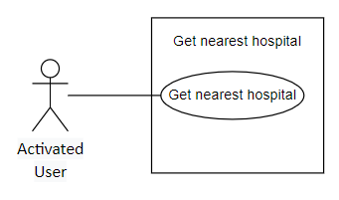

|  |  |  |  |  |  |  |
| --- | --- | --- | --- | --- | --- | --- |
| ID and Name: | **UC-48. Get Nearest Hospital** | | | | | |
| Created By: | TamNTT | | Date Created: | | 25/9/2021 | |
| Primary Actor: | Activated User | | Secondary Actors: | | Google Map | |
| Trigger: | User sends a request to search for nearest hospital | | | | | |
| Description: | This function allows user to search for the nearest hospital via Google Map | | | | | |
| Preconditions: | User views help center | | | | | |
| Post-conditions: | **Success**: System redirects to Google Map app with keyword “Hospital” in search bar  **Failure:** System shows error message | | | | | |
| Normal Flow: | Step | Actor Action | | System Response | | |
| 1 | User taps “Nearest hospital” button | | Redirect to Google Map app with keyword “Hospital” in search bar [Exception 1] | | |
| Alternative Flows: | N/A | | | | | |
| Exceptions: | No | | Cause | | | System Response |
| 1 | | User does not turn on GPS location or does not grant the location permission to the application | | | System shows message: “You need to grant location permission and turn on GPS to use this feature” |
| Priority: | Low | | | | | |
| Frequency of Use: | Normally | | | | | |
| Business Rules: | **BR-40:** User must turn on GPS location on device and grant location permission to the mobile application | | | | | |
| Other Information: | In case of Internet connection failure, user will not be able search nearest hospital | | | | | |
| Assumptions: | Internet Connection is available | | | | | |

* + 1. **View ban list**

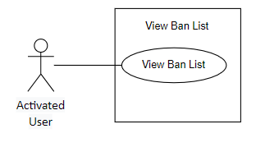

|  |  |  |  |  |  |
| --- | --- | --- | --- | --- | --- |
| ID and Name: | **UC-49. View Ban List** | | | | |
| Created By: | VanLNT | | Date Created: | | 25/9/2021 |
| Primary Actor: | Activated User | | Secondary Actors: | | N/A |
| Trigger: | The actor sends View Black List Partner request | | | | |
| Description: | This feature allows users to view the list of users that are blocked by Actor | | | | |
| Preconditions: | User has logged into Biiké application and verify their phone numbers | | | | |
| Post-conditions: | **Success**: User will be redirected to Black List screen | | | | |
| Normal Flow: | Step | Actor Action | | System Response | |
| 1 | Actor tap “View Black List” / “Xem danh sách đen” button | | System redirects to Black List screen. [Alternative 1] | |
| Alternative Flows: | Step | Actor Action | | System Response | |
| 1 | Actor taps “Unblock” button | | UC-50 | |
| Exceptions: | N/A | | | | |
| Priority: | Medium | | | | |
| Frequency of Use: | Sometimes | | | | |
| Business Rules: | **BR-62:** User can only view users who they block, user cannot view who block themselves | | | | |
| Other Information: | N/A | | | | |
| Assumptions: | Internet Connection is available | | | | |

* + 1. **Unblock partner**

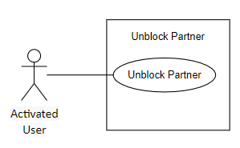

|  |  |  |  |  |  |
| --- | --- | --- | --- | --- | --- |
| ID and Name: | **UC-50. Unblock Partner** | | | | |
| Created By: | VanLNT | | Date Created: | | 25/9/2021 |
| Primary Actor: | Activated User | | Secondary Actors: | | N/A |
| Trigger: | The actor taps Unblock User button | | | | |
| Description: | This feature allows users to unblock the previous partner | | | | |
| Preconditions: | User has logged into Biiké application and verify their phone numbers | | | | |
| Post-conditions: | **Success**: User will be redirected to Black List screen | | | | |
| Normal Flow: | Step | Actor Action | | System Response | |
| 1 | Actor tap “Unblock Partner” / “Hủy chặn” button | | Change intimacy status, System redirects to Black List screen. [Alternative 1] | |
| Alternative Flows: | N/A | | | | |
| Exceptions: | N/A | | | | |
| Priority: | Medium | | | | |
| Frequency of Use: | Sometimes | | | | |
| Business Rules: | **BR-66:** After unblock, users can be matched with each other again  **BR-67:** After unblock, user can view each other profile | | | | |
| Other Information: | N/A | | | | |
| Assumptions: | Internet Connection is available | | | | |

* + 1. **Send trip feedback**

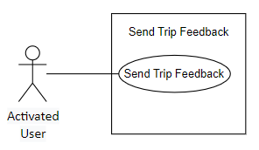

|  |  |  |  |  |  |
| --- | --- | --- | --- | --- | --- |
| ID and Name: | **UC-51. Send Trip Feedback** | | | | |
| Created By: | UyenNLP | | Date Created: | | 25/9/2021 |
| Primary Actor: | Activated User | | Secondary Actors: | | N/A |
| Trigger: | The actor finish trip and need to feedback about the trip  The Actor send feedback trip request | | | | |
| Description: | This feature allow users to send feedback about the trip and previous partner | | | | |
| Preconditions: | User has activated their Biiké account | | | | |
| Post-conditions: | **Success**: User will be redirected to main page of the application and able to use others services  **Failure**: Feedback contains inappropriate words: System informs: “Please don't use bad words'” / “Xin chỉ dùng những từ ngữ phù hợp” | | | | |
| Normal Flow: | Step | Actor Action | | System Response | |
| 1 | Actor enter feedback content | |  | |
| 2 | Actor tap “Send” / “Gửi” button | | System checks if there's any inappropriate words contained  If feedback is valid, send and redirect to main page screen  If feedback is inalid: Exception | |
| Alternative Flows: | N/A | | | | |
| Exceptions: | No | Cause | | System Response | |
| 1 | The actor’s feedback contains inappropriate words | | System informs: “Please don't use bad words'” / “Xin chỉ dùng những từ ngữ phù hợp” | |
| Priority: | Medium | | | | |
| Frequency of Use: | Always | | | | |
| Business Rules: | **BR-84:** After user finished trip, Keer need to feedback so Biker can gain more bonus points  **BR-85:** Users cannot send feedback including inappropriate words.  **BR-86:** A user can only send one feedback per trip.  **BR-87:** When giving feedback, users have to rate trips on stars scale and write reviews.  **BR-88:** "Feedback options for driver:  - On time  - Farmiliar with the road  - Friendly & Funny  - Helmet prepared "  **BR-89:** "Feedback options for Keer:  - On time  - Happy Partner  - Friendly & Funny  - Grateful "  **BR-90:** "Feedback options for driver in 1-2 stars case:  - Late  - Not farmiliar with road  - Angry  - Helmet non-prepared"  **BR-91:** "Feedback options for Keer in 1-2 stars case:  - Late  - Not kind&friendly  - Angry  - Disrespect " | | | | |
| Other Information: | N/A | | | | |
| Assumptions: | Internet Connection is available | | | | |

* + 1. **Switch Mode**

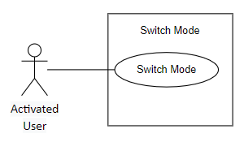

|  |  |  |  |  |  |  |
| --- | --- | --- | --- | --- | --- | --- |
| ID and Name: | **UC-52. Switch Mode** | | | | | |
| Created By: | TamNTT | | Date Created: | | 25/9/2021 | |
| Primary Actor: | Activated User | | Secondary Actors: | | N/A | |
| Trigger: | User sends a request to switch mode | | | | | |
| Description: | This feature allow users to switch to another mode | | | | | |
| Preconditions: | User has logged into Biiké application | | | | | |
| Post-conditions: | **Success**: User will be changed mode and redirect to other mode main page  **Failure**: System shows error message | | | | | |
| Normal Flow: | Step | Actor Action | | System Response | | |
| 1 | User taps switch mode button | | User’s mode changed, redirect to other mode main page [Exception 1] | | |
| Alternative Flows: | N/A | | | | | |
| Exceptions: | No | | Cause | | | System Response |
| 1 | |  | | | System shows error message: “There are some errors, please try again later or contact Biiké development team for support” when the Azure server return error response |
| Priority: | High | | | | | |
| Frequency of Use: | Usually | | | | | |
| Business Rules: | **BR-31:** User can switch between two modes when using the mobile application | | | | | |
| Other Information: | In case of Internet connection failure, user will not be able to change mode | | | | | |
| Assumptions: | Internet Connection is available | | | | | |

* + 1. **Create trip**

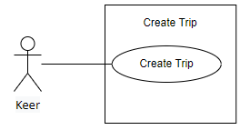

|  |  |  |  |  |  |  |
| --- | --- | --- | --- | --- | --- | --- |
| ID and Name: | **UC-53. Create trip** | | | | | |
| Created By: | UyenNLP | | Date Created: | | 25/9/2021 | |
| Primary Actor: | Keer | | Secondary Actors: | | N/A | |
| Trigger: | The actor send Create Trip request, this also called Trip Now | | | | | |
| Description: | This feature allow users to create Trip instantly | | | | | |
| Preconditions: | User has activated their Biiké account | | | | | |
| Post-conditions: | **Success**: New trip request will be created and send to Bikers  **Failure**: System shows error message | | | | | |
| Normal Flow: | Step | Actor Action | | System Response | |
| 1 | Actor tap on big plus icon | | System redirects to Create Trip screen with following field:  Position 1: Drop Box Selected  Position 2: Drop Box Selected | |
| 2 | Actor choose 2 station as positions | |  | |
| 3 | Actor tap “Ké Now” button | | New ké-now trip is created and send notifications to available Bike [Alternative 1] [Exception1] | |
| Alternative Flows: | Step | Actor Action | | System Response | |
| 1 | Actor tap back button | | Redirect to Keer main screen | |
| Exceptions: | No | Cause | | System Response | |
| 1 | Actor has cancelled too many time that account is blocked for 24 hours | | The system informs “You cannot book trip right now, please try again after 24 hours” / “Bạn không thể đặt chuyến ngay lúc này, hãy thử lại sau 24 giờ” | |
| Priority: | Medium | | | | | |
| Frequency of Use: | Usually | | | | | |
| Business Rules: | **BR-68:** Ke-er create trip base on predefined stations (one must be a place saved before)  **BR-69:** 9 mins after Keer create now trip, if no biker accept trip, then trip is canceled  **BR-70:** If User has canceled more than 3 trips on that day, user can not allows to book any trip for the next 24 hours  **BR-71:** User can only create Trip from 5a.m. to 9p.m.  **BR-72:** User has to choose station before create trip | | | | | |
| Other Information: | N/A | | | | | |
| Assumptions: | Internet Connection is available | | | | | |

* + 1. **View position detail**

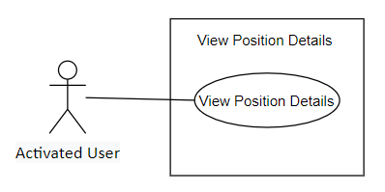

|  |  |  |  |  |  |
| --- | --- | --- | --- | --- | --- |
| ID and Name: | **UC-54. View Position Details** | | | | |
| Created By: | TamNTT | | Date Created: | | 25/9/2021 |
| Primary Actor: | Activated User | | Secondary Actors: | | Google Map |
| Trigger: | User sends a request to view position details | | | | |
| Description: | This feature allows user to view the selected position’s details | | | | |
| Preconditions: | User is on view trip details page | | | | |
| Post-conditions: | **Success**: A window on top of marker which contains location’s name will be shown  **Failure**: System shows error message | | | | |
| Normal Flow: | Step | Actor Action | | System Response | |
| 1 | User taps a marker | | A window on top of marker which contains location’s name will be shown | |
| Alternative Flows: | N/A | | | | |
| Exceptions: | N/A | | | | |
| Priority: | Low | | | | |
| Frequency of Use: | Normally | | | | |
| Business Rules: | N/A | | | | |
| Other Information: | In case of Internet connection failure, user will not be able to view selected position details | | | | |
| Assumptions: | Internet Connection is available | | | | |

* + 1. **Schedule trip**

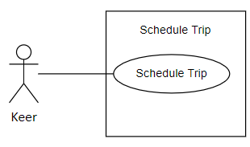

|  |  |  |  |  |  |  |
| --- | --- | --- | --- | --- | --- | --- |
| ID and Name: | **UC-55. Schedule Trip** | | | | | |
| Created By: | UyenNLP | | | Date Created: | | 25/9/2021 |
| Primary Actor: | Keer | | | Secondary Actors: | | N/A |
| Trigger: | The actor sends schedule trip request | | | | | |
| Description: | This feature allow users to create schedule trips | | | | | |
| Preconditions: | User has logged into Biiké application and verify their phone numbers | | | | | |
| Post-conditions: | **Success**: Schedule trip will be created  **Failure**: System informs “Cannot create this trip, please try again later” / “Không thể tạo chuyến đi này, xin hãy thử lại sau” | | | | | |
| Normal Flow: | Step | Actor Action | | | System Response | |
| 1 | Actor tap “Create Schedule Trip” / “Tạo chuyến đi sau” button | | | System redirects to Create Schedule trip screen with following fields:  Position 1: Drop Box selected  Position 2: Drop Box Selected  Time: Box | |
| 2 | Actor fill schedule trip information | | |  | |
| 3 | Actor tap “Create” / “Tạo Chuyến” button | | | The trip is created [Alternative 1] [Exception1] [Exception2] | |
| Alternative Flows: | Step | | Actor Action | | System Response | |
| 1 | | Actor cancel create trip during waiting time | | The trip is canceled | |
| Exceptions: | No | Cause | | | System Response | |
| 1 | The time of the trip is duplicated | | | The system informs “you already create trip at this time, please choose another time” / “bạn đã đặt chuyến vào khoảng thời gian này rồi, xin hãy chọn thời gian khác” | |
| 2 | Actor create too many trips | | | System informs “You has reached the maximum trip can be created per day, please come back tomorrow” / “Bạn đã đạt tối đa số chuyến có thể tạo trong ngày, xin hãy quay lại vào ngày mai” | |
| Priority: | Medium | | | | | |
| Frequency of Use: | Usually | | | | | |
| Business Rules: | **BR-79:** Keer can create maximum 15 schedule trips at a time  **BR-80:** If the schedule trip is not accepted before its start time 5 minutes, sytem must send notification to user.  **BR-81:** If the day user book schedule trip is not weekend, user can only schedule trip for the current week and the next week. If that day is weekend, user can create trip for the next 2 weeks | | | | | |
| Other Information: | N/A | | | | | |
| Assumptions: | Internet Connection is available | | | | | |

* + 1. **Tip for biker**

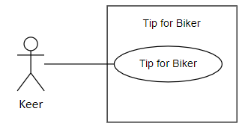

|  |  |  |  |  |  |
| --- | --- | --- | --- | --- | --- |
| ID and Name: | **UC-56. Tip for biker** | | | | |
| Created By: | UyenNLP | | Date Created: | | 25/9/2021 |
| Primary Actor: | Keer | | Secondary Actors: | | N/A |
| Trigger: | The actor sends tips for biker request | | | | |
| Description: | This feature allow keer to tips for their partner with their point | | | | |
| Preconditions: | User has logged into Biiké application and verify their phone numbers | | | | |
| Post-conditions: | **Success**: The point will be transfer to Biker wallet from Keer wallet  **Failure**: System informs “You cannot perform this transaction, please try again later” / “Bạn không thể thực hiện cuộc giao dịch này, xin hãy thử lại sau” | | | | |
| Normal Flow: | Step | Actor Action | | System Response | |
| 1 | Actor on feedback page | |  | |
| 2 | Actor type amount of point they want to tip for biker | |  | |
| 3 | Actor tap “Send” / “Gửi” button | | System checks if Actor wallet is enough points to perform the transaction  Yes: The point will be transfer from Keer wallet to Biker wallet  No: Exception | |
| Alternative Flows: | N/A | | | | |
| Exceptions: | No | Cause | | System Response | |
| 1 | The actor’s wallet is not enough to perform the transaction | | System inform “User doesn't have enough point” / “Người dùng không đủ điểm để đổi!” | |
| Priority: | Medium | | | | |
| Frequency of Use: | Usually | | | | |
| Business Rules: | N/A | | | | |
| Other Information: | N/A | | | | |
| Assumptions: | Internet Connection is available | | | | |

* + 1. **Filter Schedule Trip**

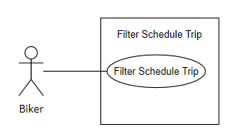

|  |  |  |  |  |  |  |
| --- | --- | --- | --- | --- | --- | --- |
| ID and Name: | **UC-57. Filter Schedule Trip** | | | | | |
| Created By: | TamNTT | | Date Created: | | 25/9/2021 | |
| Primary Actor: | Biker | | Secondary Actors: | | N/A | |
| Trigger: | User sends a request to search schedule trip by filter | | | | | |
| Description: | This feature allow Bikers to search for upcoming schedule trips | | | | | |
| Preconditions: | User has logged into Biiké application and verify their phone numbers and add their bike | | | | | |
| Post-conditions: | **Success**: A list of upcoming schedule trip will be displayed  **Failure:** System shows error message | | | | | |
| Normal Flow: | Step | Actor Action | | System Response | | |
| 1 | User chooses a standard to search trip (date, time, departure station, destination station) | | [Alternative 1] | | |
| 2 | User taps “Search” / “Lọc chuyến” button | | System shows a list of trips that match with the chosen standard [Exception 1] | | |
| Alternative Flows: | No | | Actor Action | | | System Response |
| 1 | | User taps “Clear” / “Đặt lại” button | | | List trips and the chosen standard will be cleared |
| Exceptions: | No | | Cause | | | System Response |
| 1 | |  | | | System shows error message: “There are some errors, please try again later or contact Biiké development team for support” when the Azure server return error response |
| Priority: | High | | | | | |
| Frequency of Use: | Usually | | | | | |
| Business Rules: | **BR-82:** Biker can search all schedule trips and filtered schedule trips based on chosen standard.  **BR-133:** System will display maximum 10 first schedule trips. | | | | | |
| Other Information: | In case of Internet connection failure, user will not be able to search trip | | | | | |
| Assumptions: | Internet Connection is available | | | | | |

* + 1. **View bike**

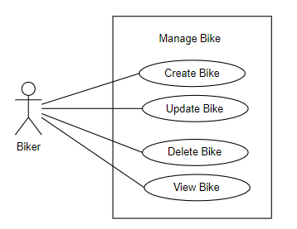

|  |  |  |  |  |  |
| --- | --- | --- | --- | --- | --- |
| ID and Name: | **UC-58. View Bike** | | | | |
| Created By: | VanLNT | | Date Created: | | 25/9/2021 |
| Primary Actor: | Biker | | Secondary Actors: | | N/A |
| Trigger: | The actor sends view Bike request | | | | |
| Description: | This feature allows users to view their Bike | | | | |
| Preconditions: | User has logged into Biiké application | | | | |
| Post-conditions: | **Success**: User will be redirected to View Bike screen  **Failure**: System shows error message | | | | |
| Normal Flow: | Step | Actor Action | | System Response | |
| 1 | Actor taps on bike card | | Redirect to Bike screen | |
| Alternative Flows: | N/A | | | | |
| Exceptions: | N/A | | | | |
| Priority: | Medium | | | | |
| Frequency of Use: | Usually | | | | |
| Business Rules: | **BR-91:** Each user can only have maximum one bike | | | | |
| Other Information: | N/A | | | | |
| Assumptions: | Internet Connection is available | | | | |

* + 1. **Delete Bike**



|  |  |  |  |  |  |
| --- | --- | --- | --- | --- | --- |
| ID and Name: | **UC-59. Delete Bike** | | | | |
| Created By: | PhatDH | | Date Created: | | 25/9/2021 |
| Primary Actor: | Biker | | Secondary Actors: | | N/A |
| Trigger: | The actor sends Delete Bike request | | | | |
| Description: | This feature allows users to delete their Bike | | | | |
| Preconditions: | User has logged into Biiké application using Biker Mode | | | | |
| Post-conditions: | **Success**: User Bike will be deleted  **Failure**: System shows error message | | | | |
| Normal Flow: | Step | Actor Action | | System Response | |
| 1 | Actor taps on delete icon | | System show pop up “Are you sure to delete this Bike?” / “Bạn có chắc muốn xóa xe này không?” | |
| 2 | Actor tap “Yes” | | The Bike will be deleted [Alternative 1] | |
| Alternative Flows: | No | Actor Action | | System Response | |
| 1 | Actor tap “No” | | The system will redirect to View Bike screen | |
| Exceptions: | N/A | | | | |
| Priority: | Medium | | | | |
| Frequency of Use: | Sometimes | | | | |
| Business Rules: | **BR-107:** If user delete the only bike they have been verified, user will become Keer | | | | |
| Other Information: | N/A | | | | |
| Assumptions: | Internet Connection is available | | | | |

* + 1. **Add Bike**



|  |  |  |  |  |  |
| --- | --- | --- | --- | --- | --- |
| ID and Name: | **UC-60. Add Bike** | | | | |
| Created By: | PhatDH | | Date Created: | | 25/9/2021 |
| Primary Actor: | Biker | | Secondary Actors: | | N/A |
| Trigger: | The actor sends add Bike request | | | | |
| Description: | This feature allows users to add Bike | | | | |
| Preconditions: | User has logged into Biiké application | | | | |
| Post-conditions: | **Success**: User Bike will be added  **Failure**: System shows error message | | | | |
| Normal Flow: | Step | Actor Action | | System Response | |
| 1 | Actor goes to add Bike screen | | System redirects to add Bike screen with following fields:  Name: text field Brand: dropdown Color: text field Type: dropdown Volume: dropdown Number Plate: text field Bike Picture: photo Bike License Pickture: photo Plate Number Picture: photo Driving License Back Picture: photo Driving License Front Picture: photo | |
| 2 | Actor enter bike’s update information | |  | |
| 3 | Actor tap “Save” / “Lưu” button | | New bike added | |
| Alternative Flows: | N/A | | | | |
| Exceptions: | N/A | | | | |
| Priority: | Medium | | | | |
| Frequency of Use: | Usually | | | | |
| Business Rules: | **BR-91:** Each user can only have maximum one bike  **BR-105:** All field is required, if any field is blank, when user click submit button, a message is shown: "Please fill enough data" | | | | |
| Other Information: | N/A | | | | |
| Assumptions: | Internet Connection is available | | | | |

* + 1. **View Ride Now**

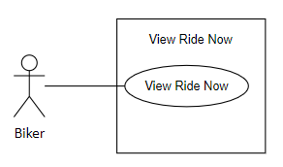

|  |  |  |  |  |  |
| --- | --- | --- | --- | --- | --- |
| ID and Name: | **UC-61. View Ride Now** | | | | |
| Created By: | TamNTT | | Date Created: | | 25/9/2021 |
| Primary Actor: | Biker | | Secondary Actors: | | N/A |
| Trigger: | User sends a request to view Ride Now page | | | | |
| Description: | This function allows Biker to view Ride Now page | | | | |
| Preconditions: | User has logged into Biiké application using Biker Mode and has verified Bike | | | | |
| Post-conditions: | **Success**: Redirect to Ride Now page  **Failure**: System shows error message | | | | |
| Normal Flow: | Step | Actor Action | | System Response | |
| 1 | User taps “Ride Now” button | | System redirects to Ride Now page | |
| Alternative Flows: | N/A | | | | |
| Exceptions: | N/A | | | | |
| Priority: | High | | | | |
| Frequency of Use: | Usually | | | | |
| Business Rules: | N/A | | | | |
| Other Information: | N/A | | | | |
| Assumptions: | Internet Connection is available | | | | |

* + 1. **Switch Ride Now status**

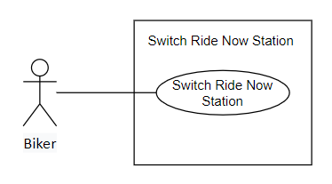

|  |  |  |  |  |  |  |
| --- | --- | --- | --- | --- | --- | --- |
| ID and Name: | **UC-62. Switch Ride Now Status** | | | | | |
| Created By: | TamNTT | | Date Created: | | 25/9/2021 | |
| Primary Actor: | Biker | | Secondary Actors: | | N/A | |
| Trigger: | Biker sends a request to change Ride Now status | | | | | |
| Description: | This function allows Biker to change Ride Now status | | | | | |
| Preconditions: | User is on Ride Now page | | | | | |
| Post-conditions: | **Success**: Ride Now status changed  **Failure**: System shows error message | | | | | |
| Normal Flow: | Step | Actor Action | | System Response | | |
| 1 | User taps “Ride Now status” button | | Ride Now status changed [Exception 1] | | |
| Alternative Flows: | N/A | | | | | |
| Exceptions: | No | | Cause | | | System Response |
| 1 | |  | | | System shows error message: “There are some errors, please try again later or contact Biiké development team for support” when the Azure server return error response |
| Priority: | High | | | | | |
| Frequency of Use: | Occasionally | | | | | |
| Business Rules: | N/A | | | | | |
| Other Information: | In case of Internet connection failure, user will not be able to change Ride Now status | | | | | |
| Assumptions: | Internet Connection is available | | | | | |

* + 1. **View Ride Now Station**

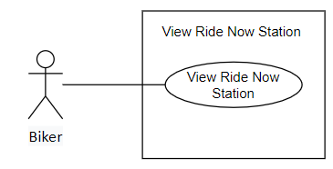

|  |  |  |  |  |  |  |
| --- | --- | --- | --- | --- | --- | --- |
| ID and Name: | **UC-63. View Ride Now Station** | | | | | |
| Created By: | TamNTT | | Date Created: | | 25/9/2021 | |
| Primary Actor: | Biker | | Secondary Actors: | | N/A | |
| Trigger: | Biker sends a request to view Ride Now station | | | | | |
| Description: | This feature allows Biker to view their Ride Now station | | | | | |
| Preconditions: | Biker is on Ride Now page | | | | | |
| Post-conditions: | **Success**: System shows a pop-up which contains Ride Now station information  **Failure**: System shows error message | | | | | |
| Normal Flow: | Step | Actor Action | | System Response | | |
| 1 | User taps on a Ride Now station | | System shows a pop-up which contains Ride Now station information [Exception 1] | | |
| Alternative Flows: | N/A | | | | | |
| Exceptions: | No | | Cause | | | System Response |
| 1 | |  | | | System shows error message: “There are some errors, please try again later or contact Biiké development team for support” when the Azure server return error response |
| Priority: | High | | | | | |
| Frequency of Use: | Sometimes | | | | | |
| Business Rules: | **BR-134:** Biker can only view their Ride Now station | | | | | |
| Other Information: | In case of Internet connection failure, user will not be able to view Ride Now station | | | | | |
| Assumptions: | Internet Connection is available | | | | | |

* + 1. **Add Ride Now Station**

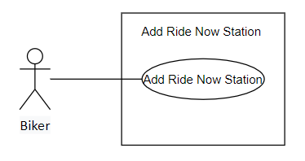

|  |  |  |  |  |  |  |
| --- | --- | --- | --- | --- | --- | --- |
| ID and Name: | **UC-64. Add Ride Now Station** | | | | | |
| Created By: | TamNTT | | Date Created: | | 25/9/2021 | |
| Primary Actor: | Biker | | Secondary Actors: | | N/A | |
| Trigger: | Biker sends a request to add Ride Now station | | | | | |
| Description: | This feature allows Biker to add Ride Now station | | | | | |
| Preconditions: | Biker is on Ride Now page | | | | | |
| Post-conditions: | **Success**: New Ride Now station will be added  **Failure**: System shows error message | | | | | |
| Normal Flow: | Step | Actor Action | | System Response | | |
| 1 | User taps “Add pick up station” / “Thêm điểm nhận chuyến” button | | System shows a pop-up with required fields: name, from time, to time [Alternative 1] | | |
|  | 2 | User taps “Add” button | | The pop-up will disappear and new station will appear on Ride Now page [Exception 1] [Exception 2] | | |
| Alternative Flows: | No | | Actor Action | | | System Response |
| 1 | | User taps somewhere outside the pop-up | | | The pop-up will disappear |
| Exceptions: | No | | Cause | | | System Response |
| 1 | | User does not input all required fields | | | System shows error message: “Please fill in all fields” |
| 2 | |  | | | System shows error message: “There are some errors, please try again later or contact Biiké development team for support” when the Azure server return error response |
| Priority: | High | | | | | |
| Frequency of Use: | Sometimes | | | | | |
| Business Rules: | **BR-135:** Biker can only add station with time between 5AM and 9PM.  **BR-136:** From time must be before to time.  **BR-137:** Biker cannot add two stations with same name and same time.  **BR-138:** Biker can only add station which predefined in Biiké system. | | | | | |
| Other Information: | In case of Internet connection failure, user will not be able to add new Ride Now station | | | | | |
| Assumptions: | Internet Connection is available | | | | | |

* + 1. **Delete Ride Now Station**

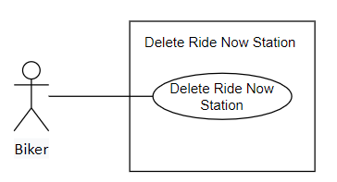

|  |  |  |  |  |  |  |
| --- | --- | --- | --- | --- | --- | --- |
| ID and Name: | **UC-65. Delete Ride Now Station** | | | | | |
| Created By: | TamNTT | | Date Created: | | 25/9/2021 | |
| Primary Actor: | Biker | | Secondary Actors: | | N/A | |
| Trigger: | Biker sends a request to delete Ride Now station | | | | | |
| Description: | This feature allows Biker to delete their Ride Now station | | | | | |
| Preconditions: | Biker is on Ride Now page | | | | | |
| Post-conditions: | **Success**: The selected Ride Now station will be deleted  **Failure**: System shows error message | | | | | |
| Normal Flow: | Step | Actor Action | | System Response | | |
| 1 | User taps “Delete” / “Xóa” button | | System shows pop-up “Are you sure you want to delete this station?” / “Bạn có chắc muốn xóa trạm này không?” [Alternative 1] | | |
| 2 | User taps “Yes” | | The pop-up will disappear and the station will be deleted [Exception 1] | | |
| Alternative Flows: | No | Actor Action | | System Response | | |
| 1 | User taps “No” | | The system will redirect to Ride Now page | | |
| Exceptions: | No | | Cause | | | System Response |
| 1 | |  | | | System shows error message: “There are some errors, please try again later or contact Biiké development team for support” when the Azure server return error response |
| Priority: | High | | | | | |
| Frequency of Use: | Occasionally | | | | | |
| Business Rules: | N/A | | | | | |
| Other Information: | In case of Internet connection failure, user will not be able to delete the selected station | | | | | |
| Assumptions: | Internet Connection is available | | | | | |

* + 1. **Accept a trip**

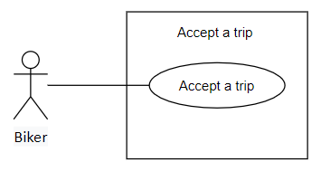

|  |  |  |  |  |  |  |
| --- | --- | --- | --- | --- | --- | --- |
| ID and Name: | **UC-66. Accept A Trip** | | | | | |
| Created By: | TamNTT | | | Date Created: | | 25/9/2021 |
| Primary Actor: | Biker | | | Secondary Actors: | | N/A |
| Trigger: | | Biker sends a request to accept a trip | | | | |
| Description: | | This function allows Biker to accept trip | | | | |
| Preconditions: | | Biker has searched trips | | | | |
| Post-conditions: | | **Success**: Trip status changed, Keer received notification about his/her new partner  **Failure**: System shows error message | | | | |
| Normal Flow: | | Step | Actor Action | | System Response | |
| 1 | User taps on a trip and taps “Accept” button | | System calls API to change trip status to matched. If success, system shows success message: “You have accepted this trip”, and send a notification to Keer about their new partner [Exception 1] | |
| Alternative Flows: | | N/A | | | | |
| Exceptions: | | No | Cause | | System Response | |
| 1 |  | | System shows error message: “There are some errors, please try again later or contact Biiké development team for support” when the Azure server return error response | |
| Priority: | | High | | | | |
| Frequency of Use: | | Regularly | | | | |
| Business Rules: | | **BR-139:** One trip can only be accepted by one Biker | | | | |
| Other Information: | | In case of Internet connection failure, Biker will not be able to accept trip | | | | |
| Assumptions: | | Internet Connection is available | | | | |

* + 1. **Mark as completed**

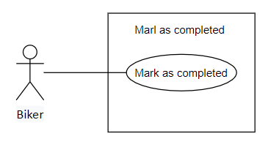

|  |  |  |  |  |  |
| --- | --- | --- | --- | --- | --- |
| ID and Name: | **UC-67. Mark as completed** | | | | |
| Created By: | TamNTT | | Date Created: | | 25/9/2021 |
| Primary Actor: | Biker | | Secondary Actors: | | N/A |
| Trigger: | Biker sends a request to complete a trip | | | | |
| Description: | This function allows Biker to change the trip status to completed | | | | |
| Preconditions: | Biker is on view trip details page | | | | |
| Post-conditions: | **Success**: Trip status changed, system redirects to feedback page  **Failure**: System shows error message | | | | |
| Normal Flow: | Step | Actor Action | | System Response | |
| 1 | Biker taps “Complete trip” button | | System redirects to feedback page [Exception 1] [Exception 2] | |
| Alternative Flows: | N/A | | | | |
| Exceptions: | No | Cause | | System Response | |
| 1 | Biker and Keer location are not matched with the booking arrived location | | Show a pop-up that Biker will not receive points when completing the trip | |
| 2 |  | | System shows error message: “There are some errors, please try again later or contact Biiké development team for support” when the Azure server return error response | |
| Priority: | High | | | | |
| Frequency of Use: | Regularly | | | | |
| Business Rules: | **BR-40:** User must turn on GPS location on device and grant location permission to the mobile application.  **BR-140:** Biker and Keer location can have a distance of maximum 500m compare to the booking arrived location | | | | |
| Other Information: | In case of Internet connection failure, user will not be able to complete trip | | | | |
| Assumptions: | Internet Connection is available | | | | |

* + 1. **Notify user**

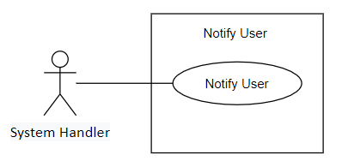

|  |  |  |  |  |  |
| --- | --- | --- | --- | --- | --- |
| ID and Name: | **UC-68. Notify User** | | | | |
| Created By: | TrieuDPH | | Date Created: | | 25/9/2021 |
| Primary Actor: | System Handler | | Secondary Actors: | | N/A |
| Trigger: | System sends user notification | | | | |
| Description: | This feature allows system to notify users via notification | | | | |
| Preconditions: | System handler | | | | |
| Post-conditions: | **Success**: User received notification  **Failure**: System shows error message | | | | |
| Normal Flow: | Step | Actor Action | | System Response | |
| 1 | System handler sends user notification | | Notification sent to user | |
| Alternative Flows: | N/A | | | | |
| Exceptions: | N/A | | | | |
| Priority: | Medium | | | | |
| Frequency of Use: | Regularly | | | | |
| Business Rules: | N/A | | | | |
| Other Information: | N/A | | | | |
| Assumptions: | Internet Connection is available | | | | |

* + 1. **View report**

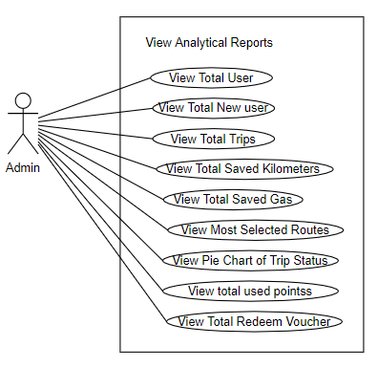

|  |  |  |  |  |  |
| --- | --- | --- | --- | --- | --- |
| ID and Name: | **UC-69. View Report** | | | | |
| Created By: | PhatDH | | Date Created: | | 25/9/2021 |
| Primary Actor: | Admin | | Secondary Actors: | | N/A |
| Trigger: | The actor wants View reports | | | | |
| Description: | This feature allow users to View reports | | | | |
| Preconditions: | User has logged into Admin Application | | | | |
| Post-conditions: | **Success**: reports will be displayed on screen  **Failure**: System shows error message | | | | |
| Normal Flow: | Step | Actor Action | | System Response | |
| 1 | Actor goes to main page of Admin Application | | Reports will be displayed on screen | |
| Alternative Flows: | N/A | | | | |
| Exceptions: | N/A | | | | |
| Priority: | Medium | | | | |
| Frequency of Use: | Usually | | | | |
| Business Rules: | **BR-109:** New user in report is number of new users in the current month | | | | |
| Other Information: | N/A | | | | |
| Assumptions: | Internet Connection is available | | | | |

* + 1. **Download report**

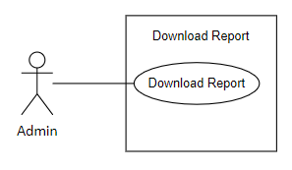

|  |  |  |  |  |  |
| --- | --- | --- | --- | --- | --- |
| ID and Name: | **UC-70. Download Report** | | | | |
| Created By: | PhatDH | | Date Created: | | 25/9/2021 |
| Primary Actor: | Admin | | Secondary Actors: | | N/A |
| Trigger: | Admin click down load report button | | | | |
| Description: | This function allows admin to download and view report on admin’s device offline | | | | |
| Preconditions: | User has logged into Admin Application | | | | |
| Post-conditions: | **Success**: reports will be displayed on screen  **Failure**: System shows error message | | | | |
| Normal Flow: | Step | Actor Action | | System Response | |
| 1 | Admin click “download report” button | | Report downloaded | |
| Alternative Flows: | N/A | | | | |
| Exceptions: | N/A | | | | |
| Priority: | Medium | | | | |
| Frequency of Use: | Normally/Generally | | | | |
| Business Rules: | **BR-74:** Admin can download report with pdf format  **BR-75:** Admin can download report with data that shown on dashboard screen | | | | |
| Other Information: | N/A | | | | |
| Assumptions: | Internet Connection is available  Admin’s device support Microsoft or any platform to view report | | | | |

* + 1. **View wallet transaction**

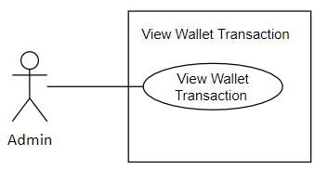

|  |  |  |  |  |  |
| --- | --- | --- | --- | --- | --- |
| ID and Name: | **UC-71. View Wallet Transaction** | | | | |
| Created By: | PhatDH | | Date Created: | | 25/9/2021 |
| Primary Actor: | Admin | | Secondary Actors: | | N/A |
| Trigger: | Admin click Wallet transaction tab on main screen’s menu | | | | |
| Description: | This function allows admin to view all wallet transactions | | | | |
| Preconditions: | User has logged into Admin Application | | | | |
| Post-conditions: | **Success**: wallet transaction will be displayed on screen  **Failure**: System shows error message | | | | |
| Normal Flow: | Step | Actor Action | | System Response | |
| 1 | Admin click “Wallet transaction” button | | Wallet transactions displayed on screen | |
| Alternative Flows: | N/A | | | | |
| Exceptions: | N/A | | | | |
| Priority: | Medium | | | | |
| Frequency of Use: | Usually | | | | |
| Business Rules: | N/A | | | | |
| Other Information: | N/A | | | | |
| Assumptions: | Internet Connection is available | | | | |

* + 1. **View trip list**

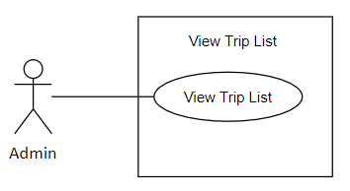

|  |  |  |  |  |  |
| --- | --- | --- | --- | --- | --- |
| ID and Name: | **UC-72. View Trip List** | | | | |
| Created By: | PhatDH | | Date Created: | | 25/9/2021 |
| Primary Actor: | Admin | | Secondary Actors: | | N/A |
| Trigger: | Admin click “Trip” button on main screen menu | | | | |
| Description: | This function allows admin to view list of user’s trips | | | | |
| Preconditions: | User has logged into Admin Application | | | | |
| Post-conditions: | **Success**: trip list will be displayed on screen  **Failure**: System shows error message | | | | |
| Normal Flow: | Step | Actor Action | | System Response | |
| 1 | Admin click “Trip” button | | List of trips displayed on screen | |
| Alternative Flows: | N/A | | | | |
| Exceptions: | N/A | | | | |
| Priority: | Medium | | | | |
| Frequency of Use: | Usually | | | | |
| Business Rules: | N/A | | | | |
| Other Information: | N/A | | | | |
| Assumptions: | Internet Connection is available | | | | |

* + 1. **View feedback**

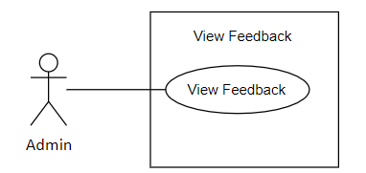

|  |  |  |  |  |  |
| --- | --- | --- | --- | --- | --- |
| ID and Name: | **UC-73. View Feedback** | | | | |
| Created By: | PhatDH | | Date Created: | | 25/9/2021 |
| Primary Actor: | Admin | | Secondary Actors: | | N/A |
| Trigger: | The actor want to view all feedback from trip | | | | |
| Description: | This feature allows users to view all feedbacks from user in trip | | | | |
| Preconditions: | User has logged into Admin Application | | | | |
| Post-conditions: | **Success**: User will be redirect to view feedback page  **Failure**: System shows error message | | | | |
| Normal Flow: | Step | Actor Action | | System Response | |
| 1 | Actor click “Feedback” tab on “User” list on menu | | System redirects to View Feedback page, list of feedbacks will be displayed | |
| Alternative Flows: | N/A | | | | |
| Exceptions: | N/A | | | | |
| Priority: | Medium | | | | |
| Frequency of Use: | Usually | | | | |
| Business Rules: | N/A | | | | |
| Other Information: | N/A | | | | |
| Assumptions: | Internet Connection is available | | | | |

* + 1. **View Biker & Keer**

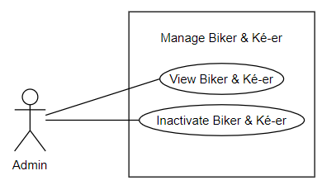

|  |  |  |  |  |  |
| --- | --- | --- | --- | --- | --- |
| ID and Name: | **UC-74. View biker & Keer** | | | | |
| Created By: | PhatDH | | Date Created: | | 25/9/2021 |
| Primary Actor: | Admin | | Secondary Actors: | | N/A |
| Trigger: | The actor wants view list of all users | | | | |
| Description: | This feature allow users to view list of all users | | | | |
| Preconditions: | User has logged into Admin Application | | | | |
| Post-conditions: | **Success**: List users will be displayed on screen  **Failure**: System shows error message | | | | |
| Normal Flow: | Step | Actor Action | | System Response | |
| 1 | Actor press “Biker & Keer” button on Người dùng menu | | Redirect to List Users Screen | |
| Alternative Flows: | N/A | | | | |
| Exceptions: | N/A | | | | |
| Priority: | Medium | | | | |
| Frequency of Use: | Usually | | | | |
| Business Rules: | N/A | | | | |
| Other Information: | N/A | | | | |
| Assumptions: | Internet Connection is available | | | | |

* + 1. **Inactive customer**



|  |  |  |  |  |  |
| --- | --- | --- | --- | --- | --- |
| ID and Name: | **UC-75. Inactive Customer** | | | | |
| Created By: | PhatDH | | Date Created: | | 25/9/2021 |
| Primary Actor: | Admin | | Secondary Actors: | | N/A |
| Trigger: | The actor send update user status request | | | | |
| Description: | This feature allow admin to update Biiké user status | | | | |
| Preconditions: | User has logged into Admin Application | | | | |
| Post-conditions: | **Success**: The Biiké user status will be updated  **Failure**: System shows error message | | | | |
| Normal Flow: | Step | Actor Action | | System Response | |
| 1 | Actor press “Update user status” button | | System show pop up “Are you sure to change this user status” | |
| 2 | Actor press “Yes” option | | Biiké user status will be updated. [Alternative 1] | |
| Alternative Flows: | No | Actor Action | | System Response | |
| 1 | Actor press “No” option | | Redirect to View user page | |
| Exception: | N/A | | | | |
| Priority: | Medium | | | | |
| Frequency of Use: | Occasionally | | | | |
| Business Rules: | **BR-76:** After admin lock a user, that user's account can no longer use Biiké's service anymore until be unlocked  **BR-77:** Admin can unlock a user to restore user's right and data when using Biiké application | | | | |
| Other Information: | N/A | | | | |
| Assumptions: | Internet Connection is available | | | | |

* + 1. **View route**

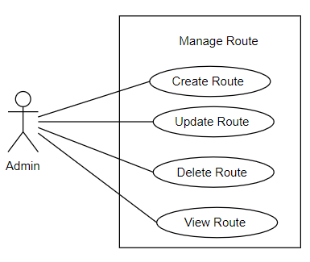

|  |  |  |  |  |  |
| --- | --- | --- | --- | --- | --- |
| ID and Name: | **UC-76. View Route** | | | | |
| Created By: | PhatDH | | Date Created: | | 25/9/2021 |
| Primary Actor: | Admin | | Secondary Actors: | | N/A |
| Trigger: | The actor sends view route request | | | | |
| Description: | This feature allow admin to view routes lists | | | | |
| Preconditions: | User has logged into Admin application | | | | |
| Post-conditions: | **Success**: Redirected to Route view screen  **Failure**: System shows error message | | | | |
| Normal Flow: | Step | Step | | System Response | |
| 1 | Actor clicks “View” on a route | | Show a pop up include route information | |
| Alternative Flows: | N/A | | | | |
| Exceptions: | N/A | | | | |
| Priority: | Medium | | | | |
| Frequency of Use: | Usually | | | | |
| Business Rules: | N/A | | | | |
| Other Information: | N/A | | | | |
| Assumptions: | Internet Connection is available | | | | |

* + 1. **Add route**



|  |  |  |  |  |  |
| --- | --- | --- | --- | --- | --- |
| ID and Name: | **UC-77. Add Route** | | | | |
| Created By: | PhatDH | | Date Created: | | 25/9/2021 |
| Primary Actor: | Admin | | Secondary Actors: | | N/A |
| Trigger: | The actor sends create add request | | | | |
| Description: | This feature allow users to add route for Biiké application | | | | |
| Preconditions: | User has logged into Admin Application | | | | |
| Post-conditions: | **Success**: New route will be created  **Failure**: System informs “This route cannot be created” | | | | |
| Normal Flow: | Step | Actor Action | | System Response | |
| 1 | Actor Clicks “Add route” button | | Create route screen is popped up on screen with following fields:  Area: Drop Down List  Departure station: Dropdown List  Destination station: Dropdown List  Default Point: Blank Box | |
| 2 | Actor fill new route information | |  | |
| 3 | Actor press “Add route” button | | New route added. [Alternative 1] [Exception1] | |
| Alternative Flows: | Step | Actor Action | | System Response | |
| 1 | Actor press “Cancel” button | | Redirect to review Route page | |
| Exceptions: | No | Cause | | System Response | |
| 1 | The route address is already existed | | System inform “This route is already existed” | |
| Priority: | Medium | | | | |
| Frequency of Use: | Occasionally | | | | |
| Business Rules: | **BR-105:** All field is required, if any field is blank, when user click submit button, a message is shown: "Please fill enough data"  **BR-110:** A route must contain one station that is central point of area  **BR-111:** Default point is relate to the distance from departure point to destination point follow the formula: 1 kilometer equal to 2 points | | | | |
| Other Information: | N/A | | | | |
| Assumptions: | Internet Connection is available | | | | |

* + 1. **Update route**



|  |  |  |  |  |  |  |
| --- | --- | --- | --- | --- | --- | --- |
| ID and Name: | **UC-78. Update Route** | | | | | |
| Created By: | PhatDH | | | Date Created: | | 25/9/2021 |
| Primary Actor: | Admin | | | Secondary Actors: | | N/A |
| Trigger: | The actor send update route request | | | | | |
| Description: | This feature allow users to update route for Biiké application | | | | | |
| Preconditions: | User has logged into Admin Application | | | | | |
| Post-conditions: | **Success**: new route information will be updated  **Failure**: System informs “This route cannot be updated” | | | | | |
| Normal Flow: | Step | Actor Action | | | System Response | |
| 1 | Actor press on a route card | | | Update route screen í popped up on screen with following fields:  Area: Dropdown List  Departure Point: Dropdown List  Destination: Dropdown List  Default Point: Blank Box | |
| 2 | Actor edit route information | | |  | |
| 3 | Actor press “Save” button | | | New route information saved [Alternative 1] [Exception1] | |
| Alternative Flows: | Step | | Actor Action | | System Response | |
| 1 | | Actor press “Cancel” button | | Redirect to review Route page | |
| Exceptions: | No | Cause | | | System Response | |
| 1 | The route information is already existed | | | System inform “This route already existed” | |
| Priority: | Medium | | | | | |
| Frequency of Use: | Seldom | | | | | |
| Business Rules: | **BR-105:** All field is required, if any field is blank, when user click submit button, a message is shown: "Please fill enough data"  **BR-110:** A route must contain one station that is central point of area  **BR-111:** Default point is relate to the distance from departure point to destination point follow the formula: 1 kilometer equal to 2 points | | | | | |
| Other Information: | N/A | | | | | |
| Assumptions: | Internet Connection is available | | | | | |

* + 1. **Delete route**



|  |  |  |  |  |  |
| --- | --- | --- | --- | --- | --- |
| ID and Name: | **UC-79. Delete Route** | | | | |
| Created By: | PhatDH | | Date Created: | | 25/9/2021 |
| Primary Actor: | Admin | | Secondary Actors: | | N/A |
| Trigger: | The actor send delete route request | | | | |
| Description: | This feature allow users to delete route for Biiké application | | | | |
| Preconditions: | User has logged into Admin Application | | | | |
| Post-conditions: | **Success**: Route is deleted  **Failure**: System informs “This route cannot be deleted” | | | | |
| Normal Flow: | Step | Actor Action | | System Response | |
| 1 | Actor press “Delete” button | | System show pop up “Are you sure to delete this route?” | |
| 2 | Actor press “Yes” | | The route deleted. [Alternative 1] | |
| Alternative Flows: | No | Cause | | System Response | |
| 1 | Actor press “Cancel” | | Redirect to View route page | |
| Exceptions: | N/A | | | | |
| Priority: | Medium | | | | |
| Frequency of Use: | Occasionally | | | | |
| Business Rules: | N/A | | | | |
| Other Information: | N/A | | | | |
| Assumptions: | Internet Connection is available | | | | |

* + 1. **View area**

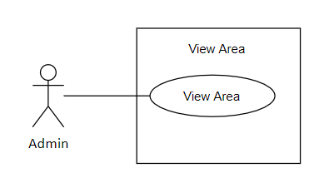

|  |  |  |  |  |  |
| --- | --- | --- | --- | --- | --- |
| ID and Name: | **UC-80. View Area** | | | | |
| Created By: | PhatDH | | Date Created: | | 25/9/2021 |
| Primary Actor: | Admin | | Secondary Actors: | | N/A |
| Trigger: | Admin goes to Area screen | | | | |
| Description: | This function allow admin to view area | | | | |
| Preconditions: | User logged into Admin application | | | | |
| Post-conditions: | **Success**: redirect to Area page  **Failure**: System shows error message | | | | |
| Normal Flow: | Step | Actor Action | | System Response | |
| 1 | Actor press “Area” button on “Movement” list on menu | | Redirect to Area page | |
| Alternative Flows: | N/A | | | | |
| Exceptions: | N/A | | | | |
| Priority: | Medium | | | | |
| Frequency of Use: | Seldom | | | | |
| Business Rules: | N/A | | | | |
| Other Information: | N/A | | | | |
| Assumptions: | Internet Connection is available | | | | |

* + 1. **View station**

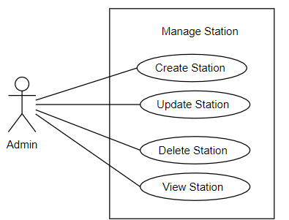

|  |  |  |  |  |  |
| --- | --- | --- | --- | --- | --- |
| ID and Name: | **UC-81. View Station** | | | | |
| Created By: | PhatDH | | Date Created: | | 25/9/2021 |
| Primary Actor: | Admin | | Secondary Actors: | | N/A |
| Trigger: | The actor sends view station request | | | | |
| Description: | This feature allow admin to view station lists | | | | |
| Preconditions: | User has logged into Admin Application | | | | |
| Post-conditions: | **Success**: Redirected to station view screen  **Failure**: System shows error message | | | | |
| Normal Flow: | Step | Actor Action | | System Response | |
| 1 | Actor Clicks “View” button on station card | | Redirect to View station screen | |
| Alternative Flows: | N/A | | | | |
| Exceptions: | N/A | | | | |
| Priority: | Medium | | | | |
| Frequency of Use: | Usually | | | | |
| Business Rules: | N/A | | | | |
| Other Information: | N/A | | | | |
| Assumptions: | Internet Connection is available | | | | |

* + 1. **Add station**



|  |  |  |  |  |  |
| --- | --- | --- | --- | --- | --- |
| ID and Name: | **UC-82. Add Station** | | | | |
| Created By: | PhatDH | | Date Created: | | 25/9/2021 |
| Primary Actor: | Admin | | Secondary Actors: | | N/A |
| Trigger: | The actor send create station request | | | | |
| Description: | This feature allow users to create station for Biiké application | | | | |
| Preconditions: | User has logged into Admin Application | | | | |
| Post-conditions: | **Success**: new station will be created  **Failure**: System informs “This station created fail” | | | | |
| Normal Flow: | Step | Actor Action | | System Response | |
| 1 | Actor press “Add station” button | | Create station page popped up on screen with following information: Name, Coordinates, Address, Area | |
| 2 | Actor fill new station information | |  | |
| 3 | Actor press “Add station” button | | New station added. [Alternative 1] [Exception1] | |
| Alternative Flows: | Step | Actor Action | | System Response | |
| 1 | Actor press “Cancel” button | | Redirect to review Station page | |
| Exceptions: | No | Cause | | System Response | |
| 1 | The station address is already existed | | System inform “This station already existed” | |
| Priority: | Medium | | | | |
| Frequency of Use: | Occasionally | | | | |
| Business Rules: | **BR-105:** All field is required, if any field is blank, when user click submit button, a message is shown: "Please fill enough data"  **BR-112:** First station is created is central point | | | | |
| Other Information: | N/A | | | | |
| Assumptions: | Internet Connection is available | | | | |

* + 1. **Update station**



|  |  |  |  |  |  |  |  |  |
| --- | --- | --- | --- | --- | --- | --- | --- | --- |
| ID and Name: | **UC-83. Update Station** | | | | | | | |
| Created By: | PhatDH | | Date Created: | | | 25/9/2021 | | |
| Primary Actor: | Admin | | Secondary Actors: | | | N/A | | |
| Trigger: | The actor send update station request | | | | | | | |
| Description: | This feature allow users to create station for Biiké application | | | | | | | |
| Preconditions: | User has logged into Admin Application | | | | | | | |
| Post-conditions: | **Success**: new station information is updated  **Failure**: System informs “This station cannot be updated” | | | | | | | |
| Normal Flow: | Step | Actor Action | | System Response | | |
| 1 | Actor press “Chỉnh sửa trạm” button | | Create station page popped up on screen with following information: Name, Coordinates, Address, Area | | |
| 2 | Actor fill update station information | |  | | |
| 3 | Actor press “Save” button | | New station information saved [Alternative 1] [Exception1] | | |
| Alternative Flows: | Step | Actor Action | | | System Response | | |
| 1 | Actor press “Cancel” button | | | Redirect to view Station page | | |
| Exceptions: | No | Cause | | System Response | | |
| 1 | The station update information is duplicated | | System inform “This station already existed” | | |
| Priority: | Medium | | | | | | | |
| Frequency of Use: | Sometimes | | | | | | | |
| Business Rules: | **BR-105:** All field is required, if any field is blank, when user click submit button, a message is shown: "Please fill enough data"  **BR-114:** Station that is central point can be update only when there are no activated station else | | | | | | | |
| Other Information: | N/A | | | | | | | |
| Assumptions: | Internet Connection is available | | | | | | | |

* + 1. **Delete station**



|  |  |  |  |  |  |
| --- | --- | --- | --- | --- | --- |
| ID and Name: | **UC-84. Delete Station** | | | | |
| Created By: | PhatDH | | Date Created: | | 25/9/2021 |
| Primary Actor: | Admin | | Secondary Actors: | | N/A |
| Trigger: | The actor send delete station request | | | | |
| Description: | This feature allow users to delete station | | | | |
| Preconditions: | User has logged into Admin Application | | | | |
| Post-conditions: | **Success**: Station will be deleted  **Failure**: System shows error message | | | | |
| Normal Flow: | Step | Actor Action | | System Response | |
| 1 | Actor press “Delete” button | | System show pop up “Are you sure to delete this station?” | |
| 2. | Actor press “Yes” option | | The station is deleted  [Alternative 1] | |
| Alternative Flows: | No | Cause | | System Response | |
| 1 | Actor press “Cancel” option | | Redirect to view station page | |
| Exceptions: | N/A | | | | |
| Priority: | Medium | | | | |
| Frequency of Use: | Occasionally | | | | |
| Business Rules: | **BR-113:** Station that is central point cannot be deleted  **BR-115:** Station cannot be delete if there is a active route has that station | | | | |
| Other Information: | N/A | | | | |
| Assumptions: | Internet Connection is available | | | | |

* + 1. **View voucher**

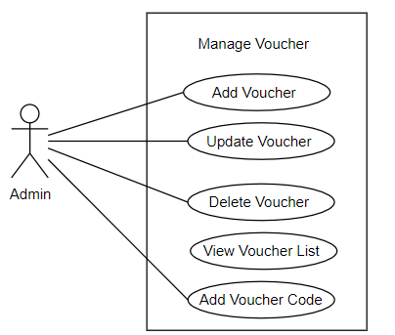

|  |  |  |  |  |  |
| --- | --- | --- | --- | --- | --- |
| ID and Name: | **UC-85. View Voucher** | | | | |
| Created By: | PhatDH | | Date Created: | | 25/9/2021 |
| Primary Actor: | Admin | | Secondary Actors: | | N/A |
| Trigger: | The actor sends view voucher request | | | | |
| Description: | This feature allow admin to view voucher lists | | | | |
| Preconditions: | User has logged into Admin Application | | | | |
| Post-conditions: | **Success**: Redirected to voucher view screen  **Failure**: System shows error message | | | | |
| Normal Flow: | Step | Step | | System Response | |
| 1 | Actor Clicks “”Voucher” button | | Redirect to View voucher screen | |
| Alternative Flows: | N/A | | | | |
| Exceptions: | N/A | | | | |
| Priority: | Medium | | | | |
| Frequency of Use: | Usually | | | | |
| Business Rules: | **BR-95:** Voucher provided by sponsor store/company. voucher code is added on store/company system. Sponsor unit provide list of voucher code to Admin, admin add those codes to application system  **BR-116:** Voucher must have voucher code list to be redeem by user  **BR-117:** Point ro redeem must bigger than 0  **BR-118:** If end time is in the past, voucher is no available in mobile app voucher list  **BR-121:** If voucher has address, the vouchers with address that nearest to customer will ne shown on user home page in mobile app  **BR-122:** Voucher has no address will be shown on the top of voucher list when user tap "Near me" on voucher page | | | | |
| Other Information: | N/A | | | | |
| Assumptions: | Internet Connection is available | | | | |

* + 1. **Add voucher**



|  |  |  |  |  |  |
| --- | --- | --- | --- | --- | --- |
| ID and Name: | **UC-86. Add Voucher** | | | | |
| Created By: | PhatDH | | Date Created: | | 25/9/2021 |
| Primary Actor: | Admin | | Secondary Actors: | | N/A |
| Trigger: | The actor sends create voucher request | | | | |
| Description: | This feature allow users to add voucher for Biiké application | | | | |
| Preconditions: | User has logged into Admin Application | | | | |
| Post-conditions: | **Success**: new voucher will be created  **Failure**: System informs “Create voucher fail” | | | | |
| Normal Flow: | Step | Actor Action | | System Response | |
| 1 | Actor Clicks “Add Voucher” button | | Create Voucher screen popped up on screen with following fields:  Voucher name, Voucher code, brand, available time, points, description, term of use | |
| 2 | Admin enter voucher information | |  | |
| 3 | Admin click “Add voucher” button | | New Voucher added [Alternative 1] | |
| Alternative Flows: | Step | | Actor Action | System Response | |
|  | | Admin click “Cancel” button | Redirect to View Voucher screen | |
| Exceptions: | N/A | | | | |
| Priority: | Medium | | | | |
| Frequency of Use: | Normally/Generally | | | | |
| Business Rules: | **BR-95:** Voucher provided by sponsor store/company. voucher code is added on store/company system. Sponsor unit provide list of voucher code to Admin, admin add those codes to application system  **BR-116:** Voucher must have voucher code list to be redeem by user  **BR-117:** Point ro redeem must bigger than 0  **BR-118:** If end time is in the past, voucher is no available in mobile app voucher list  **BR-119:** All field is required except address, if any field left is blank, when user click submit button, a message is shown: "Please fill enough data" in every field that is missing  **BR-121:** If voucher has address, the vouchers with address that nearest to customer will ne shown on user home page in mobile app  **BR-122:** Voucher has no address will be shown on the top of voucher list when user tap "Near me" on voucher page | | | | |
| Other Information: | N/A | | | | |
| Assumptions: | Internet Connection is available | | | | |

* + 1. **Add voucher code**



|  |  |  |  |  |
| --- | --- | --- | --- | --- |
| ID and Name: | **UC-87. Add Voucher Code** | | | |
| Created By: | PhatDH | Date Created: | | 25/9/2021 |
| Primary Actor: | Admin | Secondary Actors: | | N/A |
| Trigger: | The actor sends add voucher code request | | | |
| Description: | This feature allow users to add voucher code for Biiké application | | | |
| Preconditions: | User has logged into Admin Application | | | |
| Post-conditions: | **Success**: new voucher code will be created  **Failure**: System informs “This voucher cannot be created” | | | |
| Normal Flow: | Step | Actor Action | System Response | |
| 1 | Actor Clicks “Code” button on a voucher | Create voucher code page popped up on screen with following fields:  Voucher code: blank text field | |
| 2 | Admin enter voucher code |  | |
| 3 | Admin click “Add” button | New Voucher code added [Alternative 1] [Exception1] | |
| Alternative Flows: | Step | Actor Action | System Response | |
| 1 | Admin click “Cancel” button | Redirect to view voucher code screen | |
| Exceptions: | No | Cause | System Response | |
| 1 | Voucher code is duplicated | System show error message | |
| Priority: | Medium | | | |
| Frequency of Use: | Normally/Generally | | | |
| Business Rules: | **BR-95:** Voucher provided by sponsor store/company. voucher code is added on store/company system. Sponsor unit provide list of voucher code to Admin, admin add those codes to application system  **BR-116:** Voucher must have voucher code list to be redeem by user  **BR-120:** If there is no voucher code, voucher will not be shown on user mobile app | | | |
| Other Information: | N/A | | | |
| Assumptions: | Internet Connection is available | | | |

* + 1. **Update voucher**



|  |  |  |  |  |  |
| --- | --- | --- | --- | --- | --- |
| ID and Name: | **UC-88. Update Voucher** | | | | |
| Created By: | PhatDH | | Date Created: | | 25/9/2021 |
| Primary Actor: | Admin | | Secondary Actors: | | N/A |
| Trigger: | The actor send update voucher request | | | | |
| Description: | This feature allow users to update voucher for Biiké application | | | | |
| Preconditions: | User has logged into Admin Application | | | | |
| Post-conditions: | **Success**: new voucher information will be updated  **Failure**: System informs “This voucher cannot be updated” | | | | |
| Normal Flow: | Step | Actor Action | | System Response | |
| 1 | Actor press “View” on a voucher button | | Update Voucher screen popped up on screen with following fields:  Voucher Name, Voucher code, brand, available time, points, description, term of use | |
| 2 | Actor fill update voucher information | |  | |
| 3 | Actor press “Save” button | | New voucher information saved [Alternative 1] [Exception1] | |
| Alternative Flows: | Step | Actor Action | | System Response | |
| 1 | Actor press “Cancel” button | | Redirect to review voucher page | |
| Exceptions: | No | Cause | | System Response | |
| 1 | The voucher information is already existed | | System inform “This voucher already existed” | |
| Priority: | Medium | | | | |
| Frequency of Use: | Normally/Generally | | | | |
| Business Rules: | **BR-95:** Voucher provided by sponsor store/company. voucher code is added on store/company system. Sponsor unit provide list of voucher code to Admin, admin add those codes to application system  **BR-116:** Voucher must have voucher code list to be redeem by user  **BR-117:** Point ro redeem must bigger than 0  **BR-118:** If end time is in the past, voucher is no available in mobile app voucher list  **BR-119:** All field is required except address, if any field left is blank, when user click submit button, a message is shown: "Please fill enough data" in every field that is missing  **BR-121:** If voucher has address, the vouchers with address that nearest to customer will ne shown on user home page in mobile app  **BR-122:** Voucher has no address will be shown on the top of voucher list when user tap "Near me" on voucher page | | | | |
| Other Information: | N/A | | | | |
| Assumptions: | Internet Connection is available | | | | |

* + 1. **Delete voucher**



|  |  |  |  |  |  |
| --- | --- | --- | --- | --- | --- |
| ID and Name: | **UC-89. Delete Voucher** | | | | |
| Created By: | PhatDH | | Date Created: | | 25/9/2021 |
| Primary Actor: | Admin | | Secondary Actors: | | N/A |
| Trigger: | The actor send delete Voucher request | | | | |
| Description: | This feature allow users to delete Voucher for Biiké application | | | | |
| Preconditions: | User has logged into Admin Application | | | | |
| Post-conditions: | **Success**: selected Voucher will be deleted  **Failure**: System informs “This Voucher cannot be deleted” | | | | |
| Normal Flow: | Step | Actor Action | | System Response | |
| 1 | Actor press “Delete” button | | System show pop up “Are you sure to delete this Voucher?” | |
| 2 | Actor press “Yes” | | The Voucher deleted. [Alternative 1] | |
| Alternative Flows: | Step | Actor Action | | System Response | |
| 1 | Actor press “Cancel” | | Redirect to View Voucher page | |
| Exceptions: | N/A | | | | |
| Priority: | Medium | | | | |
| Frequency of Use: | Regularly | | | | |
| Business Rules: | N/A | | | | |
| Other Information: | N/A | | | | |
| Assumptions: | Internet Connection is available | | | | |

* + 1. **Add voucher category**

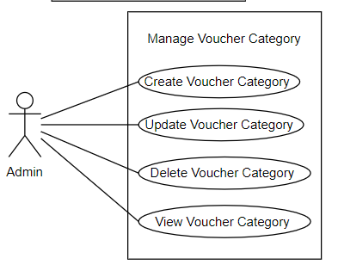

|  |  |  |  |  |  |  |  |
| --- | --- | --- | --- | --- | --- | --- | --- |
| ID and Name: | **UC-90. Add Voucher** **category** | | | | | | |
| Created By: | PhatDH | | Date Created: | | | | 25/9/2021 |
| Primary Actor: | Admin | | Secondary Actors: | | | | N/A |
| Trigger: | The actor sends create vouchercategory request | | | | | | |
| Description: | This feature allow users to add voucher category for Biiké application | | | | | | |
| Preconditions: | User has logged into Admin Application | | | | | | |
| Post-conditions: | **Success**: new voucher category will be created  **Failure**: System informs “This voucher category cannot be created” | | | | | | |
| Normal Flow: | Step | | | Actor Action | | System Response | |
| 1 | | | Actor Clicks “Add voucher category” button | | Create Voucher Category screen is popped up with following fields: Voucher Category’s name: blank text field | |
| 2 | | | Admin enter voucher category name | |  | |
| 3 | | | Admin click “Add voucher category” button | | New Voucher category added | |
| Alternative Flows: | N/A | | | | | | |
| Exceptions: | Step | Actor Action | | | System Response | | |
| 1 | Voucher Category added is duplicated | | | System show error mesgae | | |
| Priority: | Medium | | | | | | |
| Frequency of Use: | Seldom | | | | | | |
| Business Rules: | N/A | | | | | | |
| Other Information: | N/A | | | | | | |
| Assumptions: | Internet Connection is available | | | | | | |

* + 1. **View voucher category**



|  |  |  |  |  |  |
| --- | --- | --- | --- | --- | --- |
| ID and Name: | **UC-91. View Voucher** **category** | | | | |
| Created By: | PhatDH | | Date Created: | | 25/9/2021 |
| Primary Actor: | Admin | | Secondary Actors: | | N/A |
| Trigger: | The actor sends view vouchercategory request | | | | |
| Description: | This feature allow admin to view voucher category lists | | | | |
| Preconditions: | User has logged into Admin Application | | | | |
| Post-conditions: | **Success**: Redirected to voucher category view screen  **Failure**: System shows error message | | | | |
| Normal Flow: | Step | Step | | System Response | |
| 1 | Actor Clicks “View” button | | Redirect to View voucher category screen | |
| Alternative Flows: |  | | | | |
| Exceptions: | N/A | | | | |
| Priority: | Medium | | | | |
| Frequency of Use: | Seldom | | | | |
| Business Rules: | N/A | | | | |
| Other Information: | N/A | | | | |
| Assumptions: | Internet Connection is available | | | | |

* + 1. **Update voucher category**

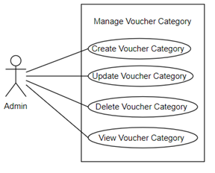

|  |  |  |  |  |  |  |  |
| --- | --- | --- | --- | --- | --- | --- | --- |
| ID and Name: | **UC-92. Update Voucher** **category** | | | | | | |
| Created By: | PhatDH | | Date Created: | | | | 25/9/2021 |
| Primary Actor: | Admin | | Secondary Actors: | | | | N/A |
| Trigger: | The actor sends update vouchercategory request | | | | | | |
| Description: | This feature allow users to add voucher category for Biiké application | | | | | | |
| Preconditions: | User has logged into Admin Application | | | | | | |
| Post-conditions: | **Success**: new voucher category will be updated  **Failure**: System informs “This voucher category cannot be created” | | | | | | |
| Normal Flow: | Step | | | Actor Action | | System Response | |
| 1 | | | Actor Clicks “View” button | | CreatUpdatee Voucher Category screen is popped up with following fields: Voucher Category’s name: blank text field | |
| 2 | | | Admin enter voucher category name | |  | |
| 3 | | | Admin click “Update” button | | Voucher category updated | |
| Alternative Flows: | N/A | | | | | | |
| Exceptions: | Step | Actor Action | | | System Response | | |
| 1 | Voucher Category added is duplicated | | | System show error mesgae | | |
| Priority: | Low | | | | | | |
| Frequency of Use: | Hardly ever / Rarely | | | | | | |
| Business Rules: | **BR-123:** All voucher category must have unique name  **BR-124:** If there is voucher have the voucher category admin is going to edit, admin still can update it and the voucher also have new voucher category name | | | | | | |
| Other Information: | N/A | | | | | | |
| Assumptions: | Internet Connection is available | | | | | | |

* + 1. **Delete voucher category**



|  |  |  |  |  |  |
| --- | --- | --- | --- | --- | --- |
| ID and Name: | **UC-93. Delete Voucher** **category** | | | | |
| Created By: | PhatDH | | Date Created: | | 25/9/2021 |
| Primary Actor: | Admin | | Secondary Actors: | | N/A |
| Trigger: | The actor send delete Vouchercategory request | | | | |
| Description: | This feature allow users to delete Voucher category for Biiké application | | | | |
| Preconditions: | User has logged into Admin Application | | | | |
| Post-conditions: | **Success**: selected Voucher category will be deleted  **Failure**: System informs “This Voucher category cannot be deleted” | | | | |
| Normal Flow: | Step | Actor Action | | System Response | |
| 1 | Actor press “Delete” button | | System show pop up “Are you sure to delete this Voucher category?” | |
| 2 | Actor press “Yes” | | The Voucher category deleted. [Alternative 1] | |
| Alternative Flows: | Step | Actor Action | | System Response | |
| 1 | Actor press “Cancel” | | Redirect to View Voucher category page | |
| Exceptions: | N/A | | | | |
| Priority: | Low | | | | |
| Frequency of Use: | Regularly | | | | |
| Business Rules: | **BR-125:** Admin cannot delete voucher category that there is a voucher saved with that category | | | | |
| Other Information: | N/A | | | | |
| Assumptions: | Internet Connection is available | | | | |

* + 1. **Add ads**

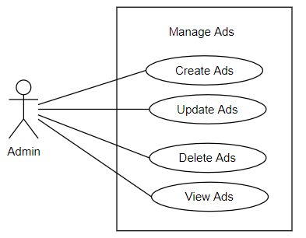

|  |  |  |  |  |  |  |  |  |
| --- | --- | --- | --- | --- | --- | --- | --- | --- |
| ID and Name: | **UC-94. Add ads** | | | | | | | |
| Created By: | PhatDH | Date Created: | | | | | | 25/9/2021 |
| Primary Actor: | Admin | Secondary Actors: | | | | | | N/A |
| Trigger: | The actor sends create ads request | | | | | | | |
| Description: | This feature allow users to add ads for Biiké application | | | | | | | |
| Preconditions: | User has logged into Admin Application | | | | | | | |
| Post-conditions: | **Success**: new ads will be created  **Failure**: System informs “This ads cannot be created” | | | | | | | |
| Normal Flow: | Step | | | Actor Action | | System Response | | |
| 1 | | | Actor Clicks “Add ads” button | | Create Ads page popped up on screen with following fields: Title, Appear option, brand, available time, link, location, banner picture | | |
| 2 | | | Admin enter ads information | |  | | |
| 3 | | | Admin click “Add ads” button | | New ads added. [Alternative 1] [Exception1] | | |
| Alternative Flows: | Step | | Actor Action | | System Response | | | |
| 1 | | Admin click “Cancel” button | | Redirect to view Ads screen | | | |
| Exceptions: | Step | Actor Action | | | | | System Response | |
| 1 | Ads added duplicated | | | | | System show error message | |
| Priority: | Medium | | | | | | | |
| Frequency of Use: | Usually | | | | | | | |
| Business Rules: | **BR-119:** All field is required except address, if any field left is blank, when user click submit button, a message is shown: "Please fill enough data" in every field that is missing  **BR-126:** If ads has address, the ads with address that nearest to customer will ne shown on user home page in mobile app  **BR-127:** Only ads with end time is not in the past can be shown on home page in mobile app | | | | | | | |
| Other Information: | N/A | | | | | | | |
| Assumptions: | Internet Connection is available | | | | | | | |

* + 1. **View ads**



|  |  |  |  |  |  |
| --- | --- | --- | --- | --- | --- |
| ID and Name: | **UC-95. View ads** | | | | |
| Created By: | PhatDH | | Date Created: | | 25/9/2021 |
| Primary Actor: | Admin | | Secondary Actors: | | N/A |
| Trigger: | The actor sends view ads request | | | | |
| Description: | This feature allow admin to view ads lists | | | | |
| Preconditions: | User has logged into Admin Application | | | | |
| Post-conditions: | **Success**: Redirected to ads view screen  **Failure**: System shows error message | | | | |
| Normal Flow: | Step | Step | | System Response | |
| 1 | Actor Clicks “View” button on ads bar | | Ads information screen popped up on screen | |
| Alternative Flows: | N/A | | | | |
| Exceptions: | N/A | | | | |
| Priority: | Medium | | | | |
| Frequency of Use: | Usually | | | | |
| Business Rules: | N/A | | | | |
| Other Information: | N/A | | | | |
| Assumptions: | Internet Connection is available | | | | |

* + 1. **Update ads**



|  |  |  |  |  |  |  |  |  |
| --- | --- | --- | --- | --- | --- | --- | --- | --- |
| ID and Name: | **UC-96. Add ads** | | | | | | | |
| Created By: | PhatDH | Date Created: | | | | | | 25/9/2021 |
| Primary Actor: | Admin | Secondary Actors: | | | | | | N/A |
| Trigger: | The actor sends create ads request | | | | | | | |
| Description: | This feature allow users to add ads for Biiké application | | | | | | | |
| Preconditions: | User has logged into Admin Application | | | | | | | |
| Post-conditions: | **Success**: new ads will be created  **Failure**: System informs “This ads cannot be created” | | | | | | | |
| Normal Flow: | Step | | | Actor Action | | System Response | | |
| 1 | | | Actor Clicks “View” button | | Update Ads page popped up on screen with following fields: Title, Appear option, brand, available time, link, location, banner picture | | |
| 2 | | | Admin enter ads information | |  | | |
| 3 | | | Admin click “Update” button | | New ads added. [Alternative 1] [Exception1] | | |
| Alternative Flows: | Step | | Actor Action | | System Response | | | |
| 1 | | Admin click “Cancel” button | | Redirect to view Ads screen | | | |
| Exceptions: | Step | Actor Action | | | | | System Response | |
| 1 | Ads updated duplicated | | | | | System show error message | |
| Priority: | Medium | | | | | | | |
| Frequency of Use: | Normally/Generally | | | | | | | |
| Business Rules: | **BR-119:** All field is required except address, if any field left is blank, when user click submit button, a message is shown: "Please fill enough data" in every field that is missing  **BR-126:** If ads has address, the ads with address that nearest to customer will ne shown on user home page in mobile app  **BR-127:** Only ads with end time is not in the past can be shown on home page in mobile app | | | | | | | |
| Other Information: | N/A | | | | | | | |
| Assumptions: | Internet Connection is available | | | | | | | |

* + 1. **Delete ads**



|  |  |  |  |  |  |
| --- | --- | --- | --- | --- | --- |
| ID and Name: | **UC-97. Delete ads** | | | | |
| Created By: | PhatDH | | Date Created: | | 25/9/2021 |
| Primary Actor: | Admin | | Secondary Actors: | | N/A |
| Trigger: | The actor send delete ads request | | | | |
| Description: | This feature allow users to delete ads for Biiké application | | | | |
| Preconditions: | User has logged into Admin Application | | | | |
| Post-conditions: | **Success**: selected ads will be deleted  **Failure**: System informs “This ads cannot be deleted” | | | | |
| Normal Flow: | Step | Actor Action | | System Response | |
| 1 | Actor press “Delete” button | | System show pop up “Are you sure to delete this ads?” | |
| 2 | Actor press “Yes” | | The ads deleted. [Alternative 1] | |
| Alternative Flows: | Step | Actor Action | | System Response | |
| 1 | Actor press “Cancel” | | Redirect to View ads page | |
| Exceptions: | N/A | | | | |
| Priority: | Medium | | | | |
| Frequency of Use: | Often / Frequently | | | | |
| Business Rules: | N/A | | | | |
| Other Information: | N/A | | | | |
| Assumptions: | Internet Connection is available | | | | |

* + 1. **Verify user’s bike**

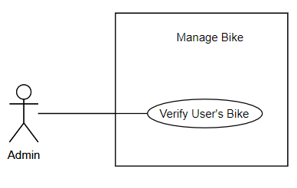

|  |  |  |  |  |  |
| --- | --- | --- | --- | --- | --- |
| ID and Name: | **UC-98. Verify User’s Bike** | | | | |
| Created By: | PhatDH | | Date Created: | | 25/9/2021 |
| Primary Actor: | Admin | | Secondary Actors: | | N/A |
| Trigger: | Actor click Verify Button | | | | |
| Description: | This function allows admin to verify Biker’s bike | | | | |
| Preconditions: | User has logged into Admin Application | | | | |
| Post-conditions: | **Success**: Bike verified  **Failure**: System shows error message | | | | |
| Normal Flow: | Step | Actor Action | | System Response | |
| 1 | Actor click Verify Button | | Bike Verified [Alternative 1] | |
| Alternative Flows: | Step | Actor Action | | System Response | |
| 1 | Actor click “Cancel” Button | | Bike verify is canceled | |
| Exceptions: | N/A | | | | |
| Priority: | Medium | | | | |
| Frequency of Use: | Usually | | | | |
| Business Rules: | **BE-128:** A bike that has been verified can be change verify status from vaid to invalid and vice versa | | | | |
| Other Information: | N/A | | | | |
| Assumptions: | Internet Connection is available | | | | |

* + 1. **Add admin**

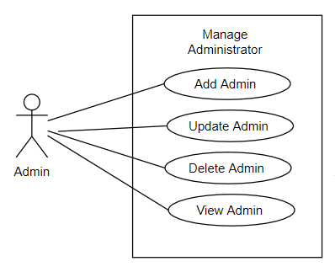

|  |  |  |  |  |  |  |  |
| --- | --- | --- | --- | --- | --- | --- | --- |
| ID and Name: | **UC-99. Add Admin** | | | | | | |
| Created By: | PhatDH | | Date Created: | | | | 25/9/2021 |
| Primary Actor: | Admin | | Secondary Actors: | | | | N/A |
| Trigger: | The actor sends Add Admin request | | | | | | |
| Description: | This feature allow users to add Admin for Biiké application | | | | | | |
| Preconditions: | User has logged into Admin Application | | | | | | |
| Post-conditions: | **Success**: new Admin will be added  **Failure**: System informs “Admin cannot be created” | | | | | | |
| Normal Flow: | Step | Actor Action | | | | System Response | |
| 1 | Admin click “Add admin” button | | | | Add admin screen is popped up with following fields:  Name, Phone Number, Email, Password | |
| 2 | Admin enter Admin information | | | |  | |
| 3 | Admin click “Add admin” button | | | | New Admin added. [Alternative 1] [Exception1] | |
| Alternative Flows: | Step | | Actor Action | | System Response | | |
| 1 | | Admin click “Cancel” button | | Redirect to view administrator screen | | |
| Exceptions: | Step | | | Actor Action | System Response | | |
| 1 | | | New Admin added duplicated | System show error message | | |
| Priority: | Medium | | | | | | |
| Frequency of Use: | Normally/Generally | | | | | | |
| Business Rules: | **BR-128 :** Only user that signed up to Biiké through mobile app can become admin | | | | | | |
| Other Information: | N/A | | | | | | |
| Assumptions: | Internet Connection is available | | | | | | |

* + 1. **View admin**

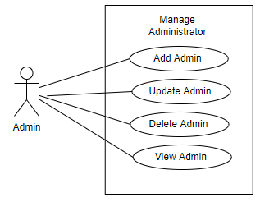

|  |  |  |  |  |  |
| --- | --- | --- | --- | --- | --- |
| ID and Name: | **UC-100. View Admin** | | | | |
| Created By: | PhatDH | | Date Created: | | 25/9/2021 |
| Primary Actor: | Admin | | Secondary Actors: | | N/A |
| Trigger: | The actor sends view Admin request | | | | |
| Description: | This feature allow admin to view Admin lists | | | | |
| Preconditions: | User has logged into Admin Application | | | | |
| Post-conditions: | **Success**: Redirected to Admin view screen  **Failure**: System shows error message | | | | |
| Normal Flow: | Step | Step | | System Response | |
| 1 | Actor Clicks “Xem” button | | Admin information is showed up on screen | |
| Alternative Flows: | N/A | | | | |
| Exceptions: | N/A | | | | |
| Priority: | Medium | | | | |
| Frequency of Use: | Usually | | | | |
| Business Rules: | N/A | | | | |
| Other Information: | N/A | | | | |
| Assumptions: | Internet Connection is available | | | | |

* + 1. **Update admin**



|  |  |  |  |  |  |  |  |
| --- | --- | --- | --- | --- | --- | --- | --- |
| ID and Name: | **UC-101. Update Admin** | | | | | | |
| Created By: | PhatDH | | Date Created: | | | | 25/9/2021 |
| Primary Actor: | Admin | | Secondary Actors: | | | | N/A |
| Trigger: | The actor sends Update Admin request | | | | | | |
| Description: | This feature allow users to add Admin for Biiké application | | | | | | |
| Preconditions: | User has logged into Admin Application | | | | | | |
| Post-conditions: | **Success**: new Admin will be updated  **Failure**: System informs “Admin cannot be updated” | | | | | | |
| Normal Flow: | Step | Actor Action | | | | System Response | |
| 1 | Admin click “Chỉnh sửa quản trị viên” button | | | | Update admin screen is popped up with following fields:  Name, Phone Number, Email, Password | |
| 2 | Admin enter Admin information | | | |  | |
| 3 | Admin click “Chỉnh sửa quản trị viên” button | | | | Admin updated. [Alternative 1] [Exception1] | |
| Alternative Flows: | Step | | Actor Action | | System Response | | |
| 1 | | Admin click “Cancel” button | | Redirect to view administrator screen | | |
| Exceptions: | Step | | | Actor Action | System Response | | |
| 1 | | | New Admin added duplicated | System show error message | | |
| Priority: | Medium | | | | | | |
| Frequency of Use: | Occasionally | | | | | | |
| Business Rules: | N/A | | | | | | |
| Other Information: | N/A | | | | | | |
| Assumptions: | Internet Connection is available | | | | | | |

* + 1. **Delete admin**

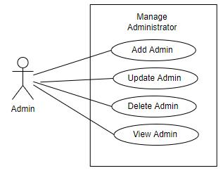

|  |  |  |  |  |  |
| --- | --- | --- | --- | --- | --- |
| ID and Name: | **UC-102. Delete Admin** | | | | |
| Created By: | PhatDH | | Date Created: | | 25/9/2021 |
| Primary Actor: | Admin | | Secondary Actors: | | N/A |
| Trigger: | The actor send delete Admin request | | | | |
| Description: | This feature allow users to delete Admin for Biiké application | | | | |
| Preconditions: | User has logged into Admin Application | | | | |
| Post-conditions: | **Success**: selected Admin will be deleted  **Failure**: System informs “This Voucher cannot be deleted” | | | | |
| Normal Flow: | Step | Actor Action | | System Response | |
| 1 | Actor press “Xóa quản trị viên” button | | System show pop up “Are you sure to delete this Admin?” | |
| 2 | Actor press “Xóa quản trị viên” | | Admin deleted. [Alternative 1] | |
| Alternative Flows: | Step | Actor Action | | System Response | |
| 1 | Actor press “Cancel” | | Redirect to View Admin sspage | |
| Exceptions: | No | Cause | | System Response | |
| 1 |  | |  | |
| Priority: | Medium | | | | |
| Frequency of Use: | Hardly ever / Rarely | | | | |
| Business Rules: | **BR-130:** Admin can delete other admin if there are more than 2 admins in the system  **BR-131:** When admin is deleted, they can continue use mobile app as a Keer wihout losing data | | | | |
| Other Information: | N/A | | | | |
| Assumptions: | Internet Connection is available | | | | |

* + 1. **View Customized Notification**

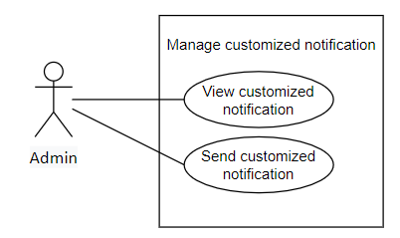

|  |  |  |  |  |  |
| --- | --- | --- | --- | --- | --- |
| ID and Name: | **UC-103. View Customized Notification** | | | | |
| Created By: | PhatDH | | Date Created: | | 25/9/2021 |
| Primary Actor: | Admin | | Secondary Actors: | | N/A |
| Trigger: | The actor wants to view notification | | | | |
| Description: | This feature allow user to manage notification | | | | |
| Preconditions: | User has logged into Admin Application | | | | |
| Post-conditions: | **Success**: redirect to Notification screen  **Failure**: System shows error message | | | | |
| Normal Flow: | Step | Actor Action | | System Response | |
| 1 | Actor press “Thông báo” button on “Người dùng” menu and want to view notification list | | Redirect to Notification screen | |
| Alternative Flows: | N/A | | | | |
| Exceptions: | No | Cause | | System Response | |
| 1 |  | |  | |
| Priority: | Medium | | | | |
| Frequency of Use: | Usually | | | | |
| Business Rules: | **BR-132:** Admin can only view notification from admin, not from system handler such as automatic notification when an biker accept a keer's trip | | | | |
| Other Information: | N/A | | | | |
| Assumptions: | Internet Connection is available | | | | |

* + 1. **Send Notification**



|  |  |  |  |  |  |
| --- | --- | --- | --- | --- | --- |
| ID and Name: | **UC-104. Send Notification** | | | | |
| Created By: | PhatDH | | Date Created: | | 25/9/2021 |
| Primary Actor: | Admin | | Secondary Actors: | | N/A |
| Trigger: | The actor wants to send notification | | | | |
| Description: | This feature allow user to send notification | | | | |
| Preconditions: | User has logged into Admin Application | | | | |
| Post-conditions: | **Success**: notification is send  **Failure**: System shows error message | | | | |
| Normal Flow: | Step | Actor Action | | System Response | |
| 1 | Actor press “Notification” button on “User” menu and want to send new notification | | Redirect to Notification screen with following fields:  Title, Short Description, Type, Cover Photo, Content, Which User will receive notification | |
| 2 | Actor enter notification information | |  | |
| 3 | Actor Press “Gửi thông báo” | | Notification is sent | |
| Alternative Flows: | N/A | | | | |
| Exceptions: | No | Cause | | System Response | |
| 1 |  | |  | |
| Priority: | Medium | | | | |
| Frequency of Use: | Usually | | | | |
| Business Rules: | **BR-105:** All field is required, if any field is blank, when user click submit button, a message is shown: "Please fill enough data"  **BR-132:** Admin can only view notification from admin, not from system handler such as automatic notification when an biker accept a keer's trip | | | | |
| Other Information: | N/A | | | | |
| Assumptions: | Internet Connection is available | | | | |

1. Functional Requirements
   1. **System Functional Overview**
2. **Screen Flow**

* **Mobile App Screen Flow**

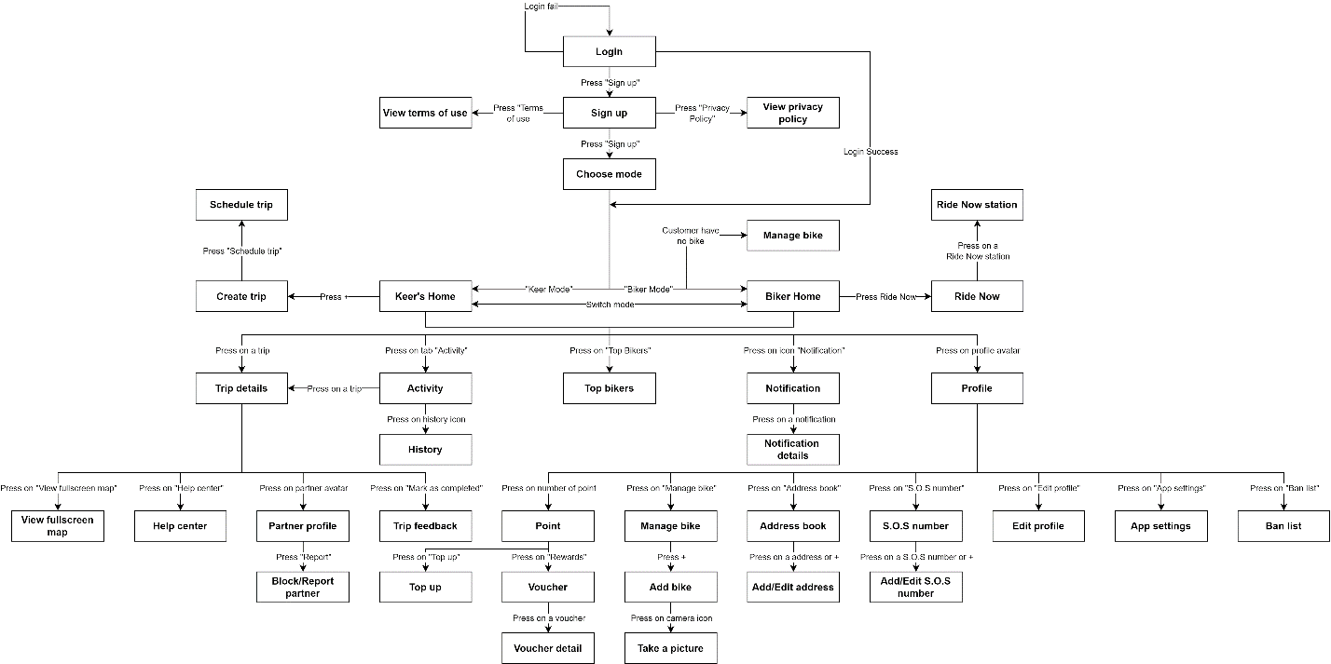

Figure 3. Mobile App Screen Flow

* **Web Admin Screen Flow**

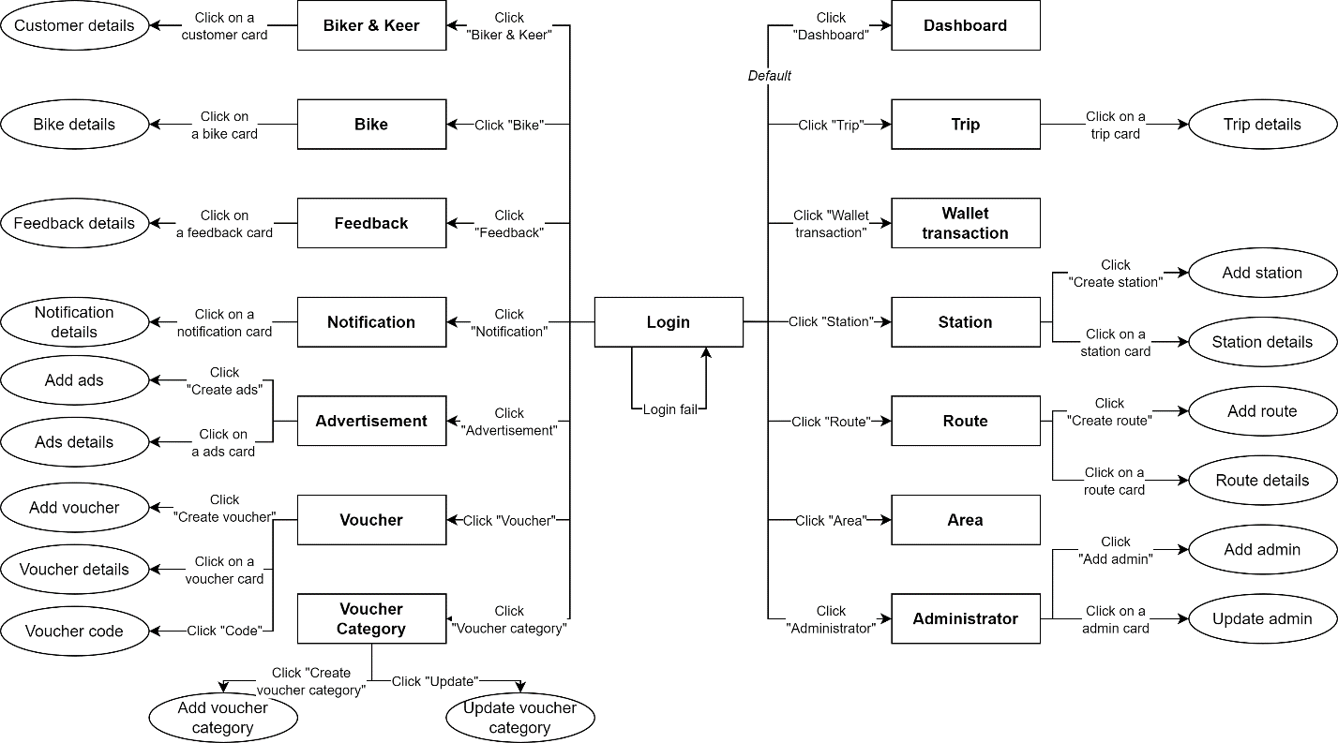

Figure 4. Web Admin Screen Flow

1. **Screen Details**

* **Mobile App Screen Details**

|  |  |  |  |
| --- | --- | --- | --- |
| **Id** | **Feature** | **Screen** | **Description** |
| 1 | Login | Login | Contains email and password fields |
| 2 | Sign up | Sign up | Contains user list, admin can click on user to view user details, lock, and unlock users |
| 3 | Choose mode | Choose mode | Contains two modes that customer can choose: Biker Mode and Keer Mode |
| 4 | View terms of use | Terms of use | Contains term of use |
| 5 | View privacy policy | Privacy policy | Contains privacy policy |
| 6 | View Keer's Home | Keer's Home | Contains switch mode button, notification icon, profile icon, upcoming trips, top biker tab, activity tab, advertising, and some vouchers |
| 7 | Create trip | Create trip | Contains a small map, button Schedule Trip, Trip Now, two dropdown boxes to choose Departure station and Destination station |
| 8 | Schedule trip | Schedule trip | Contains buttons to choose date, time and repeat in week |
| 9 | View Biker's Home | Biker Home | Contains switch mode button, notification icon, profile icon, upcoming trips, top biker tab, Ride Now tab, activity tab, advertising, some vouchers and list trip and filter area. |
| 10 | View Ride Now Settings | Ride Now | Biker can view Trip Now and settings for Ride Now |
| 11 | Create Ride Now Station | Ride Now Station | Biker can create or edit Ride Now station with station and period time |
| 12 | View Top Bikers | Top Bikers | List of Biker with highest point in current month |
| 13 | View Activity | Activity | List of upcoming trips and history button |
| 14 | View Past Trip | History | List of past trips |
| 15 | View Trip details | Trip details | Contains status of trip, small map, partner, actions with partner, buttons to cancel or mark as arrived departure station |
| 16 | View Notification | Notification | List of notifications |
| 17 | View Notification details | Notification details | Notification details with banner, title, and contents |
| 18 | View Profile | Profile | Contains user information with buttons to manage address book, S.O.S number, ban list, app settings |
| 19 | View fullscreen map | View fullscreen map | Full map with 2 stations: departure station and destination station |
| 20 | View Help center | Help center | List of action for help user in trip: share location, send location to SMS number, view nearest hospital, police station, gas station, mechanic shop |
| 21 | View Partner profile | Partner profile | Contains partner avatar, name, and phone number with buttons: call, message, report, and block |
| 22 | Block/Report partner | Block/Report partner | Contains an area text for reason report and block button |
| 23 | Feedback trip | Trip feedback | Contains trip star, area text for feedback, criteria feedback and submit button |
| 24 | View Point | Point | Contains amount of point, button to top up point and voucher |
| 25 | Top up point | Top up | Contains information when top up, a field to input number of points, amount of money and submit button to forward to MOMO wallet |
| 26 | View Voucher | Voucher | Contains list of vouchers, dropdown box to choose category, Near me button. |
| 27 | View Voucher detail | Voucher detail | Contains voucher information with title, brand, point to redeem, terms, description, button to redeem voucher |
| 28 | Manage bike | Manage bike | Contains a card with some bike information |
| 29 | Add bike | Add bike | Contains text fields to input bike information and take relative picture |
| 30 | Take a picture | Take a picture | Use camera on phone to take picture |
| 31 | Address book | Address book | Contain list of address user add |
| 32 | Add/Edit address | Add/Edit address | Contains address name, address detail, note and toggle to set default address |
| 33 | View S.O.S number | S.O.S number | Contains list of S.O.S numbers |
| 34 | Add/Edit S.O.S number | Add/Edit S.O.S number | Contains name and phone number |
| 35 | Edit profile | Edit profile | Contains fields to edit profile information |
| 36 | View App settings | App settings | Contains some action for user to set up the app |
| 37 | Ban list | Ban list | Contains list of users that have been blocked and can unblock |

* **Web Admin Screen Details**

|  |  |  |  |
| --- | --- | --- | --- |
| **Id** | **Feature** | **Screen** | **Description** |
| 1 | Login | Login | Contains email and password fields |
| 2 | View Dashboard | Dashboard | Contains report fields such as: total user, total trips, total new users, total saved km, selected rate of station, total saved gas, trip status rate by pie chart, points, voucher and ads, total number of exchanged vouchers. Admin can download voucher |
| 3 | View Trip | Trip | Contains list of trip, admin can view trip details |
| 4 | View Wallet transaction | Wallet transaction | Contains list of transaction, admin can view transaction |
| 5 | Manage Station | Station | Contains station list for admin to view, update, inactive or active |
| 6 | Manage Route | Route | Contains route list for admin to view, update, inactive or active |
| 7 | Manage Area | Area | Contains area list for admin to view |
| 8 | Manage User | Biker & Keer | Contains user list, admin can click on user to view user details, lock, and unlock users |
| 9 | Manage Bike | Bike | Contains list of Bike, admin can view and verify Bike |
| 10 | Manage Feedback | Feedback | Contains feedback list of user, admin can view feedback details |
| 11 | Manage Notification | Notification | Admin can send notification about incoming vouchers to users |
| 12 | Manage Advertisement | Advertisement | Contains Ads list for admin to view, update, delete, restore and add |
| 13 | Manage Voucher | Voucher | Contains voucher list for admin to view, update, delete, restore and add |
| 14 | Manage Voucher Category | Voucher Category | Contains voucher category for admin to view, delete, restore and add |
| 15 | View Admin | Admin | Contains area list for admin to view |

1. **Screen Authorization**

* Only Admin can login and view Web Admin. Admin cannot log in to Mobile App. Screen Authorization below only list Mobile Screen List
* **Mobile App Screen Authorization**

|  |  |  |
| --- | --- | --- |
| **Screen** | **Keer** | **Biker** |
| Login | x | x |
| Sign up | x | x |
| Choose mode | x | x |
| Terms of use | x | x |
| Privacy policy | x | x |
| Keer's Home | x |  |
| Create trip | x |  |
| Schedule trip | x |  |
| Biker Home |  | x |
| Ride Now |  | x |
| Ride Now Station |  | x |
| Top Bikers | x | x |
| Activity | x | x |
| History | x | x |
| Trip details | x | x |
| Notification | x | x |
| Notification details | x | x |
| Profile | x | x |
| View fullscreen map | x | x |
| Help center | x | x |
| Partner profile | x | x |
| Block/Report partner | x | x |
| Trip feedback | x | x |
| Point | x | x |
| Top up | x | x |
| Voucher | x | x |
| Voucher detail | x | x |
| Manage bike | x | x |
| Add bike | x |  |
| Take a picture | x |  |
| Address book | x | x |
| Add/Edit address | x | x |
| S.O.S number | x | x |
| Add/Edit S.O.S number | x | x |
| Edit profile | x | x |
| App settings | x | x |
| Ban list | x | x |

1. **Non-Screen Functions**

N/A

1. **Entity Relationship Diagram**

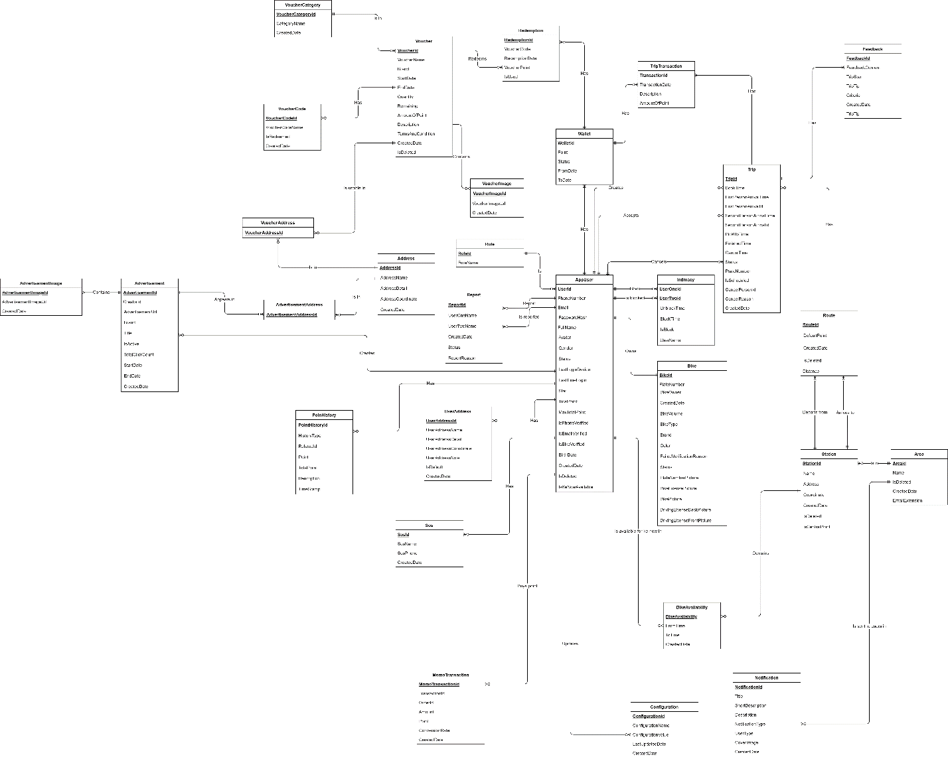

Figure 5. Entity Relationship Diagram

1. Non-Functional Requirements
   1. **External Interfaces**
2. **User Interfaces**
   * The UI shall support Vietnamese/English
   * The authenticated users UI must be fully shown in mobile app
3. **Communications Interfaces**
   * Authentication Service: The system can be integrated with Firebase Authentication framework
   * The system can send email to users to verify FPT email
   * The system can call API through data transferred by HTTP
   1. **Quality Attributes**
4. **Usability**
   * All text, label and message should be uniformly written in Vietnamese / English
   * The application should be friendly and easy for users to use without training
   * The web application for admin should require no more than 2 days of training to use
5. **Reliability**
   * N/A
6. **Security**
   * Biiké users is divided into 3 roles: Biker, Keer and Admin
   * All input data are validated before saving to the database
   * Each role only access to a group of functions
   * The system always checks authentication and authorization before doing any features
7. Software Design Description
8. Overall Description
   1. **Assumptions**

This system is designed basing on these following assumptions:

* Windows 10
* Chrome 96
* Microsoft Egde 96
* SQL Server 2019
* Android 8+
* End-User: FPT University Students, Biiké Manager team
* Security requirement: prevent users from cheating as much as possible
* Network communication: This system depends on networks connection

1. System Architecture Design
   1. **Overall System Architecture**

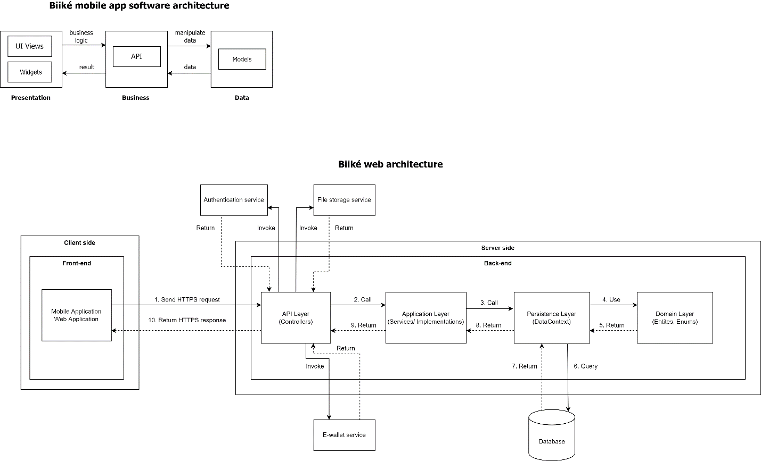

Figure 6. System Architecture Diagram

|  |  |  |
| --- | --- | --- |
| **No.** | **Name** | **Description** |
| 1. | Authentication service | It oversees authenticating 3rd party account of the user and send the result to our system |
| 2. | Email service | It handles sending emails. |
| 3. | UI | Client component to render and display data from  the server. Client component provides functions:  For admin: manage stations, routes, verify feedbacks, etc.  For biker: accept trip, manage bike, etc.  For keer: schedule trip, create Ké-now trip, etc. |
| 4. | Business logic process | It handles the business logic of the system |
| 5. | Provider/DAO | It handles reading and writing data in the system. |
| 6. | Biiké API | It handles request from mobile and web app and response from the system. |
| 7. | Database | It stores the data of the system. |

Table 16. System Architecture

* 1. **Component Diagram**

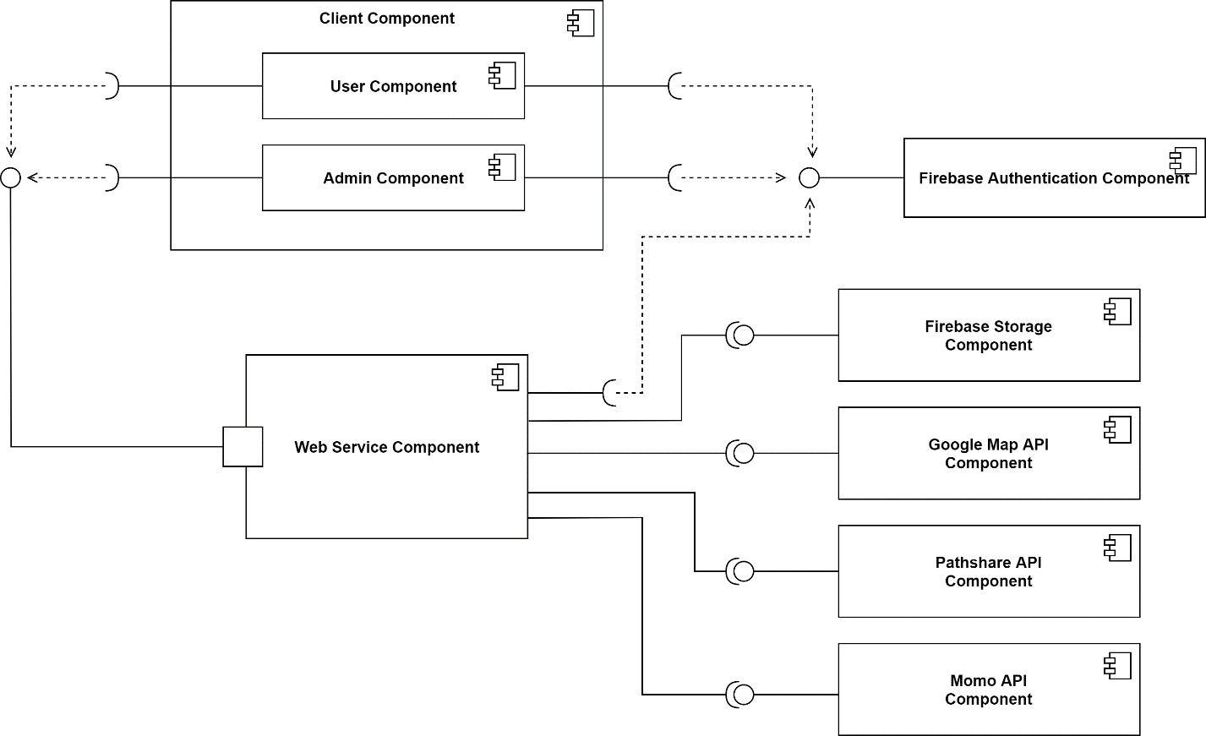

Figure 7. Component Diagram

|  |  |  |
| --- | --- | --- |
| **No.** | **Name** | **Description** |
| 1 | Firebase Authentication | User use FPT edu mail account to be authenticated in the Biiké system. This component oversees  authenticating the account of the user and send the result to our system. |
| 2 | Client component | Client component to render and display data from the server. Client component provides functions:  For admin: manage stations, routes, verify feedbacks, etc.  For biker: accept trip, manage bike, etc.  For keer: schedule trip, create Ké-now trip, etc. |
| 3 | Admin component | It provides features: manage stations, manage routes, verify feedbacks, etc. |
| 4 | User component | It provides features: create trip, accept trip, manage bike, exchange voucher, etc. |
| 5 | Firebase Storage | Store and serve user-generated content, contains photos. |
| 6 | Google Map API | Service to show the location of the Station and show the direction between 2 stations |
| 7 | Pathshare API | Service to get user real-time location via GPS |
| 8 | Momo API | Service to make in-app purchase |

Table 17. Component Diagram Description

* 1. **Package Diagram**

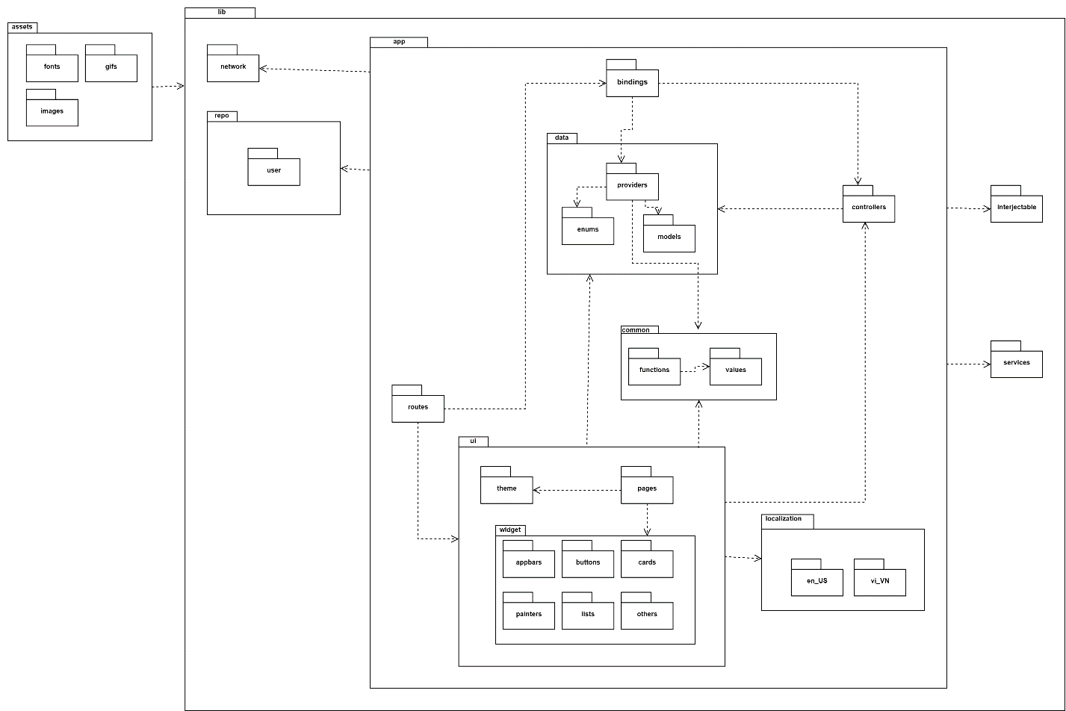

Figure 8. Package Diagram

|  |  |  |
| --- | --- | --- |
| **No** | **Package** | **Description** |
| 1 | Lib | This package contains folders of different layers in app |
| 2 | App | This package contains classes for app UI and business layers and main class |
| 3 | Bindings | This package contains classes to bind screens, providers and controllers |
| 4 | Data | This package contains folders of providers, enums and models |
| 5 | Providers | This package contains classes to send and receive HTTP requests from API |
| 6 | Enums | This package contains classes for enum data |
| 7 | Models | This package contains classes to map objects to/from json from API |
| 8 | Bindings | This package contains classes to bind ui, controllers, providers |
| 9 | Common | This package contains folders of common values and functions |
| 10 | Functions | This package contains classes for common functions |
| 11 | Values | This package contains classes for common values |
| 12 | Localizations | This package contains classes for switching language |
| 13 | en_US | This package contains English translations of the app |
| 14 | vi_VN | This package contains Vietnamese translations of the app |
| 15 | Services | This package contains classes for using outside services like Firebase, … |
| 16 | UI | This package contains folders for UI implementation |
| 17 | Theme | This package contains classes for main theme of the app |
| 18 | Pages | This package contains classes for screen UI |
| 19 | Widget | This package contains classes for widgets using in screen |
| 20 | Appbars | This package contains classes for appbar design |
| 21 | Buttons | This package contains classes for buttons in screen |
| 22 | Cards | This package contains classes for cards in screen |
| 23 | Painters | This package contains classes for drawing shapes in screen |
| 24 | Lists | This package contains classes for listview in screen |
| 25 | Others | This package contains classes for others widgets in screen |
| 26 | Routes | This package contains classes for navigation data between screens |
| 27 | Assets | This package contains assets using in UI |
| 28 | Fonts | This package contains fonts using in app |
| 29 | Gifs | This package contains gifs using in app |
| 30 | Images | This package contains images using in app |
| 31 | Network | This package contains classes for config networks and for login/logout REST client |
| 32 | Repos | This package contains user folder |
| 33 | User | This package contains classes for user behavior |

Table 18. Package Diagram Description

1. Activity Diagram

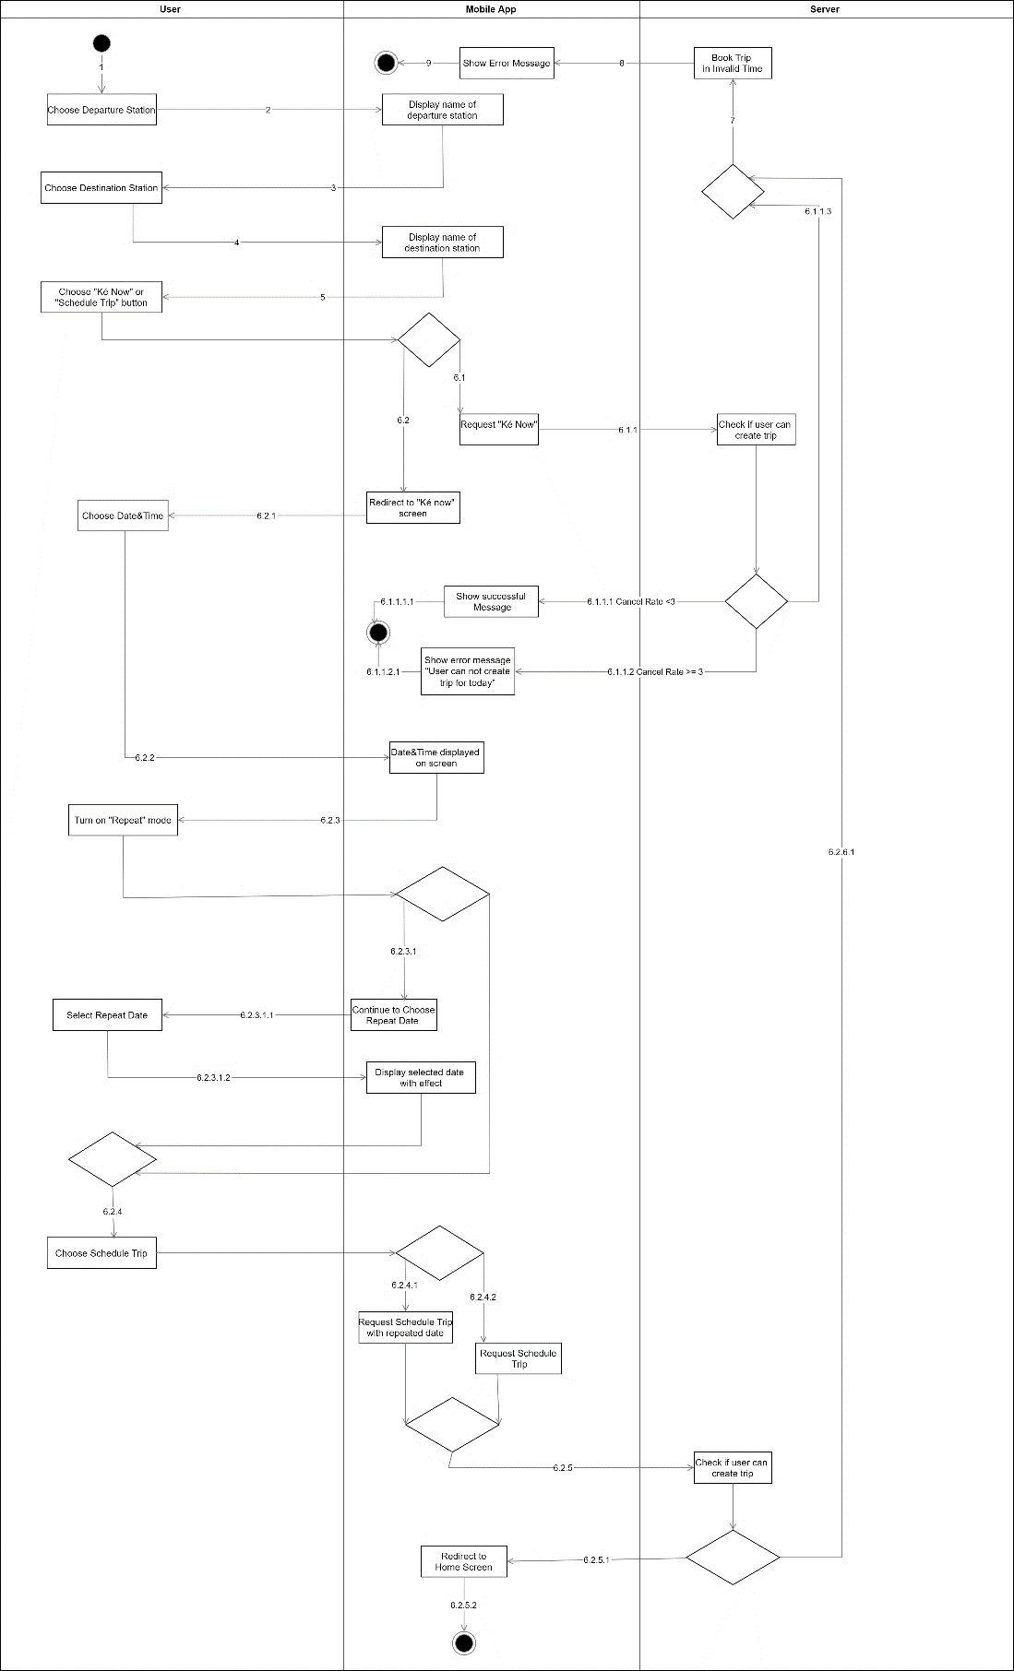

Figure 9. Activity Diagram - Create trip

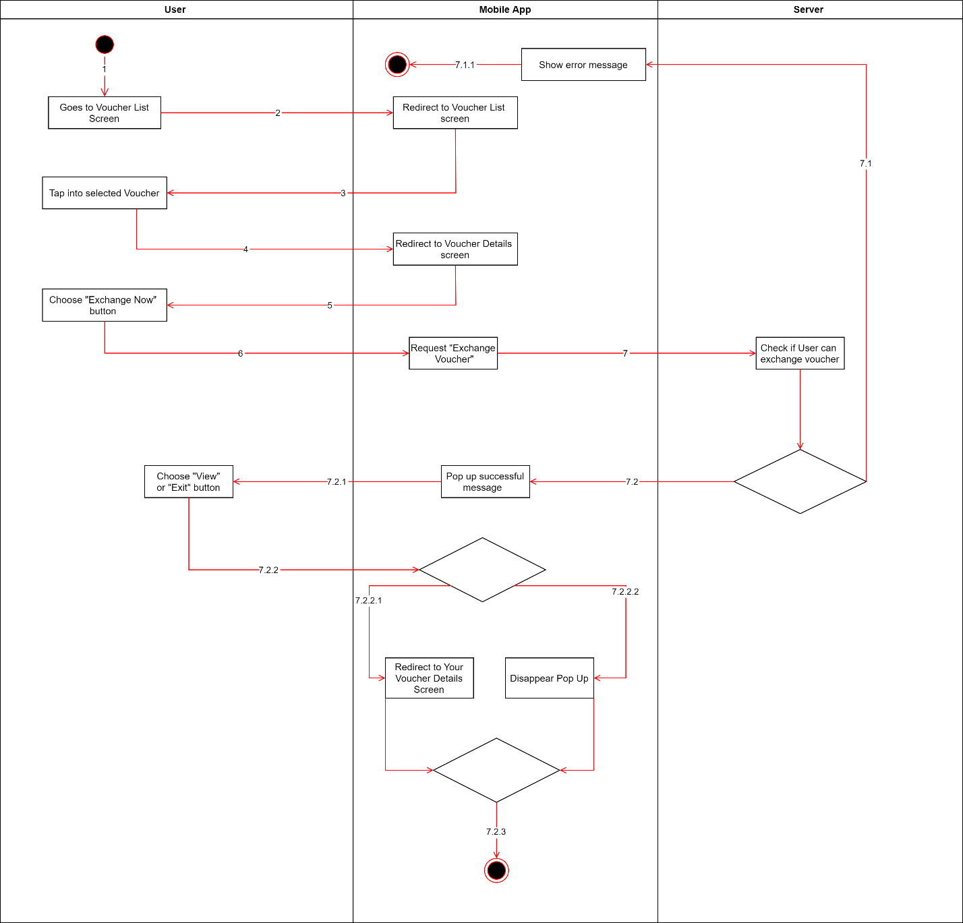

Figure 10. Activity Diagram - Redeem voucher

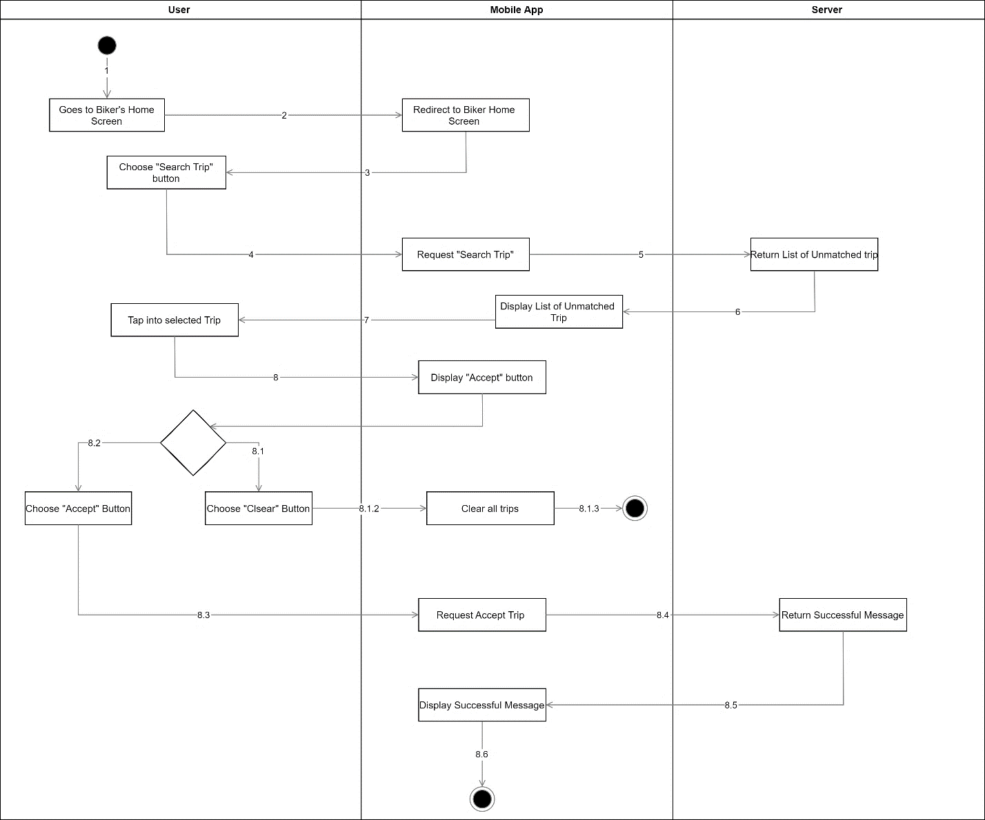

Figure 11. Activity Diagram - Accept a trip

1. System Detailed Design
   1. **Class Diagram**

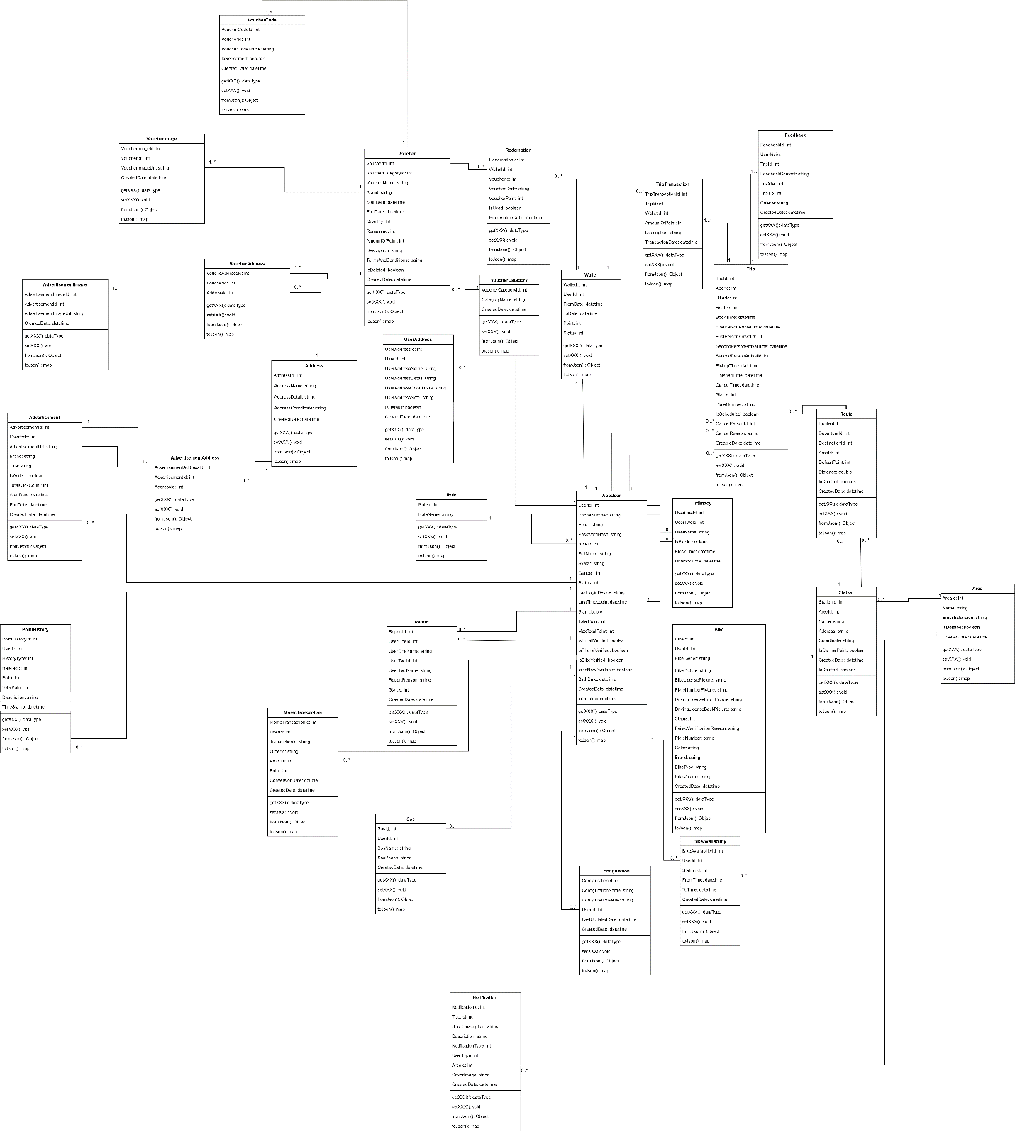

Figure 12. Class Diagram

* 1. **Class Specification**
     1. **AppUser Class**

|  |  |  |  |  |
| --- | --- | --- | --- | --- |
| **No** | **Attribute** | **Data Type** | **Visibility** | **Description** |
| 1 | UserId | Int | Private | Unique define of user |
| 2 | PhoneNumber | String | Private | Unique phone number of users |
| 3 | Email | String | Private | Unique user’s contact email |
| 4 | PasswordHash | String | Private | User password to Biiké app |
| 5 | RoleId | Int | Private | Identifier for user’s role when using Biiké |
| 6 | FullName | String | Private | User’s full name |
| 7 | Avatar | String | Private | User’s Biiké avatar |
| 8 | Gender | Int | Private | User’s Gender |
| 9 | Status | Int | Private | User’s Status |
| 10 | LastLoginDevice | String | Private | Last login device user |
| 11 | LastTimeLogin | DateTime | Private | Last time user login |
| 12 | Star | Double | Private | User Biiké star |
| 13 | TotalPoint | Int | Private | User’s total point |
| 14 | MaxTotalPoint | Int | Private | Total max point of user |
| 15 | isEmailVerify | Boolean | Private | If user’s email is verified or not |
| 16 | isPhoneVerify | Boolean | Private | If user’s phone number is verified |
| 17 | Birthday | Datetime | Private | User’s birthday |
| 18 | createdDate | Datetime | Private | User’s created date |
| 19 | isDeleted | Boolean | Private | If user is deleted |
| 20 | IsKeNowAvailable | Boolean | Private | If user’s kenow is available or not |
| 21 | IsBikeVerified | Boolean | Private | If bike is verified or not |

Table 19. AppUser Class Attribute

|  |  |  |  |  |
| --- | --- | --- | --- | --- |
| **No** | **Method** | **Return Type** | **Accessibility** | **Description** |
| 1 | getXXX | DataType | Public | To get attribute value |
| 2 | setXXX | Void | Public | Set value of attribute |
| 3 | fromJson | Object | Public | Convert Json to Object |
| 4 | toJson | Map | Public | Convert Object to Json |

Table 20. AppUser Class Method

* + 1. **Bike Class**

|  |  |  |  |  |
| --- | --- | --- | --- | --- |
| **No** | **Attribute** | **Data Type** | **Visibility** | **Description** |
| 1 | UserId | Int | Private | Unique define of user |
| 2 | BikeId | Int | Private | Unique define of user’s bike |
| 3 | BikeOwner | String | Private | Bike’s owner name |
| 4 | BikePicture | String | Private | Bike’s picture |
| 5 | BikeLisencePicture | String | Private | Bike’s license picture |
| 6 | PlateNumberPicture | String | Private | Number plate picture |
| 7 | Status | Int | Private | Bike’s status |
| 8 | FailedVerrificationreason | String | Private | Reason why the bike is failed to verify |
| 9 | PlateNumber | String | Private | Number Plate of Bike |
| 10 | Color | String | Private | Bike’s color |
| 11 | Brand | String | Private | Brand of bike |
| 12 | BikeType | String | Private | Type of Bike |
| 13 | BikeVolume | String | Private | Volume of Bike |
| 14 | CreatedDate | Datetime | Private | Time Created bike in Biiké application |
| 15 | DrivingLicenseFrontPicture | String | Private | Front picture of biker’s license |
| 16 | DrivingLicenseBackPicture | String | Private | Back picture of biker’s license |

Table 21. Bike Class Attribute

|  |  |  |  |  |
| --- | --- | --- | --- | --- |
| **No** | **Method** | **Return Type** | **Accessibility** | **Description** |
| 1 | getXXX | DataType | Public | To get attribute value |
| 2 | setXXX | Void | Public | Set value of attribute |
| 3 | fromJson | Object | Public | Convert Json to Object |
| 4 | toJson | Map | Public | Convert Object to Json |

Table 22. Bike Class Method

* + 1. **User Address Class**

|  |  |  |  |  |
| --- | --- | --- | --- | --- |
| **No** | **Attribute** | **Data Type** | **Visibility** | **Description** |
| 1 | UserId | Int | Private | Unique define of user |
| 2 | UserAddressId | Int | Private | Unique Define of user address |
| 3 | UserAddressName | String | Private | Name of user’s address in Biiké application |
| 4 | UserAddressDetails | String | Private | Information about user’s address |
| 5 | UserAddressCoordinate | String | Private | Coordinate of user’s address |
| 6 | UserAddressNote | String | Private | Note of User |
| 7 | IsDefault | Boolean | Private | If user address is default address or not |
| 8 | CreatedDate | Datetime | Private | Date user address created |

Table 23. UserAddress Class Attribute

|  |  |  |  |  |
| --- | --- | --- | --- | --- |
| **No** | **Method** | **Return Type** | **Accessibility** | **Description** |
| 1 | getXXX | DataType | Public | To get attribute value |
| 2 | setXXX | Void | Public | Set value of attribute |
| 3 | fromJson | Object | Public | Convert Json to Object |
| 4 | toJson | Map | Public | Convert Object to Json |

Table 24. UserAddress Class Method

* + 1. **Intimacy Class**

|  |  |  |  |  |
| --- | --- | --- | --- | --- |
| **No** | **Attribute** | **Data Type** | **Visibility** | **Description** |
| 1 | UserOneId | Int | Private | Unique define of user one |
| 2 | UserTwoId | Int | Private | Unique Define of user two |
| 3 | Username | String | Private | User’s Name |
| 4 | IsBlock | Bit | Private | To check if user is block or not |
| 5 | BlockTime | Datetime | Private | Time user block |
| 6 | UnblockTime | Datetime | Private | Time users unblock other user |

Table 25. Intimacy Class Attribute

|  |  |  |  |  |
| --- | --- | --- | --- | --- |
| **No** | **Method** | **Return Type** | **Accessibility** | **Description** |
| 1 | getXXX | DataType | Public | To get attribute value |
| 2 | setXXX | Void | Public | Set value of attribute |
| 3 | fromJson | Object | Public | Convert Json to Object |
| 4 | toJson | Map | Public | Convert Object to Json |

Table 26. Intimacy Class Method

* + 1. **Report Class**

|  |  |  |  |  |
| --- | --- | --- | --- | --- |
| **No** | **Attribute** | **Data Type** | **Visibility** | **Description** |
| 1 | UserOneId | Int | Private | Unique define of user one |
| 2 | UserTwoId | Int | Private | Unique Define of user two |
| 3 | ReportId | Int | Private | Unique Define of report |
| 4 | UserOneName | String | Private | User one’s name |
| 5 | UserTwoName | String | Private | User two’s name |
| 6 | ReportReason | String | Private | Reason why user report other user |
| 7 | Status | Int | Private | Status of report |

Table 27. Report Class Attribute

|  |  |  |  |  |
| --- | --- | --- | --- | --- |
| **No** | **Method** | **Return Type** | **Accessibility** | **Description** |
| 1 | getXXX | DataType | Public | To get attribute value |
| 2 | setXXX | Void | Public | Set value of attribute |
| 3 | fromJson | Object | Public | Convert Json to Object |
| 4 | toJson | Map | Public | Convert Object to Json |

Table 28. Report Class Method

* + 1. **SoS Class**

|  |  |  |  |  |
| --- | --- | --- | --- | --- |
| **No** | **Attribute** | **Data Type** | **Visibility** | **Description** |
| 1 | SosId | Int | Private | Unique define of sos |
| 2 | UserId | Int | Private | Unique Define of user |
| 3 | SosName | String | Private | Name of Sos number will be displayed on Biiké application |
| 4 | SosPhone | String | Private | Phone Number of S.o.S person |
| 5 | CreatedDate | Datetime | Private | Date added s.o.s number |

Table 29. S.O.S Class Attribute

|  |  |  |  |  |
| --- | --- | --- | --- | --- |
| **No** | **Method** | **Return Type** | **Accessibility** | **Description** |
| 1 | getXXX | DataType | Public | To get attribute value |
| 2 | setXXX | Void | Public | Set value of attribute |
| 3 | fromJson | Object | Public | Convert Json to Object |
| 4 | toJson | Map | Public | Convert Object to Json |

Table 30. S.O.S Class Method

* + 1. **PointHistory Class**

|  |  |  |  |  |
| --- | --- | --- | --- | --- |
| **No** | **Attribute** | **Data Type** | **Visibility** | **Description** |
| 1 | PointHistoryId | Int | Private | Unique define of point history |
| 2 | UserId | Int | Private | Unique Define of user |
| 3 | HistoryType | Int | Private | Type of point history |
| 4 | RelatedId | Int | Private | Related of point history |
| 5 | Point | Int | Private | History point |
| 6 | TotalPoint | Int | Private | Total history point |
| 7 | Description | String | Private | Description of point history |
| 8 | TimeStamp | Datetime | Private | Time stamp of point history |

Table 31. Point History Class Attribute

|  |  |  |  |  |
| --- | --- | --- | --- | --- |
| **No** | **Method** | **Return Type** | **Accessibility** | **Description** |
| 1 | getXXX | DataType | Public | To get attribute value |
| 2 | setXXX | Void | Public | Set value of attribute |
| 3 | fromJson | Object | Public | Convert Json to Object |
| 4 | toJson | Map | Public | Convert Object to Json |

Table 32. Point History Class Method

* + 1. **Trip Class**

|  |  |  |  |  |
| --- | --- | --- | --- | --- |
| **No** | **Attribute** | **Data Type** | **Visibility** | **Description** |
| 1 | TripId | Int | Private | Unique define of trip |
| 2 | KeerId | Int | Private | Unique Define of keer |
| 3 | BikeId | Int | Private | Unique define of Biker’s bike |
| 4 | RouteId | Int | Private | Unique define of Route |
| 5 | BookTime | Datetime | Private | Time book trip |
| 6 | PickupTime | Datetime | Private | Time pickup of trip |
| 7 | FinishedTime | Datetime | Private | Time finished of trip |
| 8 | CancelTime | Datetime | Private | Time cancel the trip |
| 9 | Status | Int | Private | Status of trip |
| 10 | PlateNumber | String | Private | Number plate of biker’s bike |
| 11 | IsScheduled | Bit | Private | If the trip is schedule or ke now trip |
| 12 | CancelPersonId | Int | Private | Unique define of cancel person |
| 13 | CancelReason | Int | Private | Cancel reason |
| 14 | CreatedDate | Datetime | Private | Created date of trip |
| 15 | FirstPersonArrivalId | Int | Private | Unique identifier for first person arrived at pick up position |
| 16 | SecondPersonArrivalId | Int | Private | Unique identifier for second person arrived at pick up position |
| 17 | FirstPersonArrivalTime | Int | Private | Time first person arrived at pick up position |
| 18 | SecondPersonArrivalTime | Int | Private | Time second person arrived at pick up position |

Table 33. Trip Class Attribute

|  |  |  |  |  |
| --- | --- | --- | --- | --- |
| **No** | **Method** | **Return Type** | **Accessibility** | **Description** |
| 1 | getXXX | DataType | Public | To get attribute value |
| 2 | setXXX | Void | Public | Set value of attribute |
| 3 | fromJson | Object | Public | Convert Json to Object |
| 4 | toJson | Map | Public | Convert Object to Json |

Table 34. Trip Class Method

* + 1. **Route Class**

|  |  |  |  |  |
| --- | --- | --- | --- | --- |
| **No** | **Attribute** | **Data Type** | **Visibility** | **Description** |
| 1 | RouteId | Int | Private | Unique define of route |
| 2 | DepartureId | Int | Private | Unique Define of departure station |
| 3 | DestinationId | Int | Private | Destination station unique definition |
| 4 | AreaId | Int | Private | Unique define of area |
| 5 | DefaultPoint | Int | Private | Default point of route |
| 6 | CreatedDate | Datetime | Private | Date created route |
| 7 | IsDeleted | Bit | Private | If the route is deleted or not |
| 8 | Distance | Double | Private | Distance of route |

Table 35. Route Class Attribute

|  |  |  |  |  |
| --- | --- | --- | --- | --- |
| **No** | **Method** | **Return Type** | **Accessibility** | **Description** |
| 1 | getXXX | DataType | Public | To get attribute value |
| 2 | setXXX | Void | Public | Set value of attribute |
| 3 | fromJson | Object | Public | Convert Json to Object |
| 4 | toJson | Map | Public | Convert Object to Json |

Table 36. Route Class Method

* + 1. **Station Class**

|  |  |  |  |  |
| --- | --- | --- | --- | --- |
| **No** | **Attribute** | **Data Type** | **Visibility** | **Description** |
| 1 | StationId | Int | Private | Unique define of station |
| 2 | AreaId | Int | Private | Unique Define of area |
| 3 | Name | String | Private | Station’s name |
| 4 | Address | String | Private | Station’s address |
| 5 | Coordinate | String | Private | Station’s coordinate |
| 6 | IsDeleted | Bit | Private | If station is deleted or not |
| 7 | CreatedDate | Datetime | Private | Date created of station |
| 8 | IsCentralPoint | Boolean | Private | If the station is Biiké’s central point |

Table 37. Station Class Attribute

|  |  |  |  |  |
| --- | --- | --- | --- | --- |
| **No** | **Method** | **Return Type** | **Accessibility** | **Description** |
| 1 | getXXX | DataType | Public | To get attribute value |
| 2 | setXXX | Void | Public | Set value of attribute |
| 3 | fromJson | Object | Public | Convert Json to Object |
| 4 | toJson | Map | Public | Convert Object to Json |

Table 38. Station Class Method

* + 1. **Area Class**

|  |  |  |  |  |
| --- | --- | --- | --- | --- |
| **No** | **Attribute** | **Data Type** | **Visibility** | **Description** |
| 1 | AreaId | Int | Private | Unique define of area |
| 2 | Name | String | Private | Name of Area |
| 3 | IsDeleted | Bit | Private | If area is deleted or not |
| 4 | CreatedDate | Datetime | Private | Date area is created |
| 5 | EmailExtension | String | Private | Condition for user’s’s register email suffix |

Table 39. Area Class Attribute

|  |  |  |  |  |
| --- | --- | --- | --- | --- |
| **No** | **Method** | **Return Type** | **Accessibility** | **Description** |
| 1 | getXXX | DataType | Public | To get attribute value |
| 2 | setXXX | Void | Public | Set value of attribute |
| 3 | fromJson | Object | Public | Convert Json to Object |
| 4 | toJson | Map | Public | Convert Object to Json |

Table 40. Area Class Method

* + 1. **Feedback Class**

|  |  |  |  |  |
| --- | --- | --- | --- | --- |
| **No** | **Attribute** | **Data Type** | **Visibility** | **Description** |
| 1 | FeedbackId | Int | Private | Unique define of feedback |
| 2 | UserId | Int | Private | Unique Define of user |
| 3 | TripId | Int | Private | Unique define of Trip |
| 4 | FeedbackContent | String | Private | Content of feedback |
| 5 | TripStar | Int | Private | Trip star of feedback given by users |
| 6 | TripTip | Int | Private | Point the Keer tip for biker |
| 7 | Criteria | String | Private | Criteria of feedback |
| 8 | CreatedDate | Datetime | Private | Created date of feedback |

Table 41. Feedback Class Attribute

|  |  |  |  |  |
| --- | --- | --- | --- | --- |
| **No** | **Method** | **Return Type** | **Accessibility** | **Description** |
| 1 | getXXX | DataType | Public | To get attribute value |
| 2 | setXXX | Void | Public | Set value of attribute |
| 3 | fromJson | Object | Public | Convert Json to Object |
| 4 | toJson | Map | Public | Convert Object to Json |

Table 42. Feedback Class Method

* + 1. **Trip Transaction Class**

|  |  |  |  |  |
| --- | --- | --- | --- | --- |
| **No** | **Attribute** | **Data Type** | **Visibility** | **Description** |
| 1 | TripTransactionId | Int | Private | Unique define of trip transaction |
| 2 | TripId | Int | Private | Unique Define of trip |
| 3 | WalletId | Int | Private | Unique define of wallet |
| 4 | AmountOfPoint | Int | Private | The amount of point transaction |
| 5 | Description | String | Private | Trip transaction’s description |
| 6 | TransactionDate | Datetime | Private | The date the transaction was made |

Table 43. Trip Transaction Class Attribute

|  |  |  |  |  |
| --- | --- | --- | --- | --- |
| **No** | **Method** | **Return Type** | **Accessibility** | **Description** |
| 1 | getXXX | DataType | Public | To get attribute value |
| 2 | setXXX | Void | Public | Set value of attribute |
| 3 | fromJson | Object | Public | Convert Json to Object |
| 4 | toJson | Map | Public | Convert Object to Json |

Table 44. Trip Transaction Class Method

* + 1. **Wallet Class**

|  |  |  |  |  |
| --- | --- | --- | --- | --- |
| **No** | **Attribute** | **Data Type** | **Visibility** | **Description** |
| 1 | WalletId | Int | Private | Unique define of wallet |
| 2 | UserId | Int | Private | Unique Define of user |
| 3 | FromDate | Datetime | Private | From date |
| 4 | ToDate | Datetime | Private | the date wallet expired |
| 5 | Point | Int | Private | Point amount of wallet |
| 6 | Status | Int | Private | Status of wallet |

Table 45. Wallet Class Attribute

|  |  |  |  |  |
| --- | --- | --- | --- | --- |
| **No** | **Method** | **Return Type** | **Accessibility** | **Description** |
| 1 | getXXX | DataType | Public | To get attribute value |
| 2 | setXXX | Void | Public | Set value of attribute |
| 3 | fromJson | Object | Public | Convert Json to Object |
| 4 | toJson | Map | Public | Convert Object to Json |

Table 46. Wallet Class Method

* + 1. **Redemption Class**

|  |  |  |  |  |
| --- | --- | --- | --- | --- |
| **No** | **Attribute** | **Data Type** | **Visibility** | **Description** |
| 1 | RedemptionId | Int | Private | Unique define of redemption |
| 2 | WalletId | Int | Private | Unique Define of wallet |
| 3 | VoucherId | Int | Private | Unique Define of voucher |
| 4 | VoucherCode | String | Private | Code of voucher |
| 5 | IsUsed | Bit | Private | Is the voucher is used or not |
| 6 | RedemptionDate | Datetime | Private | The date the voucher was redeemed |
| 7 | VoucherPoint | Int | Private | Voucher point of redemption |

Table 47. Redemption Class Attribute

|  |  |  |  |  |
| --- | --- | --- | --- | --- |
| **No** | **Method** | **Return Type** | **Accessibility** | **Description** |
| 1 | getXXX | DataType | Public | To get attribute value |
| 2 | setXXX | Void | Public | Set value of attribute |
| 3 | fromJson | Object | Public | Convert Json to Object |
| 4 | toJson | Map | Public | Convert Object to Json |

Table 48. Redemption Class Method

* + 1. **VoucherCategory Class**

|  |  |  |  |  |
| --- | --- | --- | --- | --- |
| **No** | **Attribute** | **Data Type** | **Visibility** | **Description** |
| 1 | VoucherCategoryId | Int | Private | Unique define of voucher category |
| 2 | CategoryName | String | Private | Category Name |
| 3 | CreatedDate | Datetime | Private | Name of Sos number will be displayed on Biiké application |

Table 49. Voucher Category Class Attribute

|  |  |  |  |  |
| --- | --- | --- | --- | --- |
| **No** | **Method** | **Return Type** | **Accessibility** | **Description** |
| 1 | getXXX | DataType | Public | To get attribute value |
| 2 | setXXX | Void | Public | Set value of attribute |
| 3 | fromJson | Object | Public | Convert Json to Object |
| 4 | toJson | Map | Public | Convert Object to Json |

Table 50. Voucher Category Class Method

* + 1. **Voucher Class:**

|  |  |  |  |  |
| --- | --- | --- | --- | --- |
| **No** | **Attribute** | **Data Type** | **Visibility** | **Description** |
| 1 | VoucherCategoryId | Int | Private | Unique define of voucher category |
| 2 | VoucherName | String | Private | Voucher Name |
| 3 | CreatedDate | Datetime | Private | Name of Sos number will be displayed on Biiké application |
| 4 | VoucherId | Int | Private | Unique identifier for voucher |
| 5 | Brand | Nvarchar(max) | Private | Voucher’s brand |
| 6 | StartDate | Datetime2 | Private | Date voucher started available |
| 7 | EndDate | Datetime2 | Private | Date voucher ends |
| 8 | Quantity | Int | Private | Quantity of vouchers |
| 9 | Remaining | Int | Private | Remaining quantity of vouchers |
| 10 | AmountOfPoint | Int | Private | Amount of point meeds to exchange voucher |
| 11 | Description | Nvarchar(max) | Private | Voucher’description |
| 12 | TermsAndConditions | Nvarchar(max) | Private | Voucher’s yterms and conditions |
| 13 | IsDeleted | Boolean | Private | If voucher is deleted |

Table 51. Voucher Class Attribute

|  |  |  |  |  |
| --- | --- | --- | --- | --- |
| **No** | **Method** | **Return Type** | **Accessibility** | **Description** |
| 1 | getXXX | DataType | Public | To get attribute value |
| 2 | setXXX | Void | Public | Set value of attribute |
| 3 | fromJson | Object | Public | Convert Json to Object |
| 4 | toJson | Map | Public | Convert Object to Json |

Table 52. Voucher Class Method

* + 1. **VoucherAddress Class:**

|  |  |  |  |  |
| --- | --- | --- | --- | --- |
| **No** | **Attribute** | **Data Type** | **Visibility** | **Description** |
| 1 | VouccherAddressId | Int | Private | Unique define of voucher address |
| 2 | VoucherId | Int | Private | Unique define of voucher |
| 3 | AddressId | Int | Private | Identifier of adress |

Table 53. Voucher Address Class Attribute

|  |  |  |  |  |
| --- | --- | --- | --- | --- |
| **No** | **Method** | **Return Type** | **Accessibility** | **Description** |
| 1 | getXXX | DataType | Public | To get attribute value |
| 2 | setXXX | Void | Public | Set value of attribute |
| 3 | fromJson | Object | Public | Convert Json to Object |
| 4 | toJson | Map | Public | Convert Object to Json |

Table 54. Voucher Address Class Method

* + 1. **Address Class:**

|  |  |  |  |  |
| --- | --- | --- | --- | --- |
| **No** | **Attribute** | **Data Type** | **Visibility** | **Description** |
| 1 | AddressName | String | Private | Name of address named by user |
| 2 | AddressDetails | String | Private | Address detail information |
| 3 | AddressID | Int | Private | Unique Identifier of adress |
| 4 | AddressCoordinate | String | Private | Coordinate of adderss |
| 5 | CreatedDate | Datetime | [private | Date address was added |

Table 55. Address Class Attribute

|  |  |  |  |  |
| --- | --- | --- | --- | --- |
| **No** | **Method** | **Return Type** | **Accessibility** | **Description** |
| 1 | getXXX | DataType | Public | To get attribute value |
| 2 | setXXX | Void | Public | Set value of attribute |
| 3 | fromJson | Object | Public | Convert Json to Object |
| 4 | toJson | Map | Public | Convert Object to Json |

Table 56. Address Class Method

* + 1. **Advertisement Address Class**

|  |  |  |  |  |
| --- | --- | --- | --- | --- |
| **No** | **Attribute** | **Data Type** | **Visibility** | **Description** |
| 1 | Advertisement AddressId | Int | Private | Unique define of voucher addres |
| 2 | AdvertisementId | Int | Private | Unique define of advertisement |
| 3 | AddressID | Int | Private | Unique Identifier of adress |

Table 57. Advertisement Address Class Attribute

|  |  |  |  |  |
| --- | --- | --- | --- | --- |
| **No** | **Method** | **Return Type** | **Accessibility** | **Description** |
| 1 | getXXX | DataType | Public | To get attribute value |
| 2 | setXXX | Void | Public | Set value of attribute |
| 3 | fromJson | Object | Public | Convert Json to Object |
| 4 | toJson | Map | Public | Convert Object to Json |

Table 58. Advertisement Address Method

* + 1. **Advertisement Class:**

|  |  |  |  |  |
| --- | --- | --- | --- | --- |
| **No** | **Attribute** | **Data Type** | **Visibility** | **Description** |
| 1 | AdvertisementId | Int | Private | Unique define of advertisement |
| 2 | CreatorId | Int | Private | Unique define of creator |
| 3 | Brand | String | Private | Brand of advertisement |
| 4 | IsActive | String | Private | If this ads is still active or not |
| 5 | TotalClickCount | Int | Private | Total times ads was clicked |
| 6 | StartDate | Datetime | Private | Date ads started active |
| 7 | Title | String | Private | Title of advertisement |
| 8 | EndDate | String | Private | Date ads ends |
| 9 | CreatedDate | Datetime | Private | Date ads was created |

Table 59. Advertisement Class Attribute

|  |  |  |  |  |
| --- | --- | --- | --- | --- |
| **No** | **Method** | **Return Type** | **Accessibility** | **Description** |
| 1 | getXXX | DataType | Public | To get attribute value |
| 2 | setXXX | Void | Public | Set value of attribute |
| 3 | fromJson | Object | Public | Convert Json to Object |
| 4 | toJson | Map | Public | Convert Object to Json |

Table 60. Advertisement Class Method

* + 1. **VoucherImage Class:**

|  |  |  |  |  |
| --- | --- | --- | --- | --- |
| **No** | **Attribute** | **Data Type** | **Visibility** | **Description** |
| 1 | VoucherImageId | Int | Private | Unique define of voucher image |
| 2 | VoucherId | Int | Private | Unique define of voucher |
| 3 | VoucherImageUrl | String | Private | Url of voucher’s image |
| 4 | CreatedDate | Datetime | Private | Date voucher image was added |

Table 61. Voucher Image Class Attribute

|  |  |  |  |  |
| --- | --- | --- | --- | --- |
| **No** | **Method** | **Return Type** | **Accessibility** | **Description** |
| 1 | getXXX | DataType | Public | To get attribute value |
| 2 | setXXX | Void | Public | Set value of attribute |
| 3 | fromJson | Object | Public | Convert Json to Object |
| 4 | toJson | Map | Public | Convert Object to Json |

Table 62. Voucher Image Class Method

* + 1. **Voucher Code Class**

|  |  |  |  |  |
| --- | --- | --- | --- | --- |
| **No** | **Attribute** | **Data Type** | **Visibility** | **Description** |
| 1 | VoucherCodeId | Int | Private | Unique define of vouchercode |
| 2 | VoucherId | Int | Private | Unique define of voucher |
| 3 | VoucherCodeName | String | Private | Name of voucher code |
| 4 | CreatedDate | Datetime | Private | Date voucher code was added |
| 5 | IsRedeemed | Boolean | Private | If voucher code is redeemed or not |

Table 63. Voucher Code Class Attribute

|  |  |  |  |  |
| --- | --- | --- | --- | --- |
| **No** | **Method** | **Return Type** | **Accessibility** | **Description** |
| 1 | getXXX | DataType | Public | To get attribute value |
| 2 | setXXX | Void | Public | Set value of attribute |
| 3 | fromJson | Object | Public | Convert Json to Object |
| 4 | toJson | Map | Public | Convert Object to Json |

Table 64. Voucher Code Class Method

* + 1. **Momo Transaction Class**

|  |  |  |  |  |
| --- | --- | --- | --- | --- |
| **No** | **Attribute** | **Data Type** | **Visibility** | **Description** |
| 1 | MomoTransactionId | Int | Private | Unique define of momo transaction |
| 2 | UserId | Int | Private | Unique define of user |
| 3 | TransactionId | String | Private | Unique define of transaction |
| 4 | OrderId | String | Private | Unique identifier of order |
| 5 | Amount | Int | Private | Amount of transaction order |
| 6 | Point | Int | Private | Point of transaction exchange |
| 7 | ConversionRate | Double | Private | Conversion rate from VND currency to Biiké point |
| 8 | CreatedDate | Datetime | Private | Date momo transaction was made |

Table 65. Momo Transaction Class

|  |  |  |  |  |
| --- | --- | --- | --- | --- |
| **No** | **Method** | **Return Type** | **Accessibility** | **Description** |
| 1 | getXXX | DataType | Public | To get attribute value |
| 2 | setXXX | Void | Public | Set value of attribute |
| 3 | fromJson | Object | Public | Convert Json to Object |
| 4 | toJson | Map | Public | Convert Object to Json |

Table 66. Momo Transaction Method

* + 1. **Role Class**

|  |  |  |  |  |
| --- | --- | --- | --- | --- |
| **No** | **Attribute** | **Data Type** | **Visibility** | **Description** |
| 1 | RoleId | Int | Private | Unique define of role |
| 2 | RoleName | String | Private | Name of role |

Table 67. Role Class Attribute

|  |  |  |  |  |
| --- | --- | --- | --- | --- |
| **No** | **Method** | **Return Type** | **Accessibility** | **Description** |
| 1 | getXXX | DataType | Public | To get attribute value |
| 2 | setXXX | Void | Public | Set value of attribute |
| 3 | fromJson | Object | Public | Convert Json to Object |
| 4 | toJson | Map | Public | Convert Object to Json |

Table 68. Role Class Method

* + 1. **Notification Class**

|  |  |  |  |  |
| --- | --- | --- | --- | --- |
| **No** | **Attribute** | **Data Type** | **Visibility** | **Description** |
| 1 | NotificationId | Int | Private | Unique define of notification |
| 2 | Title | String | Private | Title of notification |
| 3 | ShortDescription | String | Private | Notification’s short description |
| 4 | NotificationType | Int | Private | Type of notification |
| 5 | UserType | Int | Private | Type of user that notification will be sent to |
| 6 | AreaId | Int | Private | Unique define of area |
| 7 | CoverImage | String | Private | Cover image of notification |
| 8 | CreatedDate | Datetime | Private | Date notification was created |
| 9 | Description | String | Private | Description of notification |

Table 69. Notification Class Attribute

|  |  |  |  |  |
| --- | --- | --- | --- | --- |
| **No** | **Method** | **Return Type** | **Accessibility** | **Description** |
| 1 | getXXX | DataType | Public | To get attribute value |
| 2 | setXXX | Void | Public | Set value of attribute |
| 3 | fromJson | Object | Public | Convert Json to Object |
| 4 | toJson | Map | Public | Convert Object to Json |

Table 70. Notification Class Method

* + 1. **Configuration Class:**

|  |  |  |  |  |
| --- | --- | --- | --- | --- |
| **No** | **Attribute** | **Data Type** | **Visibility** | **Description** |
| 1 | ConfigurationId | Int | Private | Unique define of configuration |
| 2 | ConfigurationName | String | Private | Name of configuration |
| 3 | ConfigurationValue | String | Private | Value of configuration |
| 4 | UserId | Int | Private | Unique identifier for user |
| 5 | LastUpdateDate | Datetime | Private | Date of last time update configuration |
| 6 | CreatedDate | Datetime | Private | Date configuration was created |

Table 71. Configuration Class Attribute

|  |  |  |  |  |
| --- | --- | --- | --- | --- |
| **No** | **Method** | **Return Type** | **Accessibility** | **Description** |
| 1 | getXXX | DataType | Public | To get attribute value |
| 2 | setXXX | Void | Public | Set value of attribute |
| 3 | fromJson | Object | Public | Convert Json to Object |
| 4 | toJson | Map | Public | Convert Object to Json |

Table 72. Configuration Class Method

* + 1. **BikeAvailability Class:**

|  |  |  |  |  |
| --- | --- | --- | --- | --- |
| **No** | **Attribute** | **Data Type** | **Visibility** | **Description** |
| 1 | BikeAvailabilityId | Int | Private | Unique define of bike availability |
| 2 | UserId | Int | Private | Unique define of user |
| 3 | StationId | Int | Private | Unique define of station |
| 4 | FromTime | Datetime | Private | Time bike avilability started |
| 5 | ToTime | Datetime | Private | Time bike availability ends |
| 6 | CreatedDate | Datetime | Private | Date bike availability was created |

|  |  |  |  |  |
| --- | --- | --- | --- | --- |
| **No** | **Method** | **Return Type** | **Accessibility** | **Description** |
| 1 | getXXX | DataType | Public | To get attribute value |
| 2 | setXXX | Void | Public | Set value of attribute |
| 3 | fromJson | Object | Public | Convert Json to Object |
| 4 | toJson | Map | Public | Convert Object to Json |

* + 1. **AdvertisementImage Class**

|  |  |  |  |  |
| --- | --- | --- | --- | --- |
| **No** | **Attribute** | **Data Type** | **Visibility** | **Description** |
| 1 | AdvertisementImageId | Int | Private | Unique define of advertisment image |
| 2 | AdvertisementId | Int | Private | Unique define of advertisement |
| 3 | AdvertisementImageUrl | String | Private | Url of ads image |
| 4 | CreatedDate | Datetime | Private | Date ads image was ads was added |

|  |  |  |  |  |
| --- | --- | --- | --- | --- |
| **No** | **Method** | **Return Type** | **Accessibility** | **Description** |
| 1 | getXXX | DataType | Public | To get attribute value |
| 2 | setXXX | Void | Public | Set value of attribute |
| 3 | fromJson | Object | Public | Convert Json to Object |
| 4 | toJson | Map | Public | Convert Object to Json |

* 1. **State Machine Diagrams**

**Trip’s States**

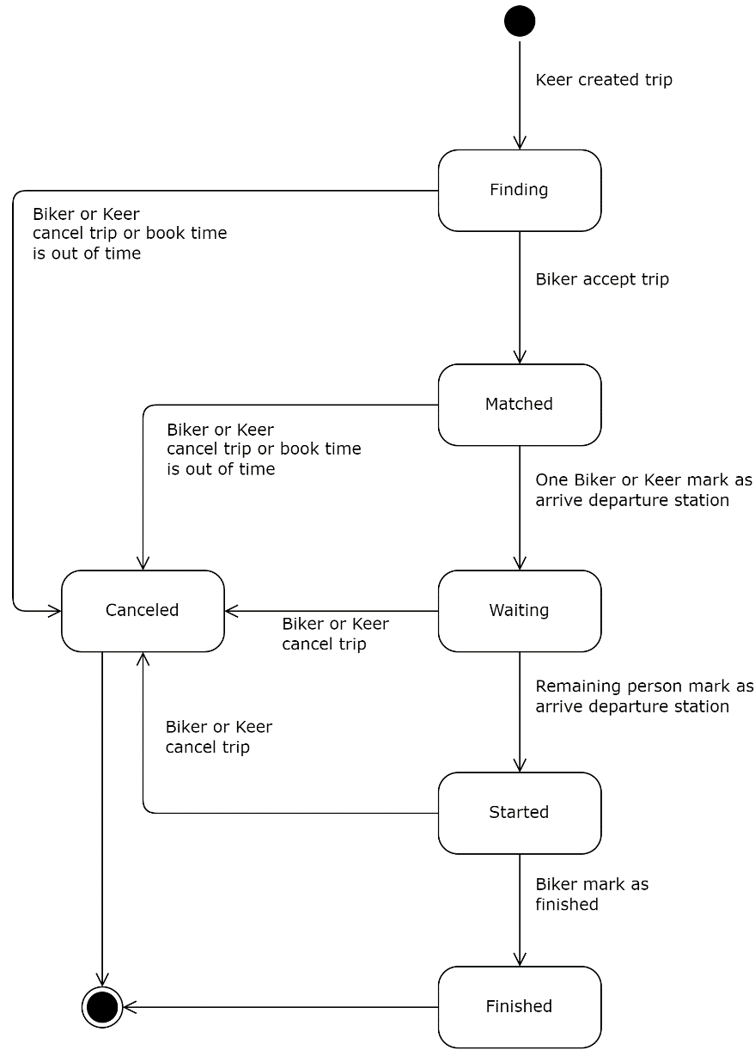

Figure 13. Trip's States

* 1. **Sequence Diagram**

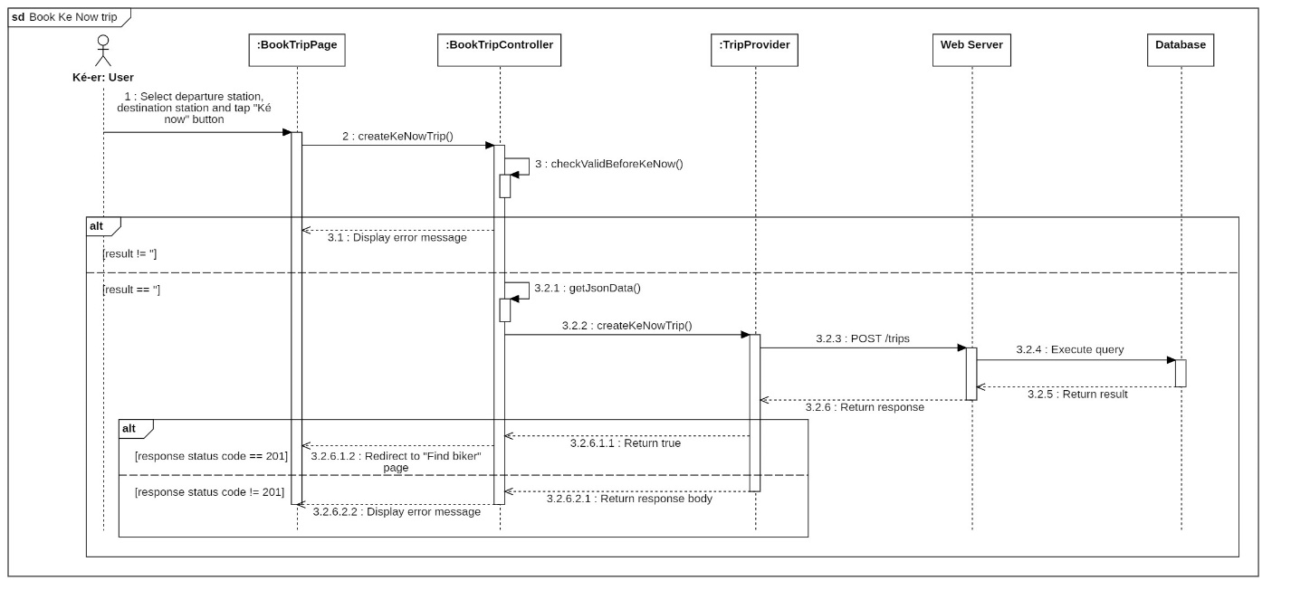

Figure 14. Create Trip Now Sequence Diagram

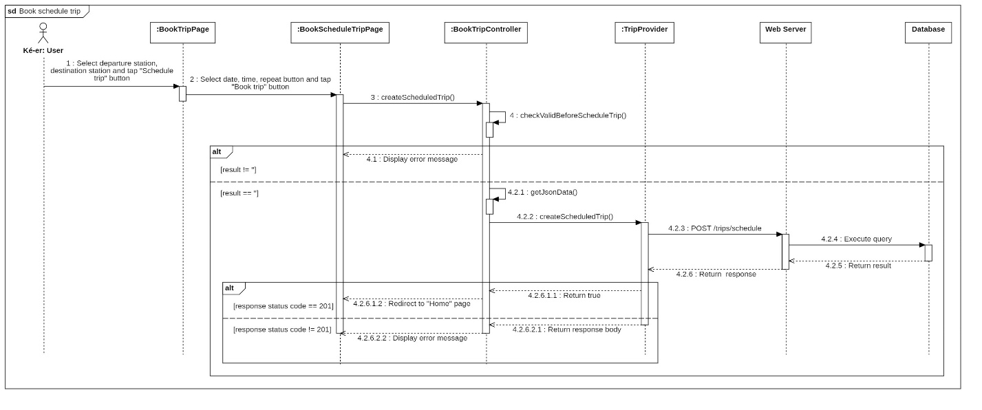

Figure 15. Create Schedule Trip Sequence Diagram

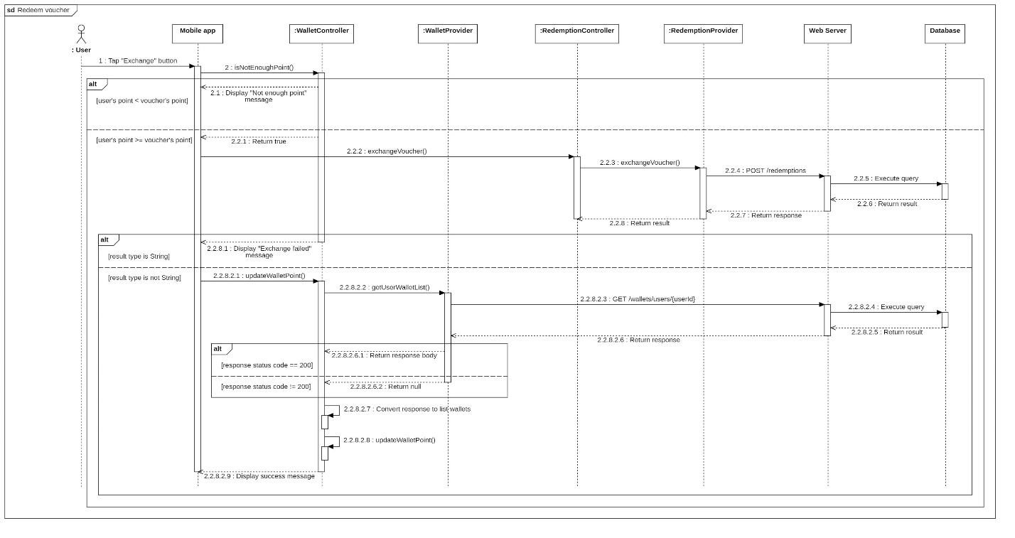

Figure 16. Redeem Voucher Sequence Diagram

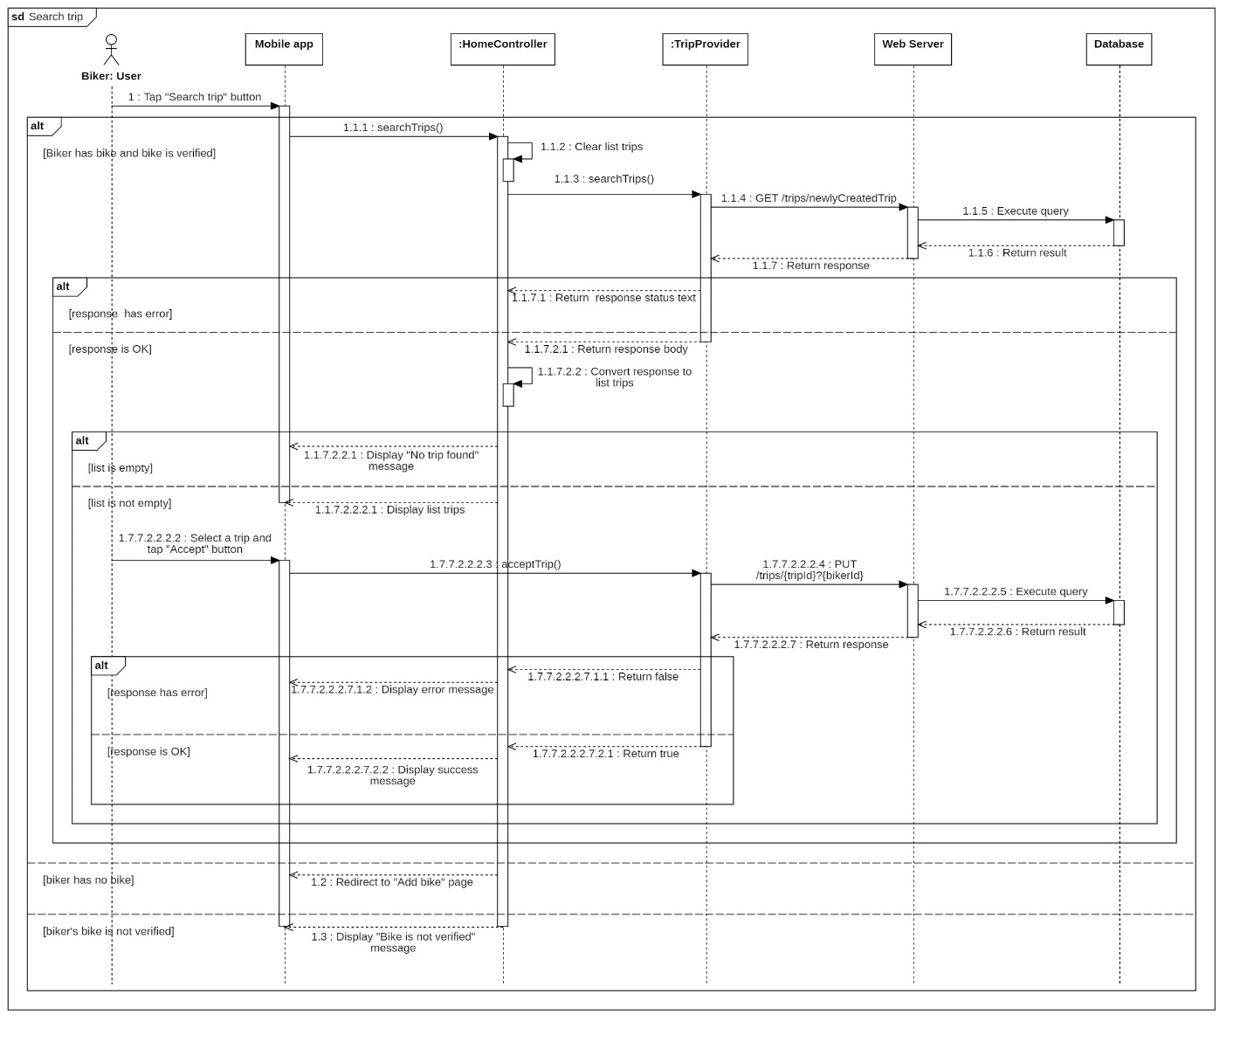

Figure 17. Search Trip Sequence Diagram

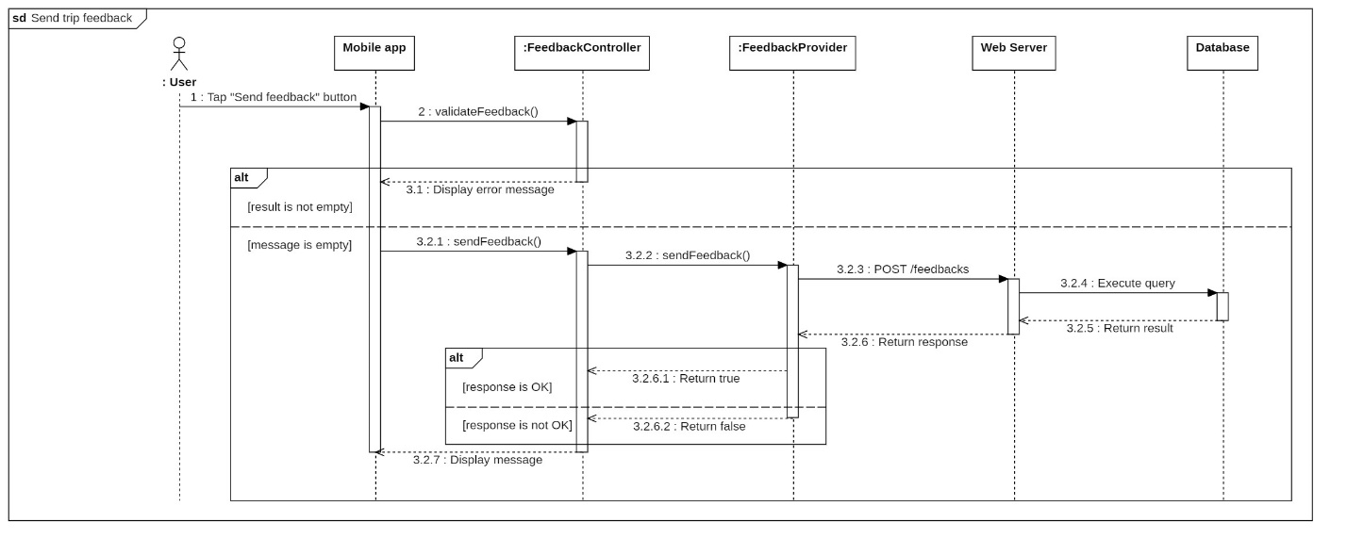

Figure 18. Send Trip Feedback Sequence Diagram

1. Data and Database Design
   1. **Database Design**

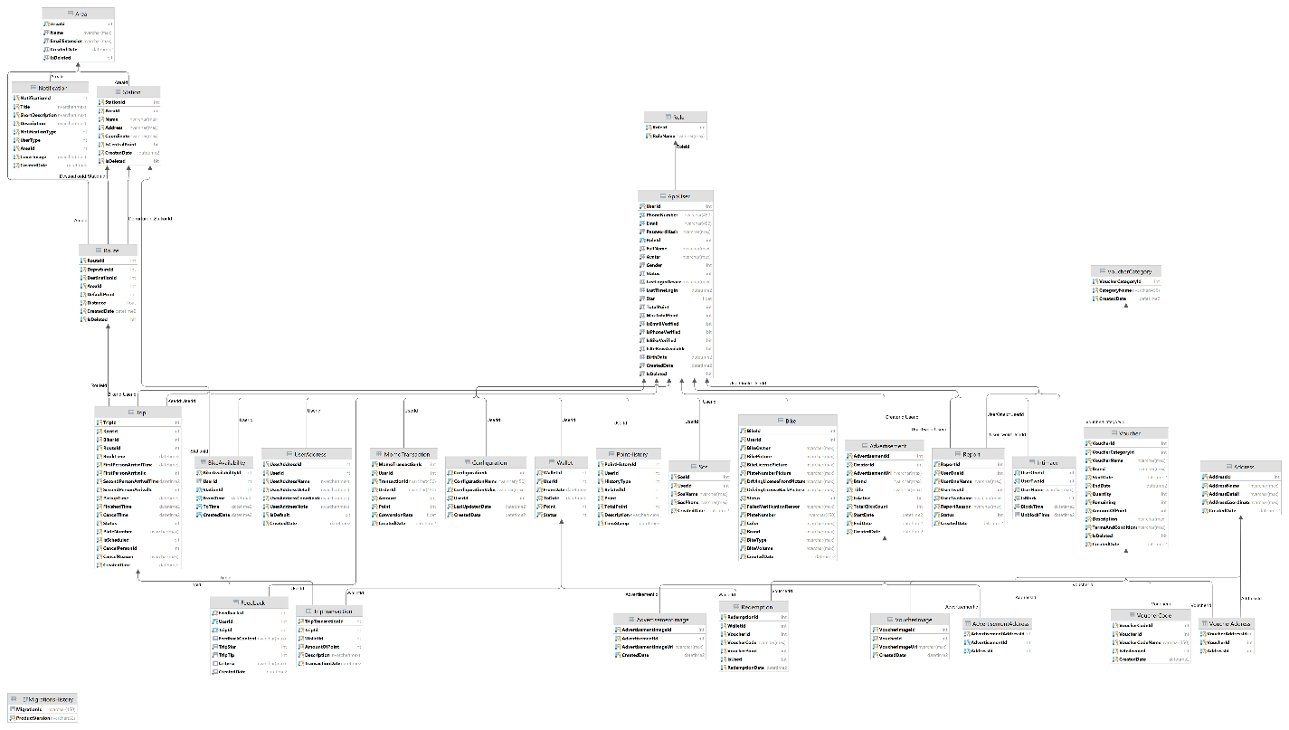

Figure 19. Physical Diagram

* 1. **Data File Design**
     1. **App User Table**

|  |  |  |  |  |  |
| --- | --- | --- | --- | --- | --- |
| **Field name** | **Type** | **Description** | **Unique** | **Not Null** | **PK/FK** |
| UserId | Int | Unique Identifier for user | Yes | Yes | PK |
| PhoneNumber | NVarchar(450) | Unique user’s phone numbers | Yes | Yes | No |
| UserEmail | Varchar(450) | User’s fpt’s contact email | Yes | Yes | No |
| RoleId | Int | Identifier for role | No | Yes | No |
| Gender | Int | User’s gender | No | No | No |
| Status | Int | User’s status | No | Yes | No |
| PasswordHash | Nvarchar(250) | User’s Biiké account password | No | Yes | No |
| CreatedDate | Datetime2 | Date user created Biiké account | No | Yes | No |
| IsDeleted | bit | If user’s account is deleted | No | Yes | No |
| FullName | NVarchar(max) | User’s full name | No | Yes | No |
| LastLoginDevice | NVarchar(Max) | User’s last login device name | No | No | No |
| LastTimeLogin | Datetime2 | Last time user login into Biiké application | No | No | No |
| Star | Float | User’s Biiké Star | No | Yes | No |
| TotalPoint | Int | User’s total point in Biiké | No | Yes | No |
| MaxTotalPoint | Int | User’s max total point | No | Yes | No |
| IsEmailVerify | Bit | If user’s email is verified or not | No | Yes | No |
| IsPhoneVerify | Bit | If user’s phone numbers is verified | No | Yes | No |
| IsKeNowAvailable | Bit | If user’s ke now mode is available | No | Yes | No |
| Is_bike_verify | Bit | If user’s bike is verified | No | Yes | No |
| Birthday | Datetime2 | User’s date of birth | No | No | No |

Table 73. App User Table

* + 1. **Bike Table**

|  |  |  |  |  |  |
| --- | --- | --- | --- | --- | --- |
| **Field name** | **Type** | **Description** | **Unique** | **Not Null** | **PK/FK** |
| BikeId | Int | Unique Identifier for bike | Yes | Yes | PK |
| UserId | Int | Unique Identifier for user | Yes | Yes | FK |
| PlateNumber | Varchar(45) | Identifier for biker’s bike | Yes | Yes | No |
| Color | Varchar(max) | Color of bike | No | Yes | No |
| IsDeleted | Bit | If Bike is deleted or not | No | Yes | No |
| BikeOwnver | Nvarchar(max) | Bike’s owner information | No | Yes | No |
| BikePicture | Nvarchar(max) | Bike’s picture | No | Yes | No |
| CreatedDate | Datetime2 | Date biker created bike | No | Yes | No |
| BikeLisencePicture | Nvarchar(max) | Picture of bike license | No | Yes | No |
| PlateNumberPicture | Nvarchar(max) | Picture of plate number | No | Yes | No |
| Status | Int | Status of bike | No | Yes | No |
| FailedVerificationReason | Nvarchar(max) | Reason the bike is failed to verified | No | No | No |
| Brand | Nvarchar(max) | Brand of bike | No | Yes | No |
| BikeType | Nvarchar(max) | Type of bike | No | Yes | No |
| BikeVolume | Nvarchar(max) | Volume of bike | No | Yes | No |

Table 74. Bike Table

* + 1. **Intimacy Table**

|  |  |  |  |  |  |
| --- | --- | --- | --- | --- | --- |
| **Field name** | **Type** | **Description** | **Unique** | **Not Null** | **PK/FK** |
| UserOneId | Int | Unique Identifier for user 1 | Yes | Yes | FK, PK |
| UserTwoId | Int | Unique Identifier for user 2 | Yes | Yes | FK, PK |
| UserName | Nvarchar(max) | Identifier name for user | No | Yes | No |
| Is_block | Bit | If user is block or not | No | Yes | No |
| UnblockTime | Datetime2 | Date user unblock other user | No | No | No |
| BlockTime | Datetime2 | Date user block other user | No | Yes | No |

Table 75. Intimacy Table

* + 1. **Wallet Table**

|  |  |  |  |  |  |
| --- | --- | --- | --- | --- | --- |
| **Field name** | **Type** | **Description** | **Unique** | **Not Null** | **PK/FK** |
| WalletId | Int | Unique Identifier for wallet | Yes | Yes | PK |
| UserId | Int | Unique Identifier for user | Yes | Yes | FK |
| Point | Int | Point of wallet | No | Yes | No |
| Status | Int | Status of wallet | No | Yes | No |
| FromDate | Datetime2 | Date wallet started | No | Yes | No |
| ToDate | Datetime2 | Date wallet expired | No | Yes | No |
| DrivingLisenceProntPicture | Nvarchar(max) | Pront picture of biker’s lisence | No | Yes | No |
| DrivingLisenceBaPictue | Nvarchar(max) | Back picture of biker’s picture | No | Yes | no |

Table 76. Wallet Table

* + 1. **Trip**

|  |  |  |  |  |  |
| --- | --- | --- | --- | --- | --- |
| **Field name** | **Type** | **Description** | **Unique** | **Not Null** | **PK/FK** |
| TripId | Int | Unique Identifier for trip | Yes | Yes | PK |
| KeerId | Int | Unique Identifier for Keer | Yes | Yes | FK |
| BikerId | Int | Unique Identifier for biker | Yes | No | FK |
| RouteId | Int | Unique Identifier for route | Yes | Yes | FK |
| BookTime | Datetime2 | Time the trip was book | No | Yes | No |
| PickUpTime | Datetime2 | Time pick up keer | No | No | No |
| FinishedTime | Datetime2 | Time the trip is finished | No | No | No |
| CancelTime | Datetime2 | Time the trip is canceled | No | No | No |
| Status | Int | Status of trip | No | Yes | No |
| PlateNumber | Nvarchar(max) | Number plate of bike | No | No | No |
| CancelPersonId | Int | Unique Identifier for cancel person | No | No | No |
| IsScheduled | Bit | If the trip is schedule or not | No | Yes | No |
| CancelReason | Nvarchar(max) | Reason cancel trip | No | No | No |
| CreatedDate | Datetime2 | Date the trip was created | No | Yes | No |
| FirstPersonArrivedId | Int | ID of first person arrived in pick up position | No | No | No |
| SencondPersonArrivedId | Int | ID of second person arrived in pick up position | No | No | No |
| FirstPersonArrivedTime | Datetime2 | Time the first person arrived in pick up location | No | No | No |
| SecondPersonArrivedTime | Datetime2 | Time the second person arrived in pick up location | No | No | no |

Table 77. Trip Tabel

* + 1. **Route Table**

|  |  |  |  |  |  |
| --- | --- | --- | --- | --- | --- |
| **Field name** | **Type** | **Description** | **Unique** | **Not Null** | **PK/FK** |
| RouteId | Int | Unique Identifier for route | Yes | Yes | PK |
| DepartureId | Int | Unique Identifier for departure station | Yes | Yes | FK |
| DestinationId | Int | Unique Identifier for destination station | Yes | Yes | FK |
| AreaId | Int | Unique Identifier for area | Yes | Yes | FK |
| DefaultPoint | Int | Default point of trip | No | Yes | No |
| IsDeleted | Bit | If the trip is deleted or not | No | Yes | No |
| Distance | Float | Distance of the route | No | Yes | No |

Table 78. Route Table

* + 1. **Station Table**

|  |  |  |  |  |  |
| --- | --- | --- | --- | --- | --- |
| **Field name** | **Type** | **Description** | **Unique** | **Not Null** | **PK/FK** |
| StationId | Int | Unique Identifier for station | Yes | Yes | PK |
| AreaId | Int | Unique Identifier for area | Yes | Yes | FK |
| Address | Nvarchar(max) | Address of station | No | Yes | No |
| IsDeleted | Bit | Is station is deleted or not | No | Yes | No |
| Name | Nvarchar(max) | Name of station | No | Yes | No |
| Coordinate | Nvarchar(max) | Coordinate of station | No | Yes | No |
| CreatedDate | Datetime 2 | Date station was created | No | Yes | No |
| IsCentralPoint | Bit | If the position is central point of Biiké list position | No | Yes | No |

Table 79. Station Table

* + 1. **Area Table**

|  |  |  |  |  |  |
| --- | --- | --- | --- | --- | --- |
| **Field name** | **Type** | **Description** | **Unique** | **Not Null** | **PK/FK** |
| AreaId | Int | Unique Identifier for area | Yes | Yes | PK |
| Name | Nvarchar(max) | Name of area | No | Yes | No |
| IdDeleted | Bit | If area is deleted or not | No | Yes | No |
| CreatedDate | Datetime2 | Date area was created | No | Yes | No |
| EmailExtension | Nvarchar(max) | Condition for sufix of user’s rgister email | No | Yes | No |

Table 80. Area Table

* + 1. **Trip Transaction Table**

|  |  |  |  |  |  |
| --- | --- | --- | --- | --- | --- |
| **Field name** | **Type** | **Description** | **Unique** | **Not Null** | **PK/FK** |
| TripTransactionId | Int | Unique Identifier for trip transaction | Yes | Yes | PK |
| TripId | Int | Unique Identifier for trip | Yes | Yes | FK |
| WalletId | Int | Unique Identifier for wallet | Yes | Yes | FK |
| TransactionDate | Datetime2 | Date transaction was made | No | Yes | No |
| AmountOfPoint | Int | Amount point of trip | No | Yes | No |
| Description | Nvarchar(max) | Description of trip | No | Yes | No |

Table 81. Trip Transaction Table

* + 1. **Feedback Table**

|  |  |  |  |  |  |
| --- | --- | --- | --- | --- | --- |
| **Field name** | **Type** | **Description** | **Unique** | **Not Null** | **PK/FK** |
| FeedbackId | Int | Unique Identifier for feedback | Yes | Yes | PK |
| UserId | Int | Unique Identifier for user | Yes | Yes | FK |
| TripId | V | Unique Identifier for trip | Yes | Yes | FK |
| FeedbackContent | Nvarchar(max) | Feedback content | No | No | No |
| TripStar | Int | Star of trip | No | Yes | No |
| Criteria | Nvarchar(max) | Criteria for feedback | No | No | No |
| CreatedDate | Datetime2 | Date feedback was sent | No | Yes | No |
| TripTip | Int | Tip of keer to biker | No | Yes | No |

Table 82. Feedback Table

* + 1. **Redemption Table**

|  |  |  |  |  |  |
| --- | --- | --- | --- | --- | --- |
| **Field name** | **Type** | **Description** | **Unique** | **Not Null** | **PK/FK** |
| RedeemtionId | Int | Unique Identifier for redemption | Yes | Yes | PK |
| WalletId | Int | Unique Identifier for wallet | Yes | Yes | FK |
| VoucherId | Int | Unique Identifier for voucher | Yes | Yes | FK |
| VoucherCode | Varchar(max) | Code of voucher | Yes | Yes | No |
| VoucherPoint | Int | Point to exchange voucher | No | Yes | No |
| IsUsed | Bit | If voucher is used or not | No | Yes | No |
| RedemptionDate | Datetime2 | Date redemption was made | No | Yes | No |
| IsDeleted | Bit | If voucher is deleted or notq | No | Yes | No |

Table 83. Redemption Table

* + 1. **Voucher Table**

|  |  |  |  |  |  |
| --- | --- | --- | --- | --- | --- |
| **Field name** | **Type** | **Description** | **Unique** | **Not Null** | **PK/FK** |
| VoucherId | Int | Unique Identifier for voucher | Yes | Yes | PK |
| VoucherCategoryId | Int | Unique Identifier for voucher category | Yes | Yes | FK |
| VoucherName | NVarchar(max) | Name of voucher | Yes | Yes | No |
| StartDate | Datetime2 | Date voucher started available | No | Yes | No |
| EndDate | Datetime2 | Date voucher expired | No | Yes | No |
| Quantity | Int | Quantity of vouchers | No | Yes | No |
| Remaining | Int | Number voucher remaining | No | Yes | No |
| AmountPoint | Int | Amount of point to exchange voucher | No | Yes | No |
| Description | Nvarchar(max) | Description of voucher | No | Yes | No |
| TermsAndConditions | NVarchar(max) | Terms and conditions to use voucher | No | Yes | No |
| CreatedDate | Datetime2 | Date voucher was created | No | Yes | No |
| Brand | Nvarchar(max) | Brand of voucher | No | Yes | No |

Table 84. Voucher Table

* + 1. **Advertisement Table**

|  |  |  |  |  |  |
| --- | --- | --- | --- | --- | --- |
| **Field name** | **Type** | **Description** | **Unique** | **Not Null** | **PK/FK** |
| AdsId | Int | Unique Identifier for ads | Yes | Yes | PK |
| AdsUrl | Varchar(max) | url of ads | No | Yes | No |
| CreatorId | Int | Unique Identifier for creator | No | Yes | No |
| Brand | Nvarchar(max) | Brand of ads | No | Yes | No |
| Title | Nvarchar(max) | Title of ads | No | Yes | No |
| Is_Active | Bit | If advertisement is active or not | No | Yes | No |
| TotalClickCount | Int | Times ads is clicked | No | Yes | No |
| StartDate | Datetime2 | Date ads started | No | Yes | No |
| EndDate | Datetime2 | Date ads ended | No | Yes | No |
| CreatedDate | Datetime2 | Date ads created | No | Yes | No |

Table 85. Advertisement Table

* + 1. **Report Table**

|  |  |  |  |  |  |
| --- | --- | --- | --- | --- | --- |
| **Field name** | **Type** | **Description** | **Unique** | **Not Null** | **PK/FK** |
| ReportId | Int | Unique Identifier for report | Yes | Yes | PK |
| UserOneId | Int | Unique Identifier for user 1 | Yes | Yes | FK |
| UserTwoId | Int | Unique Identifier for user 2 | Yes | Yes | FK |
| UserOneName | Nvarchar(max) | Name of user 1 | No | Yes | No |
| UserTwoName | Nvarchar(max) | Name of user 2 | No | Yes | No |
| ReportReason | Nvarchar(max) | Reason why user report other user | No | Yes | No |
| CreatedDate | Datetime2 | Date report request created | No | Yes | No |

Table 86. Report Table

* + 1. **S.O.S Table**

|  |  |  |  |  |  |
| --- | --- | --- | --- | --- | --- |
| **Field name** | **Type** | **Description** | **Unique** | **Not Null** | **PK/FK** |
| SosId | Int | Unique Identifier for sos | Yes | Yes | PK |
| UserId | Int | Unique Identifier for user | Yes | Yes | FK |
| SoSName | Nvarchar(max) | Name of sos person | No | Yes | No |
| SosPhone | Nvarchar(max) | Phone of s.o.s person | No | Yes | No |
| CreatedDate | Datetime2 | Date created sos number | No | Yes | No |

Table 87. S.O.S Table

* + 1. **Point History Table**

|  |  |  |  |  |  |
| --- | --- | --- | --- | --- | --- |
| **Field name** | **Type** | **Description** | **Unique** | **Not Null** | **PK/FK** |
| PointHistoryId | Int | Unique Identifier for point history | Yes | Yes | PK |
| UserId | Int | Unique Identifier for user | Yes | Yes | FK |
| HistoryType | Int | Type of history | No | Yes | No |
| RealatedId | Int | Unique Identifier for related | No | Yes | No |
| Point | Int | Amount of point | No | Yes | No |
| Total point | Int | Total amount point | No | Yes | No |
| Description | Nvarchar(max) | Description of point history | No | Yes | No |
| TimeStamp | Datetime2 | Time stamp of point history | No | Yes | No |

Table 88. Point History Table

* + 1. **User Address Table**

|  |  |  |  |  |  |
| --- | --- | --- | --- | --- | --- |
| **Field name** | **Type** | **Description** | **Unique** | **Not Null** | **PK/FK** |
| UserAddressId | Int | Unique Identifier for user address | Yes | Yes | PK |
| UserId | Int | Unique Identifier for user | Yes | Yes | FK |
| UserAdderssName | Nvarchar(max) | Name of user’s address displayed on Biiké | No | Yes | No |
| UserAddressCordinate | Nvarchar(max) | Coordinate of user’s address | No | Yes | No |
| UserAddressNote | Nvarchar(max) | Address noted by user | No | Yes | No |
| ReportReason | Nvarchar(max) | Reason why user report other user | No | Yes | No |
| CreatedDate | Datetime2 | Date report request created | No | Yes | No |

Table 89. User Address Table

* + 1. **Address Table**

|  |  |  |  |  |  |
| --- | --- | --- | --- | --- | --- |
| **Field name** | **Type** | **Description** | **Unique** | **Not Null** | **PK/FK** |
| AdderssId | Int | Unique Identifier for address | Yes | Yes | PK |
| AddressName | Nvarchar(max) | Identifier for address | No | Yes | No |
| AddressDetails | Nvarchar(max) | Address details information | No | Yes | No |
| AddressCoordinate | Nvarchar(max) | Coordinate of address | No | Yes | No |
| CreatedDate | Datetime2 | Date address created | No | Yes | No |

Table 90. Address Table

* + 1. **Advertisement Address Table**

|  |  |  |  |  |  |
| --- | --- | --- | --- | --- | --- |
| **Field name** | **Type** | **Description** | **Unique** | **Not Null** | **PK/FK** |
| AdvertisementAddressId | Int | Unique Identifier for advertisement address | Yes | Yes | PK |
| AdvertisementId | Int | Unique Identifier for advertisement | Yes | Yes | FK |
| AddressId | Int | Unique Identifier for address | Yes | Yes | FK |

Table 91. Advertisement Address

* + 1. **Advertisement Image Table**

|  |  |  |  |  |  |
| --- | --- | --- | --- | --- | --- |
| **Field name** | **Type** | **Description** | **Unique** | **Not Null** | **PK/FK** |
| AdvertisementImageId | Int | Unique Identifier for advertisement image | Yes | Yes | PK |
| AdvertisementId | Int | Unique Identifier for advertisement | Yes | Yes | FK |
| AdvertisementImageUrl | Nvarchar(max) | Url of advertisement image | No | Yes | No |
| CreatedDate | Datetime2 | Date Image was created | No | Yes | No |

Table 92. Advertisement Image Table

* + 1. **Voucher Code Table**

|  |  |  |  |  |  |
| --- | --- | --- | --- | --- | --- |
| **Field name** | **Type** | **Description** | **Unique** | **Not Null** | **PK/FK** |
| VoucherCodeId | Int | Unique Identifier for voucher code | Yes | Yes | PK |
| VoucherId | Int | Unique Identifier for voucher | Yes | Yes | FK |
| VoucherCodeName | Nvarchar(450) | Name of voucher code | Yes | Yes | No |
| IsRedeemed | Bit | If this voucher code is redeemed | No | Yes | No |
| CreatedDate | Datetime2 | Date voucher code created | No | Yes | No |

Table 93. Voucher Code Table

* + 1. **Voucher Category Table**

|  |  |  |  |  |  |
| --- | --- | --- | --- | --- | --- |
| **Field name** | **Type** | **Description** | **Unique** | **Not Null** | **PK/FK** |
| VoucherCategoryId | Int | Unique Identifier for voucher category | Yes | Yes | PK |
| CategoryName | Nvarchar(450) | Identifier for category | Yes | Yes | No |
| CreatedDate | Datetime2 | Date voucher category created | No | Yes | No |

Table 94. Voucher Category table

* + 1. **Voucher Image Table**

|  |  |  |  |  |  |
| --- | --- | --- | --- | --- | --- |
| **Field name** | **Type** | **Description** | **Unique** | **Not Null** | **PK/FK** |
| VoucherAddressId | Int | Unique Identifier for voucher address | Yes | Yes | PK |
| VoucherId | Int | Identifier for voucher | Yes | Yes | FK |
| CreatedDate | Datetime2 | Date voucher image created | No | Yes | No |
| VoucherImageUrl | Nvarchar(max) | Url of voucher image | No | Yes | No |

Table 95. Voucher Image Table

* + 1. **Voucher Address Table**

|  |  |  |  |  |  |
| --- | --- | --- | --- | --- | --- |
| **Field name** | **Type** | **Description** | **Unique** | **Not Null** | **PK/FK** |
| VoucherAddressId | Int | Unique Identifier for voucher address | Yes | Yes | PK |
| VoucherId | Int | Identifier for voucher | Yes | Yes | FK |
| AddressId | Int | Identifier for address | Yes | Yes | FK |

Table 96. Voucher Address Table

* + 1. **Role Table**

|  |  |  |  |  |  |
| --- | --- | --- | --- | --- | --- |
| **Field name** | **Type** | **Description** | **Unique** | **Not Null** | **PK/FK** |
| RoleId | Int | Unique Identifier for role | Yes | Yes | PK |
| RoleName | Nvarchar(450) | Identifier for voucher | Yes | Yes | FK |

Table 97. Role Table

* + 1. **Notification Table**

|  |  |  |  |  |  |
| --- | --- | --- | --- | --- | --- |
| **Field name** | **Type** | **Description** | **Unique** | **Not Null** | **PK/FK** |
| NotificationId | Int | Unique Identifier notification | Yes | Yes | PK |
| AreaId | Int | Identifier for area | Yes | Yes | FK |
| Title | Int | Title of notification displayed on Biiké application | No | Yes | No |
| ShortDescription | Nvarchar(max) | Short description of notification shows on screen | No | Yes | No |
| Description | Nvarchar(max) | Full description of notification | No | Yes | No |
| NotificationType | Int | Type of notification | No | Yes | No |
| UserType | Int | Type of user | No | Yes | No |
| CoverImage | Nvarchar(max) | Image of notification | No | Yes | No |
| CreatedDate | Datetime2 | Date notification created | No | Yes | No |

Table 98. Notification Table

* + 1. **Bike Availability Table**

|  |  |  |  |  |  |
| --- | --- | --- | --- | --- | --- |
| **Field name** | **Type** | **Description** | **Unique** | **Not Null** | **PK/FK** |
| BikeAvailabilityId | Int | Unique Identifier bike availability | Yes | Yes | PK |
| UserId | Int | Identifier for user | Yes | Yes | FK |
| StationId | Int | Identifier for station | Yes | Yes | FK |
| FromTime | Datetime2 | Time biker available: from | No | Yes | No |
| ToTime | Datetime2 | Time biker available: to | No | Yes | No |
| CreatedDate | Datetime2 | Date created bike availability | No | Yes | No |

Table 99. Bike Availability Table

* + 1. **Momo Transaction Table**

|  |  |  |  |  |  |
| --- | --- | --- | --- | --- | --- |
| **Field name** | **Type** | **Description** | **Unique** | **Not Null** | **PK/FK** |
| MomoTransactionId | Int | Unique Identifier for momo transaction | Yes | Yes | PK |
| UserId | Int | Identifier for user | Yes | Yes | FK |
| TransactionId | Nvarchar(450) | Identifier for transaction | Yes | Yes | No |
| OrderId | Nvarchar(450) | Identifier for order | Yes | Yes | No |
| Amount | Int | Amount of order | No | No | No |
| Point | Int | Amount of point in transaction | No | No | No |
| ConversionRate | float | Rate convert from VND currency to Biiké point | No | No | No |
| createdDate | Datetime2 | Date created transaction | No | No | No |

Table 100. Momo Transaction Table

* + 1. **Configuration Table**

|  |  |  |  |  |  |
| --- | --- | --- | --- | --- | --- |
| **Field name** | **Type** | **Description** | **Unique** | **Not Null** | **PK/FK** |
| ConfigurationId | Int | Unique Identifier for configuration | Yes | Yes | PK |
| UserId | Int | Identifier for user | Yes | Yes | FK |
| ConfigurationName | Nvarchar(450) | Name of configuration | Yes | Yes | No |
| ConfigurationValue | Nvarchar(max) | Value of configuration | No | No | No |
| LastUpdatedDate | Datetime2 | Date configuration update last time | No | No | No |
| CreatedDate | Datetime2 | Date configuration was created | No | No | No |

Table 101. Configuration Table

1. Algorithm
   1. **Create station in an area**
      1. **Definition**

* Create station in an area is let admin create a station that is really in that area with a certain distance. Biiké need to avoid station that is not in that area.
  + 1. **Define problem**
* We use coordinates of central point and new station, check if it's distance is smaller than valid radius (Configuration Table), Biiké will accept action create station
  + 1. **Solution**
* Get new station coordinate, central point coordinate and valid radius (Configuration Table)
* Calculate the distance from new station to central point using Haversine formula:
* Set lat1 and long1 are latitude and longitude of new station.
* Set lat2 and long2 are the latitude and longitude of the central point.
* R = earth’s radius (mean radius = 6,371km)
* Δlat = lat2− lat1
* Δlong = long2− long1
* a = sin²(Δlat/2) + cos(lat1).cos(lat2).sin²(Δlong/2)
* c = 2.atan2(√a, √(1−a))
* d = R.c
* d is the distance from new station to the central point
* If the distance is less than valid radius then Biiké accept admin action.
  + 1. **Complexity**
* The complexity of this algorithm is simple.
  1. **Mark as arrived or finished trip**
     1. **Definition**
* Mark as arrived or finish is to let biker or keer confirm that they are arrive the departure station or destination station. Biiké need to avoid frauds (mark as arrived or finish at any where to get point in an invalid way).
  + 1. **Define problem**
* We use coordinates of user location and corresponding station, check if it's distance is smaller than 500m, Biiké will accept action "mark as arrived" or "finish"
  + 1. **Solution**
* Get user location and corresponding station.
* Calculate the distance from user location to station using **Haversine formula**:
  + Set lat1 and long1 are latitude and longitude of use location.
  + Set lat2 and long2 are the latitude and longitude of the station.
  + R = earth’s radius (mean radius = 6,371km)
  + Δlat = lat2− lat1
  + Δlong = long2− long1
  + a = sin²(Δlat/2) + cos(lat1).cos(lat2).sin²(Δlong/2)
  + c = 2.atan2(√a, √(1−a))
  + d = R.c
  + d is the distance from user location to the station
* If the distance is less than 500m then Biiké accept user action.
  + 1. **Complexity**
* The complexity of this algorithm is simple.

1. Software Testing Documentation
2. Overall Description
   1. **Test Model**

In Biiké project, we apply Incremental testing for many purposes:

* Each Module provides a definitive role to play in the project structure
* Some function testing can start at early step of the develop process
  1. **Testing Levels:** 
     + Testing Level: System Test, User Acceptance Test
     + Testing Types: Functional Testing, User Interface Testing

1. Test Plan
   1. **Test Stages**

|  |  |  |  |
| --- | --- | --- | --- |
| **Type Of Test** | **Stage Of Test** | | |
| **Unit** | **System** | **Acceptance** |
| Function Testing |  | X |  |
| User Interface Testing |  | X |  |

* 1. **Resources**

|  |  |  |
| --- | --- | --- |
| **Worker** | **Role** | **Specific Responsibilities** |
| Đỗ Hữu Phát | Leader | Planing, verify test reseult, assign test function to members |
| Lê Nguyễn Thảo Vân | Member | Execute test and reports as planned |
| Nguyễn Thế Thanh Tâm | Member | Execute test and reports as planned |
| Nguyễn Lê Phương Uyên | Member | Execute test and reports as planned |
| Đinh Phan Hải Triều | Member | Execute test and reports as planned |

* 1. **Test Milestones**

|  |  |  |
| --- | --- | --- |
| **No.** | **Deliverables** | **Due Date** |
| 1 | Test document | 2/12/2021 |

1. Test Cases & Test Reports

|  |  |
| --- | --- |
| **Testing Level** | **File Name** |
| System Test | [Biiké - Test Case (Mobile App).xlsx](https://1drv.ms/x/s!ApXZS3wt9T_0o8oc-7rNI5BmObkJyg?e=qtHrHt) [Biiké - Test Case (Web Admin).xlsx](https://1drv.ms/x/s!ApXZS3wt9T_0o8odz2ZPjqPdUI_H7w?e=vnrhza) |
| Acceptance Test | Due to Covid-19 pandemic, there was a difficulty in performing acceptance test |

1. Release Package and User Guides
2. Deliverable Package
   1. **Source Codes and Documents**

| **No.** | **Items** | **Sub-Items** | **Type** | **Version** |
| --- | --- | --- | --- | --- |
| **Code Package** | | | | |
| 1 | Mobile Module | FHA.UserApp | New | 1.1.0 |
| 2 | Web Module | FHA.WebAdminApplication | New | 1.1.0 |
| 3 | Web API Module | FHA.BatchAPI FHA.RoutingAPI |  |  |
| **Database** | | | | |
| 1 | Initialize Database | FHA.BatchScript | New | N/A |
| FHA.RoutingScript | New | N/A |
| **Documents** | | | | |
| 1 | Project Introduction | Report1_Project Introduction.docx |  |  |
| 2 | Project Management Plan | Report2_Project Management Plan.docx |  |  |
| 3 | Software Requirement Specification | Report3_System Requirement Specification.docx |  |  |
| 4 | Software Design Document | Report4_Software Design Document.docx |  |  |
| 5 | Test Documentation | Report5_Test Documentation.docx Report5_Test Case Document.xlsx |  |  |
| 6 | Software User Guides | Report6_Software User Guides.docx |  |  |
| 7 | Final Project Report | Report7_Final Project Report.docx Brief - Report7_Final Project Report.doc |  |  |
| 8 | Task sheet | Biiké – Detail Plan.xlsx |  |  |

Table 102. Source Codes and Documents

1. Installation Guide
   1. **System Requirements**
      1. **Hardware Requirement**

* Web Admin Application

|  |  |  |
| --- | --- | --- |
| **PC** | **Minimum** | **Recommended** |
| Internet connection | Cable, Wi-fi (4 Mbps) | Cable, Wi-fi (8 Mbps) |
| Processor | Intel Core i3 1.4Ghz | Intel Core i7 2.5Ghz |
| Memory | 4GB RAM | 8GB RAM |
| Storage | 5GB | 10GB |
| Web Browser | Chromes (v69 or higher) | Chrome latest stable version |

* Mobile Application

|  |  |
| --- | --- |
| **Operating System** | Android 5.1 or higher |
| **Processor** | Intel Atom® Processor Z2520 1.2 GHz, or faster processor |
| **Storage** | Between 1GB and 2GB |
| **RAM** | Minimum of 1GB, 2GB is recommend |

* + 1. **Software Requirement**

|  |  |  |
| --- | --- | --- |
| **Component** | **Name and Version** | **Description** |
| Operating System | Windows 7 SP1/8.1/10/Window Server 2016 or above (Web application)  Android 5.1 Lollipop or above (Mobile application) | Operating system for building production |
| DBMS | SQL Server 2019 | Used to manage database |
| .Net Core Runtime 3.0 Hosting bundles | 5GB | 10Gb |

Table 103. Software Requirement

* 1. **Setup Files**
* Biiké_User_App_1_1_0.apk
  1. **Installation Instruction**

Setup and start a Windows OS (Windows 10 or Windows Server 2016):

1. For further information: [Download Windows 10 | Microsoft](https://www.microsoft.com/vi-vn/windows/get-windows-10)
2. Setup a Windows Server 2016
   * 1. **Setup environments**
3. Mobile Application
4. Download the Flutter installation bundle [here](https://flutter.dev/docs/get-started/install/windows).
5. Extract the zip file and place the contained Flutter in the desired installation location for the Flutter SDK.

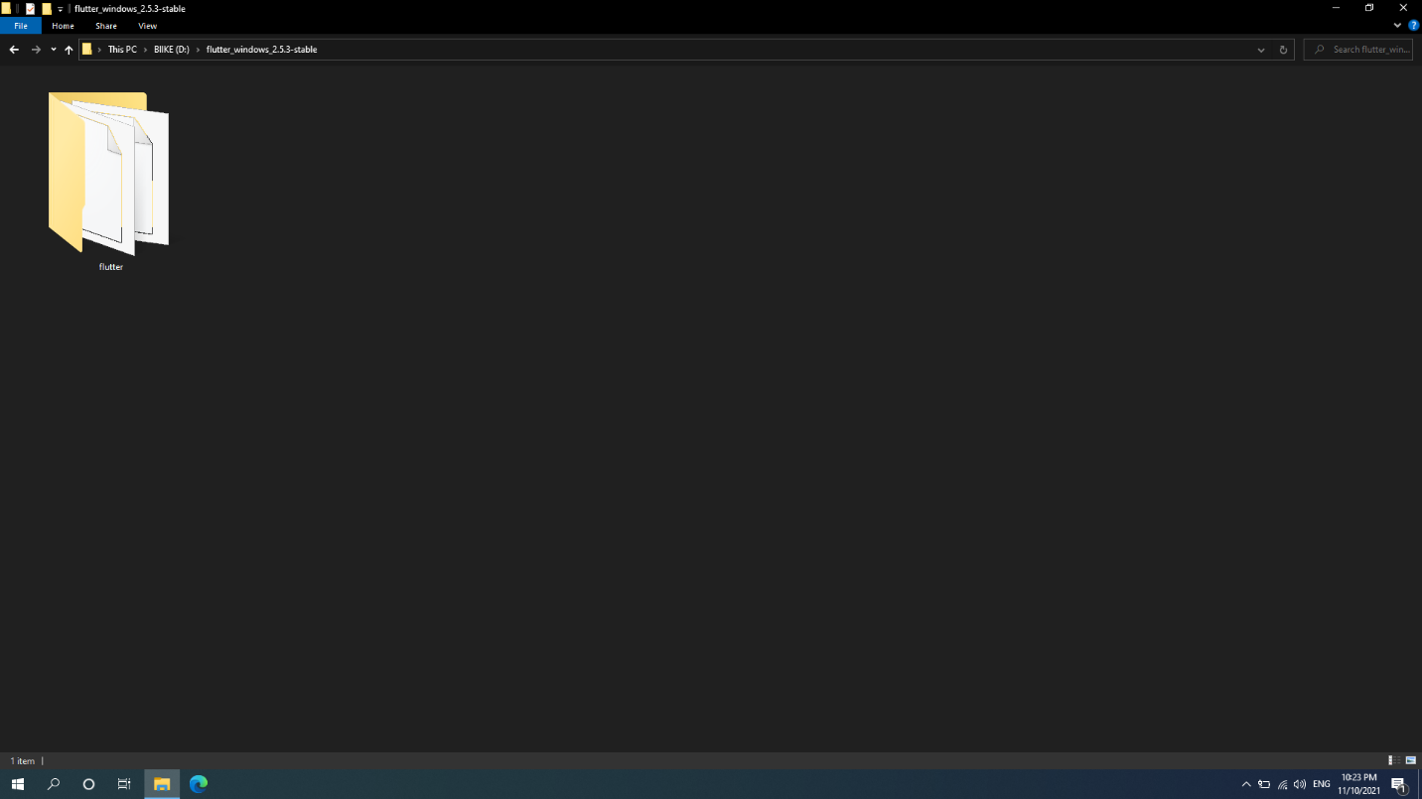

1. Update the path:

* From the Start search bar, enter ‘env’ and select **Edit environment variables for your account**.

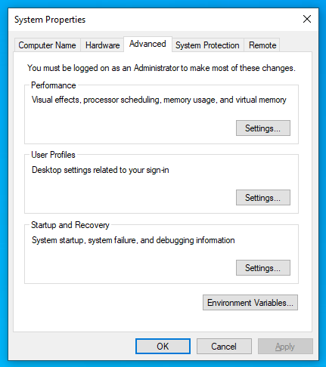

* Under User variables check if there is an entry called **Path:**

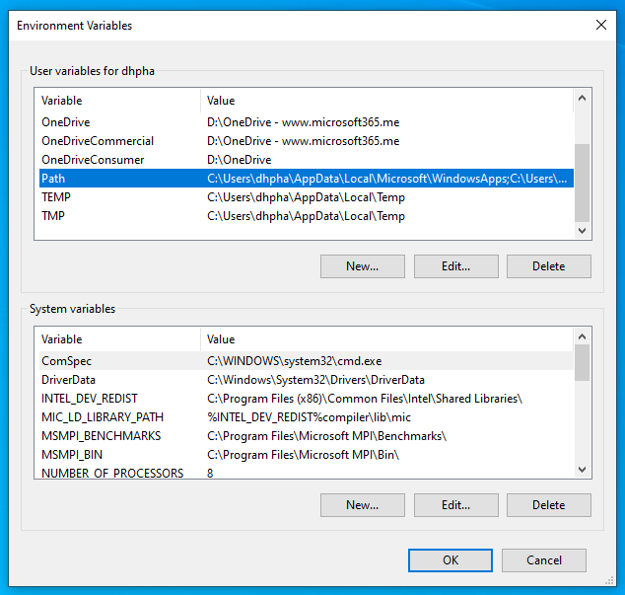

* If the entry exists, append the full path to flutter\bin using ‘;’ as a separator from existing values.
* If the entry does not exist, create a new user variable named Path with the full path to flutter\bin as its value.

1. Download and install [Android Studio](https://developer.android.com/studio).
2. Start Android Studio and go through the ‘Android Studio Setup Wizard’. This installs the latest Android SDK, Android SDK Command-line Tools, and Android SDK Build-Tools, which are required by Flutter when developing for Android.

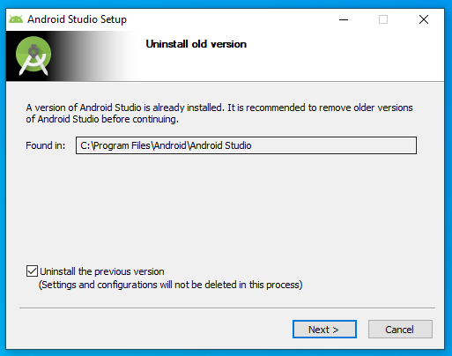

For more detail, see [here](https://flutter.dev/docs/get-started/install/windows).

1. Web Admin Application
2. Install Nodejs [here](https://nodejs.org/en/).
3. Start the Nodejs downloaded file and go through install.

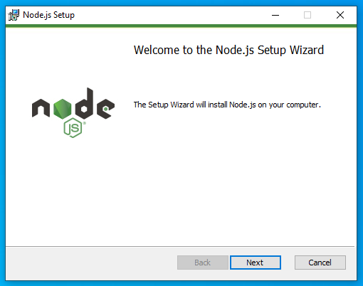

1. Open cmd and check the node version by run command *node-v*.
2. API Server Application
   1. Download .Net Core SDK x64 and .NET Core Runtime [here](https://dotnet.microsoft.com/download).
   2. Run the installer.

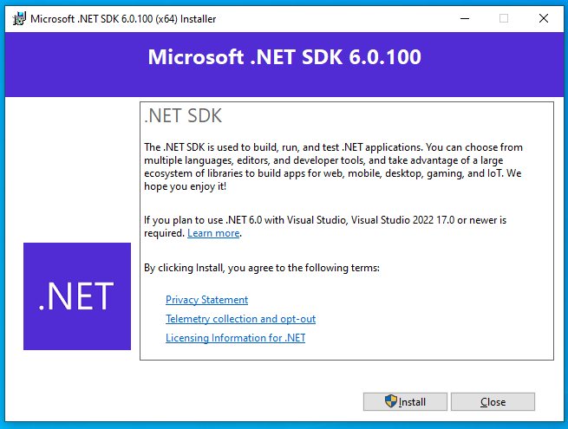

* + 1. **Setup Application**

1. Mobile Application
2. Go to the source code folder with cmd.

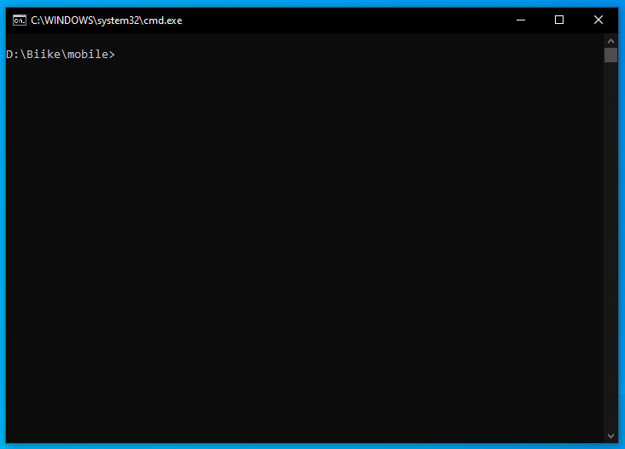

1. Run the flutter pub get command to get the project package.
2. Get the google-service .json file from Firebase project console. [See detail](https://firebase.flutter.dev/docs/installation/android/).  
   Add file to project folder for using firebase authentication.
3. Run the flutter build apk command to build the apk file.
4. Web Admin Application
5. Go to the source code folder with cmd.
6. Run the yarn command to get the project package.
7. Run the yarn dev command to build the project. The final source folder is the dist folder
8. Web API Application
9. Go to the source code folder.
10. Open SQL Server Management Studio (SSMS) and modify connection string to match with your local connection string in appsettings.Development.json
11. Build and run
12. User Manual
    1. **Terms and Definitions**

N/A

* 1. **System Requirement**
     1. **Hardware Requirement**

|  |  |  |  |
| --- | --- | --- | --- |
| **Type** | **Part/Component** | **Minimum** | **Recommended** |
| Computer | OS supported | Windows7 SP1 or later (64-bit), Linux | _ |
| Computer | Network | LAN | LAN and Internet |
| Computer | RAM | 4GB | >= 8GB |
| Computer | HDD | 100GB | >= 200GB |
| Computer | Ports | USB, Network | _ |
| Mobile | Camera | 2MP | - |

Table 104. Hardware Requirements

* + 1. **Software Requirement**
* Git v2.3.
* .NET Core Runtime 3.1 Hosting bundles.
* Nodejs v14.
* Android SDK, Flutter SDK 1.6 ([Detail](https://flutter.dev/docs/get-started/install/windows)).
  1. **Application Usage**
     1. **Overview**



Figure 20. Application Usage Overview

* + 1. **Admin Module**

1. Admin login to system

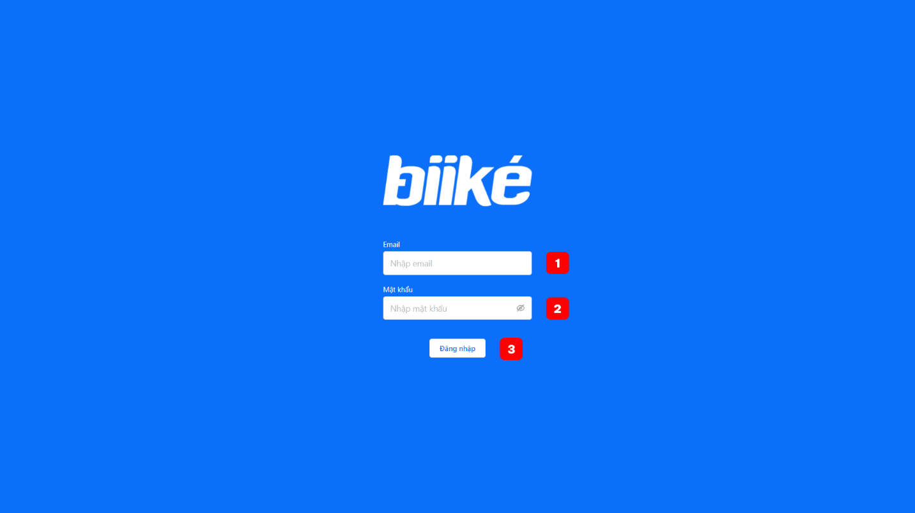

|  |  |  |  |  |  |  |
| --- | --- | --- | --- | --- | --- | --- |
| **No** | **Field Name** | **Description** | **Read only** | **Mandatory** | **Control type** | **Data type** |
| 1 | Email | The email of admin account | No | Yes | Text Box | String |
| 2 | Password | The password of admin account | No | Yes | Text Box | String |

1. View dashboard

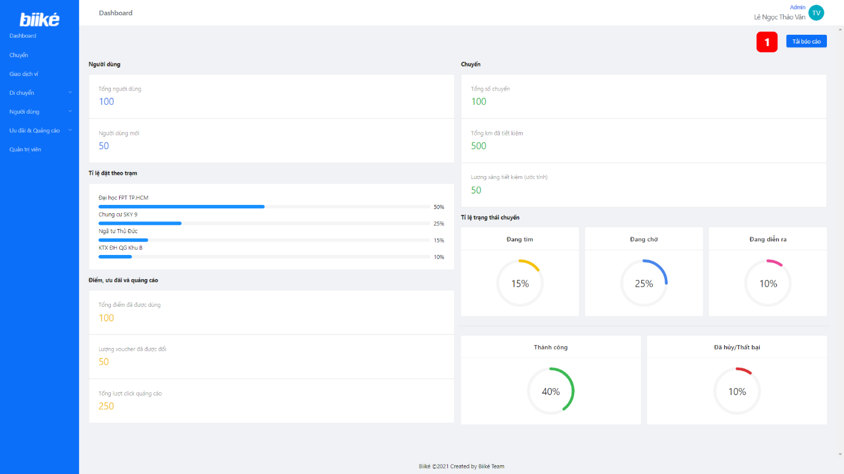

|  |  |  |  |  |
| --- | --- | --- | --- | --- |
| **No** | **Function** | **Description** | **Validation** | **Outcome** |
| 1 | Download Report | Download the analysis report | No | PDF File include data from dashboard page |

1. View trip list

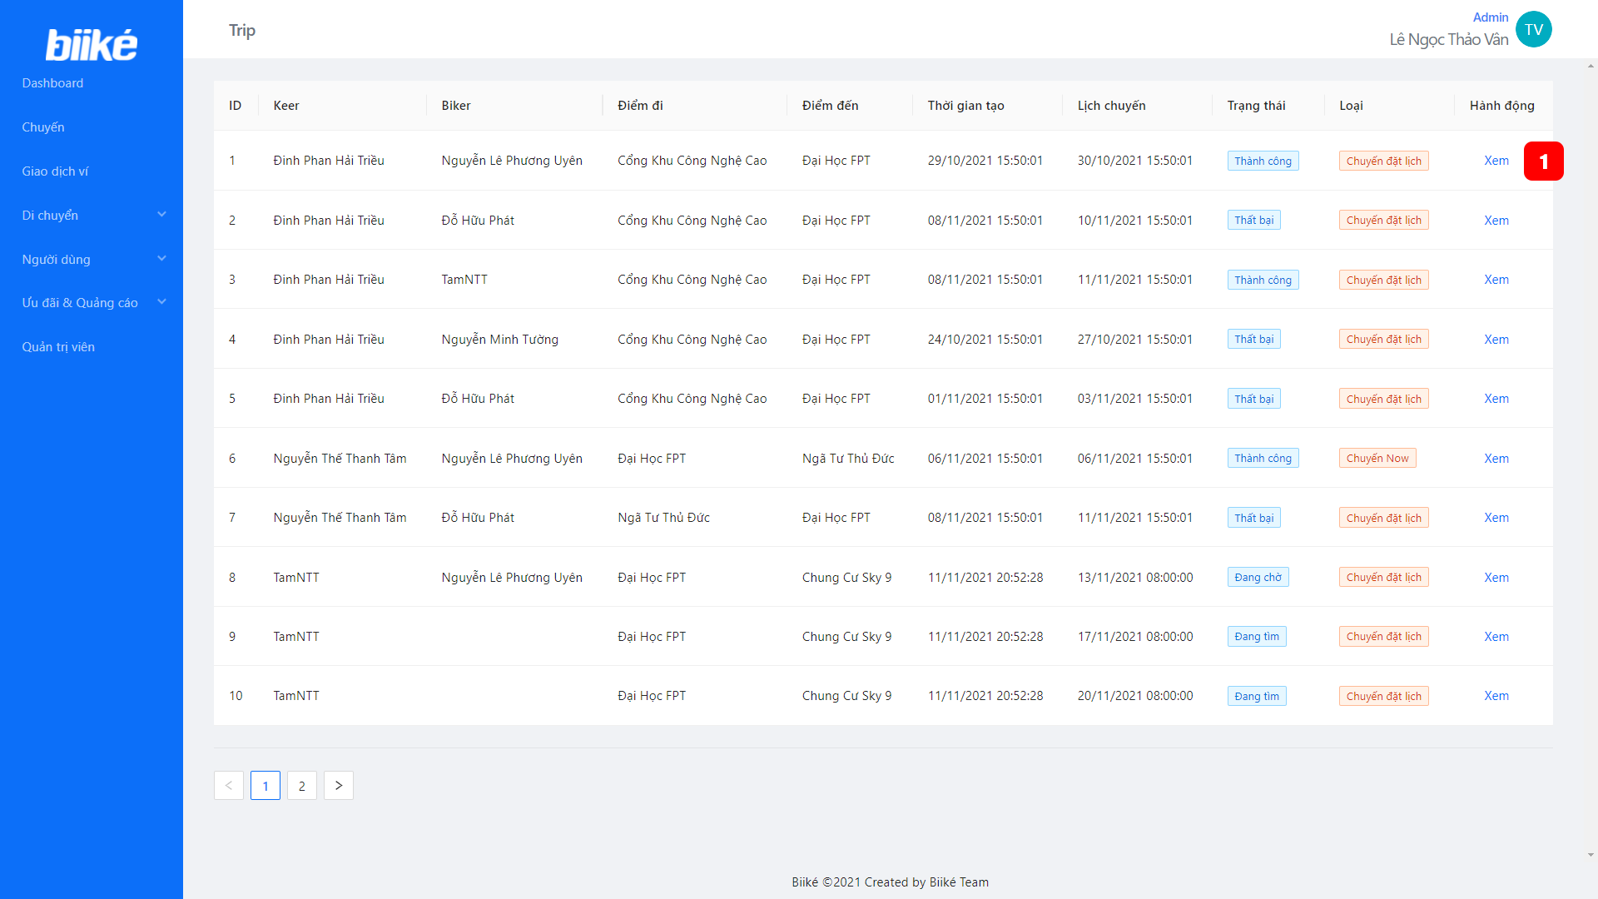

|  |  |  |  |  |
| --- | --- | --- | --- | --- |
| **No** | **Function** | **Description** | **Validation** | **Outcome** |
| 1 | View trip | Click to view trip information | No | Open trip detail pop-up |

1. View wallet transaction list

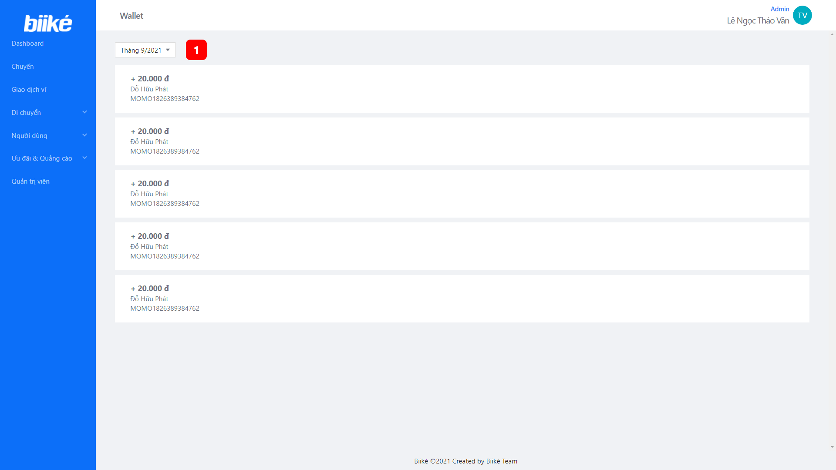

|  |  |  |  |  |
| --- | --- | --- | --- | --- |
| **No** | **Function** | **Description** | **Validation** | **Outcome** |
| 1 | Filter wallet transaction by month | Click to change month to view wallet transaction | No | Wallet transaction information by month |

1. Manage station
   1. View station list

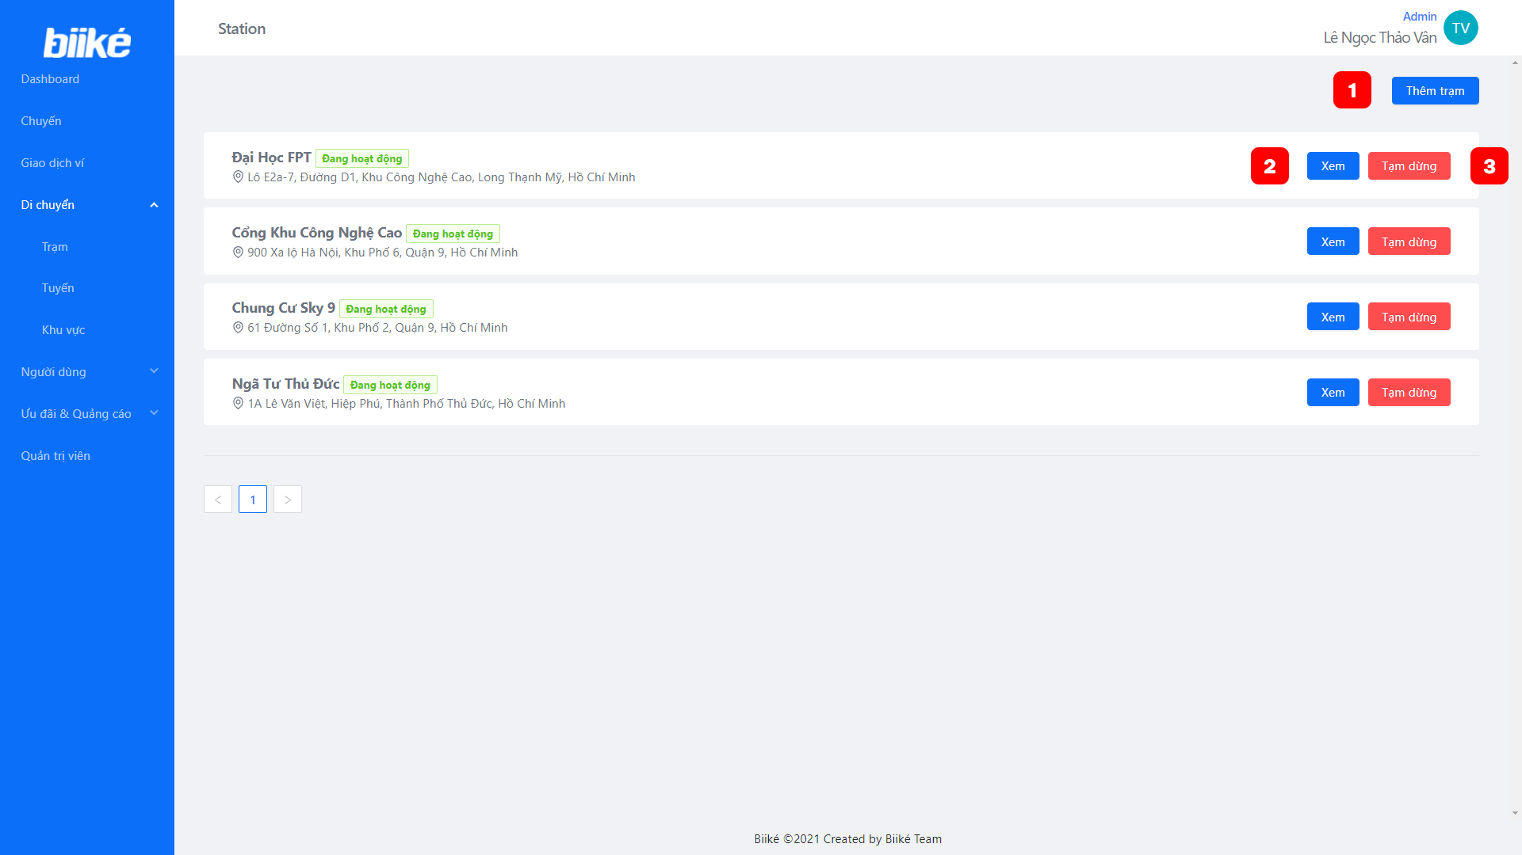

|  |  |  |  |  |
| --- | --- | --- | --- | --- |
| **No** | **Function** | **Description** | **Validation** | **Outcome** |
| 1 | Open create station pop-up | Click to show pop-up for create a new station | No | Open create station pop-up |
| 2 | View station detail | Click to show pop-up include station details | No | Open station detail pop-up |
| 3 | Unactive station | Unactive a station | No | Station is inactivated |

* 1. Create station

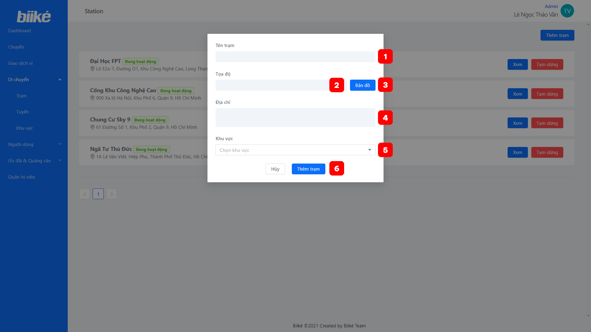

|  |  |  |  |  |  |  |
| --- | --- | --- | --- | --- | --- | --- |
| **No** | **Field Name** | **Description** | **Read only** | **Mandatory** | **Control type** | **Data type** |
| 1 | Station name | The name of station | No | Yes | Text Box | String |
| 2 | Coordinate | The coordinate of station | No | Yes | Text Box | String |
| 4 | Address | The address of station | No | Yes | Text Box | String |
| 5 | Area | The area of station | No | Yes | Dropdown | String |

|  |  |  |  |  |
| --- | --- | --- | --- | --- |
| **No** | **Function** | **Description** | **Validation** | **Outcome** |
| 3 | Open maps | Click to open maps | No | Open maps |
| 6 | Create station | Click to create a new station | Yes | New station is created |

* 1. Update station

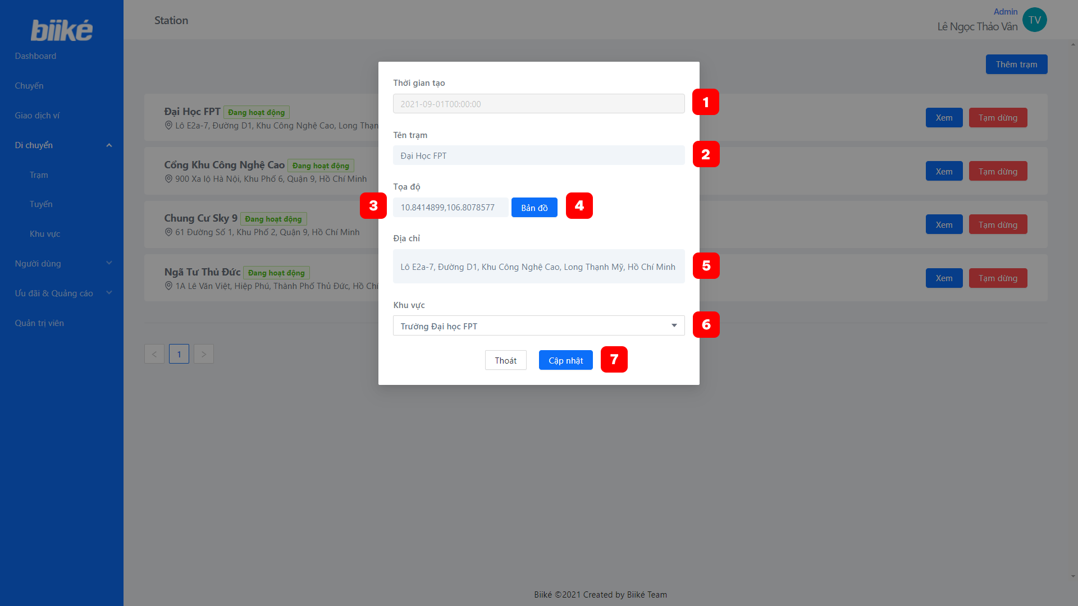

|  |  |  |  |  |  |  |
| --- | --- | --- | --- | --- | --- | --- |
| **No** | **Field Name** | **Description** | **Read only** | **Mandatory** | **Control type** | **Data type** |
| 1 | Time created | The time that the station was created | Yes | Yes | Text box | String |
| 2 | Station name | The name of station | No | Yes | Text Box | String |
| 3 | Coordinate | The coordinate of station | No | Yes | Text Box | String |
| 5 | Address | The address of station | No | Yes | Text Box | String |
| 6 | Area | The area of station | No | Yes | Dropdown | String |

|  |  |  |  |  |
| --- | --- | --- | --- | --- |
| **No** | **Function** | **Description** | **Validation** | **Outcome** |
| 4 | Open maps | Click to open maps | No | Open maps |
| 7 | Update station | Click to update station | Yes | Station is updated |

1. Manage route
   1. View route list

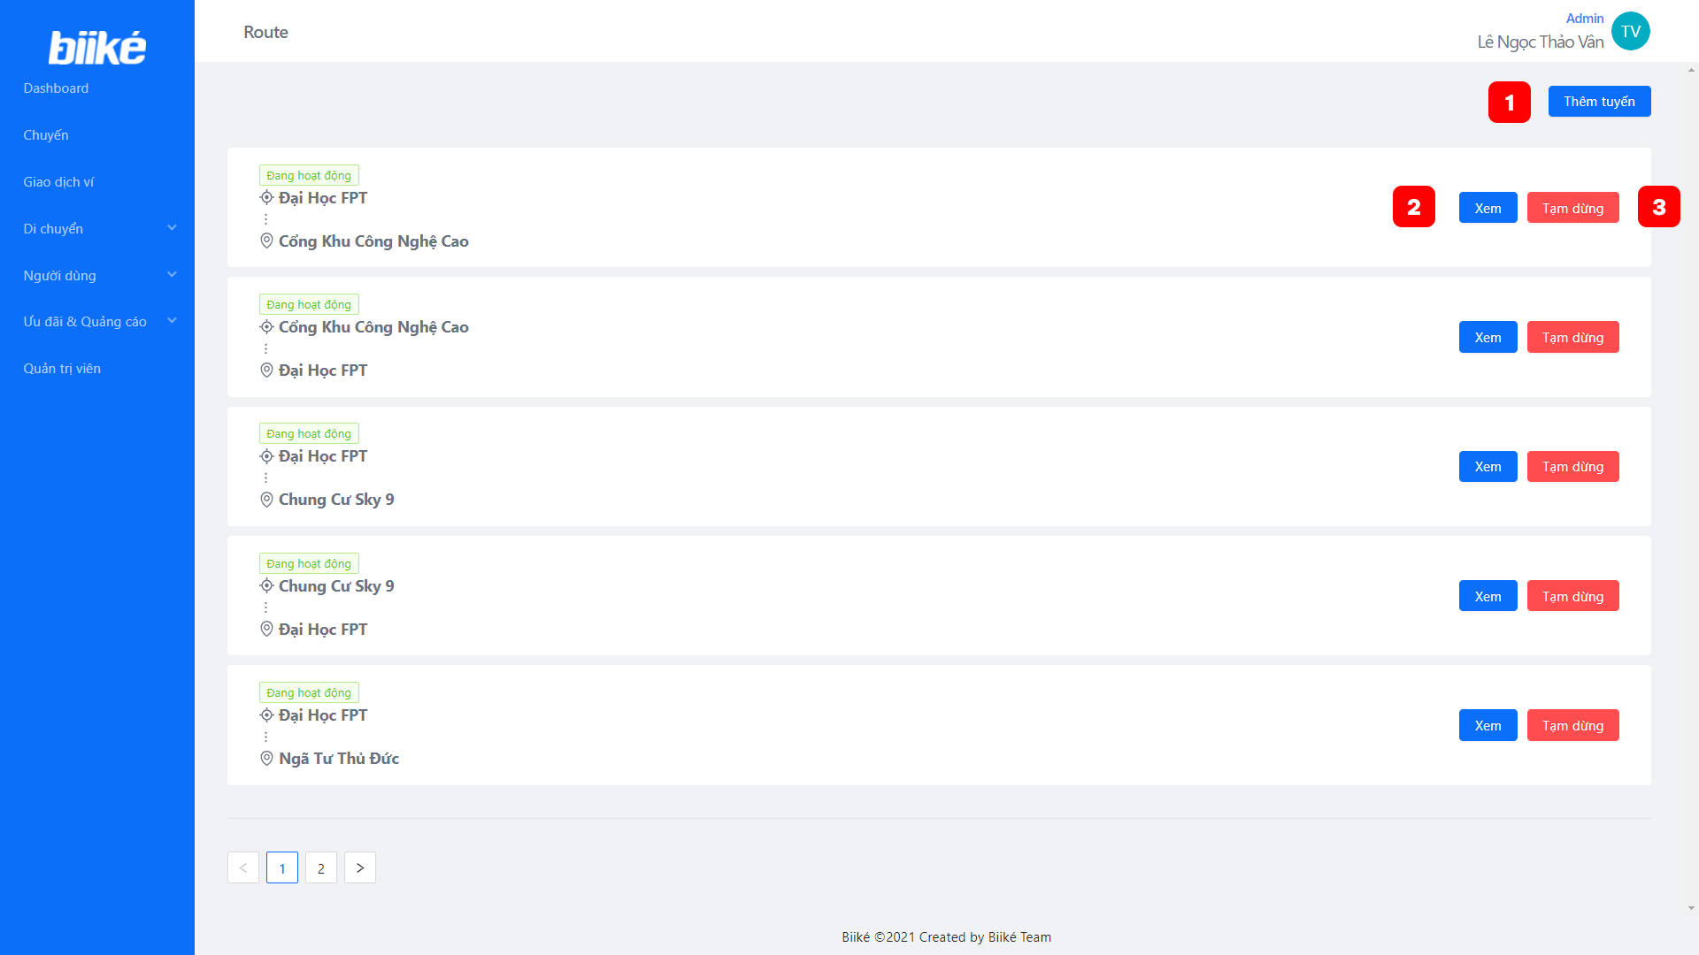

|  |  |  |  |  |
| --- | --- | --- | --- | --- |
| **No** | **Function** | **Description** | **Validation** | **Outcome** |
| 1 | Open create route pop-up | Click to show pop-up for create a new route | No | Open create route pop-up |
| 2 | View route detail | Click to show pop-up include route details | No | Open route detail pop-up |
| 3 | Unactive route | Unactive a route | No | Route is inactivated |

* 1. Create route

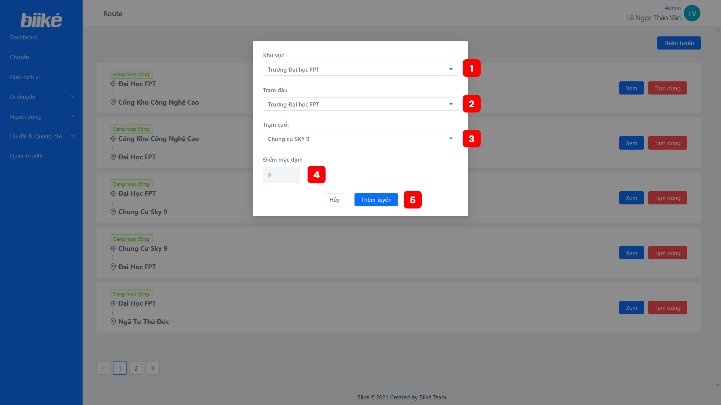

|  |  |  |  |  |  |  |
| --- | --- | --- | --- | --- | --- | --- |
| **No** | **Field Name** | **Description** | **Read only** | **Mandatory** | **Control type** | **Data type** |
| 1 | Area name | The area for the route | No | Yes | Dropdown | String |
| 2 | Departure name | The departure name of the route | No | Yes | Dropdown | String |
| 3 | Destination name | The destination of the route | No | Yes | Dropdown | String |
| 4 | Default point | The point that will add to biker when finish trip with the route | No | Yes | Text box | Number |

|  |  |  |  |  |
| --- | --- | --- | --- | --- |
| **No** | **Function** | **Description** | **Validation** | **Outcome** |
| 5 | Create route | Click to create a new route | Yes | New route is created |

* 1. Update route

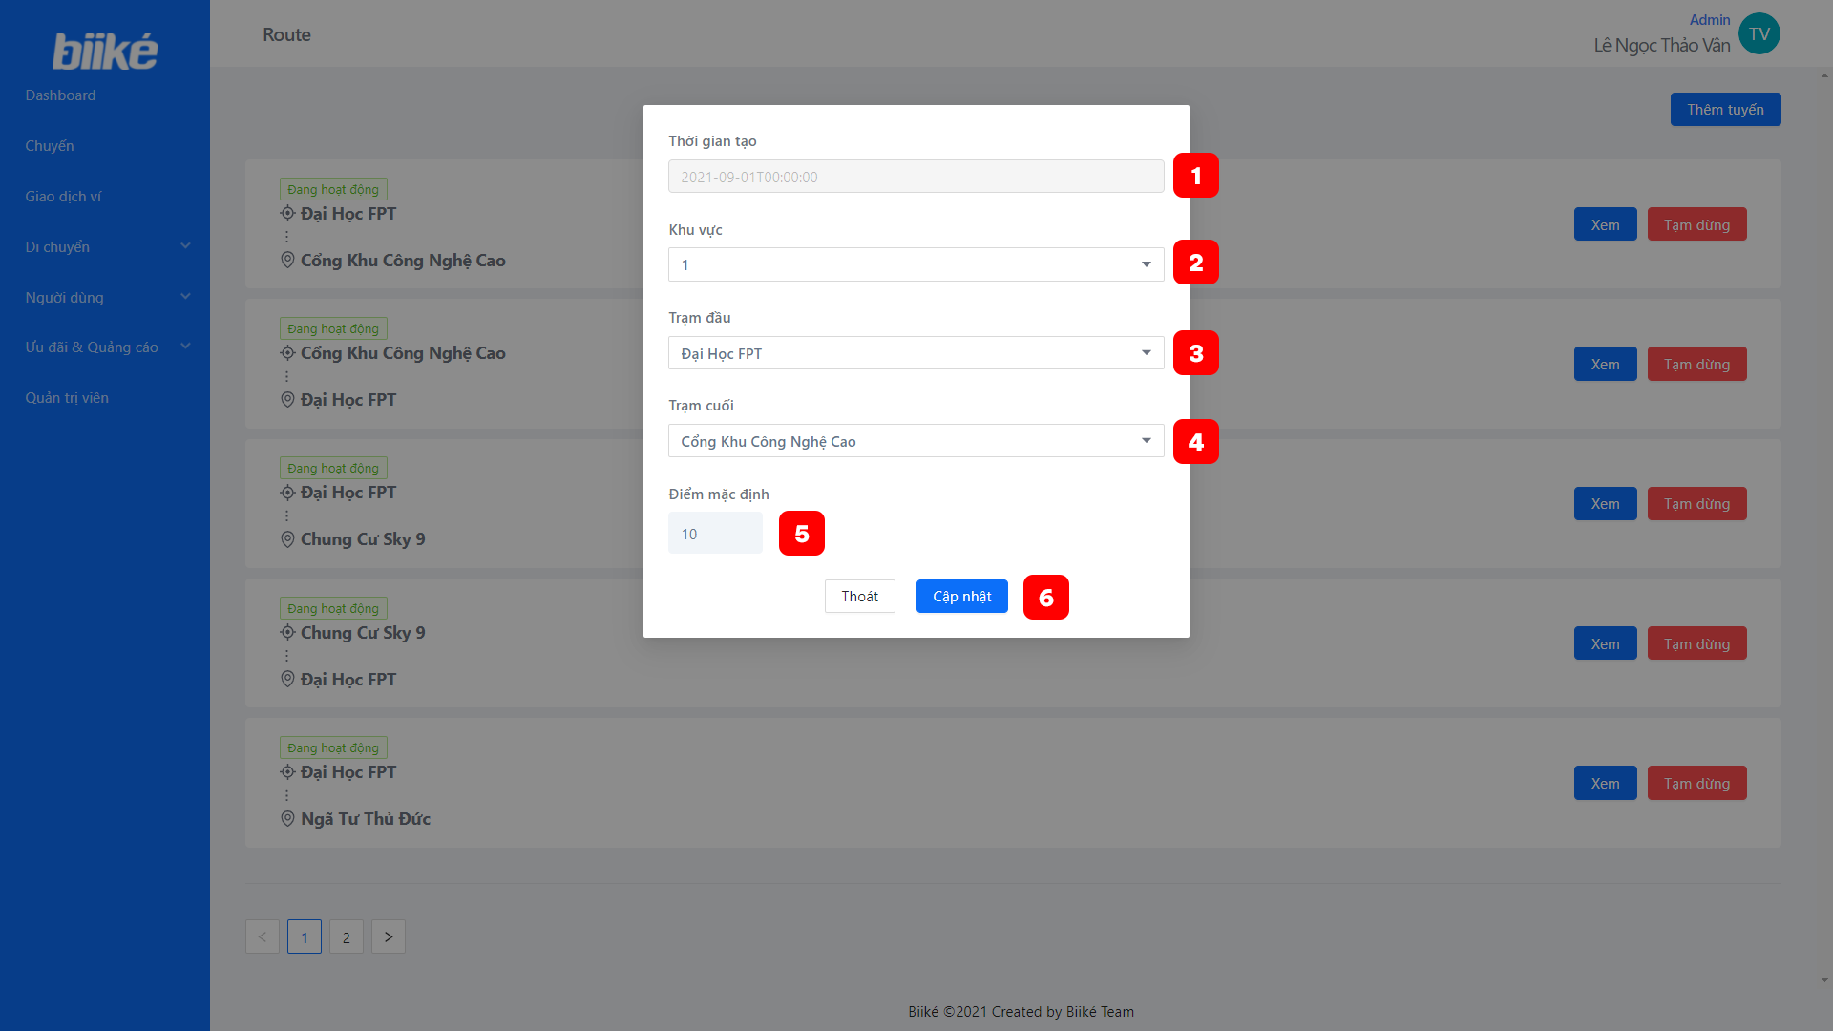

|  |  |  |  |  |  |  |
| --- | --- | --- | --- | --- | --- | --- |
| **No** | **Field Name** | **Description** | **Read only** | **Mandatory** | **Control type** | **Data type** |
| 1 | Time created | The time that the route was created | Yes | Yes | Text box | String |
| 2 | Area name | The area for the route | No | Yes | Dropdown | String |
| 3 | Departure name | The departure name of the route | No | Yes | Dropdown | String |
| 4 | Destination name | The destination of the route | No | Yes | Dropdown | String |
| 5 | Default point | The point that will add to biker when finish trip with the route | No | Yes | Text box | Number |

|  |  |  |  |  |
| --- | --- | --- | --- | --- |
| **No** | **Function** | **Description** | **Validation** | **Outcome** |
| 6 | Update route | Click to update route | Yes | Route is updated |

1. Manage customer

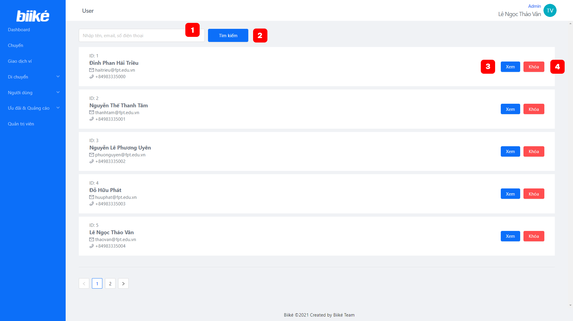

|  |  |  |  |  |  |  |
| --- | --- | --- | --- | --- | --- | --- |
| **No** | **Field Name** | **Description** | **Read only** | **Mandatory** | **Control type** | **Data type** |
| 1 | Search customer text | Name, phone number or email to search customer | No | Yes | Text box | String |

|  |  |  |  |  |
| --- | --- | --- | --- | --- |
| **No** | **Function** | **Description** | **Validation** | **Outcome** |
| 2 | Search customer | Search customer by name, phone number or email | Yes | Filtered customer by name, phone number or email |
| 3 | View customer detail | Click to show pop-up include customer details | No | Open customer detail pop-up |
| 4 | Block customer | Block a customer | No | Customer is blocked |

1. Manage bike
   1. View bike list

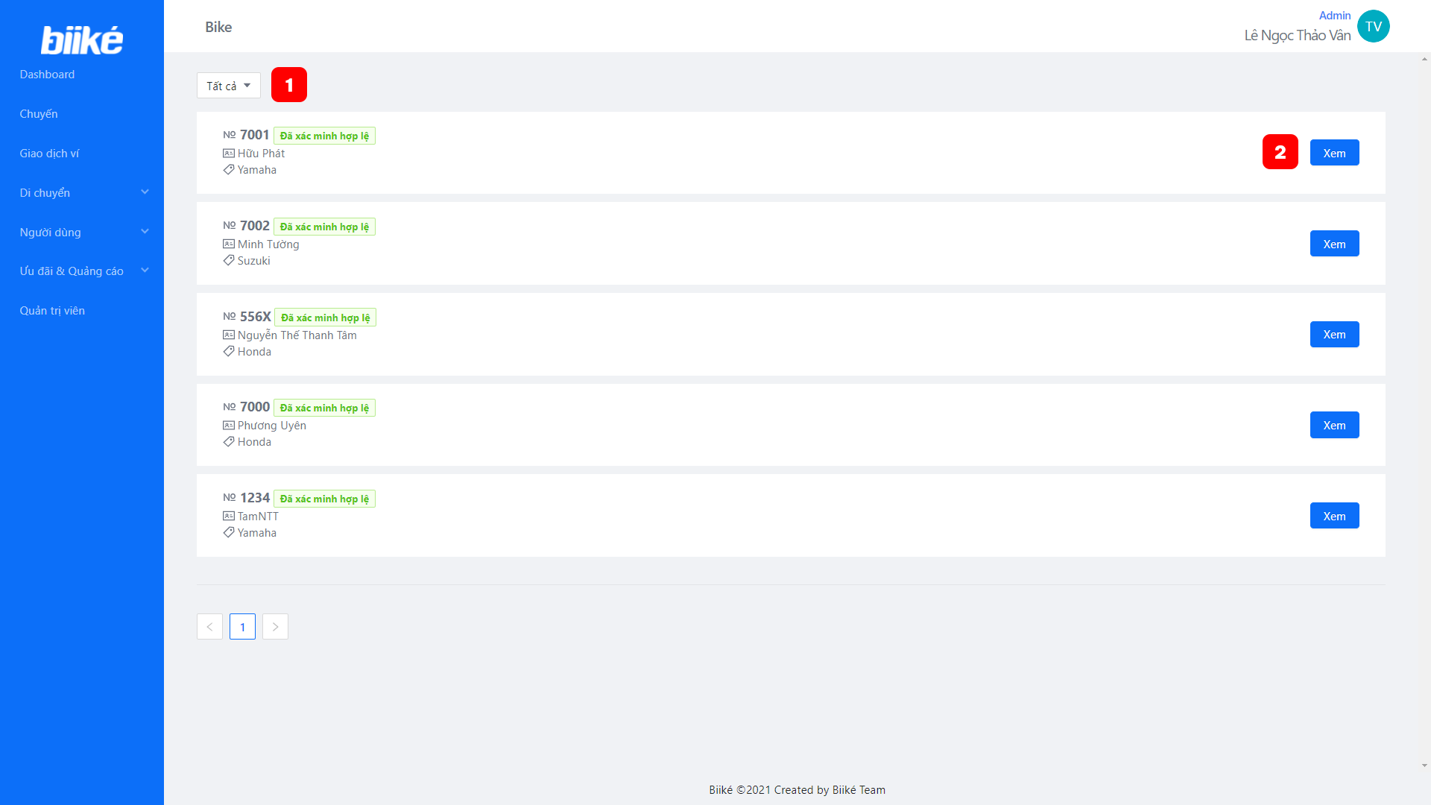

|  |  |  |  |  |
| --- | --- | --- | --- | --- |
| **No** | **Function** | **Description** | **Validation** | **Outcome** |
| 1 | Filter bike by status | Click to choose status to view bike with that status | No | Bike list by status |
| 2 | View bike detail | Click to show pop-up include bike details | No | Open bike detail pop-up |

* 1. Validate bike

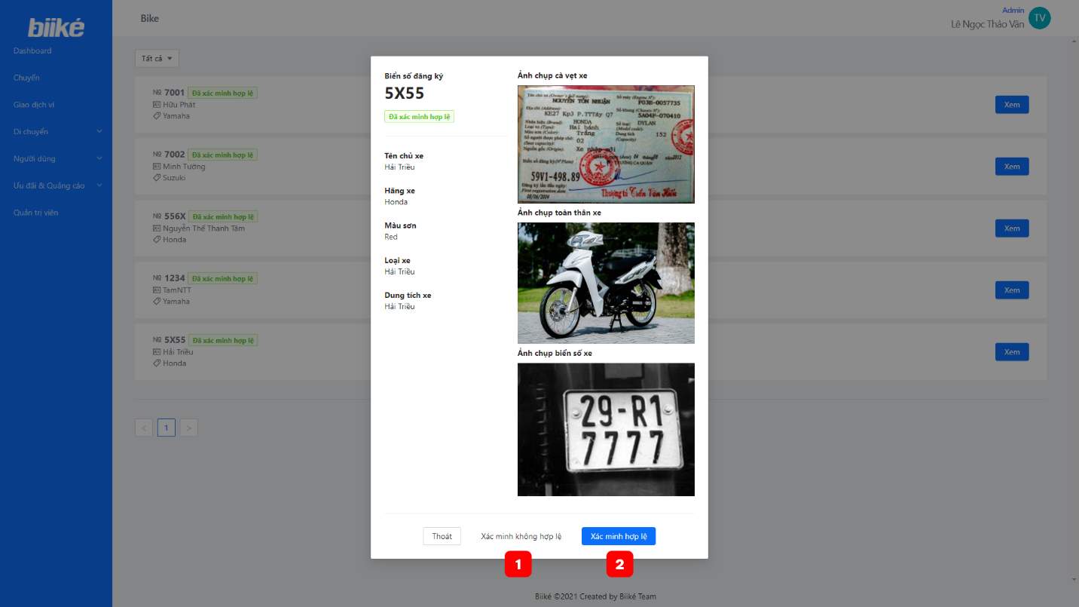

|  |  |  |  |  |
| --- | --- | --- | --- | --- |
| **No** | **Function** | **Description** | **Validation** | **Outcome** |
| 1 | Mark as invalid | Update the bike’s status to invalid | No | Bike’s status is invalid |
| 2 | Mark as valid | Update the bike’s status to valid | No | Bike’s status is valid |

1. View trip feedback

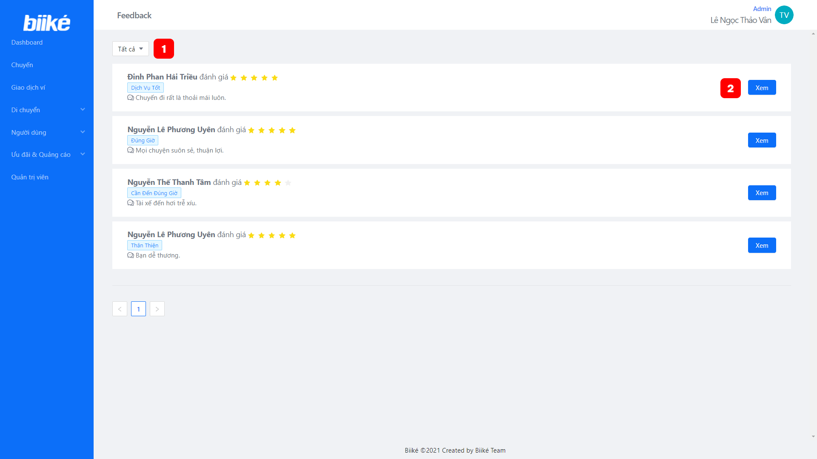

|  |  |  |  |  |
| --- | --- | --- | --- | --- |
| **No** | **Function** | **Description** | **Validation** | **Outcome** |
| 1 | Filter feedback by star | Click to choose number of stars to view feedback | No | Feedback list by number of stars |
| 2 | View feedback detail | Click to show pop-up include feedback details | No | Open feedback detail pop-up |

1. Manage notification

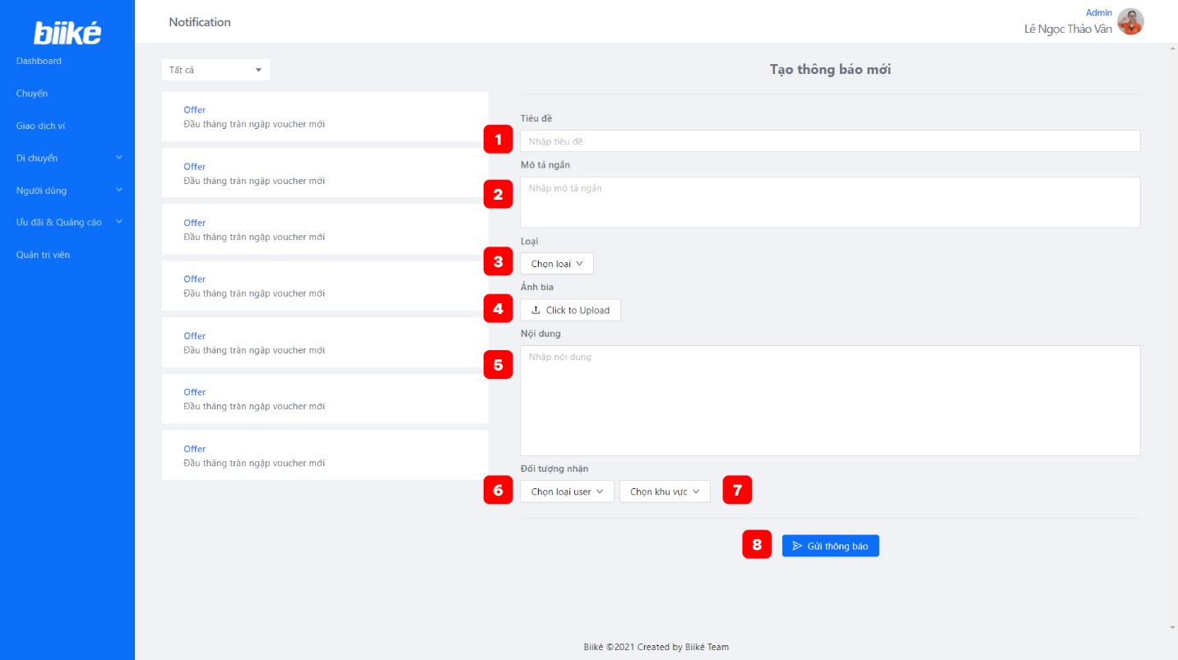

|  |  |  |  |  |  |  |
| --- | --- | --- | --- | --- | --- | --- |
| **No** | **Field Name** | **Description** | **Read only** | **Mandatory** | **Control type** | **Data type** |
| 1 | Title | Title of notification | No | Yes | Text box | String |
| 2 | Short description | Short description of notification | No | Yes | Text box | String |
| 3 | Category | Category of notification | No | Yes | Dropdown box | String |
| 4 | Image | Image of notification | No | No | Image upload | String |
| 5 | Content | Content of notification | No | Yes | Text box | String |
| 6 | Customer kind | Kind of customer: Biker of Keer | No | Yes | Dropdown box | String |
| 7 | Area | Area to send notification | No | Yes | Dropdown box | String |

|  |  |  |  |  |
| --- | --- | --- | --- | --- |
| **No** | **Function** | **Description** | **Validation** | **Outcome** |
| 8 | Send notification | Send notification to customer in app mobile | Yes | Notification is sent |

1. Manage advertising

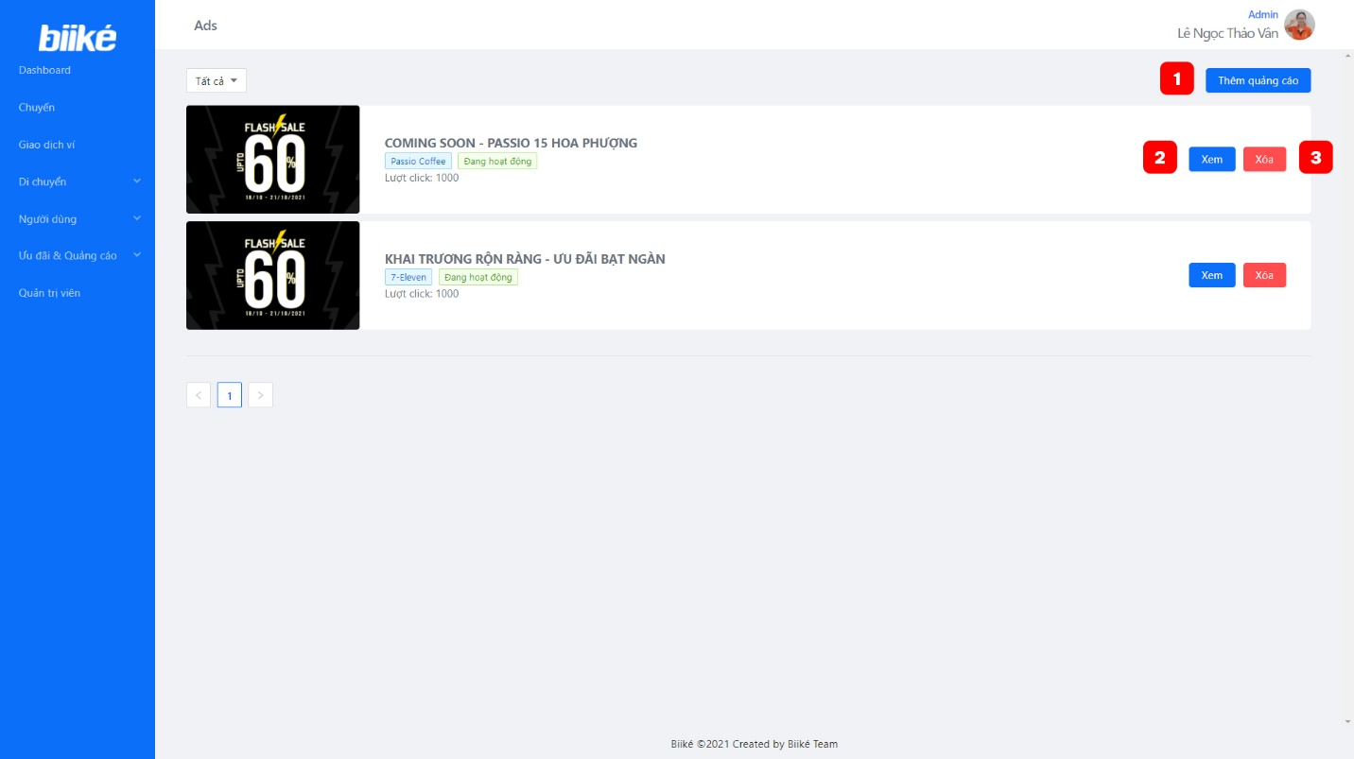

|  |  |  |  |  |
| --- | --- | --- | --- | --- |
| **No** | **Function** | **Description** | **Validation** | **Outcome** |
| 1 | Add new ads | Add a new ad to list | No | Pop up to add new ad is shown |
| 2 | View ads | View ad information | No | Pop up to view or edit ad is shown |
| 3 | Delete ads | Delete ads from list | No | Ads is deleted |

1. Manage voucher

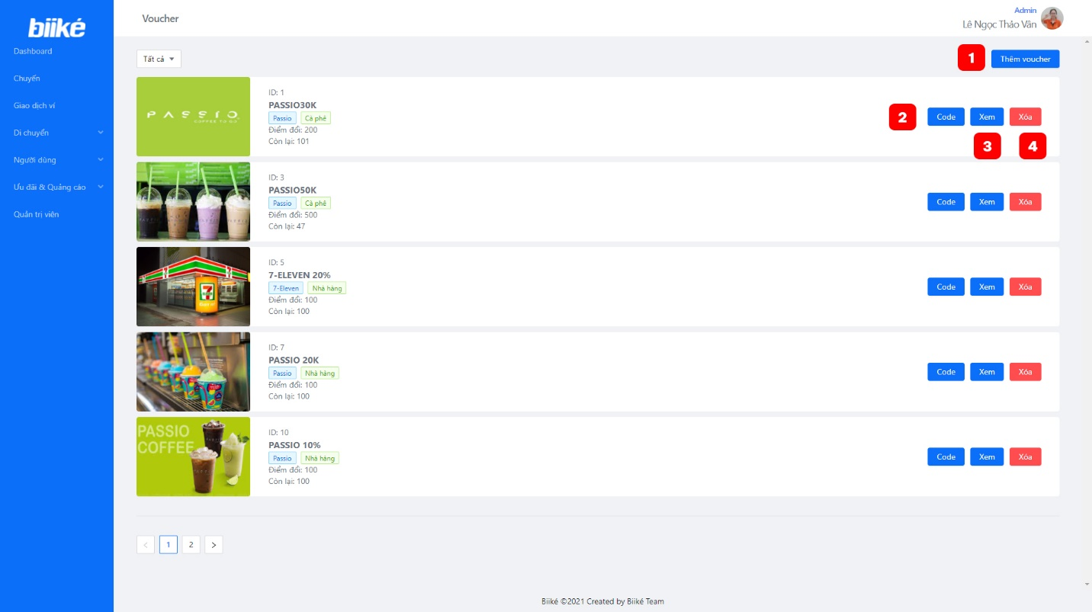

|  |  |  |  |  |
| --- | --- | --- | --- | --- |
| **No** | **Function** | **Description** | **Validation** | **Outcome** |
| 1 | Add new voucher | Add a new voucher | No | Pop up to add new voucher is shown |
| 2 | Manage voucher code | View voucher code list that admin can add | No | Pop up to manage voucher code is shown |
| 3 | View voucher | View voucher details so that admin can edit | No | Pop up to view voucher is shown |
| 4 | Delete voucher | Delete voucher | Yes | Voucher is deleted |

1. Manage voucher category
   1. View voucher category list

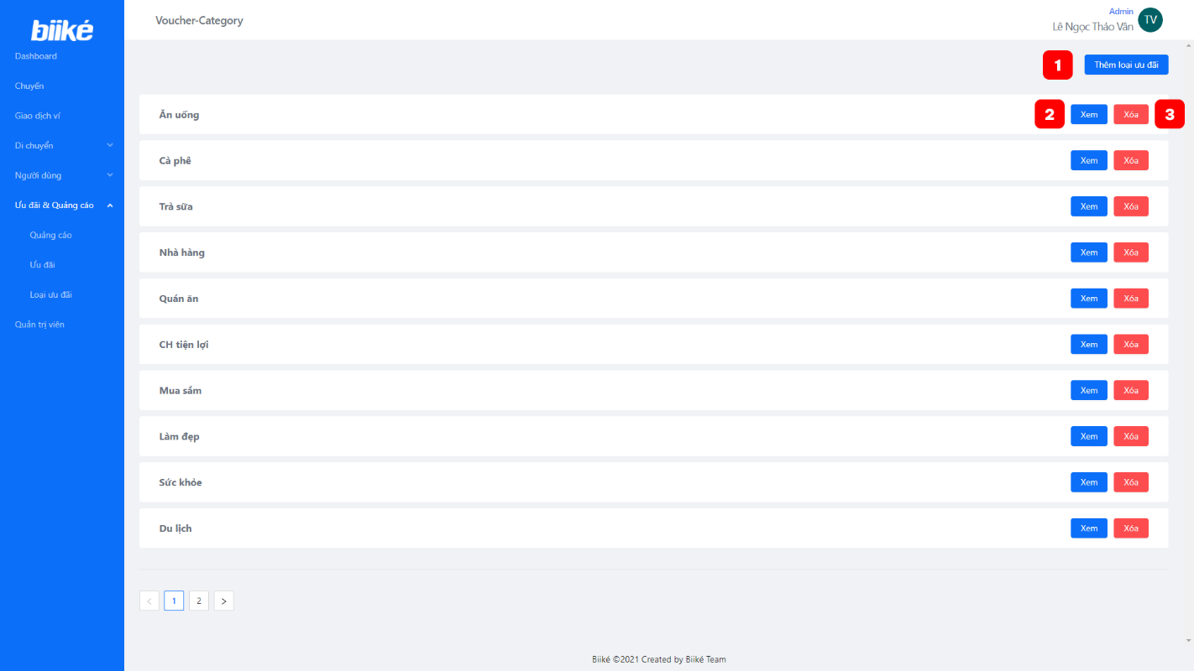

|  |  |  |  |  |
| --- | --- | --- | --- | --- |
| **No** | **Function** | **Description** | **Validation** | **Outcome** |
| 1 | Open create voucher category pop-up | Click to show pop-up for create a new voucher category | No | Open create voucher category pop-up |
| 2 | View voucher category | Click to show pop-up include voucher category name to edit | No | Open voucher category pop-up |
| 3 | Delete voucher category | Delete a voucher category | No | Voucher category is deleted |

* 1. Create a new voucher category

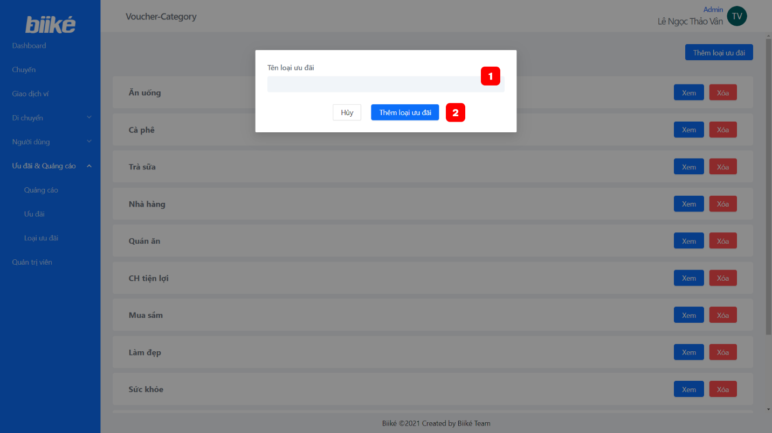

|  |  |  |  |  |  |  |
| --- | --- | --- | --- | --- | --- | --- |
| **No** | **Field Name** | **Description** | **Read only** | **Mandatory** | **Control type** | **Data type** |
| 1 | Voucher category name | The name of the category for vouchers | No | Yes | Text box | String |

|  |  |  |  |  |
| --- | --- | --- | --- | --- |
| **No** | **Function** | **Description** | **Validation** | **Outcome** |
| 2 | Create voucher category | Click to create a new voucher category | Yes | Voucher category is created |

* 1. Update voucher category name

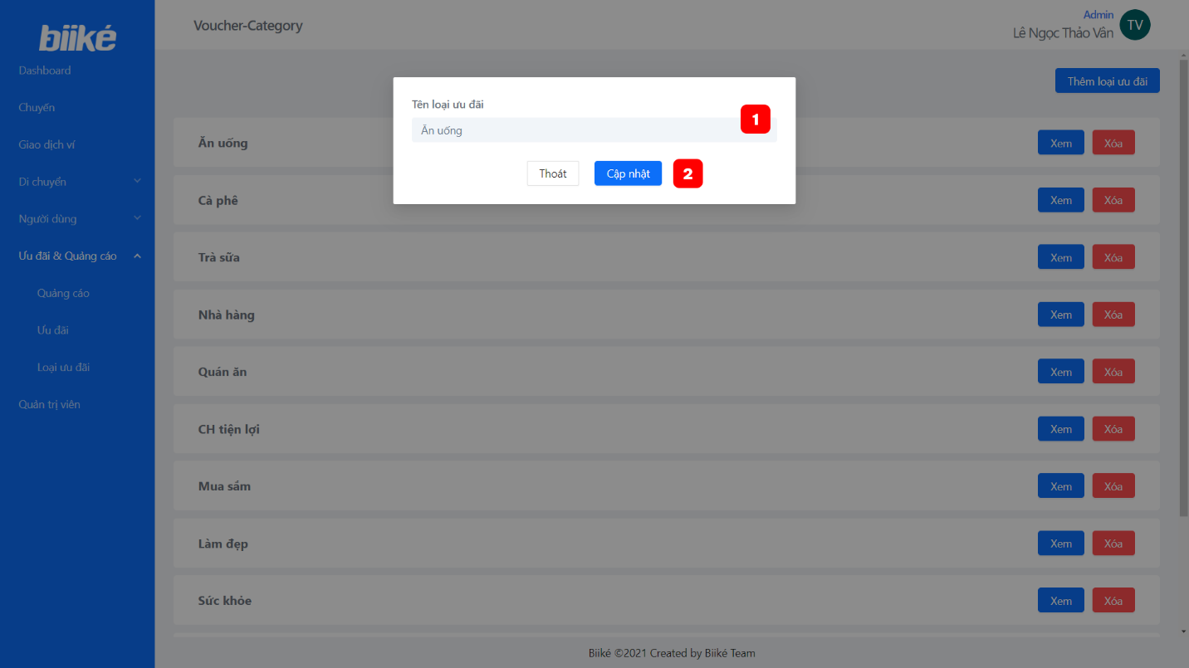

|  |  |  |  |  |  |  |
| --- | --- | --- | --- | --- | --- | --- |
| **No** | **Field Name** | **Description** | **Read only** | **Mandatory** | **Control type** | **Data type** |
| 1 | Voucher category name | The name of the category for vouchers | No | Yes | Text box | String |

|  |  |  |  |  |
| --- | --- | --- | --- | --- |
| **No** | **Function** | **Description** | **Validation** | **Outcome** |
| 2 | Update voucher category | Click to update voucher category | Yes | Voucher category is updated |

1. Manage administrator

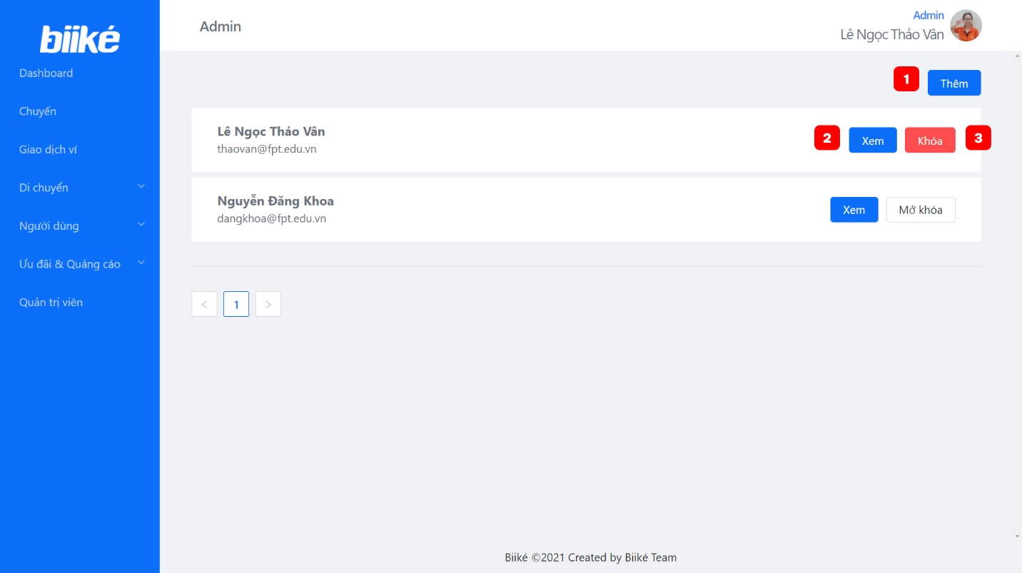

|  |  |  |  |  |
| --- | --- | --- | --- | --- |
| **No** | **Function** | **Description** | **Validation** | **Outcome** |
| 1 | Add admin | Add a new admin | No | Pop up to add admin is shown |
| 2 | View admin | View admin’s information | No | Pop up to view admin’s information |
| 3 | Remove admin | Remove admin | Yes | Admin is removed |

* + 1. **Customer Module**

1. Login and sign up
   1. Login

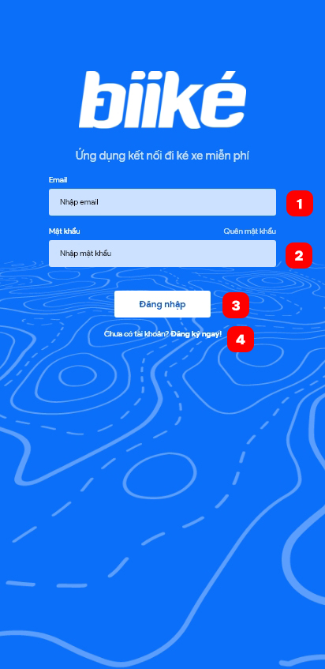

|  |  |  |  |  |  |  |
| --- | --- | --- | --- | --- | --- | --- |
| **No** | **Field Name** | **Description** | **Read only** | **Mandatory** | **Control type** | **Data type** |
| 1 | Email | Email of customer (biker/keer) | No | Yes | Text Box | String |
| 2 | Password | Password of customer (biker/keer) | No | Yes | Text Box | String |

|  |  |  |  |  |
| --- | --- | --- | --- | --- |
| **No** | **Function** | **Description** | **Validation** | **Outcome** |
| 3 | Login | Click to login to system | Yes | Navigate to Home screen if success or information pop up if fail |
| 4 | Sign up | Click to sign up | No | Navigate to Sign up screen |

* 1. Sign up

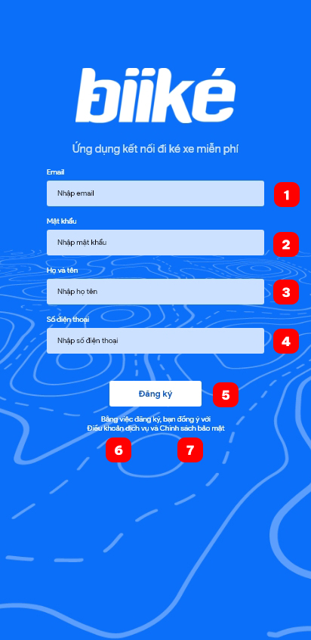

|  |  |  |  |  |  |  |
| --- | --- | --- | --- | --- | --- | --- |
| **No** | **Field Name** | **Description** | **Read only** | **Mandatory** | **Control type** | **Data type** |
| 1 | Email | Email of customer (biker/keer) | No | Yes | Text Box | String |
| 2 | Password | Password of customer (biker/keer) | No | Yes | Text Box | String |
| 3 | Full name | Email of customer (biker/keer) | No | Yes | Text Box | String |
| 4 | Phone number | Phone number of customer (biker/keer) | No | Yes | Text Box | String |

|  |  |  |  |  |
| --- | --- | --- | --- | --- |
| **No** | **Function** | **Description** | **Validation** | **Outcome** |
| 5 | Sign up | Create an account | Yes | Navigate to choose mode screen if success or information pop up if fail |
| 6 | Terms of use | View terms of use | No | Open terms of use on Biiké website |
| 7 | Privacy Policy | View privacy policy | No | Open privacy policy on Biiké website |

* 1. Choose mode

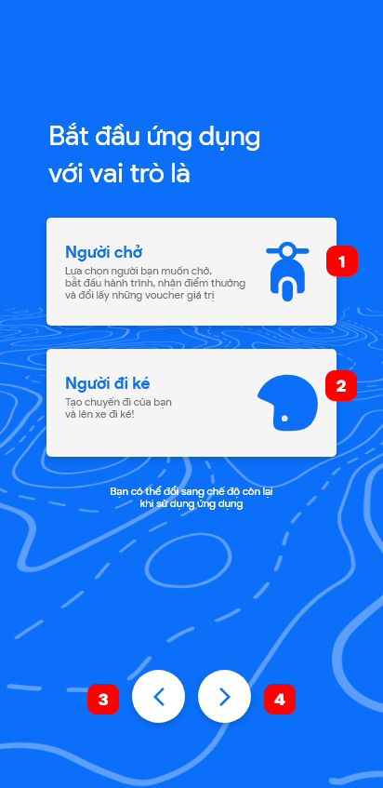

|  |  |  |  |  |  |  |
| --- | --- | --- | --- | --- | --- | --- |
| **No** | **Field Name** | **Description** | **Read only** | **Mandatory** | **Control type** | **Data type** |
| 1 | Biker Mode | Mode for biker or driver | No | Yes | Card | Number |
| 2 | Keer Mode | Mode for keer or hitchhiker | No | Yes | Card | Number |

|  |  |  |  |  |
| --- | --- | --- | --- | --- |
| **No** | **Function** | **Description** | **Validation** | **Outcome** |
| 3 | Previous | Back to previous screen | No | Previous screen |
| 4 | Next | Confirm mode and go to next screen | Yes | Navigate to Keer’s home screen (if keer) of Manage bike screen to add bike (if biker) |

1. Homepage
   1. Keer’s home page

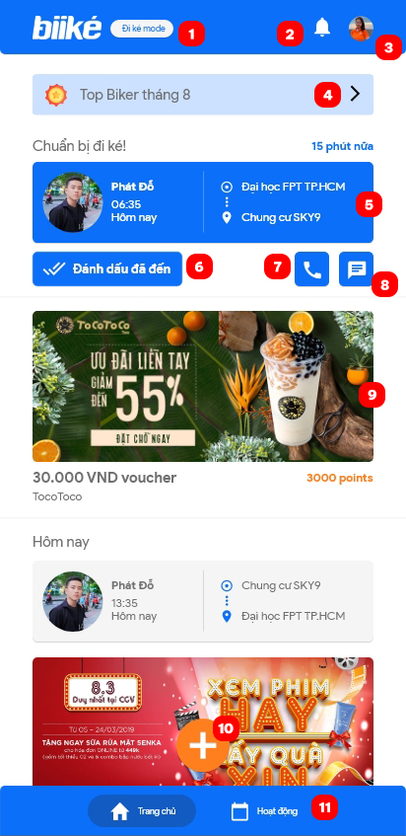

|  |  |  |  |  |
| --- | --- | --- | --- | --- |
| **No** | **Function** | **Description** | **Validation** | **Outcome** |
| 1 | Switch mode | Switch to biker mode | Yes | Navigate to Biker home screen or Manage bike screen to add bike |
| 2 | View notification | Notification | No | Navigate to notification screen |
| 3 | View profile | Profile | No | Navigate to profile page with customer information |
| 4 | View top bikers | Top 10 bikers with highest point from driving in the system | No | Navigate to top biker screen |
| 5 | View trip detail | More trip’s information | No | Navigate to trip detail screen |
| 6 | Mark as arrived | Mark the trip as arrived | Yes | Trip is marked as arrived or fail (due to customer location) |
| 7 | Call biker | Make a call to biker | No | Open call app with biker’s phone number |
| 8 | Message biker | Message to biker | No | Open message app with biker’s phone number |
| 9 | View ads or voucher | View adverting or voucher detail | No | Open advertising URL in browser or voucher detail in app |
| 10 | Create trip | Create a new trip | No | Navigate to create trip page |
| 11 | View activity | View upcoming trip and past trip | No | Navigate to activity screen |

* 1. Biker’s home page

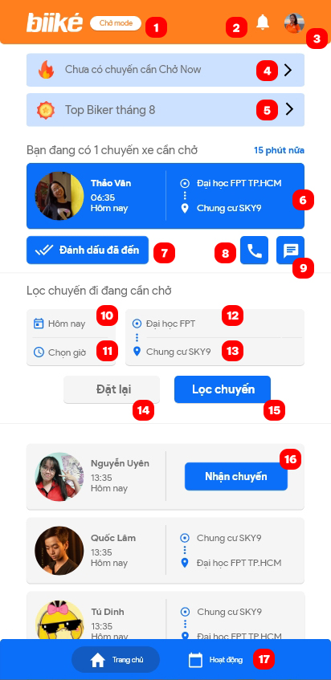

|  |  |  |  |  |  |  |
| --- | --- | --- | --- | --- | --- | --- |
| **No** | **Field Name** | **Description** | **Read only** | **Mandatory** | **Control type** | **Data type** |
| 10 | Choose date | Choose date of trip that want to filter | No | No | Date piker | String |
| 11 | Choose time | Choose time of trip that want to filter | No | No | Time piker | String |
| 12 | Choose departure | Choose departure of trip that want to filter | No | No | Dropdown | String |
| 13 | Choose destination | Choose destination of trip that want to filter | No | No | Dropdown | String |

|  |  |  |  |  |
| --- | --- | --- | --- | --- |
| **No** | **Function** | **Description** | **Validation** | **Outcome** |
| 1 | Switch mode | Switch to keer mode | Yes | Navigate to Keer home screen |
| 2 | View notification | Notification | No | Navigate to notification screen |
| 3 | View profile | Profile | No | Navigate to profile page with customer information |
| 4 | View Ride Now | View Ride Now trip and setting | No | Navigate to Ride Now screen |
| 5 | View top bikers | Top 10 bikers with highest point from driving in the system | No | Navigate to top biker screen |
| 6 | View trip detail | More trip’s information | No | Navigate to trip detail screen |
| 7 | Mark as arrived | Mark the trip as arrived | Yes | Trip is marked as arrived or fail (due to customer location) |
| 8 | Call keer | Make a call to keer | No | Open call app with keer’ s phone number |
| 9 | Message keer | Message to keer | No | Open message app with keer ‘s phone number |
| 14 | Reset | Reset field for filter trip | No | Field for filter trip (10,11,12,13) is reset |
| 15 | Filter trip | Filter trip with field (10,11,12,13) | Yes | Show trip is filtered below |
| 16 | Accept a trip | Accept a keer ‘s schedule trip | Yes | Trip is accepted |
| 17 | View activity | View upcoming trip and past trip | No | Navigate to activity screen |

1. Create and view trip
   1. Create trip

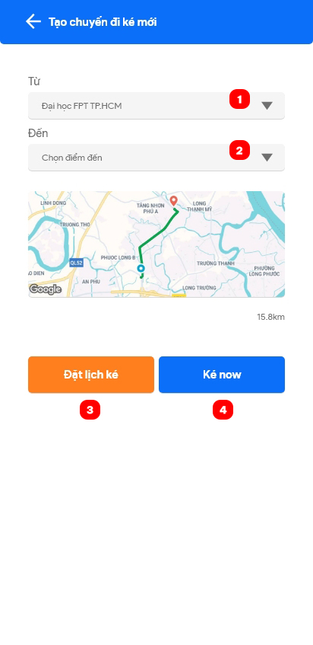

|  |  |  |  |  |  |  |
| --- | --- | --- | --- | --- | --- | --- |
| **No** | **Field Name** | **Description** | **Read only** | **Mandatory** | **Control type** | **Data type** |
| 1 | Choose departure | Choose departure of trip that want to filter | No | Yes | Dropdown | String |
| 2 | Choose destination | Choose destination of trip that want to filter | No | Yes | Dropdown | String |

|  |  |  |  |  |
| --- | --- | --- | --- | --- |
| **No** | **Function** | **Description** | **Validation** | **Outcome** |
| 3 | Schedule trip | Schedule a trip with date and time | No | Navigate to schedule trip screen |
| 4 | Trip Now | Request a trip right now | Yes | Information screen for processing Trip Now |

* 1. Create schedule trip

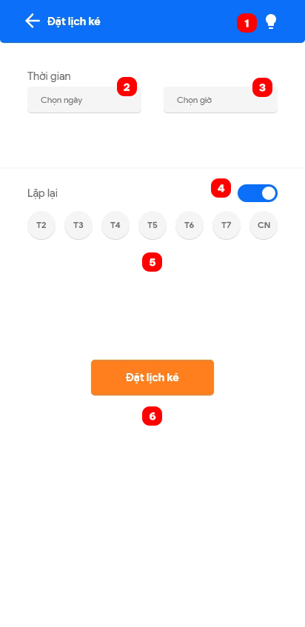

|  |  |  |  |  |  |  |
| --- | --- | --- | --- | --- | --- | --- |
| **No** | **Field Name** | **Description** | **Read only** | **Mandatory** | **Control type** | **Data type** |
| 2 | Choose date | Choose date of trip | No | Yes | Date piker | String |
| 3 | Choose time | Choose time of trip | No | Yes | Time piker | String |
| 4 | Turn on repeat | Turn on repeat feature if want to create multiple trips with the same time | No | No | Toggle | Boolean |
| 5 | Choose date in week | Choose date in week that want to repeat | No | No | Multiple check box | String |

|  |  |  |  |  |
| --- | --- | --- | --- | --- |
| **No** | **Function** | **Description** | **Validation** | **Outcome** |
| 1 | Open information pop-up | View information for schedule trip | No | Information pop-up with schedule trip rule |
| 6 | Create schedule trip | Create schedule trip with date, time and repeat data | Yes | Processing screen or fail if break the rule |

* 1. View trip

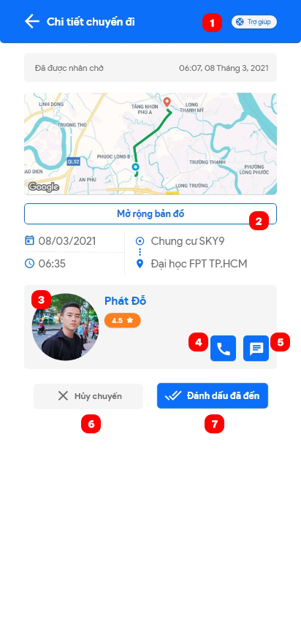

|  |  |  |  |  |
| --- | --- | --- | --- | --- |
| **No** | **Function** | **Description** | **Validation** | **Outcome** |
| 1 | Open Help Center | Open Help Center | No | Help Center pop-up is open |
| 2 | Extend map | Extend map to full screen | No | Map is extended to full screen |
| 3 | View partner | View partner information | No | Navigate to partner screen |
| 4 | Call partner | Make a call to partner | No | Open call app with partner s phone number |
| 5 | Message partner | Message to partner | No | Open message app with partner ‘s phone number |
| 6 | Cancel trip | Cancel a trip | Yes | Trip is canceled |
| 7 | Mark as arrived | Mark the trip as arrived | Yes | Trip is marked as arrived or fail (due to customer location) |

* 1. Trip help center

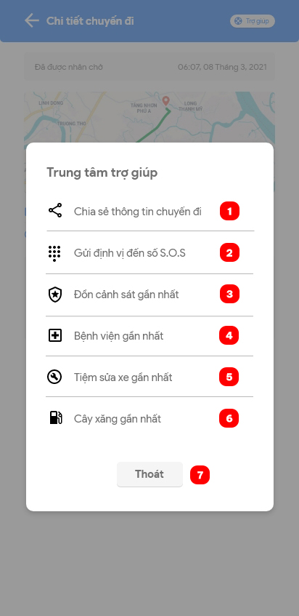

|  |  |  |  |  |
| --- | --- | --- | --- | --- |
| **No** | **Function** | **Description** | **Validation** | **Outcome** |
| 1 | Share location | Share real-time location | No | Location link is copy to clipboard |
| 2 | Send location to S.O.S numbers | Send location to S.O.S numbers | Yes | SMS include location link is sent to S.O.S numbers |
| 3 | View nearest police station | View nearest police station information | No | Open Google Maps with nearest police station is chosen |
| 4 | View nearest hospital | View nearest hospital information | No | Open Google Maps with nearest hospital is chosen |
| 5 | View nearest mechanic shop | View nearest mechanic shop information | No | Open Google Maps with nearest mechanic shop is chosen |
| 6 | View nearest gas station | View nearest gas station information | No | Open Google Maps with nearest gas station is chosen |
| 7 | Exit | Exit pop-up | No | Close Help Center pop-up |

1. View point

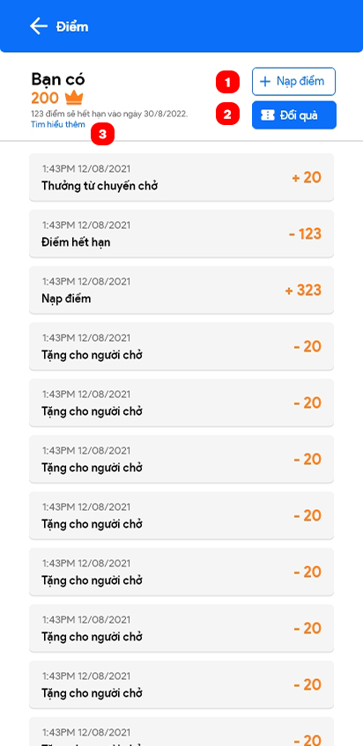

|  |  |  |  |  |
| --- | --- | --- | --- | --- |
| **No** | **Function** | **Description** | **Validation** | **Outcome** |
| 1 | Top up point | Top up point to wallet through MOMO wallet | No | Navigate to top up point page |
| 2 | Redeem reward | Redeem voucher from Biiké | No | Navigate to voucher page |
| 3 | See more | See more about point and reward | No | Open point and reward information URL on browser |

1. View partner/Manage profile
   1. View partner

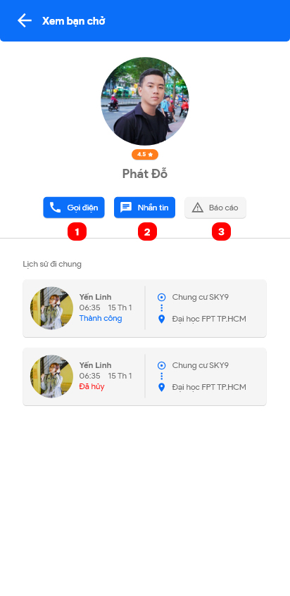

|  |  |  |  |  |
| --- | --- | --- | --- | --- |
| **No** | **Function** | **Description** | **Validation** | **Outcome** |
| 1 | Call partner | Make a call to partner | No | Open call app with partner s phone number |
| 2 | Message partner | Message to partner | No | Open message app with partner ‘s phone number |
| 3 | Report partner | Report partner to Biiké for bad behavior | No | Open Report pop-up to note reason or even block partner and confirm |

* 1. Unblock partner

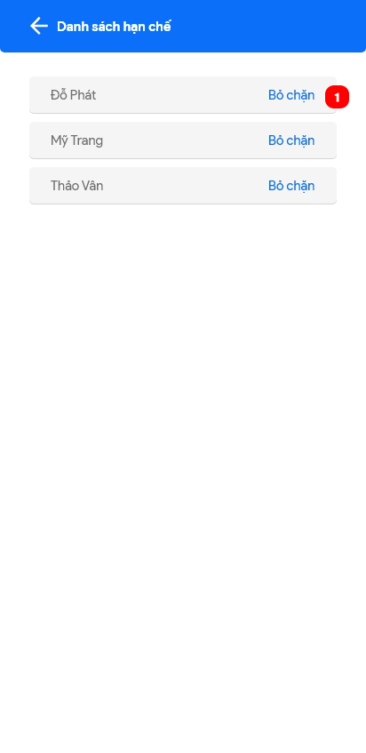

|  |  |  |  |  |
| --- | --- | --- | --- | --- |
| **No** | **Function** | **Description** | **Validation** | **Outcome** |
| 1 | Unblock partner | Unblock partner so they may have trip later | No | Partner is removed form ban list |

* 1. View profile

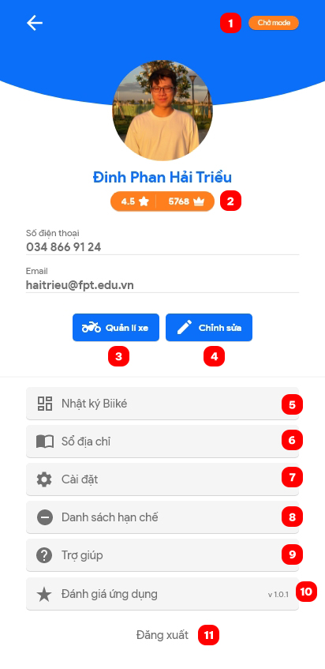

|  |  |  |  |  |
| --- | --- | --- | --- | --- |
| **No** | **Function** | **Description** | **Validation** | **Outcome** |
| 1 | Switch mode | Switch to other mode | Yes | Navigate to other home screen |
| 2 | View point | View point detail page | No | Navigate to view point screen |
| 3 | Mange bike | Manage bike information | No | Navigate to manage bike screen |
| 4 | Edit profile | Edit profile information | No | Navigate to edit profile page to edit |
| 5 | Manage address book | Manage addresses | No | Navigate to manage address screen |
| 6 | View app setting | Open settings | No | Navigate to app settings screen |
| 7 | Manage ban list | Manage list of partners was banned | No | Navigate to manage ban list screen |
| 8 | Manage S.O.S number | Manage S.O.S number to send SMS when call “Send location to S.O.S numbers” in Help Center screen | No | Navigate to manage S.O.S numbers screen |
| 9 | View help | View some help information; terms of use, privacy policy, point and voucher policy or contact to Biiké team | No | Navigate to help screen |
| 10 | Rate app | Rate Biiké on Google Play or App Store | No | Open Biiké app page on Google Play or App Store |
| 11 | Log out | Log out of Biiké | No | Customer logged out |

* 1. Add address

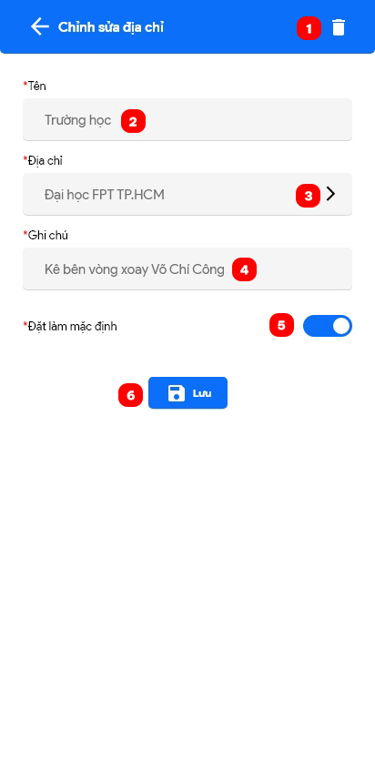

|  |  |  |  |  |  |  |
| --- | --- | --- | --- | --- | --- | --- |
| **No** | **Field Name** | **Description** | **Read only** | **Mandatory** | **Control type** | **Data type** |
| 2 | Address name | Name of address | No | Yes | Text box | String |
| 3 | Address detail | Detail of address (Use Google Maps to choose) | No | Yes | Text box | String |
| 4 | Note | Note to address | No | No | Text box | String |
| 5 | Set as default | Set address is default address | No | No | Toggle | Boolean |

|  |  |  |  |  |
| --- | --- | --- | --- | --- |
| **No** | **Function** | **Description** | **Validation** | **Outcome** |
| 1 | Delete address | Delete this address | Yes | Address is deleted or fail due to default address rule |
| 6 | Save address | Save this address | Yes | Address is added or fail due to duplicate address |

* 1. Add S.O.S number

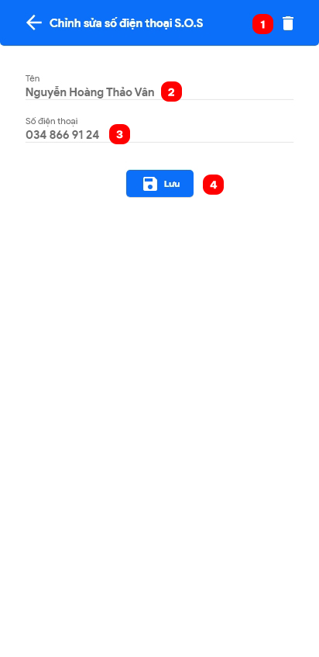

|  |  |  |  |  |  |  |
| --- | --- | --- | --- | --- | --- | --- |
| **No** | **Field Name** | **Description** | **Read only** | **Mandatory** | **Control type** | **Data type** |
| 2 | Name | Name of owner’s S.O.S number | No | Yes | Text box | String |
| 3 | Phone number | S.O.S phone number | No | Yes | Text box | String |

|  |  |  |  |  |
| --- | --- | --- | --- | --- |
| **No** | **Function** | **Description** | **Validation** | **Outcome** |
| 1 | Delete S.O.S number | Delete S.O.S number | No | S.O.S number is deleted |
| 4 | Save S.O.S number | Save S.O.S number | Yes | S.O.S number is saved or fail due to wrong number type |

1. Add bike

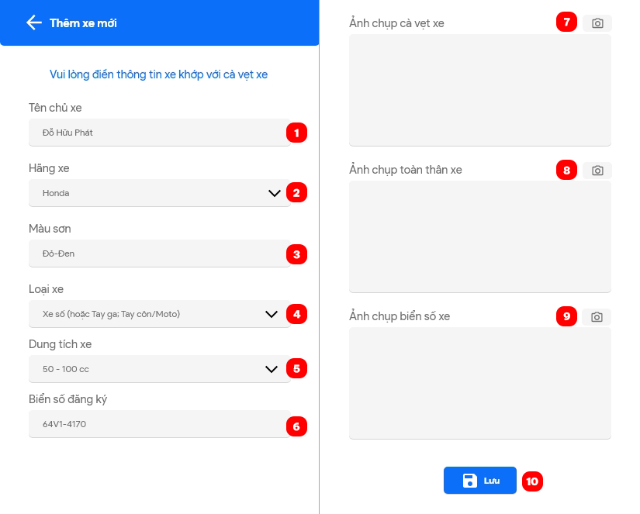

|  |  |  |  |  |  |  |
| --- | --- | --- | --- | --- | --- | --- |
| **No** | **Field Name** | **Description** | **Read only** | **Mandatory** | **Control type** | **Data type** |
| 1 | Owner name | Bike’s owner | No | Yes | Text box | String |
| 2 | Brand | Bike’s brand | No | Yes | Dropdown | String |
| 3 | Color | Bike’s color | No | Yes | Text box | String |
| 4 | Type | Bike’s type | No | Yes | Dropdown | String |
| 5 | Capacity | Bike’s capacity | No | Yes | Dropdown | String |
| 6 | Number plate | Bike’s number plate | No | Yes | Text box | String |

|  |  |  |  |  |
| --- | --- | --- | --- | --- |
| **No** | **Function** | **Description** | **Validation** | **Outcome** |
| 7 | Capture driver license | Take a picture of driver license by camera | No | Open camera |
| 8 | Capture bike’s body | Take a picture of bike’s body by camera | No | Open camera |
| 9 | Capture bike’s number plate | Take a picture of bike’s number plate by camera | No | Open camera |
| 10 | Save bike | Confirm bike, send to admin to verify | Yes | Bike is saved or fail due to wrong type |

1. Send trip feedback

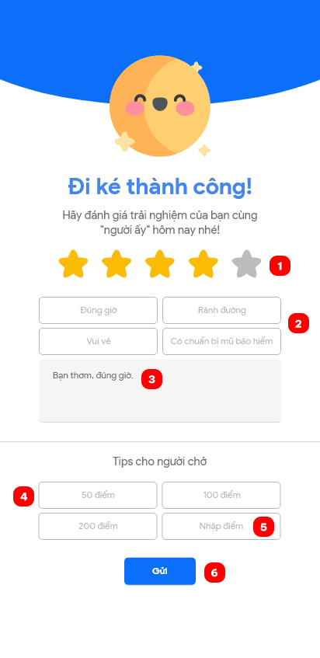

|  |  |  |  |  |  |  |
| --- | --- | --- | --- | --- | --- | --- |
| **No** | **Field Name** | **Description** | **Read only** | **Mandatory** | **Control type** | **Data type** |
| 1 | Trip star | Rate trip by star | No | Yes | Choose box | Number |
| 2 | Criteria | Criteria for quick feedback | No | Yes | Choose box | String |
| 3 | Feedback | Feedback about trip | No | Yes | Text box | String |
| 4 | Point for tip | Choose amount of point to tip for biker | No | No | Choose box | Number |
| 5 | Point for tip (input) | Input amount of point to tip for biker | No | No | Text box | Number |

|  |  |  |  |  |
| --- | --- | --- | --- | --- |
| **No** | **Function** | **Description** | **Validation** | **Outcome** |
| 6 | Send trip feedback | Send trip feedback | Yes | Feedback is sent or fail due to wrong type |

1. View notification

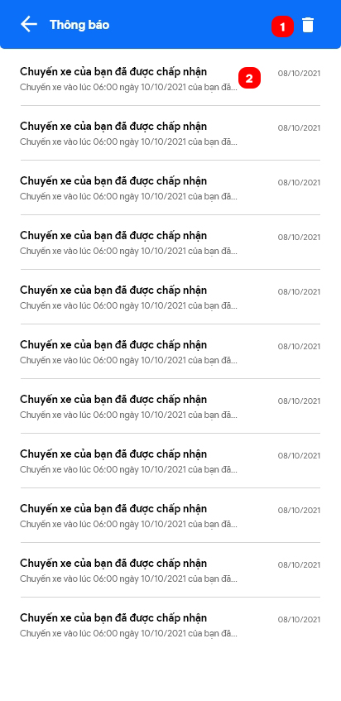

|  |  |  |  |  |
| --- | --- | --- | --- | --- |
| **No** | **Function** | **Description** | **Validation** | **Outcome** |
| 1 | Delete notification | Delete all notification | No | Confirm before delete all notification. If yes, all notification is deleted |
| 2 | View notification | View notification detail | No | Open notification detail screen |

1. View/Redeem voucher
   1. View voucher list

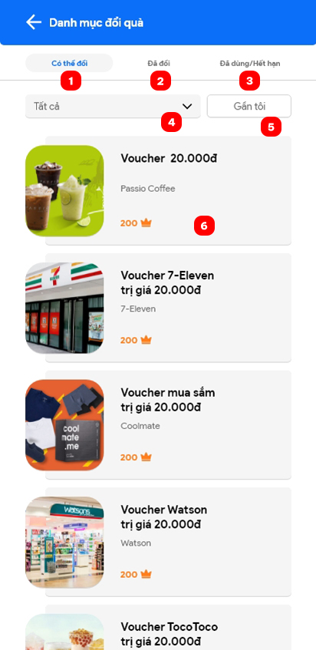

|  |  |  |  |  |  |  |
| --- | --- | --- | --- | --- | --- | --- |
| **No** | **Field Name** | **Description** | **Read only** | **Mandatory** | **Control type** | **Data type** |
| 4 | Choose voucher category | Choose one voucher category or all voucher | No | No | Dropdown | String |

|  |  |  |  |  |
| --- | --- | --- | --- | --- |
| **No** | **Function** | **Description** | **Validation** | **Outcome** |
| 1 | Can redeem | Voucher that can redeem tab | No | Open voucher that can redeem tab |
| 2 | Redeemed | Voucher that redeemed tab | No | Open voucher that redeemed tab |
| 3 | Used/Expired | Voucher that used or expired tab | No | Open voucher that used or expired tab |
| 5 | Near me | Sort voucher near customer | Yes | Voucher near customer is sorted |
| 6 | Voucher detail | View voucher details | No | Open voucher detail screen |

* 1. Voucher detail

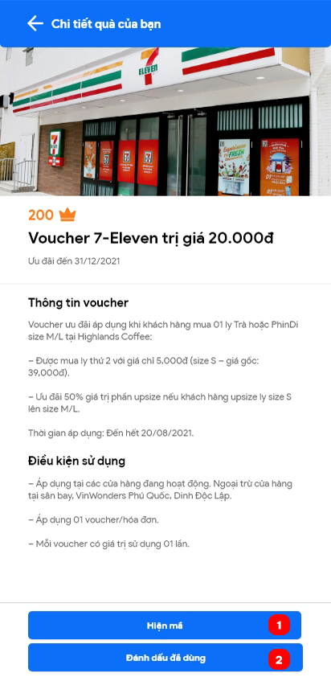

|  |  |  |  |  |
| --- | --- | --- | --- | --- |
| **No** | **Function** | **Description** | **Validation** | **Outcome** |
| 1 | Show code | Show voucher code | No | Voucher code is showed |
| 2 | Mark is used | Mark voucher as used | No | Voucher is marked as used |

1. App settings

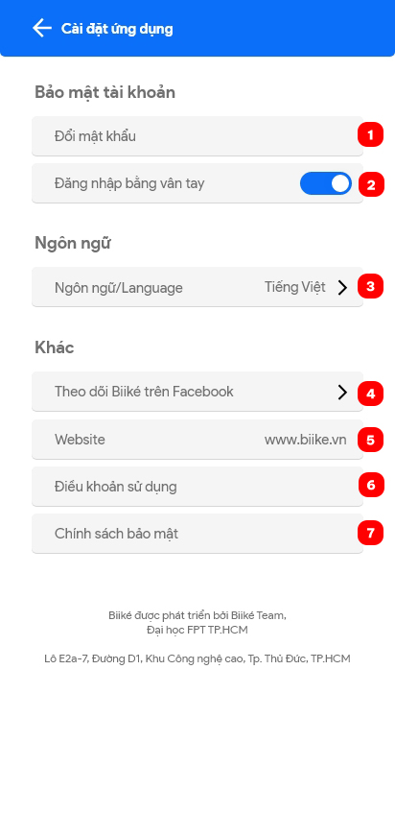

|  |  |  |  |  |
| --- | --- | --- | --- | --- |
| **No** | **Function** | **Description** | **Validation** | **Outcome** |
| 1 | Change password | Change password | No | Change password screen |
| 2 | Login by fingerprint | Turn on/off login by fingerprint | No | Login by fingerprint is turn on/off |
| 3 | Change language | Change language to English or Vietnamese | No | Language is changed to English or Vietnamese |
| 4 | Follow Biiké on Facebook | Open Biiké Facebook Page | No | Brower open Biiké’ s Facebook Page |
| 5 | Website | Open Biiké’ s website | No | Brower open Biiké’ s website |
| 6 | Terms of use | Open terms of use in Biiké’ s website | No | Brower open Biiké’ s Terms of use |
| 7 | Privacy Policy | Open privacy policy in Biiké ‘s website | No | Brower open Biiké’ s Privacy Policy |

1. Ride Now settings
   1. Ride Now page

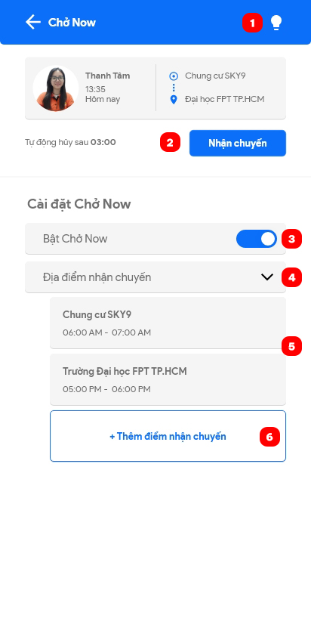

|  |  |  |  |  |
| --- | --- | --- | --- | --- |
| **No** | **Function** | **Description** | **Validation** | **Outcome** |
| 1 | View Ride Now instruction | Click to view Ride Now instruction | No | Ride Now Instruction pop-up is shown |
| 2 | Accept a Trip Now | Click to accept a Trip Now | No | Trip is accepted |
| 3 | Change Ride Now status | Turn Ride Now mode is on/off | No | Ride Now status is changed |
| 4 | Open Ride Now station list | Open to view all Ride Now stations | No | Ride Now stations are shown |
| 5 | View Ride Now station | Click to view Ride Now station | No | Ride Now station pop-up is shown |
| 6 | Add new Ride Now station | Click to add a new station for Ride Now | Yes | Ride Now station pop-up for add new is shown |

* 1. Add station to Ride Now

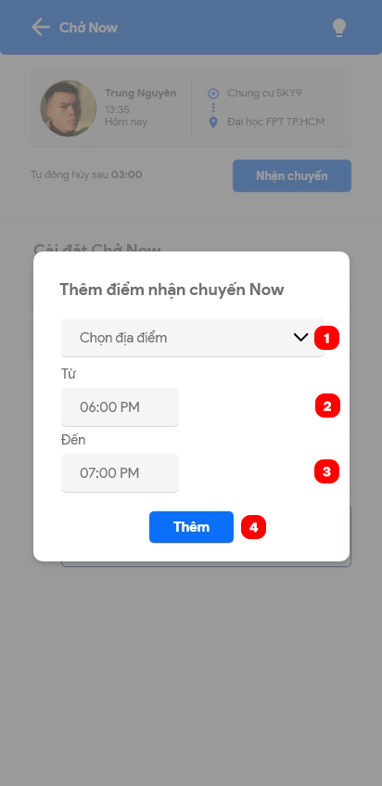

|  |  |  |  |  |  |  |
| --- | --- | --- | --- | --- | --- | --- |
| **No** | **Field Name** | **Description** | **Read only** | **Mandatory** | **Control type** | **Data type** |
| 1 | Station | Station from system that can choose to received Trip Now | No | Yes | Dropdown | String |
| 2 | Time from | Time to start to receive Trip Now on a day | No | Yes | Time picker | String |
| 3 | Time to | Time to stop to receive Trip Now on a day | No | Yes | Time picker | String |

|  |  |  |  |  |
| --- | --- | --- | --- | --- |
| **No** | **Function** | **Description** | **Validation** | **Outcome** |
| 4 | Add Ride Now station | Add a new station to Ride Now station | No | Ride Now station is added |

* 1. **Troubleshooting**

N/A

1. Appendix
2. Flutter

<https://flutter.dev/>

1. Dart

<https://dart.dev/>

1. Typescrift

<https://www.typescriptlang.org/>

1. Material Design

<https://material.io/design>

1. Firebase

<https://firebase.google.com/>

1. Ant Design

<https://ant.design/>

1. Google Maps Platform

<https://developers.google.com/maps/>

1. Pathshare

<https://pathsha.re/>

1. Haversine formula

<https://en.wikipedia.org/wiki/Haversine_formula>